
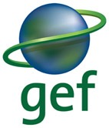

United Nations Development Programme
Project Document template for nationally implemented projects
financed by the GEF/LDCF/SCCF Trust Funds

Project title: Sustainable management of wooded production landscapes for biodiversity conservation
Country: Haiti | Implementing Partner: Ministry of Environment |  | Management Arrangements : National Implementation Modality (NIM)
UNDAF/Country Programme Outcome:
National, regional and local institutions and civil society improve the management of rural and urban areas, agriculture and the environment, and mechanisms for preventing and reducing risks in order to improve the resilience of the population to natural disasters and to climate change.
UNDP Strategic Plan 2018-2021
Development Setting B: Accelerating structural transformations for Sustainable Development. Signature solution 4: Promote nature - based solutions for a sustainable planet
Strategic Plan IRRF Outputs:
1.4.1 Solutions scaled up for sustainable management of natural resources, including sustainable commodities and green and inclusive value chains
Output Indicators: 1.4.1.2 Natural resources that are managed under a sustainable use, conservation, access and benefit-sharing regime:
- Area of land and marine habitat under protection (hectares)
- Area under sustainable forest management (hectares)
- Area of land under sustainable land management regime (hectares)
2.4.1 Gender-responsive legal and regulatory frameworks, policies and institutions strengthened, and solutions adopted, to address conservation, sustainable use and equitable benefit sharing of natural resources, in line with international conventions and national legislation
Output Indicators: 2.4.1.1. Number of countries with gender-responsive measures in place for conservation, sustainable use, and equitable access to and benefit sharing of natural resources, biodiversity and ecosystems:
- Policy frameworks
- Legal and regulatory frameworks
- Institutional frameworks
- Financing frameworks
UNDP Social and Environmental Screening Category: Moderate |  | UNDP Gender Marker: 2
Atlas Project ID/Award ID number: 00118747 |  | Atlas Output ID/Project ID number: 00115449
UNDP-GEF PIMS ID number: 5765 |  | GEF ID number: 9777
Planned start date: March, 2020 |  | Planned end date: February, 2025
LPAC date:
Brief project description:
This project will generate major biodiversity benefits, as well as sustainable land management benefits and collateral gender-sensitive socioeconomic/livelihood benefits by enhancing conditions and capacities among farmers in the north of Haiti to manage BD-friendly, sustainable and economically viable tree-based production systems (diversified cacao, coffee and home gardens).
Financing Plan
GEF Trust Fund |  | USD 3,500,000
UNDP TRAC resources |  | USD 200,000
- Total Budget administered by UNDP |  | USD 3,700,000
Parallel co-financing (all other co-financing that is not cash co-financing administered by UNDP)
Interamerican Development Bank |  | USD 43,479,737
United Nations Development Programme |  | USD 2,206,252
Food and Agriculture Organisation |  | USD 1,821,572
- Total co-financing |  | USD 47,507,561
- Grand-Total Project Financing (1)+(2) |  | USD 51,207,561
Signatures
Signature: print name below | Agreed by Government |  | Date/Month/Year:
Signature: print name below | Agreed by Implementing Partner |  | Date/Month/Year:
Signature: print name below | Agreed by UNDP |  | Date/Month/Year:

Table of Contents
II. Development Challenge 7
Context 7
Threats and drivers 28
Baseline investments 29
Barriers 33
III. Strategy 35
Selected approach 35
Lessons learned 36
Theory of change and incremental reasoning 37
Specific strategies 51
Incorporation of stakeholder concerns 52
Selection of project beneficiaries 53
Relevance in relation to the baseline scenario 53
IV. Results and Partnerships 54
Expected Results: 54
Outcomes and components 54
Partnerships: 61
Mainstreaming gender and intercultural issues: 62
V. PROJECT MANAGEMENT 63
Cost efficiency and effectiveness: 63
Risk Management: 63
Social and environmental safeguards: 63
Sustainability and Scaling Up: 63
Exit Strategy 63
South-South and Triangular Cooperation (SSC/TrC) 64
VI. Project Results Framework 65
VII. Monitoring and Evaluation (M&E) Plan 70
VIII. Governance and Management Arrangements 75
IX. Financial Planning and Management 80
X. Total Budget and Workplan 82
XI. Legal Context 91
XII. RISK MANAGEMENT 92
XIII. Mandatory Annexes 94
A. Multi year Workplan 94
B. Monitoring Plan 99
C. Evaluation Plan 102
D. Overview of Technical Consultancies 103
E. Terms of Reference 104
F. UNDP Social and Environmental Screening Procedure (SESP) 112
G. UNDP Project Quality Assurance Report (to be completed by UNDP Country Office) 126
H. UNDP Risk Log (to be completed by UNDP Country Office) 127
I. Results of the capacity assessment of the project implementing partner and HACT micro assessment 132
J. Gender rating 133
F. STANDARD LETTER OF AGREEMENT BETWEEN UNDP AND THE GOVERNMENT FOR THE PROVISION OF SUPPORT SERVICES 135
G. STAKEHOLDER ENGAGEMENT PLAN FOR THE IMPLEMENTATION PHASE 139
160
H. GENDER ANALYSIS AND STRATEGY 167
Additional Annex A. Target species of global conservation concern 188
Additional Annex B. Cumulative dry matter yields (kg ha⁻¹) of marketable products harvested in five different cocoa production systems in Bolivia from 2009 to 2013. 209
Additional Annex C. Partnership Arrangement between the MoE/UNDP/FAO/GEF Project "Sustainable management of wooded production landscapes for biodiversity conservation” and the IADB PITAG program 210
Additional Annex D. Procurement Plan 212

Abbreviations and acronyms

Abbreviation | English meaning
AECID | Spanish Agency for International Development Cooperation
AFOLU | Agriculture, forestry and other land use
ANAP | National Protected Area Agency
ANATRAF | The National Association of Fruit Processers
AOO | Area of occupancy
BD | BioDiversity
CARICOM | Caribbean Community
CASELI | Center for Support and Services for Local and International Businesses
CBC | Caribbean Biological Corridor
CBO | Community-Based Organisation
CC | Climate Change
CCA | Climate Change Adaptation
CSO | Civil Society Organisations
CTCR | Technical Commission on Rural Credit
DEED | Sustainable Economic and Environmental Development project
DSNCRP | National Strategy Document for Growth and the Reduction of Poverty
ERC | Evaluation Resource Center
EU | European Union
FACN | Federation of Native Coffee Associations
FAO | Food and Agriculture Organisation
FECCANO | Federation of Cacao Cooperatives of the North
GBV | Gender-based violence
GEBs | Global Environmental Benefits
GEF | Global Environment Facility
GEFTF | GEF Trust Fund
GHG | Greenhouse Gases
HAP | Hillside Agricultural Program
HTG | Haitian Gourdes
IDB | Interamerican Development Bank
IEO | Independent Evaluation Office
IPCC | International Panel on Climate Change
IUCN | International Union for Conservation of Nature
LD | Land Degradation
LULUCF | Land Use and Land Use Change in Forestry
M&E | Monitoring and Evaluation
MARNDR | Ministry of Agriculture and Natural Resources
MCFDF | Ministry of the Feminine Condition and Women’s Rights
MoE | Ministry of Environment
MTR | Mid-Term Review
NGO | Non-Governmental Organisation
NPCD | National Programme for the Combat of Desertification
PA | Protected Area
PAC | Project Approval Committee
NAPE | National Action Plan for the Environment
PGS | Participatory Guarantee System
PIF | Project Identification Form
PIR | Project Implementation Report
PITAG | Programme for Technical Innovation of Agriculture and Agroforestry
PO | Project Officer
PMU | Project Management Unit
PN3B | Three Bays National Park
PPG | Project Preparation Grant
PSDH | Strategic Plan for the Development of Haiti
RECOCARNO | Network of Coffee Cooperatives in the North Region
SESP | Social and Environmental Screening Procedure
STAP | Scientific and Technical Advisory Panel
TA | Technical assistance
TE | Terminal Evaluation
TPR | Resilient Productive Landscapes in Haiti
UNDP | United Nations Development Programme
UNFCCC | United Nations Framework Convention on Climate Change
USAID | US Agency for International Development
WFP | World Food Programme

Development Challenge

Context
- Haiti consists of the 2,775,000-ha portion of Hispaniola, which is shared with Dominican Republic, and six satellites islands totalling 95,400 ha.

Demography
- Haïti’s population is estimated to be 8 million with a 2.08% annual growth rate. Haiti had a Human Development Index of 0.471 in 2013, the lowest in the western hemisphere and number 168 out of 187 worldwide. Between 2005 and 2010, three-quarters of the population lived below the poverty line of US$2 per person per day, and more than half (56%) lived below the absolute poverty line of US$1/person/day.
- According to 2003 census data (updated by projection in 2012), 52% of the population is rural, 22% live in the capital Port-au-Prince and the remaining 26% live in other urban centres. The population growth rate in towns between 2003 and 2012 was double that of the country as a whole.
- Demographic growth in rural areas is leading to accelerated rates of fragmentation of land holdings. The proportion of holdings with an area of less than 1 carreau (1.29 ha) rose from for 39% (11% of farmed land) in 1980 to 69% (37% of farmed land) in 2010, while the proportion of holdings larger than 5 carreaux (6.45 ha) fell from 2% in 1980 (11% of farmed area) to 0.5% in 2010 (5% of farmed area).

Biodiversity
- There are 17 Key Biodiversity Areas (KBAs) in Haiti with five “Wholly Irreplaceable Sites” containing the only known populations of globally threatened species, namely Massif de la Hotte, Massif de la Selle, Dame-Marie (Grande-Anse Department), Plaisance (Northern region), and Presqu’île du Nord-Ouest I and II.
- Haiti’s topography produces significant regional and altitudinal differences in temperature and rainfall. The resultant vegetation varies from subtropical very dry forest formations where cacti and scrub predominate (Northwest and Northeast regions), to tropical (Montane wet forest) at the higher altitudes where pines (Pinus occidentalis, which is endemic to Hispaniola) and temperate vegetation thrive. Wetlands, lakes, lagoons, estuaries and a varied coastline provide additional diversity.
- There are 25 native mammal species, including fifteen species of bats, of which seven taxa (including species and sub-species) are considered endemic.
- The county supports over 245 species of birds, of which more than 73 are resident landbirds. The Hispaniolan avifauna exhibits exceptional levels of endemism: the island is an Endemic Bird Area (EBA), and 36 range restricted species are known from Haiti, one of which, the grey-crowned palm tanager (Phaenicophilus poliocephalus) is endemic to the country. The majority of the range restricted species are confined to, or occur in habitats above 1,000 m, emphasizing the importance of mixed montane broadleaf-pine forest.
- Overall the island of Hispaniola hosts 217 species of reptiles and amphibians (Thomas 2000), of which approximately 70% have been recorded in Haiti. Ninety-eight percent are endemic to Hispaniola with about a third of the species occurring only in Haiti. 46 of the 56 species of amphibians in Haiti are at risk, some at the verge of extinction.
- Officially, the Government has identified 35 protected areas covering about 6% of the country. However, the percentage of effective PAs, some of which are actually historical sites, is evaluated at no more than 0.5% of the surface of the country. The main PAs include national parks, a forest reserve, historic parks, hot springs and inland waters. Of the 35 legally recognized PAs, only Macaya, La Visite, Forêt des Pins and Sans Souci have some form of management.

Project target area
- The project will specifically work in 24 communes of the North, North-East and Artibonite Departments in Haiti (I.I.i.Table 1).
      - Target communes
Department | Commune | Area
North-East (Nord-Est) | Carice | 11,500
North-East (Nord-Est) | Mont-Organisé | 9,449
North-East (Nord-Est) | Vallières | 15,846
North-East (Nord-Est) | Sainte Suzanne | 12,791
North-East (Nord-Est) | Mombin-Crochu | 19,151
North (Nord) | Bahon | 14,750
North (Nord) | Port-Margot | 14,750
North (Nord) | Pilate | 12,080
North (Nord) | Plaisance | 12,152
North (Nord) | Grande-Rivière | 12,815
North (Nord) | Dondon | 12,036
North (Nord) | Milot | 7,164
North (Nord) | Plaine du Nord | 10,069
North (Nord) | Limbé | 12,580
North (Nord) | Borgne | 20,209
Artibonite | Marmelade | 10,894
Total |  | 175,991

            - Target communes


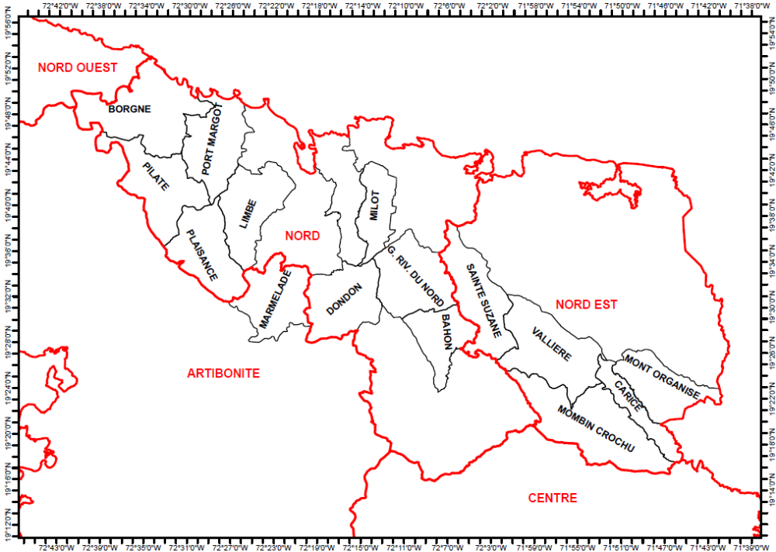
Atlantic Ocean

- This area has been selected for the following reasons:
- It contains important outlier populations of a significant number of endangered and vulnerable Hispaniolan endemic fauna species, whose main areas of distribution are located in the neighbouring Dominican Republic and whose ecological requirements are generally compatible with the conditions found in tree-rich agroecosystems. Information on these species, including their global conservation status, reported distribution and ecological requirements, is presented in Additional Annex A.
- It is also the most important region of the country for the production of cacao under diverse tree shade, as well as containing (especially in the western part of the area) significant areas of shade coffee plantations.
- The combination of these two factors means that there is significant potential for the project to improve the conservation status of these species by promoting regional connectivity, through the establishment of a functional biological corridor running along the tree-rich middle-altitude agroecosystem zone, which skirts the whole length of the northern flanks of the Massif du Nord mountain range as far as the border with the Dominican Republic.
- There are major ongoing baseline investments in the area, of relevance to the project. In particular, this area offers opportunities to maximise impact through co-financing partnerships with a major cooperation programme: the Programme for Technical Innovation of Agriculture and Agroforestry (PITAG), funded by the Interamerican Development Bank (IDB) and executed by the Ministry of Agriculture (MARNDR).

Trees in farming systems
- It is estimated that 75% of the currently wooded area in the country consists not of relics of natural forests, but of trees established and managed by farmers: recent studies suggest that predominant deforestation narratives may fail to take into account smaller scale patches of tree cover, which are typically associated with farming systems. Diverse tree species are typically associated with food crops, with species and densities varying in function of variations in physical and economic conditions. They include fruit, fodder and timber trees: in addition to providing products such as fruit, fuelwood and timber for use by the farmer and their families, trees are used as a source of cash income and as a savings bank. Although a wide number of trees are used, tree cover is dominated by a relatively few species such as mango, avocado, breadfruit, coconut and citrus. The species composition and spatial configuration of tree is strongly determined by altitude, typically with scattered patches at higher altitudes, more homogenous masses at middle altitude (350-600m) and linear forests following watercourses at lower levels, where rainfall and therefore soil humidity tend to be more limited. At higher altitudes (>600m) trees are normally limited to home gardens (“jaden pre kay”), where the required for the establishment of the gardens is derived from crop and kitchen wastes.

Agriculture and agroforestry/tree-based systems:
- Haiti is predominantly a rural country, with 53% of its population living in rural areas (The World Bank, 2010). The agriculture sector employs around 50% of the total labour force of the country. The main crops, accounting for more than 85% of farmed area, are maize, sorghum and rice (38%), pulses (beans, pigeon peas, peanuts – 28%) and banana/plantains, cassava, potatoes and yams – 19%). The main cash crops in the country are cocoa and coffee.
- The main forms of agricultural production in the project area are shown in Figure 2.
- PPG studies and consultations resulted in additional characterisation of the cropping systems in the target communes of the project:
- Polyculture cereal production system: beween 2 and 5 crops including beans (Phaseolus vulgaris), maize, sorghum/millet, pigeon peas, sweet potato and cassava; at times with animals such as donkeys, horses and cattle, depending on the socioeconomic conditions of the household.
- Seasonally mobile pasture/tree/livestock system, practised by occasional better-off farmers: the strategy of mobility is a form of adaptation to external factors affecting the herd. It is also motivated by the presence of pastures, water and other environmental conditions favourable for the development of the animals. The process consists of removing the animals from the fields during cropping seasons, and because of scarcity of water putting them on pastures that are difficult to reach, during the dry season. The animals generally include cattle, goats and poultry.
- Agro-sylvopastoral system, combining cereal crops, livestock raising and naturally regenerated trees: typically with a few head of cattle, goats, donkeys and poultry, depending on the socioeconomic conditions of the farmer (notably tenure security and access to pasture).
- Monoculture sugar cane production (notably in Vallières, Plaisance and Grande-Rivière): for self-consumption without processing, local exchange, and on rare occasions for small processing industries that exist in the region.
- Agroforestry system based on coffee (losing importance in the north), cacao or ginger (Bois de Laurence, Mombin Crochu in particular), combining cereal and vegetable production and at times livestock, practised in particular by farmers who have access to a range of different agroecosystem levels.
- Home gardens (jardins ‘‘Lakou’’) – see below.
- Agroforestry system practised in some locations inside pine woodlands, where the microclimate provided by the pines allows vegetable production.
            - Spatial distribution of principal cropping systems in Haiti
Approximate project area
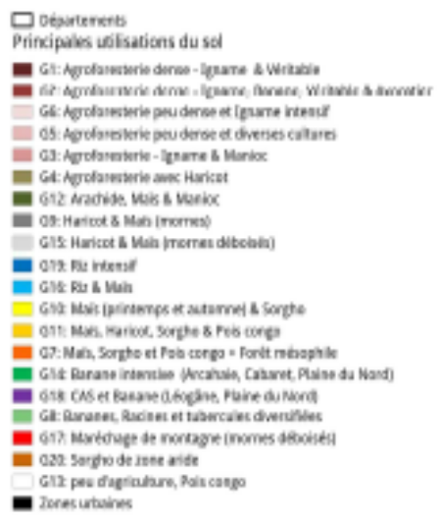
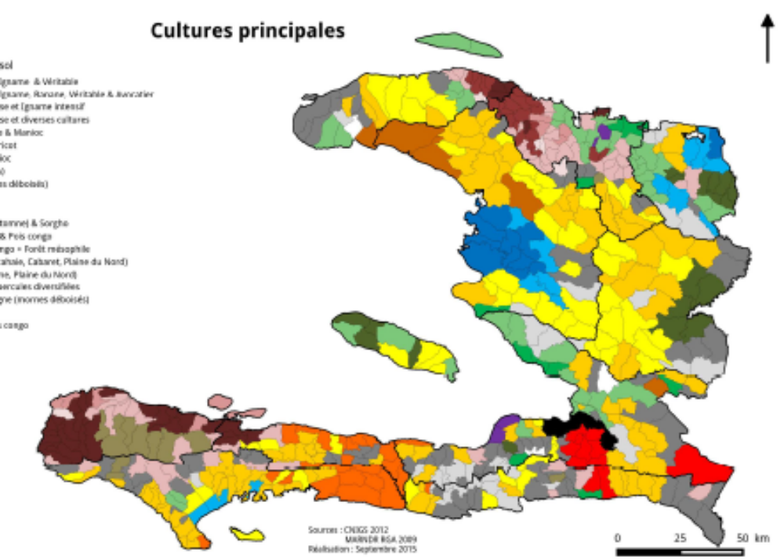
Dense agroforestry – yams and breadfruit
Dense agroforestry – yams, bananas, breadfruit and avocados
Non-dense agroforestry, intensive yam production
Non-dense agroforestry, diverse crops
Agroforestry – yam and cassava
Agroforestry with beans
Peanuts, maize and cassava
Beans and maize (hills)
Beans and maize (deforested hills)
Intensive rice
Rice and maize
Maize (spring and autumn) and sorghum
Maize, beans, sorghum and pigeon peas
Maize, sorghum and congo peas (broadleaved forest)
Intensive bananas
CAS and bananas
Bananas and diverse rootcrops
Upland vegetables
Dryland sorghum
Little agriculture, pigeon peas
Urban areas

- The principal crops encountered in these systems are as follows:
- Legumes (beans, Angola peas, vigna, peanuts);
- Cereals (rice, maize, sorghum)
- Rootcrops (yam, cassava, taro, sweet potato)
- Vegetables (onions, carrots, peppers, beetroot, gombo (okra)
- Fruits (bananas, avocados, mangos, cashew, citrus, etc.)
- Tree crops (cacao and coffee)
- Ginger
- Pine forests with intercropped vegetables.
- Livestock are encountered in all farming systems: the most common types are cattle, goats, horses, sheep, donkeys and poultry.
- Ginger is becoming increasingly important, and progressively replacing coffee and cacao in many agroforestry systems, for example in Carice, Bois de Laurence, Mombin-Crochu and in particular in Mont-Organisé; at least 25% of the wooded area in these locations are planted with ginger in agroforestry systems. Ginger is less demanding of labour than coffee or cacao (one weeding per year) and is more resistant to insects and fungi, and so requires lower levels of financial investment. Prices (at least USD 69 per 25kg bag) and market access are currently very favourable.
- Average farm size in the North Department is 1.61 ha. In the North-East Department, farm size decreases progressively as one moves from Carice to Bas Maribahoux, passing through Mont Organisé and Haut Maribahoux. Carice has the highest average size, at 2.76 ha, while in Bas Maribahoux farms are typically around 1.10 ha and those in Mont Organisé and Haut Maribahoux are similar, at around 1.91 ha (MARNDR, 2012).

Cacao
There are an estimated 25,000 cocoa farmers in the country, with around 10,000 intermediaries and processers and 4 exporters. The principal cacao production areas in Haiti are the north and the south-west, with an estimated total area of around 9,000 ha and an annual production of around 3,000 t, of which around 45% comes from the North Department. Previously, cacao was only grown between 100 and 500 m above sea level, but is now found at up to 800 m.
- Cocoa is produced in either “simple cocoa gardens” or “complex forest gardens”, which differ in terms of the diversity of their composition and the products and services they generate, the importance of cocoa relative to other products, and the level of management.
- In the project area, cacao is produced in shaded agroforestry systems, which are mainly found at altitudes between 100 and 500 m.a.s.l., especially in Petit-Bourg, Boucan Michel (Borgne), Grande Rivière du nord, Pilate, Plaisance, and Port-Margot. The most notable components are cacao, bananas, yams, taro and fruit and timber trees. Trees include citrus, mangos, avocados, breadfruit, Inga vera, Spondias mombin, and timber trees including Simarouba glauca, mahogany (Swietenia mahogany) and cigar-box cedar (Cedrela odorata). In general, shade trees are used as trellises for yam vines. The system is organized in strata with fruit and timber trees in the upper storey, cacao and bananas in the middle level and food crops (yam and taro) in the lower level. The density of plants varies from one farm to another. Food crops (plantains, bananas and yams) are the most closely spaced, with around 500-700 plants per hectare for banabas and 500/ha for yams. The density of cacao is also typically around 500 stems/ha. In certain crops, where cacao production is the main objective, the density can exceed 1000 stems/ha. Plots close to houses are generally more densely planted than those that are further away.
- In the project area, the cacao plantations are particularly old: it is estimated that 45% of the plantations are more than 40 years old. There are however some areas of young plantations, established recently as a result of the actions of projects such as the Hillside Agricultural Program (HAP) and the Sustainable Economic and Environmental Development project (DEED).
- There are a number of varieties of cacao in the project area. The “créole” variety is present throughout: in addition, some plots include the Criollo and Trinitario varieties, which come from the Dominican Republic and which have been recently introduced by the HAP and DEED projects due to their high productivity.
- Bananas and plantains are normally grown in the same plots, especially in cacao plantations. The “Ti Samuel” variety of banana occurs over large areas: it was introduced three or four years ago from the Dominican Republic and has been rapidly and widely adopted due to its high productivity, but more recently it is being rejected because it has a tendency to take over plantations at the expense of cacao, and its limited marketability. There is also a wide range of yam species in the cacao plantations (Dioscorea trifida, D. alata, D. rotundata and D. cayenensis): yellow and white varieties have good market value, and there are also other varieties with less market value, but which are important for food.

Coffee
- Nationwide, coffee production has undergone major decline in recent years, a situation which is attributable to variability in interntional markets as well as export taxes, unfavourable vaue chain and pricing structures, pests and diseases, climate conditions, political instability and limited access to finance (see below and Figure 5). In the project area, it is estimated that around 75% of coffee plantations have been lost since 2009, leaving only around 950ha (precise data are not available). Historically, however, coffee production has historically shown the potential to bounce back from successive cycles of decline and political instability.
      - Principal coffee growing areas and their potential to produce quality coffee
Department | Municipalities
High-quality coffee zones
- Grand Anse  - South  - Southeast  - Centre  - Artibonite | - Beaumont, Roseaux, Jérémie  - Tiburon, les Anglais, Marigot  - Baptiste, Savanette  - Les Cahos
Average-quality coffee zones
- North  - Northwest  - Northeast  - Nippes | - Dondon, Plaisance, Pilate, Grande Rivière du Nord, Bahon, Mermelade  - Saint-Louis du Nord, Port de Paix, Anse a Foleur  - Sainte Suzeanne, Valière, Carice, Mont Organisé  - L’Asile, Baradères
- About 150,000 to 200,000 farm families still obtain an important part of their revenues from coffee in the country. Most farmers have less than 3 ha of coffee; there are less than 200 ‘large estate’ coffee farmers with around 5-20 ha each. In general, few or no agricultural inputs such as fertilizers and pesticides are used.
- Coffee farms are typically highly diverse, containing bananas, yams, taro, citrus, mango, avocado trees, pineapples, coconuts and breadfruit, and shade is most commonly provided by sucrin (Inga vera) as well as mahogany (Swietenia mahogany), laurel (Ocotea spp.), oak (Catalpa longissimi) and rain tree (Albizia saman). In some parts of the country, cacao is also planted in association with coffee. Production levels typically range between 70 and 210 kg/ha). Income from coffee farms was found to range between 18,000-65,000 Gourdes/ha in 2003 (USD 500-1,800/ha); however, the coffee itself only represents between 12% and 28% of this income, with most of the income coming from the sale of yam, taro and bananas grown in association.
- Coffee- and cacao-based agroforestry systems are almost identical, and both are present at lower altitudes (400-500 m), while coffee also occurs above 500 m. As with cacao, this system is organised in strata, with fruit and timber trees (the same species as those in cacao plantations) in the overstorey, coffee and bananas in the middle level and food crops (yam and taro) at the lower level.
- Mirroring the national trends, coffee is in a process of sharp decline in the area. As with cacao, coffee plantations in the project area are very old. RECOCARNO, a federation of six coffee cooperatives in the north and north-east, has recently provided support to farmers for the improvement of coffee production, with funding from the European Union, but this has stopped when the funding ceased.
      - Order of importance of drivers of the decline of coffee production in the project area, based on relative numbers of respondents in stakeholder focus groups
 | Order of importance
Food insecurity reduces relative attractiveness of export crops | 1
Loss of coffee shade due to tree felling for charcoal and food crop production | 2
Reduction in global coffee prices | 3
Reluctance to associate coffee with cacao | 4
Ageing of coffee plantations: limited capacity and financial resources for renewal | 5
Lack of State support, limited interest by younger community members | 5
Lack of project support | 6
Pests and diseases | 6
Climate change | 7
Abandonment of processing facilities | 7
Limited structure and transparency of value chains, and ability of producers to influence prices | 7
- The density of coffee in the region is not well known, but it varies according to the level of decline of the crop, from a few stems/ha (in which case the plantation is effectively a rootcrop production area) to more than 1,000 stems/ha. The density of other crops is typically 700/ha in the case of banana, 500/ha for yam, 20-40 fruit trees/ha and more than 100 shade trees. The predominant variety of coffee in the zone is typica.

Mixed cacao/coffee agroforestry systems
- This system is a variant of the two previous systems (cacao and coffee). It is mostly found at an altitude of between 400 and 500 m. Given the decline in the coffee sector, cacao is gradually taking over spaces previously occupied by coffee, so long as farmers can overcome the different problems associated with the crop such as diseases and climatic and soil conditions).
- This system has the same structure as the two previous ones: an overstorey of fruit and timber/shade trees, a middle level of coffee, cacao and banana, and an understorey of yam and taro, with the trees serving as trellises for the yams. The planting distances are the same as in plantations with the individual crops, but the densities of bananas, shade trees and even yams are rather lower. Inga is the main shade tree in this system, despite its susceptibility to rot.

Banana, yam and bean association
- This association is found in spaces where coffee or cacao have disappeared: in some cases, one may find only yam and beans. In this system, mounds are formed for planting yams or ginger. Beans are planted on the yam mounds, while bananas are intercropped between the mounds. When bananas are absent, beans are sown between the mounds. The dentity of beans varies between farms, but is of the order of 60-80 kg/ha.

Pure bean system
- Although the tree cover is relatively dense in most of the mountainous area, beans are grown in clearings in low altitude zones. This is an evolving situation which has not yet reached the levels found in humid mountains in other parts of the country. If this process continues to intensify, beans may come to replace cacao and coffee plantations in the future.
- Beans can be sown in three seasons. The first season starts in February/March, in areas cleared on sloping lands, and the harvest is carried out between April and May. In the second season, the beans are sown in July/August, in cooler zones, and the harvest is in October. The third season is between October and December. In this season, beans are sown on summit plateaux and steep slopes.

Bean-maize system
- In relatively degraded areas on slopes, in gorges and foothills, maize is associated with beans (mostly black beans) during the springtime: the seed are sown at the same time, in March. Beans are harvested in May and maize in June.

Créole garden (jaden kreyol) agroforestry sytems
- The traditional agrarian landscape in Haiti is characterised by the systematic presence of agroforestry gardens around the house. The first of these are jaden lakou (home gardens), which constitute the central nucleus of the farm, in which farmers associate food crops (typically plantains, which have an arborescent form, and yams, which are climbers) with tree-based cash crops: surplus from these crops is sold in local markets or exported (principally coffee, avocado, citrus, mango etc.). One study identified a total of 69 useful species growing in jaden lakou, for food self-sufficiency and of non-food products for home consumption.
- Moving further from the house, the next system is the jaden pré-kay’ (“gardens close to the house”), in which trees occupy a lesser role (often relegated to the edges) in order to permit the production of light-demanding crops. The jaden pré-kay are essentially dedicated to annual crops managed in association, either for subsistence or sale (maize, sorghum, beans, rootcrops, vegetables), and complement the diversified production of the jaden lakou. These different cropping systems are normally associated with extensive animal production systems (poulty, goats, horses, donkeys, sheep, pigs and cattle), which provide farmers with a vital means of saving and, to a lesser extent, income generation.
- Further away still, and on less fertile land, the jaden lwen kay (“gardens far from the house”) and rack (uncultivated thicket area). The former are open areas (generally cultivated under rental or sharecropping arrangements), commony between 5 and 15 km from the house, which are used for annual, light-demanding cash crops (e.g. maize, sweet potato, sorghum and vegetables). The latter (rack) are long-term forest fallows which act as important reserves of wood (charcoal, fuelwood, tools etc.), and which alternate with short slash and burn cycles of crops with low fertility demands.
            - Typical configuration of créole garden farming systems in function of distance from the house: A = jaden lakou, B = jaden pre-kay, C = jaden lwen kay, D = rack
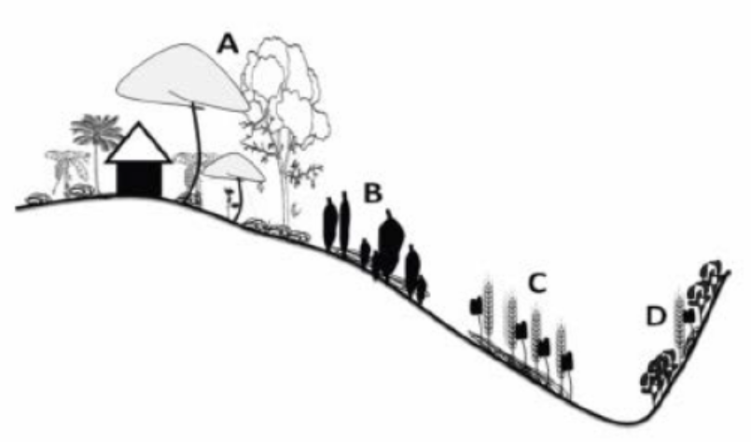
- The number of jaden lwen kay held by different farmers depends to some extent on their socioeconomic status: it varies between 3 and 6 for the better off farmers (category I), 2-3 for category 2, and 0-1 for category 3; very few of the poorest farmers have this kind of garden unless acquired through inheritance or accessed through squatting or usufruct.

Fruit and non-timber products
- The communes of Mont-Organisé, Carice and Mombin-Crochu are notable for the production of mangoes (with more than 15 different varieties), avocado, charcoal, citrus, black mushrooms (djondjon) and poultry (principally chickens). Mango production is particularly important in these communes: in recent years, however, many mango trees have been felled, principally for the production of charcoal and as fuel for limekilns. Due in large part to the isolation of the production areas, post-harvest losses of fruit are very high: farmers and representatives of BAC estimate that around 60% of mango production is wasted, and fruit production greatly exceeds current demand. Results from focus groups indicate that in addition to losses during transport and handling, which often exceed 15%, more than 35% of production (of fruit in general) is abandoned in the field due to lack of markets and/or lack of knowledge of effective methods for increasing product life.

Structure and management of agroforestry systems
- Especially in the areas of Pilate, Port-Margot, Mombin-Crochu, Borgne and Grande-Rivière du Nord, at least four strata of vegetation are recognisable in the agroforestry systems:
- Herbaceous stratum: in some cases, including ginger as a basic cash crop, and composed essentially of grasses and adventitious species. This stratum provides habitat for fauna such as mongooses, rodents, reptiles and insects.
- A stratum of cultivated plants
- A cacao/coffee stratum, which also contains bananas and sometimes sugar cane, yams and citrus
- A tree stratum, made of relatively large trees including fruit species (mango, avocado) and others, both native and naturalised (Inga, Chêne, Acajou Venezuela, Frêne, Bois-Blanc, Leucaena, etc.).
- The management of these agroforestry systems is not solely determined by market factors: it also seeks to minimise agroclimatic risks and also to meet several objectives in the same plot (food security, herd enlargement, and response to other socioeconomic and livelihood needs). Most farmers (around 80%, according to indications from focus groups) use these systems principally through ‘foraging’ rather than applying active management such as thinning, soil management or variety selection. Over much of the project area, degradation has led to the canopy of these agroforestry systems becoming fragmented, resulting in a series of patches and strips. The degradation of the traditional agroforestry systems and their progressive replacement by annual cropping systems is leading in many cases to plots being fenced off, which affects traditional patterns of access and use across the landscape.

Factors determining the choice of woody species in the agroforestry system
- PPG focus group participants highlighted six main factors that determine the selection of the woody species that they include in their agroforestry systems:
- Economic importance (for utility timber, energy or construction) compared to other species
- The utility of the species in relation to the agronomic requirements of crops in the systems (e.g. cacao, coffee, ginger, yams)
- The ability of the species to develop with the other components of their cropping systems (competition for light and nutrition, phytosociological aspects, non-invasiveness), especially food crops that are of importance for meeting socioeconomic needs
- The adaptability of the species in relation to the agroecosystem conditions in the land holding
- Contribution to the renewal of agricultural fertility and soil protection
- Tenure conditions.

Economies of agricultural holdings

Factors of production
- Labour demands are particularly high in the periods of site preparation, planting, maintenance and harvesting. The availability of farm labour is determined by the number of people in the household, their age, their occupation and their level of dedication to agricultural activities. Generally, all family members participate in agricultural operations: women tend to participate in sowing, weeding and harvesting, and children of school age also participate part-time. Labour availability is increasingly limited due to emigration in search of more attractive opportunities, and the lack of interest among young people in engaging in agricultural labour which they consider unprofitable and degrading. In order to address labour shortages, some farmers contract daily labourers. Farmers typically only have access to very basic agricultural implements, which limits their ability to intensify management.

Categories of community stakeholders
- Table 4 summarizes the principal categories of stakeholders who make up the population of the target communities, and Table 5 presents a classification of farmers, by socioeconomic category. The predominant group is made up of medium-scale farmers and herders.
      - Principal stakeholder categories in the project area, by economic status and activities, as defined in focus groups during project formulation.
Category | Examples of productive activities | Approximate proportion of total
Small farmers with <0.5 Cx of land in use, and landless | Collection and sale of fuelwood faggots; production of mats, ropes and handicrafts; sale of water; protection of gardens for those in higher socio-economic categories; urban labour; work as porters; building labourers; laundry; millet and sorghum milling; collection and transport of sand from rivers, for construction; agricultural labour (decreasingly) picking coffee, cacao and other crops; cropping and raising of small livetock; operating rented motorcycle taxis. | 10 - 15%
Medium-scale farmers/herders of 0.5- 2.5 Cx | Dominance of agricultural activities (medium scale livestock and agroforestry systems; seasonal trading of livestock; school teachers; roadside fuel sales; sale of used clothes in towns; owners of motorcycle taxis | 30 – 35%
Manual skills | Tailoring dressmaking, hairdressing, stonemasons, carpintery and cabinet-making, brickmaking, blacksmithing and metalwork, agriculture. | 10 – 15%
Employees of public and private institutions | Civil servants, NGO employees, schoolteachers, traders (stores in urban centres), owners of trucks, pickups and multiple motorcycle taxis. | 10 – 15%
Agricultural traders | Purchase and sale of foodstuffs and animals, butchery, agricultural activities (occasionally) | 20 – 25%
Better-off farmers (3-5 Cx) | Livestock rearing (cattle, goats, sheep, horses), agroforestry (ginger, cacao, coffee, yams, bananas, beans, maize, sorghum, pigeon beans, sugarcane etc.); stores in villages and sometimes in towns; owners of trucks, pickups and multiple motorcycle taxis. | 20 – 25%

      - Principal categories of farmers, by socioeconomic status, identified in focus groups
Category | Characteristics
I  Larger-scale farmers | - Well-built houses in urban centre  - Farm ≥5 ha in ≥2 agroecological zones; at least 3 plots with coffee, cacao and/or ginger  - Use animal traction (≥4 yoke of oxen)  - Transport: pickups/trucks, carts, motorcycles  - Hold ≥10 cattle, 20 sheep, 30 goats, 30 poultry  - Well and crop drying facilities  - Able to lend crops or money to others as needed  - Contract labour for most agricultural activities  - Economic system composed of self-consumption (20-30%), investment/renewal/expansion (20%) and marketing (up to 80%).  - Well inserted into markets, but vulnerable to variations in global markets  - Generally resilient
II Medium-scale farmers | - Concrete houses in urban centres  - Farm 2-3 ha in 2 agroecological zones, 1-2 plots with coffee, cacao and/or ginger  - Use animal traction (up to 3 yoke of oxen)  - Transport: pick-up, motorcycles, horses/donkeys  - ≥6 cattle, 10 sheep, 10 goats, 15 poultry  - Sometimes have well and crop drying facilities  - Able to lend crops or money to others as needed  - Contract labour for some agricultural activities  - Economic system composed of self-consumption (40-70%) and marketing (up to 35%).  - Access to credit in lean times  - Vulnerable to natural and economic shocks but buffered by livelihood diversity
III  Small farmers | - Earth- or pole-built house with corrugated iron or thatched roofs, on edge of or outside town  - Farm 0.5-1 ha, rarely in 2 agroecological zones; sometimes with one plot including coffee cacao; food crops make up more than 90% of the farmed area.  - Transport: sometimes have access to motorcycle and 1-2 donkeys  - Hold ≤2 cattle, around 5 sheep and goats, and around 10 poultry  - Sometimes have access to crop-drying facilities  - Contract or exchange labour for agricultural activities  - Economic system dominated by subsistence production, with some cash crop sale in good periods  - Sometimes obliged to migrate in lean times; very vulnerable to natural and economic shocks  - The majority are indebted; difficulty in obtaining seed, with little food reserve.
IV  Poor landless labourers | - Earth- or pole-built house with thatched roofs, on edge of or outside town  - Farm <0.5 ha, rarely with a few cacao or coffee bushes in the backyard  - Transport: sometimes have a bicycle or a donkey  - Sometimes have a cow, 2 sheep and goats and a few head of poultry  - Work as labourers, porters  - Almost completely focused on subsistence, and on maintaining food security, with extreme socioeconomic difficulties, and little or no resilience to shocks.

Resilience strategies
- Most farmers have multiple livelihood support activities in order improve resilience, satisfy food security needs, generate financial revenues and where possible accrue capital. The main reasons for the emphasis given to ensuring livelihood resilience include the seasonal nature of agricultural activities, the unreliability and instability of agricultural income, natural disasters, poverty, limited access to factors of production and social and historical constraints. In the first half of 2018, for example, mountain communities in the target communes of Mont-Organisé, Carice, Mombin Crochu, Sainte Suzanne and Vallières were affected by a severe and prolonged drought which seriously affected their crops. The vunerability of rural livelihoods has further been affected by the reduction of State support for the agricultural sector, associated with structural adjustment policies.
- Another coping strategy in relation to this situation is migration. Focus group participants reported that members of at least 35% of families migrated to urban centres for between three and seven months per year, despite the fact that the urban centres do not have the capacity to absorb and provide opportunities for this large, and growing, influx.

Non-agricultural activities
- Non-agricultural activities provide often substantial and regular income for certain families, allowing them for example to hire daily labour for agricultural activities and to meet the financial needs of the family. The proportion of agricultural holdings with non-agricultural activity is smaller in the North-East than in the communes of the North. The frequency of charcoal production is striking: it is reported in all of the areas under study. Driving motorcycle taxis is also a very popular activity, and in some areas it accounts for almost all of the non-agricultural activity. Emigration to the Dominican Republic is more common in the North-East Department (which borders the Dominican Republic) than those of the North.
- Participation in non-agricultural activities reduces the amount of time dedicated at strictly agricultural activities: overall, it was reported than farmers dedicate between 110 and 200 days per year to non-agricultural activities, concentrating their on-farm activities especially on the periods of sowing and harvesting and having in some cases to hire daily-paid labour. Poorer farmers, who work as daily labourers and are unable to hire daily labour themselves, tend as a result to take longer to undertake and complete their agricultural activities, with consequent effects on their production.

Landscape categories
- Three main types of landscape groupings are distinguishable in the project area, based on the following criteria:
- Agroecological characteristics and level of degradation
- Landscape and natural resource governance models
- Biophysical, agricultural and socioeconomic determinants
- Level of degradation and erosion of biodiversity in the agroforestry systems
- Social incentives for the maintenance of agroforestry systems.
- These main landscape categories are summarized in Table 6.
      - Principal categories of landscape by agroecological characteristics and level of degradation (Departments: N = Nord, NE = Nord-Est, AB = Artibonite)
Category | Area of communes |  | Total area of interest (ha) | Approximate area of agroforestry systems (ha)
Category | Commune | Area (ha) | Total area of interest (ha) | Approximate area of agroforestry systems (ha)
“Conservation zone”:  - Processes of degradation and erosion of biodiversity are visible but recoverable in the medium term  - Opportunities to work with local authorities  - Organizational bases are active but financially and technically weak  - Alarming levels of migration of young people, or switches to other economic activities outside of agriculture (e.g. motorcycle taxis) | Carice (NE) | 11,500 | 83,400 | 50,040  (60%)
 | Mont-Organisé (NE) | 9,449 | 83,400 | 50,040  (60%)
 | Vallières (NE) | 15,846 | 83,400 | 50,040  (60%)
 | Sainte Suzanne (NE) | 12,791 | 83,400 | 50,040  (60%)
 | Mombin-Crochu (NE) | 19,151 | 83,400 | 50,040  (60%)
 | Bahon (N), Port-Margot (N) | 14,750 | 83,400 | 50,040  (60%)
“Preservation zone”:  - Relatively weak processes of degradation, significant diversity of species  - Well developed and extensive structure of vegetation, with at least three strata  - Well developed environmental awareness among farmers, despite the weakness of State authorities at central level  - Positive collaborations between elected local authorities and local leaders for the protection of agro-environmental heritage | Pilate (N) | 12,080 | 24,100 | 18,075  (75%)
 | Plaisance (N) | 12,152 | 24,100 | 18,075  (75%)
“Recuperation zone”:  - Accelerated processes of degradation, with serious risks to the possibility of recovery and regeneration  - Maintenance of remaining ecosystems is due in part to the presence of value chain actors (Novella, FECCANO, RECOCANO  - Better off producers tend to be more resilient | Grande-Rivière (N) | 12,815 | 74,800 | 52,360  (70%)
 | Dondon (N) | 12,036 | 74,800 | 52,360  (70%)
 | Milot (N) | 7,164 | 74,800 | 52,360  (70%)
 | Plaine du Nord (N) | 10,069 | 74,800 | 52,360  (70%)
 | Limbé (N) | 12,580 | 74,800 | 52,360  (70%)
 | Borgne (N) | 20,209 | 74,800 | 52,360  (70%)
 | Marmelade (AB) |  | 74,800 | 52,360  (70%)
Totals |  |  | 182,300 | 120,475

Valuation of biodiversity
- Focus group meetings revealed that farmers in the project area value agricultural biodiversity highly, given the predominance of mixed cropping systems and their importance for minimising the risks associated with the failure of individual crops: environmental and biodiversity considerations were, however, only prioritised in the context of their contribution to food security.
- Focus group participants were asked to what extent they would be prepared to allow biodiversity considerations to affect each of the main objectives that they gave for the management of their landholdings. The results, by socioeconomic category, are shown in Table 7: they show that poorer people (categories III and IV) give overwhelming priority to food security, with no willingness to sacrifice their existing priorities to favour biodiversity: it is only the better-off farmers (categories I and II) who are willing to forego any of their other objectives, and even with them their flexibility is minimal.
      - Degree of flexibility to provide for biodiversity (+/- indicates degree of change farmers would be prepared to accept in relation to each priority)
Priority | Socioeconomic category
Priority | I |  | II |  | III |  | IV
Priority | Relative priority (% of total) | +/- | Relative priority (% of total) | +/- | Relative priority (% of total) | +/- | Relative priority  (% of total) | +/-
Household food needs | 25 | - | 56 | - | 85 | - | 95 | -
Renewal of the holding | 13 | - | 7 | - | 3 | - | 1 | -
Extension of the holding | 10 | +3 | 5 | - | 2 | - | 0 | -
Needs for management and renewal | 4 | - | 2 | - | 1 | - | 0 | -
Basic social needs (schooling, health, travel) | 35 | - | 25 | - | 7 | - | 4 | -
Biodiversity (technical innovation, marketing etc.) | 5 | +3 | 3 | +3 | 0 | - | 0 | -
Other social needs (e.g. emergency reserve funds) | 14 | -6 | 6 | -3 | 3 | - | 0 | -
- Focus groups also served to evaluate members’ perceptions on the importance of biodiversity. The results (Table 8) again suggest limited interest in specifically providing for biodiversity unless it contributes to cropping systems or is of medicinal use.
      - Focus groups responses regarding the importance of biodiversity
Comments | % of respondents
Aware of the importance of some elements of BD, however they increase the cost of plot management work and reduce productive due to competition for space | 53
Interested in BD but would require technical support to see how to integrate it into cropping systems | 15
Always protect plants with medicinal uses, which are used to treat local people due to the lack of a health centre. | 15
Solely interested in cultivated plants, food crops and the management of coffee, coaco, yam and ginger shade | 9
Do not understand the important of non-agricultural BD | 8

Value chains and market potential
- Haitian agriculture is predominantly focused on domestic markets. Although progress has been made in improving and simplifying value chains for crops such as mango, vetiver, coffee and cacao, value chains for food crops are typically long and complex, with high transport costs: this results in high sales prices for consumers, little of which feeds back to the farmer. This also means that in some cases it is more attractive for businesses to import their agricultural raw materials than to purchase them from these local value chains: imports may also allow them to access larger and more reliable volumes, with higher standards of quality control (for example, better drying standards and mycotoxin control).

Cocoa
- There is great potential for growth of cocoa exports, given the predicted 25% supply deficit worldwide by 2020: global demand has grown by 1% annually, while supply has only grown by 3%, and prices have almost doubled over the last 10 years. However, there are significant technical obstacles to the growth of the sector: for example, while 95% of production in Latin American countries is from grafted disease-resistant material, in Haiti there is limited or no knowledge of the varietal heritage available, which consists of multiple varieties, or consequently of their management. In consequence, typical yields are around 250 kg/ha as compared to 3,000 kg in some countries of Latin America with similar agroecological conditions. There are significant opportunities for improving productivity, for example through the use of grafted plants and improved fertility and disease management.
- Although the predominant varieties of cocoa grown in Haiti are in strong demand worldwide, the potential of Haiti’s cocoa has never been optimized, as it has long been sold on the international market in the form of ordinary unfermented cocoa. Only recently have producers become aware of the benefits of producing fermented cocoa. In 2009, thanks to technical assistance from the Peruvian cooperative CEPICAFE for the Haitian cooperative network FECCANO, and support from the French NGO Agronomes et Vétérinaires Sans Frontières (AVSF), their fermented cocoa output was immediately taken up and marketed by European firms, including the French fair-trade company Ethiquable.
            - Trends in value of cocoa exports from Haiti 1960 - 2010
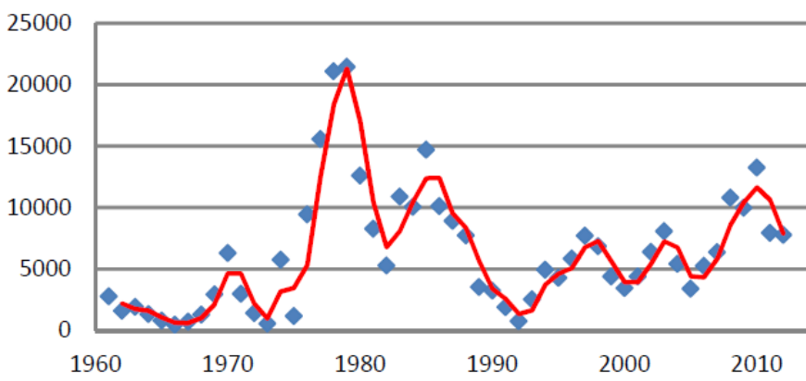

Coffee
- Coffee exports have declined sharply in recent years, and current exports are reported to be minimal or nil, while internal demand has increased at a steady rate of 2-3% annually. The decline commenced in the 1980s, with production falling from 42,900 tonnes to 30,088 tonnes by 1987: by 2003, production fell to around 27,000 tonnes. Haïti is currently an insignificant actor on global markets, accounting for only 0.4% of global production between 1995 and 2000.
            - Quantity and value of Haitian coffee exports 1961-2007
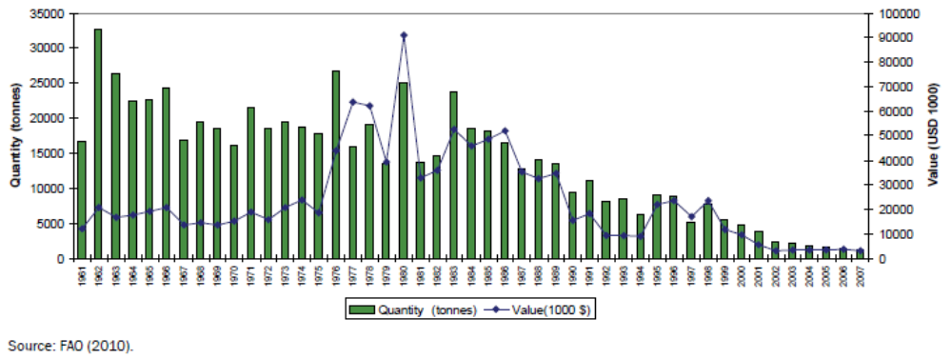
- More than 90% of coffee produced corresponds to natural (or dry-processed) coffee, where the beans are left to dry in the sun for a period of three to four months, then milled by rudimentary means (typically by women) at the farm, producing café pilé, or milled in facilities that are equipped to produce “natural coffee”. Very few farmers carry out “wet processing”, which involves de-pulping, washing and fermentation, despite the promotion of this practice by some agencies with the aim of improving coffee value. The option in fact exists of promoting “naturel” coffee (dried without de-pulping) as a niche product for certain markets, given its full-bodied taste.
- Local roasters commonly buy coffee from speculators and occasionally from farmers’ associations; small and medium enterprises are involved in roasting and grinding, and in 2010 the coffee chain had only four private exporters.
      - Summary of coffee value chain constraints
Links in the chain | Constraints | Strategic objectives necessary to address constraints
Production | No effective state policy toward coffee subsector | Define state policies toward coffee sub-sector
Production | Low access to capital | Improve access to capital for coffee producers
Production | Insufficient technical assistance | Make technical assistance available, efficient and appropriate
Production | High incidence of pests and diseases | Reduce incidence and spread of pests and diseases
Production | Soil erosion | Foster soil protection
Transformation | Scarce infrastructure and local skills available for processing washed coffee | Promote basic infrastructure for processing washed coffee
Transformation |  | Local capacity building (focus on maintaining quality)
Transformation |  | Foster the development of cupping labs in selected cooperatives
Commercialisation | Weak business management skills at grassroots level | Strengthen regional networks (and co-ops) in organisational and business management skills with a strong market orientation

- Despite declines in production and export since the 1990s, a number of new market opportunities have opened up, including export to the Dominican Republic, growing domestic demand and growing global demand for premium quality coffees.
- Growing domestic demand is largely related to demoraphic rowth and increasing urbanization: today, domestic consumption accounts for 68% of production. Domestic demand significantly exceeds supply (processing capacity in organizations/regional networks is frequently underutilized due to low volumes of available coffee), and domestic prices are significantly higher than those available on international markets, both of which factors constitute disincentives for entering into export markets, apart from any quality constraints. A further factor that makes domestic markets more attractive than international markets is the fact that when exporting, the sector is required to offer advance payments to producers while revenues are generated only when green coffee reaches the final market, whereas the domestic market offers immediate payments upon the sale of coffee cherries.
- The agroecological conditions in Haiti are favourable for the production of high-quality coffee, with potential to obtain premium prices on international markets, as shown by recent initiatives such as the promotion of Haitian Blue coffee.

Rootcrops and plantains
- Demand in this sector is growing, including for yam and taro, which are commonly associated with cacao and coffee agroforestry systems in the north of the country. The exception is the dominant crop banana/plantain, which is stagnating due to a combination of its high demand for water and its susceptibility to Sigatoka disease.

Fruit
- Investments in support of tree crops by the Government and donors have to date focused principally on coffee, cacao and mango; this does not, however, reflect their relative importance in terms of the total value of production in the country. Avocado and breadfruit are the highest-ranking tree crops in terms of product value: avocado is the most consumed fruit on national markets, and also has significant export potential.
      - Value of tree crop/fruit production
Crop | Numbers of trees, or area | Yield (t/ha) | Approximate price (USD/t) | Total value of production (USD million)
Avocado | 2,096,506 trees |  | 315 | 53
Breadfruit | 1,522,211 trees |  | 300 | 37
Coffee | 25,000 ha | 0.35 | 3,200 | 28
Mango | 392,000 trees |  | 420 | 13
Cacao | 4,967 ha | 0.65 | 3,500 | 11
 |  |  |  | 142
- Plantains and bananas are almost exclusively for domestic consumption, but there is major potential for export, and organic certification opens up additional opportunities in European and American markets if organisational and value chain issues can be addressed, as well as post-harvest losses due to poor harvesting and transport conditions.
- In the case of citrus, the diversity of species and varieties grown in traditional agroforestry systems means that there is production all year round. The importance of citrus and grapefruit varies between communes. Overall, around 60-70% is sold in other regions of the country, 10% is consumed locally and 20-30% is left unharvested. Around 20-30% of production is lost in transport. Fruit value chains are similar to those of bananas and plantains: farmers supply markets regularly, and the product is purchased by first level intermediaries who then resell it to wholesalers, or second level intermediaries, who in turn place the product on sale in markets. In Marmelade, the Federation of Native Coffee Associations (FACN) has organised to collect fruit from coffee collection centres, paying farmers a fixed price during the whole harvest season, and making special provisions to minimise losses in transport to the factory.
- Significant quantities of fruit are imported from the neighbouring Dominican Republic (worth USD 12,416,713 in 2011): these imports serve to satisfy national demand which cannot be met by national production, a situation which confirms that there is ample market potential for the fruit produced in the agroforestry systems of project area.
- There is a juice production plant in the commune of Marmelade, which processes oranges, chadeque and grapefruit produced by local farmers. This plant was established in 2003 and reopened in 2014 with support from the Government of Taiwan: it forms part of an agroindustrial complex established with Taiwanese aid in 2000, which also includes a bamboo processing plant and a dairy.
- There are also artisanal fruit juice production facilities in rural areas, including associations in Dondon and Plaisance. Neither of these facilities are well consolidated, however, and the plant in Plaisance is not currently functioning. Additionnally, ANATRAF (the National Association of Fruit Processers) has attempted to organise producers in the area: however as with coffee and cacao, more than 80% of producers still do not form part of an organisation or a network, and most continue to sell their products in bulk to local markets, or sell the fruit standing.
- Citrus production has declined alongside coffee. There are however positive indications of the economic and market potential of fruit and derivatives from agroforestry systems: CONASA (Conserverie Nationale SA), for example, produced juice from guava, mango and soursop, which sold well at local and national levels – the company is no longer operating but this is understood to be due to management and political issues rather than lack of financial viability.
- The commercial viability of other products such as jams and jellies is rather more limited, due to a combination of high packaging costs, limited domestic demand and difficulty in competing with imported products of superior quality and presentation.
- Some examples of other tree crops and derivatives which have been shown to have commercial potential include the following:
- The transformation of coconut and cashew nut into sweets (tablettes sucrées). The north and north-east are some of the principal areas of cashew production in the country. These products have a ready local market as they are accessible to people with limited budgets, and so marketing costs are low. It has the disadvantage of being perishable, with a shelf life of only 15-21 days.
- Ackee (Blighia sapida): there is potential to develop further the production and marketing of this crop, which is currently little known but for which there is major demand among the English-speaking Caribbean diaspora in the USA and UK: Haiti is well placed to compete with Jamaica in supplying these markets. Production to date has been from plantations in the Cul de Sac area of the north, but there is much potential for this tree crop to be further developed in the area, including in smallholder agroforestry systems.
- Bitter orange: in the communes of St Raphael and St-Michel de l’Atalaye, this crop is produced in significant quantities, producing a wide range of products: immature fruit (orangettes), which fall naturally as the trees develop, are purchased by the company Novella for the production of essence; as the remaining crop develops, a proportion is harvested green and its peel is dried and sold for the production of oils; the remainder is harvested and sold when mature, being particularly prized for marinating meat. The peel of mature bitter oranges is also purchased by local intermediaries for resale in Cap Haitien. The largest operators purchase up to 25 t of orangettes and 50 t of dried peel over a period six weeks, with prices (in 2014) of Gdes 6-10/lb for orangettes and Gdes 8-12/lb for peel.
- Fruit jams: although profitable on paper, these have the disadvantages of having limited local demand, requiring a source of reasonably-priced jam jars, having high production costs compared to other products and having competition from imported products. Strategies to overcome these barriers include obtaining favourably priced jars through cooperatives and other organisations such as ANATRAF, and developing attractive and innovative products with non-conventional fruits such as melon, mirliton (chayote), date bananas and tamarind.
- Fruit juices, nectars and syrups: fruit juices tend to be undervalued as they may be confused with lower value nectars, and also require cold chains which may be a problem for accessing more distant markets. Nectars tend to be more familiar to consumers and may include a wide diversity of fruits such as citrus, soursop, pineapple and mango; they are lower priced than juices however, and these low prices may limit the range of packaging options that it is cost-effective to use. Juices are less affected by competition from imports than nectars. Syrups are a higher value product, but tend to be less familiar to consumers; there is however significant potential to develop the market for them, for example in restaurants in Cap Haitien, given that they can be used as concentrate for making fruit juice.
- Liqueurs: these are becoming increasingly popular for drinking in special events; there is potential to diversify the product by mixing other fruits (citrus, pineapples and others), with coffee and cacao. Profit margins are attractive, and these products sell well in regional fairs. There is also much potential for individual sales.
      - Profitability and market potential of selected products (1 USD = 75.4 HTG)
 | Sweet cashew tablets (240 g) | Fruit jam (16 oz.) | Fruit nectar  (350 ml) | Fruit syrup  (700 ml) | Fruit liqueur (700 ml) | Fruit wine  (700 ml)
Sale price (HTG) | 50 | 225 | 75 | 300 | 400 | 400
Profit | 20 | 25 |  | 30 | 35 | 40
Ease of sale
Local markets | *** | * |  |  | *** | *
Formal markets | * | ** |  |  | ** | *
Consumer demand and individual sales | *** | ** |  |  | **** | ***

Finance for agriculture
- In general, the agricultural ector in Haiti is characterised by the absence of an inclusive system for credit. Agricultural credit makes up less than 5% of the portfolio of micro-finance institutions, and less than 1% of the portfolio of conventional banks is for the agriculture, forestry and fisheries sectors, and the credit that is available is subject to very high rates of interest.
- In 2006, the Technical Commission on Rural Credit (CTCR) was established as a successor to the ealier Haiti Institute for Agricultural and Industrial Credit (IHCAI), the Institute for Agricultural and Industrial Development (IDAI) and the National Bank for Agricultural and Industrial Development (BNDAI). The aim of the CTCR was to facilitate access to credit among the rural population and to promote agricultural enterprises and job creation. In 2008, financial institutions which had given loans to the agricultural sector had heavy losses, following the four hurricanes that affected Haiti in that year, which led them to indicate their reluctance to return to financing small farmers unless adequate risk mitigation measures were in place. For a long time, rural finance has been assured by the Agricultural Credit Bureau (BCA). Following the earthquake, the aim of MARDNR was to put in place a guarantee system for agricultural loans, accompanied with an assurance-credit system able to encourage financial institutions to increase the proportion of their credit portfolio available to agriculture and small-scale processing.
- Sources of finance at present incude:
- Community savings banks (caisses populaires).
- Cooperatives
- Credit National
- Le Levier Network (Savings and Loans Cooperative Network)
- Center for Support and Services for Local and International Businesses (CASELI)
- National Council for Popular Finance (KNFP)
- State projects (Ministry of Finance, business support projects)
- Industrial Development Fund (FDI)
- In 2018, the Bank of the Republic of Haiti (BRH) established a mechanism for the facilitation of agricultural credit, aimed at incentivising financial institutions to meet the credit (loan) needs of actors along the length of agricultural value chains, with the objective of revitalising agriculture and the development of agribusiness. The interest rate charged by the BRH to banks and financial institutions is not to exceed 4%, and that charged to producers by savings and loans cooperatives is not to exceed 12%/annum. Banks and financial development societies will use these advances from BRH to finance medium- and long-term agricultural activities with interest rates not exeeding 6%. These loans are intended to promote the integration and organisation of agricultural areas into duly delimited and authorised “agricultural free zones”.
- Financing covers a range of costs including the purchase, installation, management and/or improvement of storage and processing facilities for agricultural products, and agricultural machinery such as tractors, pumps, irrigation equipment etc. The volume of credit available per client is limited to USD 4 million.
- Despite the relevance of this initiative, there are still challenges in terms of the confidence of institutions. There have been many initiatives aimed at strengthening the finance sub-sector in the country, but results have not been as expected: there is an ongoing need for the strengthening of State financing institutions and for a legal framework able to protect all of those involved.
- The Agribusiness Programme is financed by the Industrial Development Fund: loans are collective, and the legal registration of participating businesses is preferred but is not a strict requirement (support for registration may be provided for eligible businesses). Eligible activities are agriculture (livestock and cropping), agro-industry and tourism. Coffee and cacao are among the crops specifically supported. Credit ranges from Gdes 500,000 – 40 million, with a fixed interest rate of 8%/annum (although this may be fixed lower in certain cases). This programme has provided credit since 2015: it features grace periods to allow producers to wait until marketing is underway before repaying loans. Initially no guarantee is required, but guarantees are required before credit is issued. In order to request credit, businesses are required to submit a business plan; they may be provided with technical support if needed to improve their business plan. Once the plan is completed, a profitability analysis of the investment is carried out: if considered profitable, the team sends the plan to the Interministerial Committee (CIC), which is composed of MARNDR, the Ministry of Commerce and Industry, and the Interamerican Institute for Cooperation on Agriculture (IICA), prior to final approval by the Ministry of Finance, and disbursement.
- Many of the communes in the project target area do not have any microfinance institutions operating. Fonkoze and rural savings and loans banks (caisses populaires) are present in some cases, however these tend to finance small businesses, rather than agriculture. The conditions of the finance available from these sources do not tend to be widely communicated.
- CASELI (the Cente for Support and Services for Local and International Businesses) is a spin-off of Root Capital in Haiti, dedicated to the development of rural entreprise and innovative leadership, through the provision of consultancy services, the identification of resilient commercial ecosystems and investing in local businesses in order to promote sustainable livelihoods. CASELI functions now as a Business Support Operator (BSO) for food production businesses, and for small, micro and medium sizes businesses. It helps current and potential clients to manage strategic, financial and technological risks. CASELI has provided more than USD 2 million of finance to more than 84 local businesses, including farmer cooperatives and food production businesses.
      - Strengths, Weaknesses, Opportunities and Threats (SWOT) analysis of agricultural finance
Strengths | Weaknesses
Self-finance: farmers contribute their resources as well, meaning that they have added motivation to ensure success. | - Lack of an assurance system  - Limited organization of the sub-sector  - Limited management capacities among farmers  - Interest rates not tailored to the agricultural sector  - Limited creditworthiness of creditors  - Limited transparency of credit products  - Credit for agriculture and food production tends to be one-off rather than transformative
Opportunities | Threats
- Community and mutual solidarity banks have potential to penetrate rural areas and to offer accessible financial services  - There are associations grouping finance institutions  - There is experience in most grassroots community organisations with mutual solidarity finance (existing culture of credit) | - Changes or disturbance to the international market  - Diseases affecting cacao and coffee plantations  - Natural disasters (hurricanes, floods)  - Accelerated emigration of farmers to other countries.

Policy and regulatory context

National Strategy Document for Growth and the Reduction of Poverty (DSNCRP)
- Written in 2007, the DSNCRP implemented an approach with a long-term vision, characterised by an emphasis on the development and renewal of institutional structure, aiming at improved effectiveness in terms of the mobilisation of natural resources in order to put the country on a course of sustainable development, through for example sustainable agriculture and rural development. Specifically, it was concerned with carrying out an analysis of poverty and inequality, to emphasis the vision of certain State and non-State actors as well as the challenges for 2015, to present strategic sector policies and directions that reflect the overall issues defined by the Government, taking into account the macroeconomic framework and the objectives of stabilisation and growth.

Agricultural development policy and triennial programme for agricultural revival
- The Agricultural Development Project (2010-2020) published by MARNDR in 2010, contained provisions for the sustainable development of agricultural productivity, with the aim of protecting natural resources (soils, water, forests) through the practice of integrated, conservationist and intensive agriculture, capable of reducing the vulnerability of the population to natural cataclysms. Priority axis 5 of this policy concerns the preservation and management of natural resources, favouring the accelerate adjustment of watershed management in humid and semi-arid mountains, and the proection of economic activities in the face of natural catastrophes.

Strategic Plan for the Development of Haiti (PSDH)
- The PSDH is organised around four major issues, which ar divided into a number of programmes:
- Territorial reestablishment: this concerns the identification, planning and manaement of new poles of development within a framework of territorial planning. The environmental programme focuses on the protection of the environment through a collection of oversight and normative measures, the establishment of a network of protected areas and the good management and utilisation of forests.
- Economic reestablishment: the agricultural and livestock modernisation programme stresses the use of agricultural practices capable of protecting the environment, and the construction and bringing back into operation of irrigation systems. The fisheries sector modernisation programme emphasises resource studie and the promotion of aquaculture, to supply national markets and ensure food security.
- Social reestablishment: this prioritises the creation of modern social and educational networks, the protection of cultural resources, the development of civic action, and the establishment of a gender equality programme.
- Institutional reestablishment: this focuses on achieving deconcentration and decentralisation du pays, reviewing judicial frameworks, strenthening legislative and judicial administrations as well as independent institutions indépendantes, and consolidating territorial collectivities and civil society.

National Action Plan for the Environment (NAPE) and Triannual Intervention Plan for the Sector
- The objectives of the NAPE are to i) reinforce and rationalise the management of the environment; ii) reestablish the ecological equilibrium of watersheds through the implementation of management norms and best practices; iii) improve quality of life through improved management of urnam and rural areas, and the valuation of the conservation of natural and cultural heritage; iv) propose a framework for improving the coherence of different environmental action plans and programmes. Over the period 2000-2015, NAPE was working on the following programmes: strengthening of institutional capacities for environmental management and different governance levels; energy and sustainable development; information, education and training on the environment; conservation and sustainable use of biodiversity; management of strategic watersheds; integrated management of coastal and marine zones; management of the risks of natural catastrophes; environmental health; rational management of mines and quarries; support to activities linked to sustainable development.
- Three of the four areas of action of the Triennial Plan relate to climate change: 1) Risk reduction, through reforestation, and integrated management of watersheds and coastal zones; 2) strengthening of environmental governance; 3) sustainable management of protected areas and natural landscapes. Its specific objectives are: i) to increase forest cover from 1.5% to 5% ; ii) to reduce by 10% the pressures affecting forest resources; iii) to reduce the environmental vulnerability of populations living in watersheds through the integrated management of floods and risks iv) to develop the resilience of coastal communities through actions to sustainably improve the supply of goods and services related to coastal and marine resources; v) move Haiti from the status of a country affected by risks to one capable of managing them.

National Programme for the Combat of Desertification (NPCD)
- The project for an NPCD has been prepared by the Ministry of Environment, but its text has not yet been submitted for approval by the Council of Ministers. It deals in a cross-cutting manner with the phenomenon of desertification and provides for a strengthening of the links beween the struggle against poverty and the struggles against desertification. It has the following priorities: i) Strengthening of national capacities for the management of desertification, notably for the transfer of responsibilities to territorial collectivities, through the establishment of databases and the operationalisation of a decentralized system for monitoring and evaluation; ii) Ensuring the sustainable management of natural resources, notably by protecting ecologically fragile zones and those with high levels of biodiversity; iii) Restoration/rehabilitation of degraded soils and ecosystems, notably by promoting plant species and varieties that are adapted to climate change and to the evolution of ecosystems, by practising agroforestry and the management of crops in fallows, carrying out research, and perfecting locally developed practices; iv) Improvement of living conditions, incomes, and links with local development, favouring the creation of employment along the length of agricultural value chains, encouraging the creation of rural businesses and improving market access.

National Programme for Adaptation and Strategy for Response to Climate Change
- A National Adaptation Plan corresponding to the United Nations Framework Convention on Climate Change (UNFCCC) has been developed for Haiti, with eight priority actions:
- Conservation of watersheds and lands;
- Coastal zone management;
- Promotion and preservation of natural resources;
- Preservation and improvement of food security;
- Protection and conservation of water;
- Construction and rehabilitation of infrastructure;
- Waste management;
- Awareness raising through education and information.
- The national policy on climate change and the national adaptation strategy are not however fully in place : the elements required for their generation have been developed, but they have not yet been organised or systematised.

Regional frameworks for planning, incentives and policy development
- Haiti has formed part of a number of regional and strategic initiatives of relevance to climate change resilience and the management of productive landscapes:

Mauritius Strategy for the sustainable development of Small Island Developing States (SIDS)
- This strategy emphasises a series of connected measures notably related to climate change and sea level rise, natural and environmental catastrophies, waste management, the management and protection of coastal and marine resources, and biodiversity.

Regional Strategy for a Caribbean with CC-resilient sustainable development (2009-2015).
- This regional strategy has as its objective the preparation of member states for the development of resilience to climate-change (CC) impacts, through (i) the integration of CC adaptation stratégies into the sustainable development programmes of Caribbean Community (CARICOM) states; (ii) the promotion of actions aimed at reducing GHG emissions through energy conservation and efficiency measures and reduction of the vulnerability of human and natural systems in CARICOM states; (iii) the promotion of actions able to realise the social, economic and environmental benefits of sound management of remaining forests.

The Saint-Marc/Haïti Action Pan for the Association of Caribbean States
- This plan implements the political commitments related to the resolutions of the Hyogo action framework, concerning the hierarchisation of risk considerations in national policy frameworks. It is considered to be the guide for the work programme of the Association of Caribbean States (AEC) for the reduction of disaster risks, and therefore provides for: i) the provision of assistance as needed at regional, national and local levels for the formulation and strengthening of community disaster risk management plans; ii) promoting synergies between the Hyogo Action Framework and international mechanisms related to PEID, and contributing to the creation of instruments for the strengthening of national capacities for the reduction of the effects of disasters, the development and deployment of early warning systems, ensuring the transfer of technologies and carrying out vulnerability assessments.

Cooperatives
- Over the last three decades, a number of agencies have supported the maintenance of agroforestry systems. Since, 1986, cooperatives in the area have come to play an increasing role in the marketing of coffee and cocoa, following the departure of other powerful actors. The main cooperatives in the area (CAPB, CAFUPBO) were regrouped at the end of the 1990s around the Network of Coffee Cooperatives in the North Region (RECOCARNO) for the marketing of coffee, and the Federation of Cacao Cooperatives of the North (FECCANO) in the case of cacao.
- RECOCARNO has supported cooperative members with the regeneration of old coffee plantations and the establishment of new plantations, with the use of compost as the main fertiliser in order to facilitate access to equitable markets where the best prices are obtained. Coffee production has since markedly declined in the region, due in part to pests and diseases, and RECOCARNO now operates on a very small scale. FECCANO is mainly focused on the production of fermented coffee for export.

Threats and drivers
- Participants in focus groups during the process of project formulation identified a number of changes that have occurred over the last three decades in the more degraded parts of the project area, comparing the situation in 1990 to that of today (see Box 1):
- Changes in target landscapes between 1990 and 2018, as reported in focus group meetings
- Before there was a greater diversity of forest and fruit species in all altitude belts than today
- Riverine forests have been degraded, and productive areas and settlements are increasingly threatened by floods
- The number of permanent water sources has declined (to 35% of the previous number) and mountain households are having increasing problems with water supply for domestic use and livestock
- Rainfall was much more frequent and dependable, which made it easier to carry out different farming practices in accordance with crop requirements.
- Coffee-based agroforestry systems have greatly declined (more than 70% reduction); however cacao plantations are widespread and the proportion of the farmed area that they occupy is increasing
- The total area being farmed has decreased (by more than 35%).
- Tree-felling (especially of mangos and Inga) is accelerating: this is a fundamental cause of the degradation of wooded landscapes and of the ecological niches of threatened species;
- Little goat and sheep raising is practised now; cattle raising is also in decline (cattle are sold to pay for airline tickets for emigration to South America or to buy motorcycle taxis)
- Areas planted with beans and vegetables are in decline (estimated >50% reduction), due mainly to the degradation of humid ecosystems and newly cultivated areas, together with prolonged drought;
- Today fertility is renewed using slash and burn and artificial fertilisers where possible; before it was achieved using organic manure and/or lime, complemented with crop rotation techniques;
- Some crops have practically disappeared or are disappearing in some areas, e.g. taro, maize, pois-de-souche (lima beans), mirliton (chayote) and some yam varieties of importance for local food systems
- Wildlife is in decline (>50% reduction): some birds, reptiles, frogs and insects are no longer found
- The decline in bird populations means that people no longer have to employ daily labour to protect cereal crops from predation
- Crop yields are unreliable, unstable and in decline, which means however that prices on local and international markets have increased
- Periods of scarcity in purely agricultural households are becoming longer, and in at least 50% of farms production is not sufficient to meet minimum food needs;
- Plots are becoming more and more fragmented, and land transations are very dynamic; even land is being traded for motorcycle taxis in some zones;
- Home gardens (jaden lakou) were more productive and diversified before.

- In the less degraded areas, these changes were generally less pronounced: for example, the less degraded areas still produce significant amounts of rootcrops, cocoa, livestock and fruit for local, national and cross-frontier markets; jaden lakou are still largely intact, apart from the loss of a few varieties of trees, and the absence of horses and donkeys which previously played an important role in fertility renewal but have now in many been cases been sold to raise money to buy motorcycle taxis.

Habitat Loss and Degradation:
- Today, cutting of trees for charcoal, the country’s chief source of fuel, is a major contributor to deforestation. In recent years, among the secondary causes of deforestation and land clearing in Haiti is the increasing demand for wood for construction (Geo Haiti 2010), which can be expected to increase with the need for reconstruction following the January 2010 earthquake. Deforestation has led to severe erosion in the mountainous areas and also periodic (but often catastrophic) flooding.

Ecosystem Degradation:
- Continued farming and grazing and expansion, which prevent the tree component from re-establishing itself. The resulting slumping and landslides generate impacts on farm in the form of the loss of scarce agricultural land; given the small average farm size in the country the implications of this for the livelihoods of individual farmers can be severe. Such impacts on farm and livelihood sustainability pose significant threats to landscape stability and result in increased pressures being placed on remnant ecosystems as farmers seek new cultivation areas and alternative income generation opportunities.

Fire:
- Associated with agriculture and grazing is the risk posed by fire, which is typically used as a tool for land clearance and for the control of weeds and pests, and commonly spreads into the wider landscape, killing trees and impeding natural regeneration.

Abandonment of shade coffee farms:
- Although when first introduced into the country in the 18th century, the expansion of coffee farms had significant negative impacts on the natural vegetation in mountain areas, today both coffee and cacao plantations, with their associated shade canopy, generally represent a net benefit relative to the deforested areas in which they are typically established. Coffee farms are in fact estimated to represent about 50% of the remaining forest cover in the country. In fact, a greater threat would therefore be posed by any reduction in the area of these crops, and their replacement by pasture or annual cropping.
- Although the harvested area of coffee in the country has remained on average largely stable over the last 50 years, with a notable increase towards the end of the first decade of the 21st century, since 2010 the crop has suffered significant pest problems including the coffee borer (Hypothenemus hampei), in addition to coffee rust (Hemileia vastatrix) and root rotting. Other major threats to coffee production are reported as the age of plantations (almost 70% of all planted coffee corresponds to old stands); and the low levels of technical inputs to improve productivity. Coupled with the problem of producers’ limited access to investment funds, these factors have led to the abandonment of coffee in a number of areas. This situation raises the risk of the conversion of plantations to pasture and agriculture, with corresponding loss of biodiversity values and watershed protection functions. This risk is particularly pronounced at higher altitudes (>600m), where on the one hand the expansion of coffee/tree associations (typically in home gardens) is hindered by fertility constraints and, on the other, farmers’ motivations to grow such perennials may be limited by the relatively narrow range of useful tree species that will grow here and by fluctuations in the price or yield of coffee.

Baseline investments
- There is a solid and diverse baseline of investments in relation to natural resource management, conservation and CC resilience in Haiti, however this lacks the integrated vision proposed in the present project, which is necessary to take into account the landscape-wide spatial interrelations between these considerations. These include national and local scale programmes and projects supported by resources of the Government of Haiti as well as international agencies, as well as initiatives being executed by UN agencies, multilateral financial institutions and bilateral development assistance agencies.
- Efforts promoted by governmental agencies that are exclusively funded from the Public Investment Budget tend to focus on (i) ensuring primary needs and provide a social safety net for the most vulnerable: women, elderly, children and disabled people, and combatting social exclusion; (ii) improving food security; (iii) addressing the implications of exposure and vulnerability to extreme weather events.
- The Ede Pèp (Help the Haitian People) Programme, is a social assistance programme aimed at fighting poverty and facilitating access to social protection and social safety nets, in order to achieve social inclusion. No firm projections are available of spending under this programme during the project period, but in one six-month period (2013-2014) 311,440,246 Haitian gourdes (around US$6.92 million) were spent.
- The Ministry of Environment (MoE) national reforestation campaigns employ aerial seeding methods and classic tree reproduction techniques in nurseries. The priorities published by the MoE call for actions include the humid uplands in the departments of the North-East, North and the region of Saint-Louis du Nord, and the National Park La Visite/Massif de la Selle focussing on the National Park La Visite and the districts of Jacmel and Léogane.
- The US Agency for International Development (USAID) has made significant investments in support of agricultural productivity and environmental sustainability to date, especially in the centre and north of the country. USAID has supported cacao production through a number of USAID projects and programmes over the last 15 years, including the Hillside Agricultural Program (HAP) and Sustainable Economic and Environmental Development (Développement Economique et Environnemental Durable, DEED), which supported yam and cacao production in the area of Borgne; and the USAID project Support to the Valuation of the Agricultural Potential of the North, and Economic and Environmental Security (Appui à la Valorisation du Potentiel Agricole du Nord, à la Sécurité Economique et Environnementale, AVANSE).
- Most significantly in relation to this project, USAID is currently funding the “Reforestation Project”, implemented by Chemonics over the period 2017-2022, which will provide an important partnership opportunity permitting the optimisation and scaling-up of environmental benefits. The intervention area of the project coincides to a large extent with that of this project (see Figure 6). The objectives of the Reforestation Project are to:
- Reduce the threat of deforestation, focusing on the role of the wood-fuels and construction market as deforestation drivers in Haiti
- Improve resilience to economic and natural shocks by strengthening agro-forestry and animal husbandry as ways to generate income
- Increase tree cover in targeted areas and boost communities’ investments in tree management and soil and water conservation practices
- Improve environmental governance to develop sub-watershed management plans and foster local community ownership of those plans
            - Area of operation of the USAID/Chemonics Reforestation Project
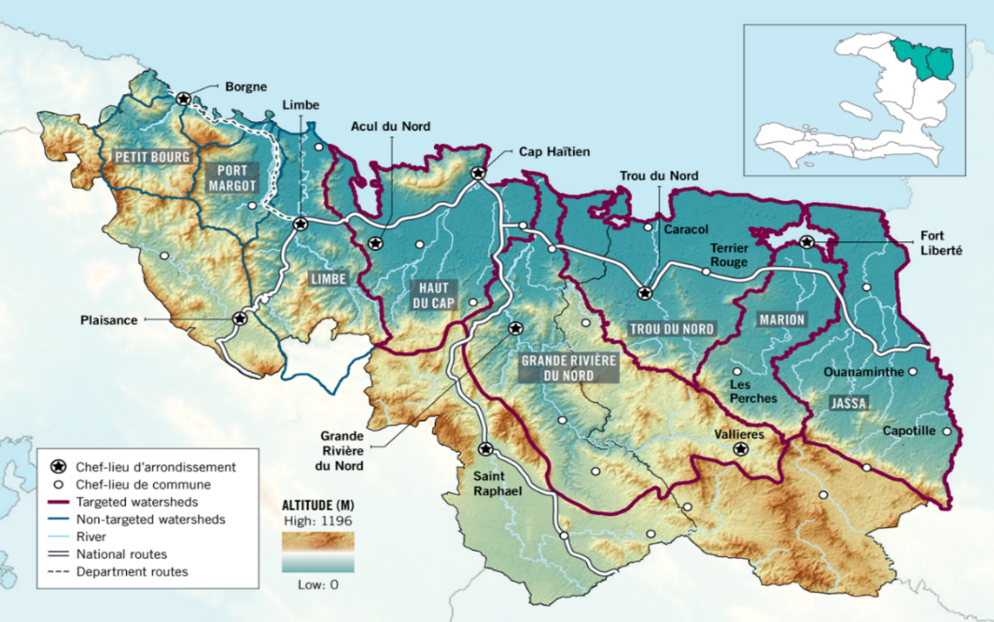
- The Interamerican Development Bank (IADB) also contributes significantly to the baseline. The Technology Transfer to Small Farmers Project (Projet de transfert de technologies aux petits agriculteurs, PTTA) financed by the IADB and the Global Agriculture and Food Security Programme (GAFSP) has supported the dissemination of management practices for cacao agroforestry systems, the regeneration of old plantations and the establishment of new ones.
- Current IADB initiatives in the project area are:
- Land Tenure Security Programme in Rural Areas, which aims to increase land tenure security of rural households in pilot targeted areas and improve the quality of land administration services.
- The Natural Disaster Mitigation Programme II, which aims to reduce rural economic losses through the improvement of climate risk management in selected watersheds.
- The Agricultural and Agroforestry Technical Innovation Programme (PITAG), the general objectives of which are to increase agricultural income and food security for smallholder farmers in selected areas of Haiti. The specific objectives are to increase agricultural productivity and improve the use of natural capital through the adoption of sustainable technologies.
            - Areas of operation of IDB projects in the North and North-east Departments
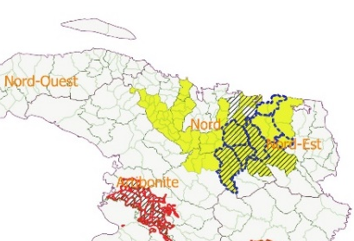
Land Tenure Security Programme in Rural Areas (dashed line)
Natural Disaster Mitigation Programme II (hatched)
Technical Innovation for Agriculture and Agroforestry Programme (shaded)
- PITAG will constitute the main source of cofinancing for the project (see Additional Annex C).
- Norwegian cooperation, in support to UNDP, UN Environment and the World Food Programme (WFP), funds the “Frontière Verte Programme Framework”, including the “Revegetation and Transboundary Natural Resources Management –Phase I and II Massacre and Pédernales Rivers Watersheds Project”, which includes the North-East and South-East of the country. Impacts expected include reduction of soil erosion and sedimentation of water bodies and dams; improved quality of life of communities and poverty reduction; recovery of forest natural regeneration capacity; reversal of desertification and drought processes; and reduction of vulnerability to extreme flooding.
- The European Union is funding the Establishment of the Caribbean Biological Corridor (CBC) as a framework for biodiversity conservation, environmental rehabilitation and development of livelihoods options for Haiti, the Dominican Republic and Cuba, which aims to establish the CBC in the three countries, through environmental rehabilitation and poverty alleviation, with the overarching goal of developing a cooperation platform to boost integration of conservation actions among states. The European Union is also proposing to finance the Binational Observatory on Haitian-Dominican Relations”, one of the target themes of which will be environment.
- In the south-east of the country, the Directorate of Development Cooperation (DDC) of the Swiss Federal Ministry of Foreign Affairs supports the NGO Helvetas in Unit II of Forêt des Pins, where the High Altitude Biodiversity Valuation Programme is being implemented. Swiss cooperation has contributed to PAs through support to the development and implementation of managerial and control mechanisms and tools, for example by assisting ANAP to design and experiment a platform for co-management of Forêt des Pins National Park with a local stakeholder platform.
- Fondation Seguin is working with support from the German International Development Agency GIZ in the protection of La Visite National Park, in the project’s south-east target locality, including the provision of planting materials to farmers located in the altiplano vegetable growing area, and financial incentives to rehabilitate forest remnants.
- The Spanish Government (AECID) and Solidaridad Internacional are both active in the project’s south-east target locality. SI has supported the development of the land use plan for Anse a Pitre; and AECID has supported the delimitation of La Visite National Park.
- The World Bank is financing, with support of Global Agriculture and Food Security Programme (GRASP), the US$50 million project Relaunching Agriculture and Strengthening Agriculture Public Services-Phase II (RESEPAG), strengthening MARNDR in providing agricultural support services and providing support for local agricultural extension and innovation services. It also promotes market-based access to inputs, under the new MARNDR approach of using demand-priming voucher systems to stimulate demand for planting material from nurseries, for fertilizer and other inputs, thereby strengthening incentives for the private provision of inputs.
- The Intersector Committee for Land Use Planning (CIAT) is in the process of finalizing the country’s first regional territorial land use plan, for the north-east coast region; a limited level of experience has also been generated with the development of watershed-level plans, for example through the USAID-supported WINNER project. However, the regional plan is “broad-brush” in nature, and mechanisms, capacities and experience are still lacking for putting it into practice at local level, and for integrating it with more specific local level plans.
- The “SNAP project” (Establishing a Financially Sustainable National Protected Areas System, GEF ID 3616, implemented by UNDP) is helping to create a favourable overall environment for effective PA management, by developing a strengthened PA governance system, backed by policies, regulations and competent institutions. Still lacking, however, is the incorporation of a more integrated, landscape/seascape-wide approach to delivering environmental benefits of global, national and local significance and addressing the implications of climate change.
- Resilient Productive Landscapes in Haiti (Territoire productif résilients/TPR) (GEF project 9750, implemented by World Bank) aims to increase resilience of agriculture and ecosystems in certain watersheds, and allows the Government to respond rapidly and effectively to emergency situations. It is comprised of four components: 1) Strengthening of institutional and organisational capacities for interventions at territorial level; 2) investment to promote the resilience of agriculture and ecosystems; 3) coordination and monitoring and evaluation of projects and 4) the mechanism for emergency interventions.
- TPR aims to contribute to the utilisation of environmentally sustainable agricultural technologies, through support to ecologically sustainable and socially acceptable practices, as well as the restoration of native mangrove and upland forests.
- TPR works with relevant institutions to promote their technical and administrative strengthening, in order to improve the services provided by MARNDR (in relation to agriculture) and MoE (in relation to environment). Impacts related to component 2 include the intensification, improvement, development and diversification of agriculture activities, due to i) the improvement of techniques and systems of production due notably to improvements in the linkages between research and extension (production techniques adapted to soil characteristics, maintenance and recovery of soil fertility, management of water erosion, improvement of water management, etc.); ii) the reduction of post-harvest losses; iii) the improvement of income and trading conditions; iv) improved valuation of production through processing and agricultural-based businesses; v) broadening of the range of products; vi) protection of natural ecosystems; vii) information and training in relation to good agricultural practices; viii) water management and ix) increases in the resilience of farmers to natural catastrophes.
- There have been significant initiatives related to the development of the cacao sector and the strengthening of cacao cooperatives in the north of the country. A local NGO, the Service for Action Learning for Economic and Social Development (Service de Formation Action pour le Développement Economique et Social, SEFADES) has supported the strengthening of six cooperatives beloning to the Federation of Cacao Cooperatives of the North (Fédération des Coopératives Cacaoyères du Nord, FECCANO, which has around 2,500 members and covers the communes of Grande Rivière du Nord, Milot, Acul du Nord, Borgne and Port-Margot. Significant work has been done with marketing: FECCANO itself sells its producers’ cocoa on international markets, rather than relying on private sector companies. There has also been progress with the process of cocoa fermentation by FECCANO, with support from the NGO Agronomists and Veterinarians without Borders (AVSF).
- These actions have not however yet been sufficient to resolve the challenges affecting the sector, and therefore the livelihood and food security needs of producer families. There is little information on cacao production systems in the region; the plantations are ageing; cocoa is on the whole not fermented, as required by export markets; and the cooperatives are not sufficiently structured or able to organise cocoa marketing effectively.

Barriers
- The principal barriers to resolving the threats described above are as follows:
1: Lack of an integrated landscape-scale vision in relation to the management and conservation of mountain massifs of high biodiversity value
- Inadequate incorporation of considerations of BD and landscape stabilization in spatial zoning and development plans: typically land use planning (including regional and local spatial zoning and development plans) does not take adequately into account the locations, nature and magnitude of environmental values, biological connectivity, threats, the implications of climate change or the livelihood support needs of local communities.
- Inadequate dialogue and coordination between stakeholders influencing landscape conditions and dynamics: Despite the existence of interinstitutional and inter-sector entities such as the National Environment Council (CONAE), the Inter-Ministerial Commission on the Environment (CIME) and the Inter-Ministerial Committee on Territorial Land Use Planning (CIAT), in the practice there is a very limited degree of dialogue and coordination, especially regarding the interactions between the agriculture and environment sectors (presided by MoE and MARNDR respectively).
- Deficient conditions of governance: the Ministry of Agriculture, Natural Resources and Rural Development (MARDNR) which is in charge of the agricultural, forestry and fisheries sectors, has severely limited financial, technical and human resources and as a consequence virtually no field presence for the promotion and enforcement of the regulatory framework.
- Limited development of social capital: poor levels of development of social capital resources (e.g. for example, kinship obligations, traditional rotating labour and credit groups, and peasant organizations) limit the willingness of smallholders to adopt agricultural technologies, including agroforestry and tree planting . When these limiting factors are adequately addressed, peasants may be willing to adopt technologies with long time horizons such as tree planting even on short-term tenures including leasehold and sharecropping, and under conditions of complicated watershed management regimes in degraded watersheds with multiple ownership .
- Market structures and conditions do not favour environmentally-sustainable forms of production: linkages between producers and markets with potential to reward environmentally-sustainable forms of production area weak; in the case of coffee, the market niche for environmentally-sustainable products is poorly developed and there is little motivation to export (thereby potentially gaining access to overseas markets with sustainability criteria) given the high level of national demand and the more favourable payment conditions that are available domestically.
2: Inadequate capacities and conditions in farming communities for the sustainable application of tree-based production systems that contribute to the generation of multiple environmental benefits
- Inadequate technical and financial capacities for investing in tree-based production systems: management problems, such as the high incidence of coffee pests and diseases (especially shoot borers and rusts) and soil erosion, are largely a function of low access by farmers to financial capital and to effective technical assistance: agricultural research and extension services are available to only a small fraction of households. The key constraint to wider adoption and continued extension services is the absence of a permanent institutional base for extension. With cocoa, the situation is generally more positive, but there is still limited incorporation in crop management systems of provisions for resilience to the impacts of climate change.
- Inadequate capacities for processing: improvement of quality in the processing stage of the value chain, and therefore product value and crop profitability, is hindered by the scarcity of infrastructure and local skill for processing and quality control. Also lacking are quality control facilities in the form of cupping laboratories.
- Weak business management and marketing skills among producers: regional coffee producer networks and grassroots organizations exist, but there is weak vertical integration and cooperation along the value chain, especially between private sector companies involved in retail, processing and export, and coffee producers and their organizations. This limits opportunities for private sector actors to invest in producers in order to protect their supply base, for example through the provision of technical assistance or financing facilities.
- Limited recognition and incorporation of traditional knowledge on native tree species and their management: traditional knowledge has been eroded and failed to adapt to changing demographic, productive and climatic conditions, and is rarely taken into account in resource management interventions and extension programmes, which tend to focus predominantly on exogenous approaches that may not be well adapted to local needs, conditions and cultural norms. These traditional systems include farmer-assisted natural regeneration and tree-rich home gardens.
- The management of perennial-based crop systems does not reflect BD conservation needs: rustic low input management systems tend to be more favourable for BD than alternative land uses, but the specific ecological requirements of high conservation priority species are not necessarily met, such as the existence of types of trees with fruit and flowers preferred for food by birds and bats, structural diversity of shade systems to favour small mammals, microclimate to favour amphibians, or spatial configurations to favour cross-landscape movement between ecosystem remnants.
3. Insufficient access to knowledge and information of relevance to sustainable land management and biodiversity conservation in production landscapes
- Knowledge is not adequately managed and disseminated to facilitate scaling up: gender issues are not adequately considered in initiatives related to environmental considerations in production sectors, and information on experiences (success and failures) and impacts is not routinely systematized and disseminated in such a way as to facilitate scaling up.

Strategy

Selected approach
- The long-term solution is to create conditions and capacities in national, regional and local institutions, local communities and the private sector that will allow farmers to manage their lands in ways that generate multiple environmental benefits and respond to landscape-wide social, productive and environmental dynamics, especially through the increased incorporation and improved management of woody perennials in diverse components of their farming systems.
- The project will promote a landscape approach to resource management in the target area, leading to a situation in which:
- The landscape is composed of stable mosaics of land units (including tree-based cash crop systems, tree-rich annual cropping and fallow areas, integrated functionally with remnants of natural ecosystems), favouring the resilience and landscape-level conservation status of species of high global conservation value, while protecting the productive capacity of natural resources and promoting the generation of ecosystem services;
- Local people receive benefits in terms of the sustainability and viability of their farming and livelihood support systems as a result of the protection of natural resources on which these depend, and their participation in value chains that reward production systems that generate environmental benefits.
- This approach is particularly relevant to current conditions in the target area because:
- Prices for tree crops such as cocoa and coffee, which are strong determinants of the willingness and ability of farmers to maintain tree-rich production systems, are notoriously unstable, which exposes these tree-rich systems to the risk of elimination in favour of annual crops. This has clearly been demonstrated in the case of coffee: an estimated 75% of shade coffee plantations have been eliminated in the project area over the last 9 years.
- At the same time, there is significant investment in Haiti in promoting the cacao sector, in response to currently favourable market and price conditions, but there is the risk that if this being done at the expense of the considerations of resilience and biodiversity.
Table 13. Rationale for project strategies
Situation sought | Indicators | Rationale | Strategies
Increase in productivity and BD-friendliness of cacao and coffee plantations | Structural diversity of vegetation in coffee and cacao plantations | Improved habitat and connectivity value for globally important species | - Development of farmers’ knowledge and capacities (through farmer field schools, knowledge systematization, strengthened extension systems) for applying management prescriptions which combine productivity, production diversification and habitat/connectivity value  - Strengthening and diversification of value chains to maximize financial benefits received from the products of diversified agroforestry systems
 | Density of vegetation in coffee and cacao plantations
 | Species diversity of vegetation in coffee and cacao plantations | Increased food availability for globally important fauna
 | Productivity and profitability of coffee and cacao plantations | Motivations for maintenance of plantations rather than conversion to lower-BD annual cropping and pasture
Increased and diversified food crop production in cacao and coffee plantations | Quantity and quality of food obtained from coffee and cacao plantations
Improved landscape-wide connectivity | Area of tree-based land units in landscapes of the target communes | Improved connectivity value for globally important species | - Promotion of agroforestry systems in annual cropping and grazing areas  - Restoration of vegetation in degraded areas

Lessons learned
- A number of studies have been carried out into the factors determining the effectiveness and levels of uptake of reforestation initiatives to date in Haiti,. Key findings include the following:
Motivations for tree planting
- Whether marketed or used for one’s own house, the overwhelming motivation [for tree planting] is economic. Farmers use trees to store value, less vulnerable to drought than annual crops: in some regions, farmers calculate a 50% probability of losing one’s annual food crop to drought, and under such conditions of agrarian peril the domestic tree stand becomes an economic safety net that is protected until absolutely needed, and even then cut only selectively. Trees provide ecological benefits to the fields as well, but these come as secondary side effects of behaviours in which smallholders engage for economic reasons.
- Farmer innovate to optimize economic benefits, converting what technicians intend as ecological strategies into microeconomic income-enhancing strategies (for example by introducing perennial food crops into hedgerows promoted as soil conservation measures.
Locations and social categories
- Farmers generate more money from the sale of tree products on closer, more fertile, actively cropped fields of greater tenure security, where tree seedlings and fruit trees were more common and there is a greater density of mature trees. Farmers prefer to plant trees on these fields as it allows them to protect them better against threats from livestock, thieves, and relatives. These threats generate an economically and ecologically formidable barrier to the expansion of tree planting onto precisely the underutilized plots where the competition from trees would be lowest and the economic increments from wood would be greatest. The problems will all be solvable at a more advanced stage of the transition to planting wood. Kin groups and communities can make arrangements to neutralize each of the three predators and to make tree planting possible on these marginal landscapes.
- There is a slight statistical tendency for tree-planters to be older, to have slightly more land under secure tenure, and to be in a better position to hire labour. Even in households with a conjugal couple, case studies have shown that wives of participants are heavily involved in household decisions whether to plant or not to plant and in the subsequent management of the plantings.
Determinants of tree planting
- The functionally important variable determining willingness to plant is not legally deeded ownership of the plot but rather secure control over the trees, which can be acquired through informal de facto land ownership. Purchased and subdivided inheritance plots are recognized by the community as ‘owned’ by farmers even in the absence of surveyed deeds. The ownership of the tree is, in fact, the key variable predicting willingness to plant.
- There is a strong tendency to plant project trees in conjunction with one’s plots. The agroforestry configurations that emerge on agricultural land and on house sites are rich in their diversity. The preferred strategy is to convert the border of the plot into the principal locus of the trees. No clear-cutting is generally performed on these trees; they are kept rather as a permanent source of wood, to be harvested selectively as needed.
- As a general rule, sharecropping arrangements impedes tree-planting. Barring exceptional arrangements, tenants will not plant trees as they will probably not be the ones to harvest them. The landowner will not plant, as the sharecropper will take subtle measures to eliminate them.
- In a small number of cases even entire plots with at least some agricultural potential are allowed to evolve into permanent woodlots. But this is done for exceptional reasons – the owner may be aging and may have less energy for agrarian pursuits, or may migrate temporarily to the Dominican Republic and can get more from the land by turning it over to low-maintenance trees. This is not done with enough frequency to cause a cut in local food supplies.
Participation
- Organizations involved in natural resource management projects in Haiti all acknowledge that community participation is critical to success. Yet project beneficiaries and civil servants often say that projects are inadequate for local needs, communities often feel little ownership, and interventions are often unsustainable.
- In some cases, participatory projects initially satisfy communities less than short-term, quick-impact programs do, but eventually, they usually result in a higher level of community engagement and ownership. Participation in establishing protected areas also encourages compliance and reduces the need for and cost of extensive systems of enforcement.
- Having a project office on-site facilitates the participatory process, maximizes capacity building, and enables effective monitoring. Coordinators in an on-site support office can earn the trust of local communities and authorities because they are accessible.
Lessons learned from EBA project
- GEF Project 5380 “Increasing Resilience of Ecosystems and Vulnerable Communities to CC and Anthropic Threats Through a Ridge to Reef Approach to BD Conservation and Watershed Management“ (known as the “EBA project”) had its mid-term evaluation in October 2018. Key findings and lessons learned include the following:
- The inclusion of three separate target areas added excessive complexity and logistical difficulty to the project.
- Inadequate attention to formalizing cofinancing arrangements during the PPG phase results in limited buy-in during implementation, compounded by inadequate leadership in following up opportunities.
- The project’s proposals to improve governance and inter-institutional coordination were excessively ambitious.
- Department-level sector platforms were largely ineffective, and there was little coordination between Environment and Agriculture Directorates at Department level.
- Value chain aspects were not adequately taken into account in production systems, which undermined sustainability.
- Agroforestry reforestation targets were excessively ambitious.

Theory of change and incremental reasoning
- The project theory of change is depicted in Figure 12. The principal threat that the project will address, with potentially negative implications for global environmental values and local livelihoods, is the conversion of shade cacao and coffee farms to less BD-friendly annual crops and pasture (for more detail see Section II). Without external technical, marketing and investment support, these plantations are subject to very low intensity management (Figure 8). These “rustic” plantations tend to be relatively BD-friendly and generate a wide diversity of food and other products for farmers. They are, however, characterized by low productivity, and at the same time farmers typically lack the ability to access high and/or stable prices for their production. As a result, these plantations may be less able to meet farmers’ short-term income needs than annual crops or livestock, and in consequence they are often cleared for conversion to annual agriculture or pasture. The BD and livelihood services generated by these rustic plantations are therefore not sustainable.
- At the same time, other farm units are being managed unsustainably leading to land degradation, increasing the amount of land that farmers are obliged to use to meet their livelihood support needs, typically at the expense of areas of trees (including cacao and coffee plantations). Other threats include the unsustainable extraction of charcoal and wildfires.
            - Land use changes and trade-offs under alternative scenarios
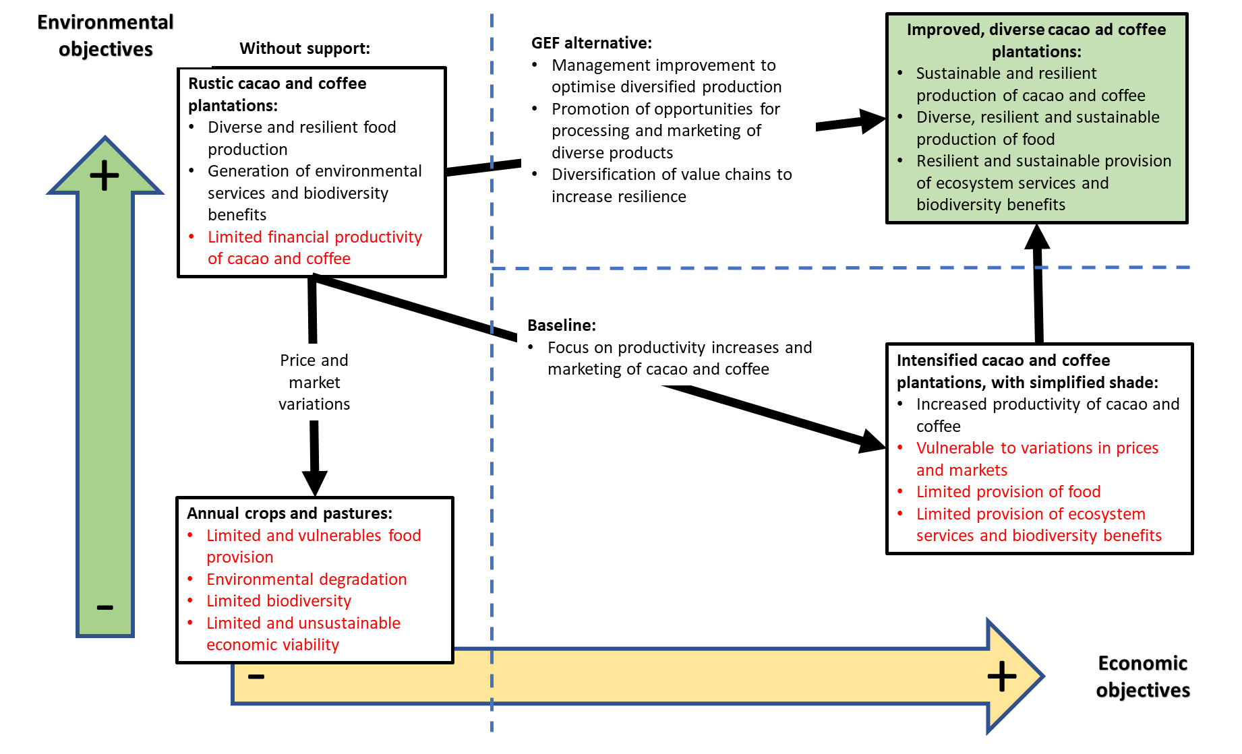
- Although limited data are available in Haiti, a case study in Bolivia (see Additional Annex B) found that diversified cacao agroforestry systems generated lower yields of cacao dry beans and plantains, but, importantly, higher cumulative levels of all marketable products, than conventional or organic monocrops of cacao. Total system yields over four years ranged from 13,618 kg dry matter ha⁻¹ in conventional agroforestry systems to only 3,464 kg dry matter ha⁻¹ organic monocrops: in successional agroforestry systems, 5,118 kg ha-1 of diversified fruits and tubers were harvested.
            - Situation without external support (BD = biodiversity benefits, EC = economic/productivity benefits, LH = livelihood benefits, with a rating of 1-5 where 5 is the best)
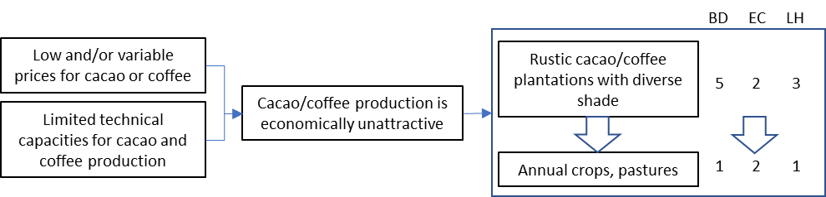
- Under the baseline situation (Figure 10), technical, marketing and short-term investment support to cacao and coffee production, agroforestry systems and reforestation would result in improved uptake and productivity of tree-based production systems, but with limited BD benefits. In the case of cacao and coffee plantations, management with a narrow focus on productivity would tend to result in the simplification of the tree canopy to favour optimal shade species, and the elimination of plants and shrubs in the understorey, which might hinder management efficiency, impede air circulation and/or compete with the cacao or coffee. This would result in a loss of the value of the plantations as BD habitat, as well as a reduction in their ability to generate food and other products alongside the cacao and coffee.
            - Baseline situation
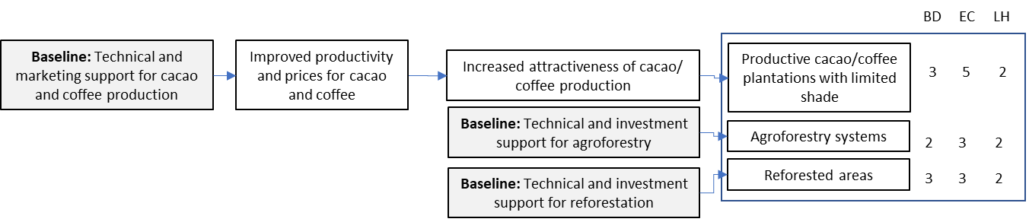
- Stakeholder consultations during the PPG phase found that farmers were prepared to accept very little economic loss in order specifically to favour biodiversity. This was especially the case with the poorer categories of farmers. Under the GEF alternative, the project will result in the application of production and management alternatives which do not involve trade-offs between biodiversity and social benefits, but rather “win-win” situations where improvements in the management of production units confer simultaneous environmental and economic benefits. The baseline investments would be complemented by incremental GEF investments, and would therefore come to constitute co-financing, contributing to the delivery and scaling up of production systems capable of generating not only productive and livelihood benefits, but also global environmental benefits, in a sustainable manner. This logic is summarised in Figure 11Figure 8.
- In complement to the co-financed provision of technical and advisory support for cacao and coffee production, GEF resources will be used to provide specific support to farmers in accessing markets which actively favour environmental sustainability and the generation of BD benefits, and to strengthen capacities for delivering technical assistance to farmers to enable them to apply environmentally-sustainable and BD-friendly production practices (Outputs 1.3 and 2.1). This will further be complemented by GEF-funded support to the development and application of sustainable financing mechanisms (Output 2.2) which will enable farmers to meet initial investment costs of these BD-friendly production systems, as well as helping to compensate them for externalities (such as the modification of management prescriptions to favour BD, which may lead to reductions in short-term productivity).
- The project will adopt a pragmatic approach and emphasise to both purchasers and producer the tangible benefits that can be expected from compliance with market-based environmental standards, rather than relying solely on arguments related to intangible environmental benefits (please see risk table): in addition to generating environmental benefits such as improved habitat value and connectivity, the maintenance of tree-rich production systems with diverse composition and structure will contribute to the ecological and productive sustainability of crop production by, for example, promoting nutrient capture and cycling, the maintenance of soil humidity, the maintenance of populations of natural pest control agents, and the buffering of crop production against the impacts of climate change such as increases in temperature and drought intensity. These benefits have been clearly shown elsewhere in the case of coffee, where moderate increases in tree shade have been shown to reduce the need for chemical inputs to maintain production, and increase resilience. Such increases in the sustainability and resilience of production will be of benefit to both producers, for whom the crops constitute an important source of support for their often otherwise fragile livelihoods, and purchasers, who require reliable supplies (in the case of both coffee and cocoa, purchasers are currently faced with difficulties in obtaining such supply).
- The project will also support farmers in managing trees elsewhere on their farms, in addition to coffee and cacao plantations, for example in the form of dispersed trees managed in association with crops, live fences bordering cropping areas, diversified home gardens, assisted natural regeneration in cropping and fallow areas. This will lead to increases in the density of standing trees in throughout farmers’ lands, and the maintenance or improvement of the diversity of tree species on farm, including species of specific ecological importance (e.g. as food source, habitat, connectivity) for the threatened BD identified in the target areas. To this end, the project will invest in increasing farmers’ knowledge and capacities for traditional forms of tree management, supporting the recovery, adaptation and scaling up of such practices. These management practices and tree species or varieties may in many cases already be familiar to many farmers and may have been eroded or neglected: in recognition of this, and to maximize the likelihood of ownership, uptake and social sustainability, the project will prioritize participatory approaches including farmer-based participatory systematization and knowledge exchange, as well as farmer-based systems for the production and exchange of planting material.
- Co-financed technical and investment support to other forms of tree management, such as agroforestry and reforestation, will be complemented by GEF-funded support to participatory systems for knowledge generation and development (Output 2.3), in order to ensure that these management practices incorporate relevant traditional knowledge wherever possible, that farmers have the ability to adapt their knowledge and practices in the light of evolving conditions, and that knowledge and experiences generated are communicated and scaled-up effectively. GEF resources will also help farmers to gain revenue from other BD-friendly tree-based systems on farm (Output 2.4), in order to maximize their attractiveness and sustainability; in complement to the baseline investments, GEF value-added will result in farmers managing an increased diversity of familiar native or naturalised tree species, which will favour native BD as well as generating economic and nutritional benefits for farmers.
- A further key element of GEF value-added, missing from the baseline scenario, will be the development and operationalisation of landscape-level decision-making tools (Output 1.1), and socially- and institutionally sustainable mechanisms for natural resource governance (Output 1.2). The former will raise the level of project operations from farm to landscape-level, enabling landscape elements to be configured appropriately in relation to spatial aspects of connectivity, biological importance, production potential, vulnerability and flows of ecosystem services. These tools will also include a robust biodiversity monitoring protocol, in order to ensure that global environmental benefits (GEBs) are optimised. The governance mechanisms, meanwhile, will help to ensure that interactions between actors across the landscape are compatible with its sustainable management (including the effective combat of unsustainable tree felling for charcoal, and wildfires) and the delivery of GEBs, while at the same time providing for social equity.
            - GEF Alternative
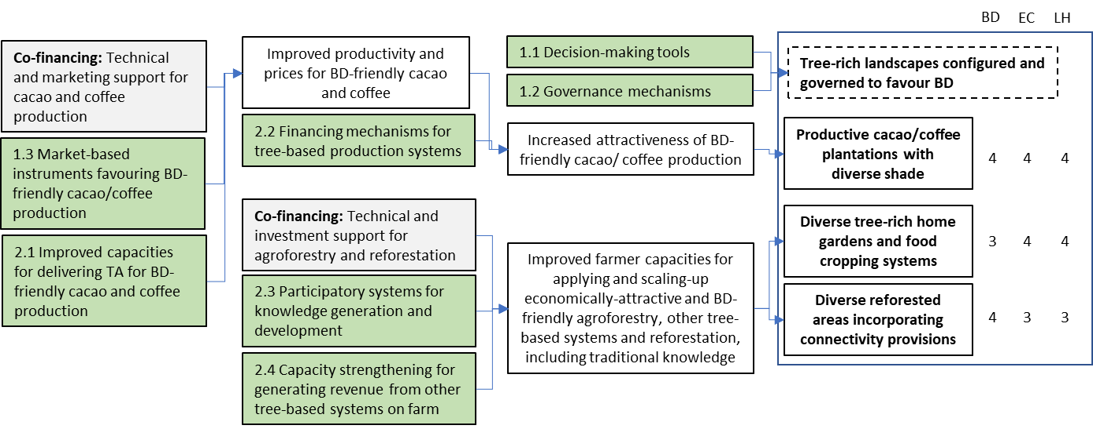
- The following table further clarifies baseline and alternative scenarios for relevant practices, and global environmental benefits which the project will generate.
Tabe 14. Baseline and alternative scenarios, and resulting environmental benefits
Baseline scenario | Alternatives to be put in place by the project | Global Environmental Benefits
Shade coffee farms will be poorly managed, increasingly unviable and replaced by less BD/LD friendly alternatives such annual crop production and grazing, which will prevent the tree component from re-establishing itself. | - Market-based instruments to facilitate the delivery of environmental benefits  - Improved service delivery systems for technical assistance  - Strengthened decision making tools to optimize the configuration of landscape elements | - Biodiversity: increased habitat value in tree-based production systems and connectivity at landscape level, for globally important (Red List and endemic) species.  - Land degradation: improved productive resilience of tree-based production systems due to management and diversification, of annual cropping and pastures due to agroforestry systems, and of degraded areas through restoration.  - Climate change: reduction in rates of loss of carbon sinks in perennial-based production systems (due to degradation and conversion to annual cropping) and increased carbon capture due to establishment of agroforestry systems and restoration of degraded areas.
Investments in promoting agronomic, productive and commercial aspects of tree-based production systems will not be effective in generating GEBs
Promotion of other tree species is likely to be carried out using conventional tree planting practices with questionable sustainability and little generation of GEBs. | - Participatory systems for knowledge generation and development  - Improved financing mechanisms for tree-based production systems  - Capacities for generating revenue from other tree-based systems on farm
Promotion of green value chains (for e.g. mango, cashew, ricin, cocoa and vetiver) will not necessarily favour the generation of GEBs, as these crops are typically grown in management systems with limited structural or compositional diversity. | - Support to development of industry-wide sustainability standards and environmental certification/branding, with emphasis on combining environmental and productive sustainability
Remnants of natural ecosystems will continue to be affected by wood harvesting for charcoal, construction (especially post-disaster reconstruction) and agriculture expansion, and the continued use of fire as a tool for land clearance and for the control of weeds and pests | - Strengthening of socially- and institutionally sustainable mechanisms for governance in support of tree-rich production systems, as a complement to weak State capacities

- The achievement of the expected outcomes, in terms of harmonised landscape- planning, cross-sectoral governance, effective value chain instruments supporting sustainable production, access to technical and financial support, increased farmer capacities and effective knowledge management, and the consequent delivery of diverse environmental and social benefits, are subject to a number of assumptions being met:
- Actors in central and local governments must recognize and prioritize the importance of incorporating considerations of environmental sustainability (including BD conservation) in land use planning instruments, given the medium- and long-term benefits of this relative to shorter term goals focused solely on productivity.
- Adequate conditions of social cohesion and receptiveness to addressing inter-stakeholder issues must exist at local level: although sporadic instances of civil unrest do occur in Haiti, social structures in rural communities tend to be sufficiently well developed to provide a basis on which natural resource governance mechanisms can be established or strengthened.
- Adequate and reliable demand must exist for products (such as cocoa and coffee) from BD-friendly production systems: while the scale of this international demand is subject in part to factors outside of the project control, highly successful experiences have been generated in many countries of Latin America and the Caribbean with linking farmers to premium markets which reward environmental sustainability (such as Rainforest Alliance certified and Bird-Friendly coffee).

            - Project Theory of Change
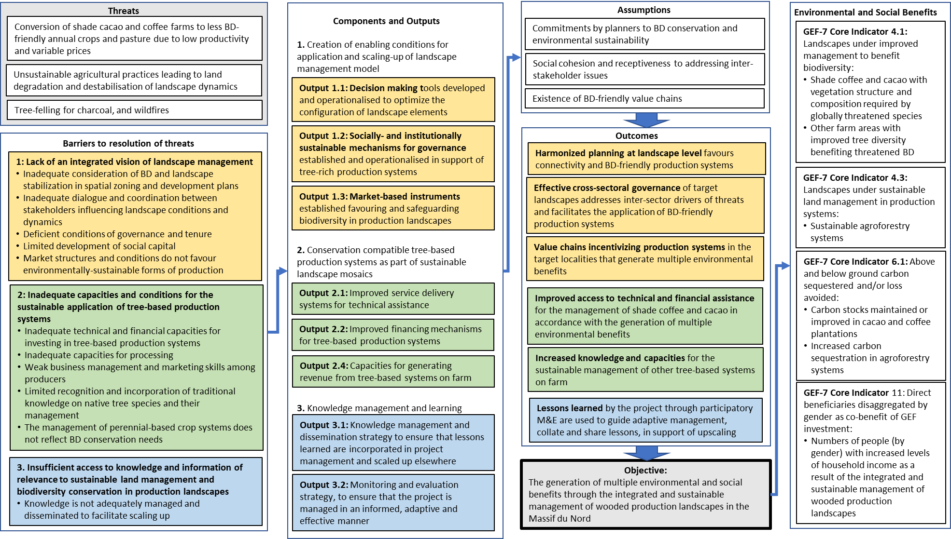

Resilience
- The emphasis of the project on productive diversification in tree-based production systems reflects the results of analyses of the implications of the effects of climate change and recommendations of corresponding resilience strategies:
- Haiti’s agricultural production may be strongly affected by sea-level rise and more frequent extreme weather events (e.g., hurricanes) hitting coastal areas.
- The quality and yields of coffee in regions where it is currently produced (especially at lower elevations) may decline as a result of lower rainfall and higher night and daytime temperatures.
- A projected upward shift in the areas where coffee is suitable will increase the risk of high-altitude forests and protected areas being converted to cropland.
- Key ecosystem services provided by coffee must be protected through short- and long-term risk management strategies (e.g., crop diversification and full crop substitution).
- In areas where climate change will make coffee only slightly less suitable, farmers should adapt their production by investing in irrigation systems, improving shade management, and adopting drought-tolerant coffee varieties.
- In areas where coffee production will cease to be suitable, landowners should begin diversifying agricultural systems, with the aim of eventually switching to crops, such as cocoa, that are expected to remain highly suitable for cultivation throughout the country.
- Mango will also remain highly suitable for cultivation in Haiti and could, therefore, replace coffee and dry beans, which will become less suitable in areas between 500 and 1,000 masl by 2050.
- Sorghum and yam are also good options for crop diversification, since they are highly likely to become more suitable for future conditions in Haiti.
            - Results of a species distribution model to assess changes in coffee and mango suitability under future climates in Haiti. Red areas show reductions in suitability, while green areas show increases by 2050 (CIAT).
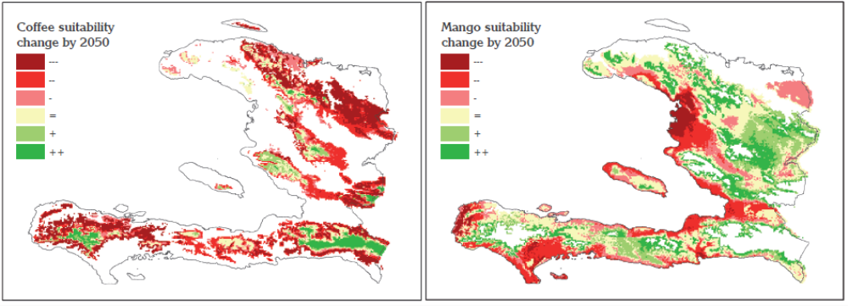
- These climate suitability analyses for specific crops show that cocoa is, in general, highly suitable for production in Haiti and is likely to remain so, despite long-term changes in the climate.
Biodiversity conservation strategies:
- The project strategies will deliver biodiversity benefits through i) improving the habitat conditions of the agroecosystem and ii) improving landscape-wide connectivity. In accordance with concepts of island biogeography, improvements in connectivity between currently fragmented “islands” of species occurrence in remnant habitat outliers will contribute to the resilience of species’ conservation status and range by facilitating the influx of new individuals to compensate for local population declines or extinctions due to pressures affecting these outliers (as well as increasing the overall habitat area available).
- The hills of the northern part of Haiti form part of the Caribbean Biological Corridor; they are of vital importance for connectivity between the more intact forests of the Dominican Republic to the east (dominated by the Global 200 Hispaniolan moist forests ecoregion) and Cuba to the west.
            - Location of the Caribbean Biological Corridor
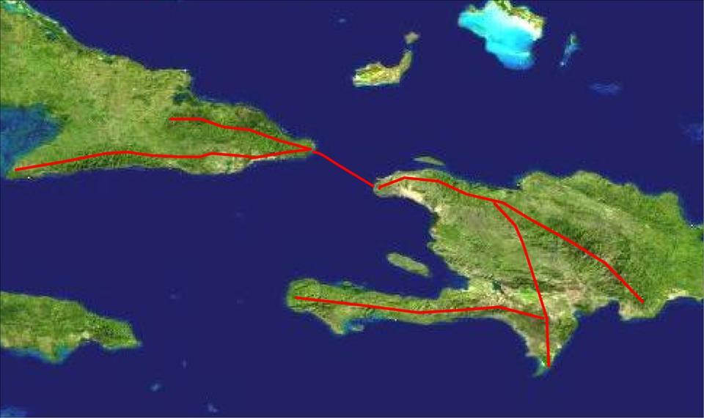
- The predominant direction in which there is potential for the promotion of island-wide connectivity is approximately WNW – ESE, along the length of the mountainous axis linking the Massif du Nord in Haiti to the densely forested Cordillera Central mountain range in the centre/west of the Dominican Republic.
            - Principal needs/potential for regional biological connectivity
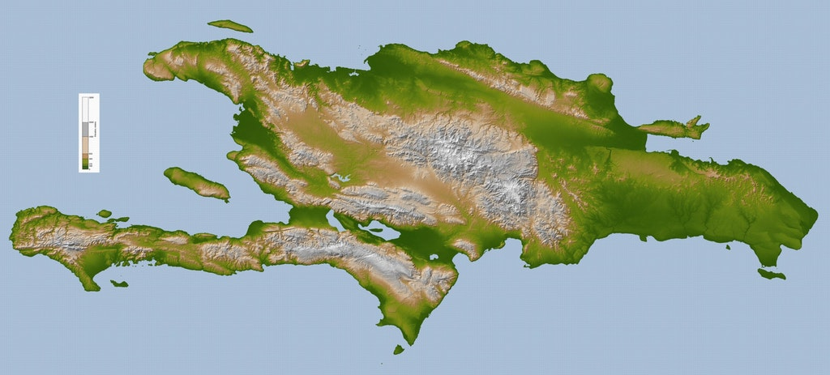
- In particular, there is potential for the middle-altitude agroecosystem belt, that runs along much of the length of the northern slopes of Haiti’s Massif du Nord, to deliver regional connectivity functions: although much more disturbed and fragmented than the vegetation found in much of the Dominican Republic, this belt contains significant levels of tree cover, in the form of fallows, home gardens and coffee and cacao plantation, that provide potentially favourable conditions of habitat and connectivity for species that require some degree of tree cover yet are able to tolerate ecosystem disturbance.
- A schematic representation of the broad-brush configuration of the target landscapes is shown in Figure 16. There are no significant areas of intact vegetation remaining in the landscape, with the potential to act as refugia for forest-dependent biota, on which to concentrate conservation actions, and between which to promote specific biological corridors at local level. Rather, the project will aim to improve the habitat value of the middle-altitude agroecosystem belt as a whole, enabling it to function as a regional level corridor.
            - Broad-brush schematic representation of target landscapes
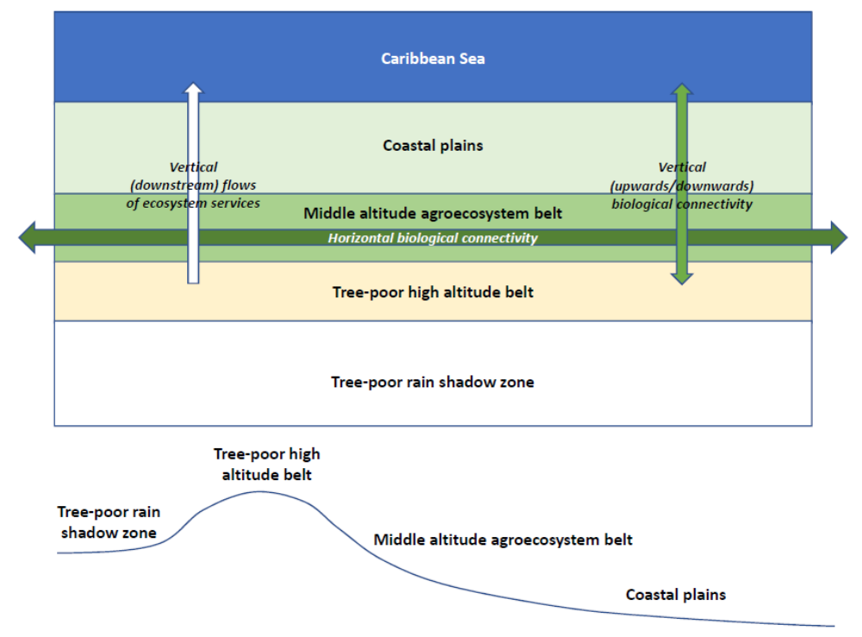
            - Typical landscape cross-section (source: Google Maps)
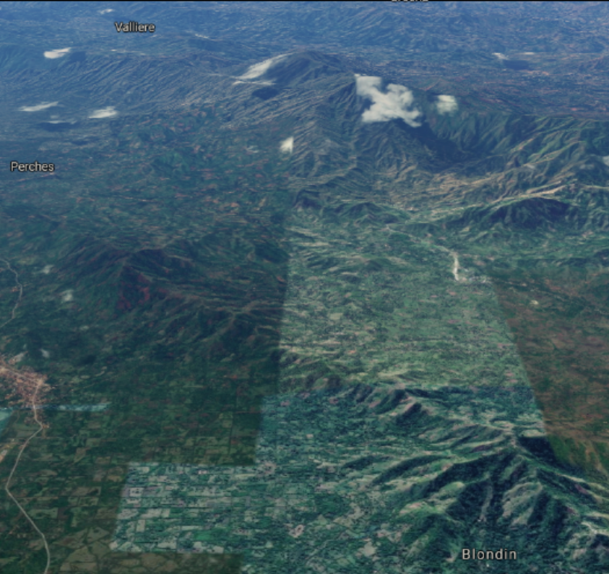
Coastal plains
Middle altitude agroecosystem mosaic
Denuded mountain tops
- The maintenance or increases in the numbers of trees on farm and in associated land units such as ravines and stream sides, and modifications or diversification of the types of species present, will contribute to improving the conservation status of endemic, globally rare and/or threatened species by:
- Promoting connectivity between populations which are becoming increasingly isolated due to fragmentation of their original habitat into ever-smaller and more widely-separated fragments; reversal of this situation, by creating conditions that help them move and interact between landscapes, will contribute to their long term genetic viability;
- Promoting upstream-downstream connectivity, for example by protecting or increasing ravine-side vegetation, will facilitate the movement of elements of (especially aquatic) fauna, on a daily or seasonal basis, between altitude zones.
- Promoting favourable habitat conditions in production landscapes (for example by increasing numbers of food species for birds and bats and ensuring suitable microclimates for amphibians) will increase the effective range size, and therefore numbers and success, of species that are otherwise inhibited from venturing out of every-shrinking ecosystem remnants due to hostile anthropomorphic conditions.
- Promoting agroforestry-based systems will increase ecological and productive sustainability, reducing the need for periodic abandonment of exhausted plots, and thereby contributing to landscape stabilization and reducing the advance of the agricultural frontier into remnant ecosystems.
- Species which have potential to benefit from this approach include the following (see Additional Annex A for more detail):
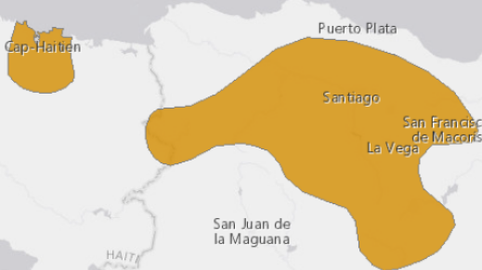
- The Critically Endangered, Hispaniolan endemic Schmidt's Robber Frog (Eleutherodactylus schmidti), which has a restricted range, divided into two separate areas in the Cordillera Septentrional and Cordillera Central, in the Dominican Republic, and in the Massif du Nord, Haiti. This species is usually found beside streams in mesic closed-canopy rainforests and so may (subject to confirmation) potentially benefit from increases in tree-based production systems such as diverse cacao and coffee plantations.
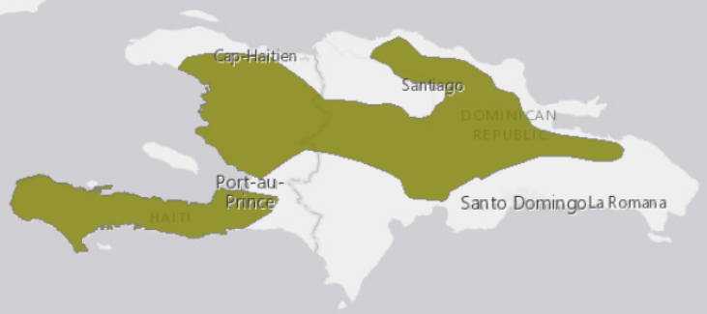
- The Vulnerable Hispaniolan endemic Los Bracitos Treefrog (Hypsiboas heilprini), which has a spotty and fragmented distribution throughout Hispaniola, from sea level up to 1,856 m asl. This is a stream-breeding amphibian found in high-quality mountain streams associated with well-conserved mesic broadleaf forests. It has also been found in areas with various land uses, such as cacao plantations, coffee plantations, pastures, crop agriculture, areas with livestock, and forestry activities. although this frog is found in habitat types that are contained within a variety of different land uses, it requires forests as the main habitat pockets to subsist within these different landscapes. In terms of micro-habitat occupation, males have been reported to call from rocks or low vegetation near and in water. It has been observed breeding in slow-moving water at Diego de Ocampo in April 2009 (G. Ross pers. comm. March 2011). Due to the fact that it is a mountain stream-dweller, it is considered to be more sensitive to habitat destruction than many other species.
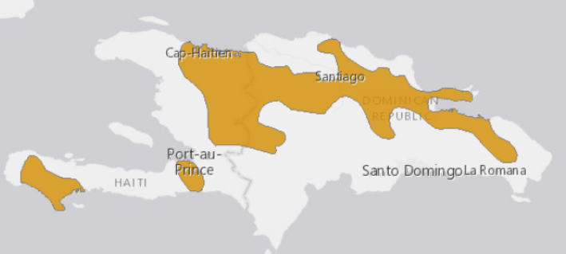
- The Vulnerable, Hispaniolan endemic Hispaniolan Yellow Treefrog (Osteopilus pulchrilineatus), which has a highly fragmented distribution on Hispaniola, which suggests that it has declined from a previously more uniform distribution. It occurs in mesic broadleaf forests, riparian forests including remnant forests, mangrove forests, grasslands, marshes and agricultural landscapes including rice plantations, coffee and cacao plantations. Although this frog is found in habitat types that are contained within a variety of different land uses, survey results suggest that it requires forests and/or wetlands as the main habitat pockets to subsist within these different landscapes.
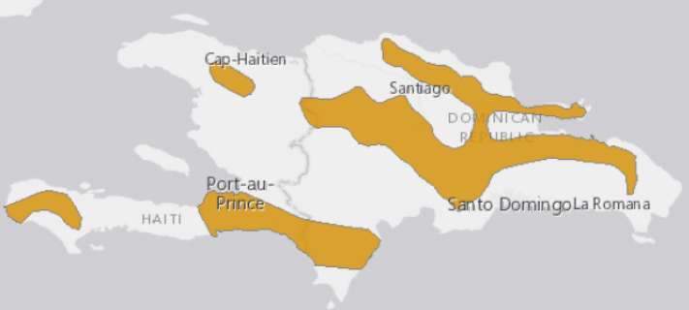
- The Vulnerable, Hispaniolan endemic Hispaniolan Giant Treefrog (Osteopilus vastus), whose very patchy distribution in Hispaniola similarly suggests that it has declined from a previously more uniform distribution. It is found in mesic broadleaf forests, and has more recently been recorded in cacao and coffee plantations, pastures, and other types of crop agriculture (e.g., avocados and yams). Within these different habitat types it can often be found along creeks and streams. Although this frog is found in habitat types that are contained within a variety of different land uses, survey results suggest that it requires forests as the main habitat pockets to subsist within these different landscapes.
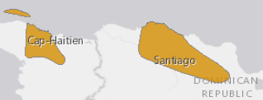
- The Giant Hispaniolan Galliwasp Celestus warren is a Vulnerable, Hispaniolan endemic species of anguid lizard. It is presumed to be a burrowing species that occurs in mesic lowland broadleaf forest, dry forest, banana groves and cacao plantations. There is a large geographical disconnect between its reported areas of occurrence in the north of the Dominican Republic and northern Haiti. It is listed as Vulnerable due to its limited distribution (with an extent of occurrence of 14,646 km²), fragmented subpopulations and ongoing threats include expanding agricultural activities, charcoal production, predation by cats, dogs and mongooses, it is killed by local people who mistakenly consider these lizards to be venomous, and it is on the illegal pet trade. It is only found in one small protected area.
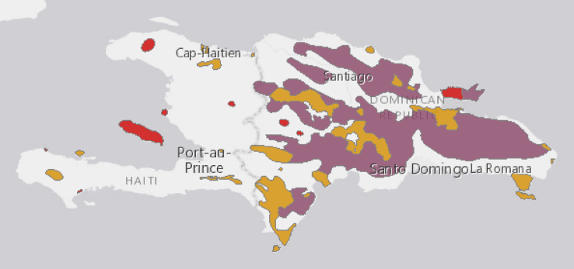
- The Vulnerable, Hispaniolan endemic Hispaniolan Parrot (Amazona ventralis) inhabits a variety of wooded habitats, from arid palm-savannah to pine and montane humid forest, up to and slightly above 1,500 m; it frequently forages in cultivated lands such as banana plantations and maize fields. Nests are situated in tree-cavities, and sometimes dead tree-stumps Agricultural conversion and charcoal production have destroyed most suitable habitat; it is also persecuted as a crop-pest, hunted for food and trapped for the local and formerly at least, international cage-bird trade.
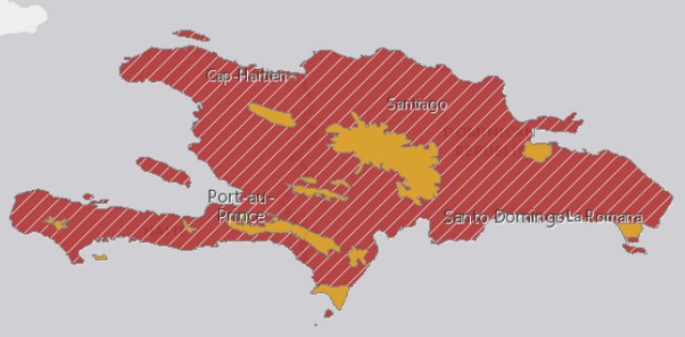
- The Vulnerable Hispaniolan endemic White-necked Crow (Corvus leucognaphalus) has declined rapidly since the early 1980s, and the population and range are now small, fragmented and continuing to decline. It inhabits lowland and montane wooded regions, where it probably favours old, mature forest; it is intolerant of degraded habitats or areas opened up by forest clearance, although its mapped current range does apparently include areas of highly altered landscape in Haiti; so the potential for it to be benefited by actions focused on increasing the tree component in the middle altitude moist agroecosystem requires further analysis.
Extinct
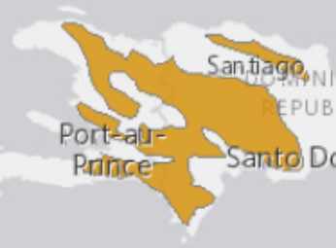
- The Near Threatened Palm Crow (Corvus palmarum) occurs only in Hispaniola and Cuba (a separate race, whose range has significantly declined). The Hispaniolan race has decreased, and in Haiti it only remains locally common in the Massif de la Selle and the northern pine belt. On Hispaniola its decline is a result of widespread forest clearance for agriculture and probably also hunting for food: the species is extremely intolerant of humans and now lives in municipalities with the lowest human population densities.
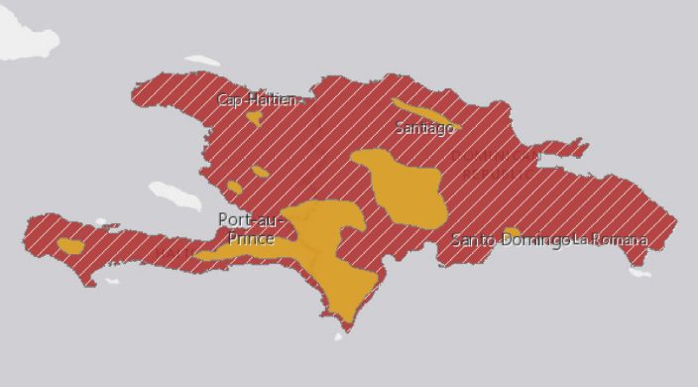
- The Vulnerable Hispaniolan endemic Hispaniolan Parakeet (Psittacara chloropterus synonym Aratinga chloroptera) has a small and fragmented range and population, which continues to decline as a result of habitat loss and persecution. It has been suggested that it may be extinct in Haiti, but there are claims that it is common in the Massif de la Selle and la Citadelle area of the Massif du Nord. It inhabits all kinds of natural habitat from montane forest to arid lowland forest, palm-savannah and open woodland, and ranges into agricultural land and second growth. Nesting takes place in tree-cavities or arboreal termite nests.
Extinct
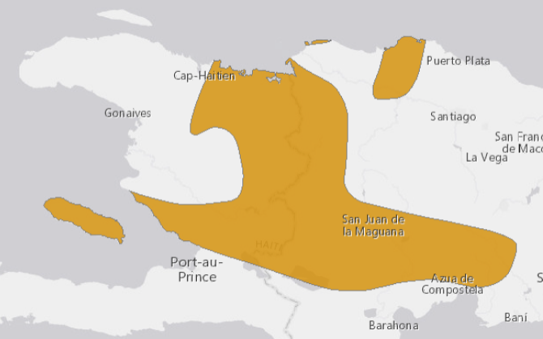
- The Near Threatened, Hispaniolan endemic Least Pauraque/Poorwill (Siphonorhis brewsteri) is believed to have moderately small and declining populations owing to habitat loss and degradation. It is found in arid or semi-arid lowlands, especially scrubby woodland, and also broadleaf, pine or mixed forest up to 800 m.

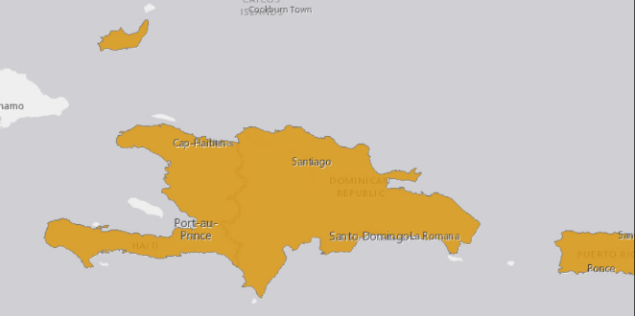
- The Vulnerable Minor Red Bat (Lasiurus minor) has a small geographic range, occuring in less than 15 localities in only three Caribbean islands (Puerto Rico, Bahamas and Hispaniola). It rests among the leaves of trees and does not take shelter in tree hollows, buildings, or caves; it is a swift flier but not highly manoeuvrable, consequently, it typically forages in open areas (above the canopy, in woodland open areas, and along forest edges).
- The promotion of tree cover in this belt also has the potential to benefit migrating Nearctic warblers such as the Blackpoll warbler (Setophaga striata) and Connecticut warbler (Oporornis agilis), whose habitat while migrating includes broadleaved forests and which have been shown through geolocation to use the Antilles, including Haiti, as a stepping stone in their overwater migration between North and South America. The Near Threatened Golden-Winged Warbler (Vermivora chrysoptera) occasionally winters in Haiti and is listed by Rainforest Alliance as an indicator bird associated with the sustainable management of coffee farms: it uses all kinds of woodland and scrub during migration, and birds generally winter in secondary growth forest or forest edge with a good understorey.
- The limited level of knowledge of biodiversity in Haiti means that the above information on potential beneficiary species is very far from being exhaustive. There is also a significant possibility that the Red List “endangered” Hispaniolan endemic mammals Plagiodonta aedium (Hispaniolan hutia) and Solenodon paradoxus (Hispaniolan solendon) may occur in the area. Both of these species have been considered extinct in the past: little is known about their ecological requirements, habitat associations, or landscape-level and regional distributions; however, previous studies have suggested that solenodons may be more abundant and widely distributed than hutias across much of the island, with populations recorded in highly disturbed landscapes in both the Dominican Republic and Haiti, whereas hutias probably have a greater requirement for tree cover.
- Direct measurement of the impacts of the project on the conservation status of endemic, globally rare and/or threatened species would be impractical and costly. The project will therefore rely principally on proxy measures of biodiversity status, including the following:
- Area of agricultural land brought into agroforestry systems, with improved tree cover, that favour the delivery of multiple environmental benefits
- Area of deforested land restored to forest, and forested land with improved tree cover, favouring the delivery of multiple environmental benefits
- Area of cacao and coffee plantations in project target communities with improved management that favours BD habitat and connectivity (e.g. increased diversity of structure and composition), increases overall economic viability, contributes to food security, and responds to provisions of spatial plans that provide for BD connectivity and ecosystem services
- Area of cacao and coffee plantations in the overall project area certified under certification schemes with requirements that coincide with those of target BD
- The utility of these indicators as proxy measures of BD status are based on the assumption that the management practices proposed and applied, including increases in tree cover, and the diversification and modification of composition and structure, are favourable for BD, in terms of habitat value and connectivity. This assumption is supported by the information in the scientific literature (summarised above) on the ecological requirements of numerous endemic species of global conservation concern. These assumptions will further be validated through short term studies to be carried out at intervals throughout the project period by international experts in conservation biology, into the specific relationships between alternative management models for production units (including the requirements of alternative certification schemes), and the generation of specific BD benefits; these studies will be complemented by participatory studies of local ecological knowledge. The Institute of Zoology of the Zoological Society of London, the Durrell Wildlife Conservation Trust and the International Union for the Conservation of Nature Species Survival Commission (IUCN SSC) Small Mammal Specialist Group have carried out significant fieldwork into the ecology and conservation biology of species including the Hispaniolan hutia and Hispaniolan solenodon, and constitute important potential sources of expertise for the project to draw on.
- Land degradation: the project will result in increases in the area of integrated natural resource management (INRM) practices in the target landscapes, in the form of diverse agroforestry systems (covering an estimated 20,000ha within the overall target landscapes); these will contribute to combating land degradation processes by facilitating nutrient capture and recycling, facilitating soil water protection and recharge, and reducing rainfall impact and erosive runoff flow.
Contribution to Aichi biodiversity targets
- This proposed project will also contribute to the following Aichi Targets:
- By promoting the application of market-based incentives for tree-based production systems, the project will contribute to Strategic Goal A: Address the underlying causes of biodiversity loss by mainstreaming biodiversity across government and society/Target 3: By 2020, at the latest, incentives, including subsidies, harmful to biodiversity are eliminated, phased out or reformed in order to minimize or avoid negative impacts, and positive incentives for the conservation and sustainable use of biodiversity are developed and applied, consistent and in harmony with the Convention and other relevant international obligations, taking into account national socio economic conditions/Target 4: By 2020, at the latest, Governments, business and stakeholders at all levels have taken steps to achieve or have implemented plans for sustainable production and consumption and have kept the impacts of use of natural resources well within safe ecological limits.
- By supporting the stabilization of landscapes and the consequent erosion of ecosystem remnants, and promoting connectivity between remnants, the project will contribute to Strategic Goal B: Reduce the direct pressures on biodiversity and promote sustainable use/Target 5: By 2020, the rate of loss of all natural habitats, including forests, is at least halved and where feasible brought close to zero, and degradation and fragmentation is significantly reduced/Target 7: By 2020 areas under agriculture, aquaculture and forestry are managed sustainably, ensuring conservation of biodiversity.
- By supporting the protection of ecosystem remnants and increasing the value of production landscapes or habitat and connectivity, the project will contribute to Strategic Goal C: To improve the status of biodiversity by safeguarding ecosystems, species and genetic diversity/Target 12: By 2020 the extinction of known threatened species has been prevented and their conservation status, particularly of those most in decline, has been improved and sustained.
Contribution to UNDP Strategic Plan
- The project will contribute to Development Setting B of the UNDP Strategic Plan: Accelerating structural transformations for Sustainable Development. Specifically, it will contribute to the goals of:
- Inclusive and accountable governance, through its support to socially- and institutionally sustainable mechanisms for governance for tree-rich production systems
- Effectively leveraging technological advances, overcoming unsustainable natural resource management practices, high-quality technical and policy advice, and innovative development finance solutions, through the consolidation of the capacities of producer cooperatives/federations, improved service delivery systems for technical assistance, improved financing mechanisms for tree-based production systems, and the development of capacities for generating revenue from tree-based systems on farm, including men and women farmers, and market-based instruments to facilitate the delivery of environmental benefits.
Contribution to national strategies and plans
- The project is in accordance with the principal strategic guidelines presented in the country’s draft National Biodiversity Strategy and Action Plan (NBSAP), including the reduction of poverty in communities who rely on biodiversity for their survival and prosperity, the correlation of biodiversity actions with measures that provide employment opportunities and diversify income generation activities, the promotion of the ecosystem approach, promoting gender equity in biodiversity programmes and management, the promotion of a decentralizing approach to manage biodiversity by strengthening civil society and local organizations to facilitate sustainable use of biodiversity, the development of increasing partnerships with the private sector, and the valorisation of traditional and local knowledge. The Triannual Plan of Operations of MOE for 2013-2016 also prioritizes reforestation, integrated watershed management, strengthening of environmental governance and the sustainable management of PAs and natural spaces.
- The project is in line with the 2010-2020 Action Plan of MARNDR, which prioritizes the protection of natural resources (soil, water and forests) through the practice of integrated and conservationist agriculture, together with the expansion of traditional and non-traditional export crops.
- The project will contribute to the priorities and targets set out in Haiti’s Climate Action Plan (2015) in relation to increases in reforestation (with emphasis on local species), the protection and conservation of existing forest reserves and the restoration and extension of agroforestry systems.
- The project will also contribute to the targets of Haiti’s 2015 National Action Plan for the Combat of Desertification, in particular that populations in areas affected by desertification/degradation will have improved and diversified livelihood support options and will obtain revenue through sustainable land management; sustainable improvements in the productivity of lands and the goods and services provided by ecosystems, contributing to livelihoods.
- In January 2017 Haiti launched its process for the definition of a strategy for Land Degradation Neutrality, with corresponding targets, through a national information and coordination workshop. It is expected that national targets will have been established by the time of CEO Endorsement of this project, and the level of contribution of this project to those targets will accordingly be defined with a clear SLM mainstreaming and scaling out strategy.
- Furthermore, the project is consistent with the Sustainable Development Goals (SDGs), in particular:
- Goal 1: No poverty. The project will increase incomes among project beneficiaries, and contribute to the resilience of their incomes, through the promotion of value chain opportunities, the development of farmer capacities for production and value adding, and the diversification of income sources.
- Goal 2: Zero hunger. The project will contribute to the productive diversification of agroforests, including nutritionally important food crops such as plantains, bananas, citrus and breadfruit.
- Goal 5: Gender equality. The project will promote opportunities for women to obtain benefits from natural resource management, including through small businesses focused on adding value to the products of BD-friendly agroforests, and through trade in these products.
- Goal 8: Decent work and economic growth. The project will generate employment activities for local people (including the poor and women) in businesses involved in adding value to the products of BD-friendly agroforests.
- Goal 12: Responsible production and consumption. The project will support the production of globally traded commodities (cocoa and coffee) in accordance with principles of environmental sustainability.
- Goal 15: Life on land. The project will contribute to the restoration of degraded landscapes in such a way as to improve habitat and connectivity conditions of benefit for globally threatened biodiversity.

Specific strategies
- In recognition of the complexity of the target landscapes and the issues affecting them, the project will apply a wide range of key strategies: despite their diversity, these will be highly complementary and integrated, as well as clearly defined and relevant to the needs and conditions in the landscape, and to the specific changes which the project will promote in land use trends.
- Strengthening enabling conditions
- The project will help to orient and form policy and planning processes at national and regional levels in order to ensure that these are supportive of the landscape management approaches promoted at field level. This support will focus on ensuring that policies and plans are consistent and harmonized between sectors in order to avoid contradictions and “perverse incentives” for deforestation; and that policy makers and planners have access to reliable information that allows them to appreciate and weigh the diverse potential implications of alternative decision scenarios, including the economic value of the goods and services provided by ecosystems.
- Environmental governance
- The project will support the strengthening of governance conditions in the target localities in order to ensure that the provisions of regulatory and zoning instruments, such as restrictions on the felling of primary forest, are respected. This will be achieved through support to local governance mechanisms (including those of indigenous communities and women), complemented by policy influence and awareness raising, which is expected to lead to increases in budgetary allocation by central and regional governments for environmental supervision and enforcement.
- Landscape planning
- The project will help to ensure that management activities are located in the landscape in accordance with productive potential, ecological conditions and sociocultural conditions, and take into account the spatial dynamics affecting the landscape as a whole.
- Producer support
- The project will support producers in managing their production systems in ways that combine the optimization of environmental benefits with productive sustainability, profitability and compatibility with livelihood sustainability and sociocultural conditions, mainstreaming gender and inter-cultural issues.
- Emphasis will be placed on tree-based production systems such as coffee and cacao, with the aim of stabilizing the productive dynamics that drive agricultural frontier advance.
- Private sector involvement
- The project will involve the private sector, and work with market-based instruments and green value chains, in order to promote environmentally sustainable and zero-deforestation forms of production.

Incorporation of stakeholder concerns
- There are no indigenous people in Haiti.
- Project design responds to the results of extensive consultation processes during the formulation phase, including community meetings, focus groups meetings and bilateral meetings with representatives of specific organisations (including community-based organisations, NGOs and institutions of local and central government).
- As reported in Section I, the main concerns of most rural families include food security, income generation to meet cash expenditure obligations, and saving to cover lean periods. Farm families are also typically risk averse; they also expressed very limited willingness for their main priorities to be affected in order to favour biodiversity.
- The project will respond to these expressed concerns and priorities by promoting a “win-win” approach focused on supporting, through technical support and market-based instruments, the productive diversification of tree-based units on farm: as shown in Figure 8, this will be attractive to farmers as a means of increasing net economic benefits as well as food security and resilience to climate change and other shocks, relative to the expected land use scenarios without GEF support. Biodiversity gains will thereby be delivered as incidental benefits in the back of these livelihood benefits which will motivate farmers’ buy-in.
- The project will incorporate the participation of community-based organizations (CBOs), particularly in relation to the strengthening of natural resource governance, under Output 1.2. There is a wide range of CBOs active in rural communities in Haiti, which vary in terms of their objectives, level of consolidation and origins, with some emerging as endogenous responses to specific community concerns (such as agriculture, local development, environmental protection and environmental vulnerability), some having been especially created with the arrival of NGO projects, and others being “opportunist”, lacking functionality at present but waiting to become legitimate community interlocutors if opportunities arise.
- A stakeholder engagement plan is presented in Appendix O. As explained in Section VII, a Local Advisory Committee (LAC) will be established, in which representatives of all major stakeholder types will have the opportunity to participate; the LAC will serve as a mechanism for airing and discussing stakeholder concerns, for consideration by the project (a representative of the LAC will participate in the Project Steering Committee).

Selection of project beneficiaries
- As shown in Table 4, the population of the target areas and communities is heterogenous, ranging from small (<0.5 Cx) or landless farmers to better-off farmers with 3-5 Cx of land; and farmers range from the highly vulnerable and food-insecure landless (category IV) to the relatively well-off, with diverse productive options, ample reserves of livelihood capital and a relatively high level of resilience to environmental and economic shocks (category I).
- Given that its strategy for delivering environmental benefis is based on achieving improvements at scale in the management of production systems, the principal target group of the project will be medium or larger-scale farmers (categories I – III): it is these sectors of society who have the potential to deliver impact in terms of area. Within this group, the project will focus primarly, but not exclusively, on cacao and coffee producers; the principal criterion for selection, however, is the farmers’ willingness and potential to modify management of their production systems in order to increase, improve and diversify tree cover. On this basis, farmers with production systems other than cacao and coffee may also be included, if this potential exists.
- Some Category IV farmers will also be included in order to contribute to the social acceptability of the project by broadening the distribution of social benefits, despite the relatively limited area of land on which they are able to have influence. Category IV farmers will also benefit indirectly, even when not included as direct beneficiaries, through the generation of employment opportunities in the production systems, and associated processing and commerce activities, to be supported by the project.

Relevance in relation to the baseline scenario
- The project is timely and relevant given the solid baseline of other investments with which it will be associated and on which it will build, and which in the absence of the project are expected to either exacerbate these negative impacts or fail to take advantage of opportunities to apply integrated and sustainable solutions (see Section II for details of baseline investments).
- Building on, complementing and synergizing with these baseline initiatives, GEF resources will be used in an incremental manner to deliver additional benefits (global environmental benefits or GEBs) in terms of the conservation status of globally important elements of biodiversity, while at the same time generating globally significant benefits in terms of sustainable land management. In qualitative terms, GEF funds will add incremental value to the baseline situation by showing how to deliver GEBs in the focal areas of BD and SLM in an integrated manner, through the promotion of tree-rich production and resource management systems that favour biodiversity, while at the same time stabilizing landscape dynamics and helping to protect the natural productive capital of the landscape units and their potential to yield environmental goods and services in a sustainable manner.

Results and Partnerships

Expected Results:
- The objective of the project is the generation of multiple environmental and social benefits through the integrated and sustainable management of wooded production landscapes in the Massif du Nord with globally significant biodiversity.

Outcomes and components
- The objective of the project will be achieved through actions structured under three components. Components 1 and 2 will be executed by NGOs/CSOs with strong experience in this field
- In order to remove the barriers and achieve global environmental benefits, the financial resources of GEF will be invested in an incremental way to the aforementioned baseline initiatives, as detailed below:

Component 1: Creation of enabling conditions for the application and scaling-up of the landscape management model

This component will be implemented by NGO/CSO (such as FECCANO, RECOCARNO) with strong local experience, which were identified as most relevant during stakeholder’s consultation and assessment, and results of procurement processes.

Output 1.1 Decision making tools to optimize the configuration of landscape elements in relation to spatial aspects of connectivity, biological importance, production potential, vulnerability and flows of ecosystem services:
    - Region-wide framework for harmonizing interventions in relation to the promotion of sustainable production and management systems
- The project will facilitate and inform planning and negotiation processes, covering the whole of the project intervention area and involving multiple stakeholders from central and regional Governments and civil society, leading to the development of a harmonized and consensus-based framework (including principles, targets and region-wide plan specifying priority areas for connectivity and protective management) for interventions in relation to the promotion of sustainable production and management systems across the north and north-east of the country.
    - Social and economic development plans formulated and implemented by local governments that include provisions for the promotion of BD-friendly production systems
- In order to optimize impacts in relation to the spatial dynamics of ecosystems, environmental services and threats, the farm level support proposed under Component 2 will need to be carried out within the framework of landscape-wide tools for decision-making and planning. To this end the project will support, and strengthen the institutional capacities of, regional governments in incorporating these environmental considerations into spatial zoning plans covering their areas of jurisdiction, and in ensuring that the spatial plans of the different regional governments that cover the target massifs are effectively harmonized. This will be accompanied by the development and adoption of a robust protocol for the monitoring of biodiversity conditions and emplacement of implementation structure, supported by the provision of training to regional governments in its application. Similar mainstreaming support will be provided for social and economic development plans developed by regional governments, in order to highlight potential risks of development proposals undermining environmental values, and propose mitigation measures accordingly.
- The project’s support to these planning instruments will include facilitation and capacity development for the definition of specific territorial zones to be prioritised for different management objectives, including connectivity, protection and restoration, on the basis of region-wide variations in factors including BD values, connectivity needs and current natural resource conditions
- Facilitation, advisory, information and capacity development support will be provided to local governments (at commune or collectivité térritoriale level) for the formulation of plans setting out their thematic and spatial priorities for social and economic development, with particular emphasis on the inclusion of provisions for environmental sustainability, and with particular reference to sustainable production systems. Needs for project support will be defined on a case-by-case basis, but may include the training of local functionaries on aspects of planning and environmental sustainability (including for example considerations of landscape-wide flows of ecosystem services); the provision of reliable, relevant and up to date information on biophysical and socioeconomic variables, including their spatial dimensions; the establishment or strengthening of systems for information management, planning and monitoring in the local Governments; the facilitation of multi-stakeholder processes for the participatory formulation of the planning instruments; and the publication and dissemination of the instruments. In some cases (for example the commune of Marmelade), social and economic development plans may already have been formulated; in such cases, the project will be focus on supporting and overseeing their implementation, with particular attention to issues of environmental sustainability, and on mainstreaming considerations of environmental sustainability when the time comes for them to be updated.
    - Systems for environmental monitoring and information management at landscape level established and operationalised in Department and Commune governments (including Commune Agricultural Offices), permitting management of landscapes in favour of environmental benefits to respond adaptively to evolving social, economic and environmental conditions:
- In order to help maximize the effectiveness and ongoing relevance of planning and management instruments, the project will ensure that they are supported by flows of reliable and relevant information on conditions in the target landscapes, for example in relation to vegetation status, land uses and biodiversity values. This support will take advantage of and build upon existing information management systems and platforms such as ONEV.
- These systems will include, for example:
- GIS-based mapping
- Systems for the management and communication of information, including web-based portals
- Further studies of value chain opportunities and market trends, including other crops and products in addition to cacao and coffee, and emerging opportunities.
- Community-based systems for participatory monitoring of social and environmental trends, including the definition of appropriate indicators and mechanisms for information management, exchange and use
- The project will provide advisory and training support to local institutions for the application of a range of information management and planning tools, the utility of which has been widely proven by FAO in similar situations elsewhere, including Collect Earth for augmented visual interpretation for land monitoring, the WOCAT database and WOCAT-LADA mapping tool, Land Degradation Assessment in Drylands (LADA) for local level assessments of land degradation and sustainable land management and the Ex-Ante Carbon Balance Tool (Ex-ACT) (for land use change and value chains). Collect Earth, for example, would be of use for the monitoring of ecosystem conditions in response to changes in the management of production systems. These tools are all free and available on line, and the project will provide local staff with training on their application.
    - Consolidation of the capacities of producer cooperatives/federations for monitoring the compliance of their member producers with environmental management and traceability standards
- Although responsibility for the inspection of farms to ensure their compliance with certification standards lies with the certification bodies themselves, it is also necessary for producer organisations to ensure compliance of their members prior to inspection. The project will support the producer organisations and their members in developing and applying administrative procedures to ensure effective inspection of compliance, including effective record-keeping and traceability systems.

Output 1.2. Socially- and institutionally sustainable mechanisms for governance in support of tree-rich production systems:
    - Community-based mechanisms for countering threats to community interests in relation to natural resources
- Building where possible on existing social structures, the project will support the establishment and/or consolidation of community-based mechanisms for joint work at watershed level to counter threats that affect the interests of community members, such as encroachment on areas of importance for the protection of community water supplies, or the felling of trees in the community for charcoal, by external actors.
    - Community-based organisations strengthened to facilitate joint action in support of BD-friendly landscape and ecosystem management such as the protection of remnants of vegetation and the restoration of degraded areas around water catchment areas, and the effective social control of threats
- Similarly, the project will support the strengthening of community-based institutions capable of organizing joint action in support of BD-friendly landscape and ecosystem management, such as the establishment and protection by communities of riparian reserves, the restoration of degraded areas, and the effective social control of threats, such as fire, affecting such areas and other environmental values. This will to some extent compensate for the limited capacities and resource of State institutions with responsibility for overseeing environmental governance.
- In this regard, the project will take into account lessons learned from other projects in the past regarding the importance of building on relevant existing community structures wherever possible, before developing new ones, in order to promote community acceptance and sustainability. Such existing associations can function as the primary channels for diffusion and adoption of technical innovations and awareness-raising messages.

Output 1.3 Market-based instruments to facilitate the delivery of environmental benefits:
- The project will support the use of market-based instruments to motivate application of production practices that favour the generation of environmental benefits. Studies during the PPG phase show that the price differentials obtainable through certification far outweighs the costs of becoming certified, resulting in significant net financial benefits for cooperatives and their members. Conversely, analyses show that there is limited motivation for private sector actors in Haiti to impose environmental standards on producers, given that the demand for coffee and particularly cacao far outweighs supply: the principal strategy whereby private sector actors will be able to influence the environmental stability of their supply chains will be through the provision of technical support to producers.
- Certification: the case of FECCANO
FECCANO has three forms of certification: Ecocert, Symbole de Producteurs Paysans and Fairtrade. The cost of certification varies in accordance with the number of producers (although the certification is held by FECCANO itself).
The total annual cost to FECCANO of holding these three certifications is USD 18,000, equal to USD 200/t of cacao (the certification covers 4,200 producers in 8 member cooperatives, with a total annual production of 200 t of cacao).
Certification allows producers to obtain a price differential of USD 1,500/t, however (USD 4,000/t instead of USD 2,500/t), giving a net benefit of USD 1,410/t (56% on top of non-certified).

    - Coherent framework for Government support to integrating producers into markets that favour sustainable production
- The project will work with key relevant sector institutions (particularly the Ministry of Agriculture, the Ministry of Environment and the National Coffee Institute INCAH), to consolidate cross-sector policy support for sustainable production systems, and for the development of corresponding markets and value chains. This will result for example in policy documents recognising their importance and potential, and identifying them as institutional priorities; and the institutionalisation of mechanisms for cross-sector and public-private coordination in support of these systems and value chains. Examples of specific issues to be prioritised may include commitments to supporting third-party certification; financial instruments to allow producers to invest in carrying out sustainable production practices and in meeting the quality requirements of prime/niche markets; and the development and promotion of (a) national brand(s) featuring environmental sustainability and tradition as selling points.
    - Branding based on socio-cultural-environmental factors
- The project will provide specific support to the development of branding based on a combination of factors including quality, environmental sustainability and cultural traditions (for example using a term such as “Creole Garden” or « Jaden Creole » to deliver this message). Project support will include market preference surveys in both local and export markets; advisory support for the definition of the precise product characteristics on which the brand would be based (quality standards, origins and growing/processing methods); and development of marketing materials. A brand such as “Creole Garden” would have the potential to be applied not only to specific products, but also as an overall marketing slogan for the country.
    - Local and national value chains
- In order to lessen the risks associated with exclusive dependence on export markets (which, in the case of cacao and coffee are notoriously fickle), the project will work with producers, cooperatives, the national private sector and the Government to strengthen local and national value chains for cacao, coffee and other products of diverse agroforestry systems.
- The strategies to be pursued will vary between crops. In the case of food crops (such as yam and plantain), for which value chains tend to be relatively short (with a large proportion being consumed in the producer communities or in nearby urban centres), the project will for example support the development of Participatory Guarantee Systems (PGS). The PGS model has been widely tested in over 70 countries globally: it is a low-cost, locally-based system of quality assurance with a strong emphasis on social control and knowledge building; it is based on the active participation of farmers, consumers, rural advisors, local authorities, who come together in order to make decisions, visit farms, support each other and check that farmers are producing according to agreed standards.
- In the case of non-staple crops such as coffee and cacao, the principal focus will be on the more discerning middle-class market, located mainly in urban centres, and including the growing number of cafés, hotels and supermarkets that cater for consumers seeking quality coffee. The project will work with private sector companies (such as REBO and Wiener) to develop this market, focusing (as in the case of export markets, as described above) on the promotion of branding based on a combination of quality, environmental sustainability and cultural traditions (creole “gardens”). It will also work to link specific growers and cooperatives in the target communes with such outlets and branding schemes, thereby helping to ensure their reliable access to favourable markets, while at the same time helping to ensure that upstream value chain actors and retailers have access to reliable sources of supply capable of consistently satisfying requirements for quality and environmental compliance.
    - Increased involvement of chambers of commerce in support of sustainable production systems
- Local chambers of commerce typically bring together the main business actors operating at local level, including those involved in marketing and processing. They therefore potentially consistute a valuable entry point for interventions aimed at developing and strengthening green value chains, and fora for bringing together producer organisations and value chain actors in order to discuss opportunities for commercial partnerships. Often, their members are also of high social and political standing, potentially making them useful entry points for policy lobbying in relation to issues of environmental sustainability and green value chains.
- The project will develop interest and capacities in chambers of commerce through the provision of information materials and awareness-raising sessions regarding the commercial potential of environmentally-sustainable production systems, and opportunities and potential benefits for developing commercial links with sustainable growers and cooperatives. Project staff will also provide active facilitation support to meetings between chambers of commerce and producers in order to enable the development of such links.

Component 2: Conservation compatible tree-based production systems as part of sustainable landscape mosaics
- This component will focus on developing capacities and mechanisms among local institutions, farmers and value chain actors to enable the expansion of the area managed under conservation-friendly tree-rich production systems. This component will be implemented by NGO/CSO (such as FECCANO, RECOCARNO) with strong local experience, which were identified as most relevant during stakeholder’s consultation and assessment, and results of procurement processes..
- As a result of this support, there will be an increase of 5,838 ha in the area of land with improved condition and management that favours BD habitat and connectivity (e.g. increased diversity of structure and composition), increases overall economic viability, contributes to food security, and responds to provisions of spatial plans that provide for BD connectivity and ecosystem services. This will include 5,040 ha of cacao agroforests, 30 ha of coffee agroforests and 630 ha of home gardens, annual cropping and grazing areas with agroforestry, as well as a further 138 ha of deforested land restored to forest or forested land with improved tree cover, through direct support to restoration by the project or through partnership with the USAID Reforestation Project.

Output 2.1 Improved service delivery systems for technical assistance:
- The principal incremental focus of technical assistance support to coffee and cacao producers will be on the application of management measures capable of delivering environmental benefits, such as the diversification of shade trees to favour bird species, the management of ground cover to favour amphibians, reptiles and microfauna, and the protection of riparian zones in plantations to favour aquatic fauna. These messages will benefit farmers by helping to ensure their compliance with the requirements of green value chains and certification systems. However, as mentioned above, this may often not be an adequate motivation for producers to adopt environmentally-beneficial practices. The incremental messages will therefore be delivered as part of broader extension packages focused principally on considerations of productivity and resilience, which are likely to be of more immediate concern to farmers.
    - Mechanisms for the generation and transfer of knowledge on the application of tree-based systems generating multiple environmental benefits
- Wherever possible, GEF support will be added incrementally to co-financed technical assistance programmes, with GEF support focusing specifically on the mainstreaming of global environmental considerations. This will be the case, for example, with farmers participating in PITAG, who will receive technical support from service providers (including local technicians, technical assistance companies and NGOs); both the farmers and the service providers will receive support through the project in relation to the selection and application of production systems that optimise environmental benefits, and accessing favourable markets for the products of these systems. In cases where such cofinancing support is not available, GEF funds will be used for the direct provision of technical assistance covering both productivity and environmental issues, either by project staff or by sub-contractors.
- The project will emphasise the application of participatory approaches to technology development and transfer, such as Farmer Field Schools, in order to maximize ownership of the extension messages by farmers. This will include farmer-based participatory systematization and knowledge exchange, as well as farmer-based systems for the production and exchange of planting material
- The project will invest in the development of lasting institutional capacities for technical support, rather than limiting itself to short-term support during its own implementation period (and that of co-financing partners). This will be achieved in part through the provision of orientation to the service providers working with co-financing partners (PITAG), which will leave them with lasting knowledge and skills; in part through the sub-contracting by the project itself of service providers (including local NGOs and groups of professionals); and in part through the provision of direct training support to cooperatives, groups of professionals, NGOs, local Governments and others, in technical aspects of tree-based production systems as well as Farmer Field School methodologies.
- The project will also promote and support the role of the private sector in the development and consolidation of systems for the provision of technical assistance to their supplying farmers, including environmental considerations. This approach will serve to address concerns raised by private sector actors regarding the lack of continuity of the technical assistance typically provided by short-term development projects. The project will work with multiple private sector actors in this regard, in order to promote economies of scale and harmonization of technical assistance packages.
- As a result of these actions, a total of 7,500 farming families throughout the project area will have improved access to reliable sources of technical support for the application of sustainable production systems, and an estimated 4,740 families will as a result apply and maintain modifications to their farms as a result of the knowledge gained.
    - Technical guidelines and extension materials on the management of tree-based production systems.
- The project will in addition invest in the production of technical guidelines and extension materials for use by farmers and by extension agents in Government, development agency project technicians, NGOs and private sector, focusing particularly on BD-friendly management practices. These materials will constitute a lasting resource which will contribute to the ongoing communication and uptake of project messages in the future, beyond the life of the project.

Output 2.2 Improved financing mechanisms for tree-based production systems:
- The project will seek to improve farmers’ access to the finance needed to enable them to invest in establishing or improving the productivity of tree-based production systems. As a result, it is projected that over the project lifetime around 75 families will be receiving financial support for businesses based on sustainable production systems, of at least HTG 250,000 (USD 3,193) each.
    - Analysis and guidance materials on creditworthiness of businesses related to tree-based production systems
- In order to overcome the habitual lack of confidence in the financial sector regarding the creditworthiness of businesses based on agriculture and natural resources, the project will support detailed analyses of the creditworthiness of a range of different business options. These will cover aspects such as: business and financial management capacities; access to reliable guarantees; profitability, and opportunities for improvement (for example through improvements in practices, sourcing of inputs and selection of markets); and the magnitude, resilience and projected trends of markets.
    - Tree-based businesses with capacities to take on and manage finance
- The project will provide advisory support to local businesses selling the products of tree-based production systems, in order to increase their abilities to access, manage and use financing. This support will include:
- Business planning, in order to define the levels, types and timeframe of financing needs, based on projections of business growth, profitability and repayment capacity, guarantee options and risks.
- Identification and selection of potential sources of finance, based on factors including portfolio coverage, guarantee requirements, interest rates, repayment terms and availability of business management and technical support.
- Development of capacities (skills and systems) for business and financial management.
    - Credit packages developed and offered by diverse financing sources
- Through awareness-raising (including the results of the creditworthiness analyses described above), the provision of orientation, the facilitation of strategic planning and support to discussions with potential beneficiaries, the project will lead to appropriate financing packages being made available by a range of different sources, in support of businesses based on the products of tree-based production systems.
- These sources will include, for example: local community-based finance mechanisms, savings banks and cooperatives, private sector value chain actors (such as cacao purchasers) mechanisms and Government incentive programmes. The credit packages will feature, for example, eligibility criteria tailored to the nature of the businesses (for example favourable guarantee requirements, interest rates and payback periods that reflect the time-scale of tree-based production systems); assurance mechanisms (based for example on the assurance provided by the Agricultural Credit Bureau, BCA); and provisions for ensuring ongoing access by beneficiaries to sources of technical and management advisory support.
- In the case of cash crops such as coffee and cocoa that are purchased by national or international companies, the project will work with the companies on the development of finance mechanisms for their producers, emphasizing (as with the provision of technical assistance as explained above) the benefits of this for the companies in terms of increased continuity and quality of supply.

Output 2.3 Capacities for generating revenue from tree-based systems on farm:
- In addition to promoting farmers’ knowledge and interest in traditional trees and management systems, the project will support the target population in generating revenue from them: this will provide them with direct economic benefits, and this in turn with further contribute to their farmers’ motivations to adopt and maintain the trees and management practices. This strategy will have particular potential to generate benefits for women, through their involvement in small-scale processing and in the commercialization of tree products.
    - Producer organisations, businesses and cooperatives with strengthened capacities for identifying favourable market opportunities and gaining access to certification systems
- The project will provide training to members of producer organisations, businesses and cooperatives on marketing, covering aspects including:
- The identification, scoping and selection of market options
- Product branding, presentation and promotion
- The negotiation of contracts
- Administrative procedures for sale and export
- The costs, requirements and market/price benefits of alternative options for third-party certification.
- As a result of this support, the area of cacao and coffee under third party certification schemes with requirements that coincide with those of the biodiversity elements targeted by the project will increase to an estimated 2,575 ha.
    - Improved capacities for adding value to the products of trees and tree-based management systems
- Project support aimed at helping farm families to generate income from trees and tree-based management systems will include the provision of initial investment, training and advisory support for the establishment and management of small-scale processing facilities managed by farmers and community organizations, especially women. The potential of a range of such products is analysed in Section III.

Component 3: Knowledge management and learning

This outcome will be implemented by UNDP taking advantage of its Green Commodities Programme, which connects commodity practitioners around the world and provides a safe space for them to share their knowledge and experience. Through this programme, UNDP helps building knowledge across a wide range of online and in-person activities and with representation of 12 commodity-producing countries, 30 organizations and 8 different agricultural and marine commodities. the Green Commodities Community works to increase and enhance connectivity among its members, creating a global network of changemakers, and to promote robust multi-stakeholder dialogue for systemic change.

Output 3.1 Knowledge management and dissemination/scaling up strategy
- In order to maximise the impact of the project, a strong emphasis will be placed on scaling up. To this end, a knowledge management strategy will be formulated and implemented, providing for the systematization of lessons learned and their effective dissemination, resulting in improvements to policies, approaches and enabling conditions at national level as well as replication at local level elsewhere in the country where suitable and comparable conditions exist. Lessons and experiences will also be interchanged as relevant with other countries in the region, particularly others that form part of the Caribbean Biological Corridor (such as Cuba and the Dominican Republic). The decision support framework developed by FAO and WOCAT can help promoting scaling up of SLM and contribute to land degradation neutrality.

Output 3.2 Communication strategy
- A communication strategy will be developed and applied, including provisions to ensure that project objectives, concepts, principles and progress are effectively communicated to all key stakeholder categories. The specific provisions of the strategy will be defined on the basis of an in-depth analysis of the characteristics and needs of the different target groups at project start-up.
- Messages of particular importance to be covered by the strategy will include, for example, the benefits of tree-based production systems for climate change resilience and livelihood sustainability, the importance of biodiversity for maintaining functioning ecosystems and productive sustainability, the net economic benefits of productive diversification, and the existence and potential of green value chains – providing value chain actors, especially smallholder farmers and small and medium-sized enterprises (SMEs), with the awareness, knowledge, technology and expertise required to make the move towards sustainable and resilient value chains, as well as developing communication systems and networks (including education and media) that allow information and knowledge to be strengthened, harmonized and shared, as well as progress to be monitored. Information supply is one of the central pillars on which the promotion and scaling up of environmentally sustainable and resilient value chains depends.

Output 3.3 Monitoring and evaluation strategy
- Project indicators will be confirmed and quantified during the PPG phase, together with a plan for their measurement and an M&E plan. These will be validated during project inception, and developed into a comprehensive M&E strategy during the first months of the implementation phase, to ensure that the project is managed in an informed, adaptive and effective manner.

Partnerships:
- There will be significant opportunities for coordination and complementarity between this project and the CCA/BD project 5380 “Increasing Resilience of Ecosystems and Vulnerable Communities to CC and Anthropic Threats Through a Ridge to Reef Approach to BD Conservation and Watershed Management”. Lessons on resource management practices will be exchanged: this project will benefit from the lessons that will have been learned, by the time it starts, through Project 5380 in relation to CC resilient production systems, and this project will then feed lessons on tree-based production systems into project 5380. The projects will also learn from each other in relation to interactions with community-based organizations and local and regional governments. There will be valuable opportunities for exchanges of lessons learned given that Project 5380 will operate in similar landscapes in the watershed of Grande Riviere du Nord and the watersheds draining into the Three Bays, which also include cocoa production areas.
- The project will coordinate, for example in the sharing of experiences and knowledge, the dissemination of information and lessons learnt, and the scaling-up of results, with the newly-approved World Bank GEF project “Resilient Productive Landscapes in Haiti”, which will target watersheds in other areas of the country. Details of collaboration will be defined during the PPG phases of this project and the World Bank one, which will largely coincide.
- The GEF Small Grants Programme (SGP) in Haiti provides grants to NGOs and CBOs (Community-Based Organisations) in support of community-based initiatives that could contribute to the GEF focal areas on biological diversity, climate change, land degradation and international waters. The SGP is currently implementing 18 community projects in 5 departments: North-East, North, Artibonite, Plateau Central and South. It operates, with the support of AusAid, the “Community-Based Adaptation to Climate Change Programme” with a view to improve adaptation capacity to climate change and climate variability through community measures capable of increasing resilience of livelihoods systems and ecosystems. Opportunities will be explored during the PPG phase for specific collaboration with the SGP in support of community-based resource management initiatives.
- The achievement of the project’s objective of generating multiple environmental and social benefits through the integrated and sustainable management of wooded production landscapes will be achieved by associating GEF resources with significant co-financing. GEF resources will be used to mainstream environmental considerations (BD/LD) into a number of the baseline initiatives described above, with the result that these initiatives will come to contribute actively to the generation of GEBs. This cofinancing source is as follows:
- The IADB-funded Agricultural and Agroforestry Technological Innovation Program – PITAG. The co-financing partnership with PITAG will help optimise the environmental sustainability of the agricultural technologies which it supports, and the achievement of its aim of generating positive environmental externalities at the same time as long-term farm profitability; and to maximize the overall impact of the GEF project, by catalysing the generation of environmental benefits at scale through strategic association with a larger development program. The GEF project will work with PITAG on:
- The provision of logistical, technical and facilitation support to members of selected target communities in developing spatial and strategic plans;
- The provision of technical and facilitation support to candidate farmers in developing proposals of productive options, for inclusion in their requests for support through PITAG;
- The provision of technical, material and advisory support to farmers, for the development and management of value-adding and commercial activities based on the environmentally-sustainable production practices supported by PITAG, in order to optimise the financial benefits accruing to farmers, while at the same time providing financial incentives to farmers to favour sustainable forms of production;
- The provision of technical training to service providers collaborating with PITAG, in order to increase their effectiveness in supporting the application of environmentally-sustainable production practices by beneficiary farmers;
- The provision of technical advisory support to PITAG in developing and applying criteria, safeguards and indicators, applicable to the specific conditions of the target communities, to the production practices supported by PITAG.
Table 15. Stakeholder engagement:
Ministry of the Environment (MoE) | Project executing agency
Ministry of Agriculture and Natural Resources (MARNDR) | Sector head with responsibility for promoting the development of agricultural crops including coffee and cocoa
Inter-ministerial Commission on the Environment (CIME) | Presided by the Prime Minister and involves the Ministers of Environment, of Public Works, Transport and Communication, and of Public Health and Population; responsible for inter-ministerial coordination on issues related to the environment.
Inter-Ministerial Committee on Territorial Land Use Planning (CIAT) | Inter-institutional coordination of territorial land use planning
Ministry of Planning and External Cooperation | Lead entity with responsibility for overseeing and regulating territorial land use planning
Regional and local governments | Responsible for overseeing land use planning and social/productive development programmes at local level
Private companies (e.g. Rebo and Weiner) | Purchasers from producers; roasters and exporters.
Regional networks e.g. FACN, RECOCARNO, the Cooperative of Planters of Coffee from the District of Belle-Anse-Thiotte (COOPCAB), the Union of Coffee Cooperatives of Baptiste (UCOCAB) and FECOCAS, and grassroots organizations (e.g. COOPACVOD and UPAB) | Coffee exporters, linking coffee producers/roasters and international commodity markets
Development NGOs (e.g. Fondation Seguin) | Promotion of tree planting, sustainable agriculture and conservation.
Coffee and cocoa farmers | Principal project beneficiaries

Mainstreaming gender and intercultural issues:
- Men and women have differential roles and interests in relation to the management of the natural resources in the target areas, and specifically in relation to the management of the target production systems, as well as the overall livelihood support systems of the participating families. The promotion of tree-based production systems may therefore have a number of potential gender-related implications, in relation for example to the balance of control of economic resources in the family and community, balances in work load, and levels of representation in decisions on natural resource governance.

PROJECT MANAGEMENT

Cost efficiency and effectiveness:
- The cost-effectiveness of the project will be maximized by:
- Supporting the establishment of overarching planning frameworks to ensure that investments in support of tree-based production systems are focused on the localities where they have most potential to deliver a combination of social, productive and environmental benefits
- The highly targeted incremental investment of GEF funds in promoting aspects including biodiversity, environmental sustainability, green value chains and spatial planning, thereby leveraging impacts through the significant baseline investments.

Risk Management:
- Risks and corresponding mitigation measures are detailed in the UNDP Risk Log presented in Annex H. These include the social and environmental risks identified in the Social and Environmental Risk Screening in Annex F.

Social and environmental safeguards:
- The project risk has been categorized as Moderate. Please see Social and Environmental Risk Screening in Annex F. Environmental and social grievances will be reported to the GEF in the annual PIR. Additionally, an ESMF will be prepared by a project safeguards specialist in the first year of project implementation, during which the risks will be fully identified and the need for further assessment/management properly determined.

Sustainability and Scaling Up:
- The sustainability of the project will be ensured by:
- Linking the conservation of forest cover to the application of production systems with proven social and economic viability and sustainability
- Strengthening socially-sustainable governance mechanisms to underpin the application of the proposed resource models
- Developing institutional capacities to ensure the continued provision of technical assistance to producers in the long term.
- A challenge for sustainability will be the aging of the population due to rural-urban migration by young people, a phenomenon which affects the target areas in common with much of the rest of rural Haiti: this threatens to erode traditional knowledge and its transmission between generations, and to reduce the availability of labour for the management of the target production systems. Subject to the recommendations of PPG studies, this will be at least partly addressed by placing particular emphasis on targeting project messages and technical assistance at younger farmers, and by promoting forms of economic activity (such as processing and marketing), related to the target production systems, that provide opportunities and motivations for young people to remain in the target communities.
- This proposed project envisages the scaling up of the landscape approach at a broader scale based on the valuable information and lessons learned from the proposed pilot experiences. There is scope for project experiences to be scaled up to all other coffee and cocoa production areas in Haiti, including the south-west peninsula, the Artibonite area in the centre of the country and the Belladere/Savanette area in the centre/east, on the border with the Dominican Republic. The proposed project will thus develop the capacity of institutions and producers to expand the coverage and programmatic scope to include additional producers in the target areas as well as the potential to replicate practices in other provinces. Scaling-up will be promoted by ensuring that project messages and lessons learned regarding the viability of the proposed management approaches are effectively communicated to entities working with producers in those areas, including Government institutions, development NGOs, producer groups and private sector value chain actors: this communication (to be confirmed during the PPG phase) will achieved through a combination of audiovisual and printed dissemination materials, workshops/seminars, and visits by representatives of these entities to project pilots.

Exit Strategy
- The project will ensure that its impacts are sustained in the long term following the withdrawal of GEF funding by:
- Ensuring that a solid planning framework is in place, with buy-in from all relevant stakeholders (especially Government institutions and civil society organisations), for the management of the target landscapes in favour of BD and the optimization of ecosystem services (Output 1.1).
- Supporting the consolidation of governance conditions in the target areas to counter potential threats to the sustainability of the BD-friendly production and resource management systems, that may emerge in the future (Output 1.2).
- Supporting the development and application of market-based instruments, including policy support, the development of brands, the development of value chains and the involvement of chambers of commerce, in order to provide farmers with lasting incentives for the application of BD-friendly production systems (Output 1.3).
- Advising on the incorporation into extension programmes and materials used by national actors (Government, NGOs and producer organisations) of information on the benefits and technical prescriptions of BD-friendly production systems, including the provision of training to service providers (Output 2.1). This will allow the maintenance and scaling up of these systems beyond the life of the project.
- Increasing the availability to farmers of financial support to enable them to invest in and sustain BD-friendly production systems (Output 2.2).
- Strengthening of producer capacities to generate income from BD-friendly production systems (Output 2.3).

South-South and Triangular Cooperation (SSC/TrC)
- Under Output 3.1, lessons and experiences will be interchanged as relevant with other countries in the region, particularly others that form part of the Caribbean Biological Corridor (such as Cuba and the Dominican Republic), for example on technical approaches for the management of agroforests, the BD implications of agroforest management and strategies for maximizing them, agroforest products with potential for generating sustainable income, and market/value chain opportunities.

Project Results Framework
This project will contribute to the following Sustainable Development Goals:
- Goal 1: No poverty.
- Goal 2: Zero hunger.
- Goal 5: Gender equality.
- Goal 8: Decent work and economic growth.
- Goal 12: Responsible production and consumption.
- Goal 15: Life on land.
This project will contribute to the following country outcome included in the UNDAF/Country Programme Document: National, regional and local institutions and civil society improve the management of rural and urban areas, agriculture and the environment, and mechanisms for preventing and reducing risks in order to improve the resilience of the population to natural disasters and to climate change.
This project will be linked to the following outcome / output of the UNDP Strategic Plan:
- Output 1.4.1 Solutions scaled up for sustainable management of natural resources, including sustainable commodities and green and inclusive value chains
- Output 2.4.1 Gender-responsive legal and regulatory frameworks, policies and institutions strengthened, and solutions adopted, to address conservation, sustainable use and equitable benefit sharing of natural resources , in line with international conventions and national legislation
Vertical logic | Indicator | Baseline value | Mid-term Target | Target value (GEF-7 core indicators in bold) | Sources of Verification | Assumptions
Objective: The generation of multiple environmental and social benefits through the integrated and sustainable management of wooded production landscapes in the Massif du Nord with globally significant biodiversity | - Area of deforested land restored to forest, and forested land with improved tree cover, favouring the delivery of multiple environmental benefits  GEF Core Indicator 3.2: Area of forest and forest land restored (hectares)  IRRF output Indicator 1.4.1.2: Natural resources that are managed under a sustainable use, conservation, access and benefit-sharing regime: d) Area under sustainable forest management (hectares) | N/A | 50 ha | 138 ha | Field inspections of survival and height of trees | No major negative climatic, social or political events
 | Areas of agroforests (managed by men and women) in project target communities with improved management that favours BD habitat and connectivity (e.g. increased diversity of structure and composition), increases overall economic viability, contributes to food security, generate specific benefits for women, and responds to provisions of spatial plans that provide for BD connectivity and ecosystem services  - Cacao agroforests  - Coffee agroforests  - Home gardens, annual cropping and grazing areas with agroforestry  Total for GEF-7 Core Indicator 4.1: area of landscapes under improved management to benefit biodiversity | N/A  N/A  N/A | 2,000 ha  10 ha  250 ha | 5,040 ha  30 ha  630 ha  5,700 ha | Field inspections, supported by focused technical studies of the compatibility between conditions in agroforests and the needs of target BD.  Review of degree of coincidence between trends in agroforest conditions and targets set out in spatial plans | No major negative climatic, social or political events
 | - Area of cacao plantations in the overall project area certified under certification schemes with requirements that coincide with those of target BD  - Area of coffee plantations in the overall project area certified under certification schemes with requirements that coincide with those of target BD  GEF-7 Core Indicator 4.2: Area of landscapes that meet national or international third-party certification that incorporates biodiversity considerations (hectares) | 2,250 ha  0 ha | 2,350 ha  40 ha | 2,475 ha  100 ha  2,575 ha | Review of certification registers Review of certification registers | No major changes in functioning, requirements of costs of certification schemes
 | - Total area of land in target communities with improved tree cover, delivering SLM benefits  GEF-7 Core Indicator 4.3: Area of landscapes under sustainable land management in production systems  IRRF output indicator 1.4.1.2: Natural resources that are managed under a sustainable use, conservation, access and benefit-sharing regime: e) Area of land under sustainable land management regime (hectares) | N/A | 2,310 ha | 5,838 ha | Total of indicators O1, O2, O3 and O4 | No major negative climatic, social or political events
 | - Net carbon balance as a result of reduced loss of tree-rich production systems, and enrichment of tree cover on agricultural and forest lands  GEF-7 Core Indicator 6.1: Carbon sequestered or emissions avoided in the AFOLU sector | N/A |  | 728,011 tCO_{2eq} | Derived from monitoring of land use and management changes | No major negative climatic, social or political events
 | - Number of households (led by men and women) with increased levels of household income as a result of the integrated and sustainable management of wooded production landscapes  GEF-7 Core Indicator 11: Number of direct beneficiaries disaggregated by gender as co-benefit of GEF investment | N/A | 10,000 families (of which 30% female led) | 21,198 - 22,458 families (of which 30% female led) | Questionnaires and focus groups | No major negative climatic, social or political events
Component 1:  Creation of enabling conditions for application and scaling-up of landscape management model | Harmonized inter-sector planning at landscape level favours connectivity and BD-friendly production systems (e.g. diversified shade coffee and cocoa, diverse tree-rich annual production systems and home-gardens, enriched fallows based on assisted natural regeneration), indicated by:
 | - Area prioritised in land use plans (produced through inter-sector processes and accords) across the project area for production systems on the basis of their importance for connectivity  IRFF Output Indicator 2.4.1.1. Number of countries with gender-responsive measures in place for conservation, sustainable use, and equitable access to and benefit sharing of natural resources, biodiversity and ecosystems | 0 ha | 30,118.75 ha | 30,120 ha | Land use plans | Willingness to collaborate among key actors
 | - Area prioritised in land use plans across the project area for protective management and restoration as forest cover  IRRF output indicator 1.4.1.2: Natural resources that are managed under a sustainable use, conservation, access and benefit-sharing regime: a) Area of land and marine habitat under protection (hectares) | 0 ha | 3,500 ha | 3,500 ha | Land use plans | Willingness to collaborate among key actors
 | Improved conditions of community governance addressing threats to tree cover and the sustainability of management
 | - Number of communities with improved mechanisms for natural resource governance | 0 | 16 communities (25,600 ha) in 8 communes | 32 communities (51,200 ha) in 16 communes | Focus groups, interviews with community members | Underlying social stability
 | Value chains incentivizing production systems in the target localities that generate multiple environmental benefits, indicated by:
 | - Number of value chains, based on products of sustainable production systems, functioning consistently and generating equitable benefits for producers (producers receive at least 80% of the final sale price in the case of crops and 70% in the case of value-added products) | 0 | 3 value chains | 5 value chains | Focus groups, interviews with value chain actors | No major negative social or political events
  - Decision making tools developed and operationalised to optimize the configuration of landscape elements in relation to spatial aspects of connectivity, biological importance, production potential, vulnerability and flows of ecosystem services including a robust biodiversity monitoring protocol and implementation structure
  - Socially- and institutionally sustainable mechanisms for governance established and operationalised in support of tree-rich production systems
  - Market-based instruments established for safeguarding biodiversity in production landscapes
Component 2: Conservation compatible tree-based production systems as part of sustainable landscape mosaics | Improved access to mechanisms for knowledge and capacity development and financial support for the sustainable management of tree-based production systems, generating multiple environmental benefits, indicated by:
 | 2.1 Number of farming families with improved access to reliable sources of technical support for the application of sustainable production systems | N/A | 3,750 families (of which at least 20% female led) | 7,500 families  (of which at least 20% female led) | Farmer interviews, reviews of extension systems | No major negative social or political events
 | 2.2 Number of farmers who have applied and maintained modifications to their farms as a result of knowledge and skills gained through participation in Farmer Field Schools | N/A | 2,500 families  (of which at least 20% female led) | 4,740 families (of which at least 20% female led) | Field visit, farmer interviews | No major negative social or political events
 | 2.3 Number of families with businesses based on sustainable production systems, with improved access to reliable sources of financial support | N/A | 30 families (of which at least 20% female led) | 75 families (HTG 250,000 = USD 3,193 each) (of which at least 20% female led) | Farmer interviews, review of financial institutions’ credit packages | No major negative social or political events
2.1 Improved service delivery systems for technical assistance
2.2 Improved financing mechanisms for tree-based production systems
2.3 Capacities for generating revenue from tree-based systems on farm
Component 3: Knowledge management and learning | Knowledge management supports adaptive project management and upscaling, indicated by:
Component 3: Knowledge management and learning | 3.1 Number of other projects incorporating project approaches in their operations | N/A | 2 | 5 | Interviews with staff of other projects | Receptiveness of staff of other projects
Component 3: Knowledge management and learning | 3.2 Proportion of members in key stakeholder categories with adequate knowledge and understanding of project objectives, concepts, principles and progress | N/A | 40% | 75% | Interviews and questionnaires | No major negative social or political events
3.1 Knowledge management and dissemination strategy to ensure that lessons learned are incorporated in project management and scaled up elsewhere
3.2 Communication strategy to ensure that project objectives, concepts, principles and progress are effectively communicated to all key stakeholder categories
3.3 Monitoring and evaluation strategy, to ensure that the project is managed in an informed, adaptive and effective manner taking into account environmental and safeguards considerations

Monitoring and Evaluation (M&E) Plan
- The project results as outlined in the project results framework will be monitored annually and evaluated periodically during project implementation to ensure the project effectively achieves these results. The project monitoring and evaluation plan will also facilitate learning and ensure knowledge is shared and widely disseminated to support the scaling up and replication of project results.
- As joint Implementing Agency, UNDP will be directly responsible for reporting project progress and impacts to GEF. Project-level monitoring and evaluation will be undertaken in compliance with UNDP requirements as outlined in the UNDP POPP and UNDP Evaluation Policy. While these UNDP requirements are not outlined in this project document, the UNDP Country Office will work with the relevant project stakeholders to ensure that these respective M&E requirements are met in a timely fashion and to high quality standards. Additional mandatory GEF-specific M&E requirements (as outlined below) will be undertaken in accordance with the GEF M&E policy and other relevant GEF policies. This will include reporting on GEF Core Indicators, which are included in the project Results Framework.
- In addition to these mandatory UNDP and GEF M&E requirements, other M&E activities deemed necessary to support project-level adaptive management will be agreed during the Project Inception Workshop and will be detailed in the Inception Report. This will include the exact role of project target groups and other stakeholders in project M&E activities including the GEF Operational Focal Point and national/regional institutes assigned to undertake project monitoring. UNDP and The GEF Operational Focal Point will strive to ensure consistency in the approach taken to the GEF-specific M&E requirements across all GEF-financed projects in the country.
M&E Oversight and monitoring responsibilities:
- Project Officer: The Project Officer (PO) will be responsible for day-to-day project management and regular monitoring of project results and risks, including social and environmental risks. The PO will ensure that all project staff maintain a high level of transparency, responsibility and accountability in M&E and reporting of project results. The PO will inform the Project Director, the Project Board, the UNDP Country Office, the UNDP-GEF Regional Technical Advisor (RTA) and the FAO Country Representation of any delays or difficulties as they arise during implementation so that appropriate support and corrective measures can be adopted.
- The PO will develop annual work plans based on the multi-year work plan included in Annex A, including annual output targets to support the efficient implementation of the project. The PO will ensure that the standard M&E requirements are fulfilled to the highest quality. This includes, but is not limited to, ensuring the results framework indicators are monitored annually in time for evidence-based reporting in the GEF PIR, and that the monitoring of risks and the various plans/strategies developed to support project implementation (e.g. gender strategy, knowledge management strategy etc.) occur on a regular basis.
- Project Board: The Project Board (Project Steering Committee) will take corrective action as needed to ensure the project achieves the desired results. The Project Board will hold project reviews to assess the performance of the project and appraise the Annual Work Plan for the following year. In the project’s final year, the Project Board will hold an end-of-project review to capture lessons learned and discuss opportunities for scaling up and to highlight project results and lessons learned with relevant audiences. This final review meeting will also discuss the findings outlined in the project terminal evaluation report and the management response.
- Project Implementing Partner: MoE will be the Implementing Partner (IP) of the project. The IP will be responsible for providing any and all required information and data necessary for timely, comprehensive and evidence-based project reporting, including results and financial data, as necessary and appropriate. The Implementing Partner will strive to ensure project-level M&E is undertaken by national institutes and is aligned with national systems so that the data used by and generated by the project supports national systems.
- UNDP Country Office: The UNDP Country Office will support the Project Officer and project team members as needed, including through annual supervision missions. The annual supervision missions will take place according to the schedule outlined in the annual work plan. Supervision mission reports will be circulated to the project team and Project Board within one month of the mission. The UNDP Country Office, as joint Implementing Agency (IA), will initiate and organize key GEF M&E activities including the annual GEF Project Implementation Report (PIR), the independent mid-term review and the independent terminal evaluation. The UNDP Country Office will also ensure that the standard UNDP and GEF M&E requirements are fulfilled to the highest quality.
- The UNDP Country Office will be responsible for complying with all UNDP and FAO project-level M&E requirements as outlined in the UNDP Programme and Operations Policies and Procedures (POPP). This includes ensuring the UNDP Quality Assurance Assessment during implementation is undertaken annually; that annual targets at the output level are developed, monitored and reported using UNDP corporate systems; the regular updating of the ATLAS risk log; and, the updating of the UNDP gender marker on an annual basis based on gender mainstreaming progress reported in the GEF PIR and the UNDP Results Oriented Annual Report (ROAR). Any quality concerns flagged during these M&E activities (e.g. annual GEF PIR quality assessment ratings) will be addressed by the UNDP Country Office and the Project Officer.
- The UNDP Country Office will retain all M&E records for this project for up to seven years after project financial closure in order to support ex-post evaluations undertaken by the UNDP Independent Evaluation Office (IEO) and/or the GEF Independent Evaluation Office (IEO).
- UNDP-GEF Unit: Additional M&E and implementation quality assurance and troubleshooting support will be provided by the UNDP-GEF Regional Technical Advisor and the UNDP-GEF Directorate as needed.
Audit:
- The project will be audited according to UNDP Financial Regulations and Rules and applicable audit policies on National Implementation Modality (NIM) implemented projects.
Additional GEF monitoring and reporting requirements:
- Inception Workshop and Report: A project inception workshop will be held within two months after the project document has been signed by all relevant parties to, amongst others:
a) Re-orient project stakeholders to the project strategy and discuss any changes in the overall context that influence project strategy and implementation;
b) Discuss the roles and responsibilities of the project team, including reporting and communication lines and conflict resolution mechanisms;
c) Review the results framework and finalize the indicators, means of verification and monitoring plan;
d) Discuss reporting, monitoring and evaluation roles and responsibilities and finalize the M&E budget; identify national/regional institutes to be involved in project-level M&E; discuss the role of the GEF Operational Focal Point (OFP) in M&E;
e) Update and review responsibilities for monitoring the various project plans and strategies, including the risk log; Environmental and Social Management Plan and other safeguard requirements; the gender strategy; the knowledge management strategy, and other relevant strategies;
f) Review financial reporting procedures and mandatory requirements, and agree on the arrangements for the annual audit; and
g) Plan and schedule Project Board meetings and finalize the first year’s annual work plan.

- The PO will prepare the inception report no later than one month after the inception workshop. The inception report will be cleared by the UNDP Country Office and the UNDP-GEF Regional Technical Adviser and will be approved by the Project Board.
- GEF Project Implementation Report (PIR): The PO, the UNDP Country Office, the FAO Country Office and the UNDP-GEF Regional Technical Advisor will provide objective input to the annual GEF PIR covering the reporting period July (previous year) to June (current year) for each year of project implementation. The Project Officer will ensure that the indicators included in the project results framework are monitored annually in advance of the PIR submission deadline so that progress can be reported in the PIR. Any environmental and social risks and related management plans will be monitored regularly, and progress will be reported in the PIR.
- The PIR submitted to the GEF will be shared with the Project Board. The UNDP Country Office will coordinate the input of the GEF Operational Focal Point and other stakeholders to the PIR as appropriate. The quality rating of the previous year’s PIR will be used to inform the preparation of the subsequent PIR.
- Lessons learned and knowledge generation: Results from the project will be disseminated within and beyond the project intervention area through existing information sharing networks and forums. The project will identify and participate, as relevant and appropriate, in scientific, policy-based and/or any other networks, which may be of benefit to the project. The project will identify, analyse and share lessons learned that might be beneficial to the design and implementation of similar projects and disseminate these lessons widely. There will be continuous information exchange between this project and other projects of similar focus in the same country, region and globally.
- Independent Mid-term Review (MTR): An independent mid-term review process will begin after the second PIR has been submitted to the GEF, and the MTR report will be submitted to the GEF in the same year as the 3rd PIR. The MTR findings and responses outlined in the management response will be incorporated as recommendations for enhanced implementation during the final half of the project’s duration. The terms of reference, the review process and the MTR report will follow the standard templates and guidance prepared by the UNDP IEO for GEF-financed projects available on the UNDP Evaluation Resource Center (ERC). As noted in this guidance, the evaluation will be ‘independent, impartial and rigorous’. The consultants that will be hired to undertake the assignment will be independent from organizations that were involved in designing, executing or advising on the project to be evaluated. The GEF Operational Focal Point and other stakeholders will be involved and consulted during the terminal evaluation process. Additional quality assurance support is available from the UNDP-GEF Directorate. The final MTR report will be available in English and will be cleared by the UNDP Country Office and the UNDP-GEF Regional Technical Adviser, and approved by the Project Board.
- Terminal Evaluation (TE): An independent terminal evaluation (TE) will take place upon completion of all major project outputs and activities. The terminal evaluation process will begin three months before operational closure of the project allowing the evaluation mission to proceed while the project team is still in place, yet ensuring the project is close enough to completion for the evaluation team to reach conclusions on key aspects such as project sustainability. The PO will remain on contract until the TE report and management response have been finalized. The terms of reference, the evaluation process and the final TE report will follow the standard templates and guidance prepared by the UNDP IEO for GEF-financed projects available on the UNDP Evaluation Resource Center. As noted in this guidance, the evaluation will be ‘independent, impartial and rigorous’. The consultants that will be hired to undertake the assignment will be independent from organizations that were involved in designing, executing or advising on the project to be evaluated. The GEF Operational Focal Point and other stakeholders will be involved and consulted during the terminal evaluation process. Additional quality assurance support is available from the UNDP-GEF Directorate. The final TE report will be cleared by the UNDP Country Office and the UNDP-GEF Regional Technical Adviser, and will be approved by the Project Board. The TE report will be publically available in English on the UNDP ERC.
- The UNDP Country Office will include the planned project terminal evaluation in the UNDP Country Office evaluation plan, and will upload the final terminal evaluation report in English and the corresponding management response to the UNDP Evaluation Resource Centre (ERC). Once uploaded to the ERC, the UNDP IEO will undertake a quality assessment and validate the findings and ratings in the TE report, and rate the quality of the TE report. The UNDP IEO assessment report will be sent to the GEF IEO along with the project terminal evaluation report.
- Final Report: The project’s terminal PIR (to be prepared by UNDP) along with the UNDP and FAO terminal evaluation (TE) reports and corresponding management response will serve as the final project report package. The final project report package shall be discussed with the Project Board during an end-of-project review meeting to discuss lesson learned and opportunities for scaling up.
Table 16. Mandatory GEF M&E Requirements and M&E Budget:

GEF M&E requirements | Primary responsibility | Indicative costs to be charged to the Project Budget (US$) |  | Time frame
GEF M&E requirements | Primary responsibility | GEF grant | Co-financing | Time frame
Inception Workshop | UNDP Country Office | USD 2,000 | USD 2,000 | Within two months of project document signature
Inception Report | Project Officer | None | None | Within two weeks of inception workshop
Standard UNDP monitoring and reporting requirements as outlined in the UNDP POPP | UNDP Country Office | None | None | Quarterly, annually
Monitoring of indicators in project results framework | Project Officer | USD 18,000 | USD 18,000 | Annually
GEF Project Implementation Report (PIR) | Project Officer and UNDP Country Office and UNDP-GEF team | None | None | Annually
NIM Audit as per UNDP audit policies | UNDP Country Office | USD 25,000 |  | Annually or other frequency as per UNDP Audit policies
Monitoring of environmental and social risks, and corresponding management plans as relevant | Project Officer  UNDP CO | USD 25,000 part of ESMF National consultant fees
Addressing environmental and social grievances | Project Officer , UNDP Country Office, BPPS as needed | None for time of project Officer , and UNDP CO |  | Costs associated with missions, workshops, BPPS expertise etc. can be charged to the project budget.
Project Board meetings | Project Board, UNDP Country Office, Project Officer | USD 7,500 travel costs (USD1,500/year) |  | At minimum annually
Supervision missions | UNDP Country Office | None | USD 7,500  (USD 1,500/year) | Annually
Oversight missions | UNDP-GEF team | None76 | USD 7,500  (USD 1,500/year) | Troubleshooting as needed
Knowledge management | Project Officer | USD35,000 (1% of GEF grant) |  | On-going
GEF Secretariat learning missions/site visits | UNDP Country Office and Project Officer and UNDP-GEF team | None | USD 2,500 | To be determined.
Independent Mid-term Review (MTR) and management response | UNDP Country Office and Project team and UNDP-GEF team | USD42,000 (includes international and national support consultant) | USD 20,000 | Between 2nd and 3rd PIR.
Independent Terminal Evaluation (TE) included in UNDP evaluation plan, and management response | UNDP Country Office and Project team and UNDP-GEF team | USD42,000  (includes international and national support consultant) | USD 20,000 | At least three months before operational closure
Translation of MTR and TE reports into English | UNDP Country Office | USD12,000
TOTAL indicative COST  Excluding project team staff time, and UNDP staff and travel expenses |  | USD208,500 (5.95% of GEF grant) | USD 77,500

Governance and Management Arrangements

- Roles and responsibilities of the project’s governance mechanism: The project will be jointly implemented by UNDP, FAO and selected CSO/NGO. Implementation will be in accordance with UNDP’s National Implementation modality (NIM), according to the Standard Basic Assistance Agreement between UNDP and the Government of Haiti, and the Country Programme. The Ministry of Environment (MoE) will be the Implementing Partner in this project, given its role in ensuring compliance with environmental standards and defining national territorial planning law and procedures, in coordination with other responsible entities.
- UNDP will support the implementation of the project by providing the necessary technical and operational assistance. Likewise, it will be responsible for high-level monitoring of the project and all necessary reporting to GEF. All actions will be planned and conducted in close collaboration between UNDP, FAO, MoE and the other members of the Project Board.
- UNDP will be responsible for the selection, appointment and oversight of consultants and contractors in relation to the Outcomes for which it is the Responsible Party, and for the procurement of other goods and services necessary under these Outcomes. For these services, a Letters of Agreement will be signed between UNDP and the Ministry of Environment, through which the Implementing Partner will request UNDP to provide the services required for the implementation of activities indicated in the multi-annual work plan. In this context, the rules and regulations of UNDP will apply, and will include direct cost recovery; UNDP will charge Direct Project Services (DPS) as shown in the Total Budget and Workplan in Section III.
- Considering the kind of results, activities and actions proposed, the implementation of the project will involve the participation of various public and private institutions. The expected participation of each institution in the project's implementation is described below.
- As GEF implementing agency, UNDP will be ultimately accountable and responsible for the delivery of results, subject also to their certification by the Ministry of Environment, as Implementing Partner. UNDP shall provide project cycle management services as defined by the GEF Council (described in Section IV Part XII), that will include the following:
- Providing financial and audit services to the project
- Overseeing financial expenditures against project budgets,
- Ensuring that activities including procurement and financial services are carried out in strict compliance with UNDP/GEF procedures,
- Ensuring that the reporting to GEF is undertaken in line with the GEF requirements and procedures,
- Facilitate project learning, exchange and outreach within the GEF family,
- Contract the project mid-term and final evaluations and trigger additional reviews and/or evaluations as necessary and in consultation with the project counterparts.
- The project assurance role will be provided by the UNDP Country Office Programme Officer. Additional quality assurance will be provided by the UNDP Regional Technical Advisor as needed. UNDP provides a three–tier supervision, oversight and quality assurance role – funded by the GEF agency fee – involving UNDP staff in Country Offices and at regional and headquarters levels. Project Assurance must be totally independent of the Project Management function. The quality assurance role supports the Project Board and Project Management Unit by carrying out objective and independent project oversight and monitoring functions. This role ensures appropriate project management milestones are managed and completed. The Project Board cannot delegate any of its quality assurance responsibilities to the Project Officer . This project oversight and quality assurance role is covered by the GEF Agency.
- Within the UNDP Country Office, the Internal Control Framework will be strictly followed, through which roles and responsibilities are explicitly differentiated among staff members. In this sense, at the request of the government of Haiti and in accordance with UNDP’s Operational Policies and Procedures, UNDP will provide operational and programmatic support as described in the ProDoc and Letter of Agreement (LOA). At the same time, UNDP will fulfill its role as project assurance and service provider according to the project’s governance structure.
- The organizational structure of the project is shown below:
            - Organisational structure of the project

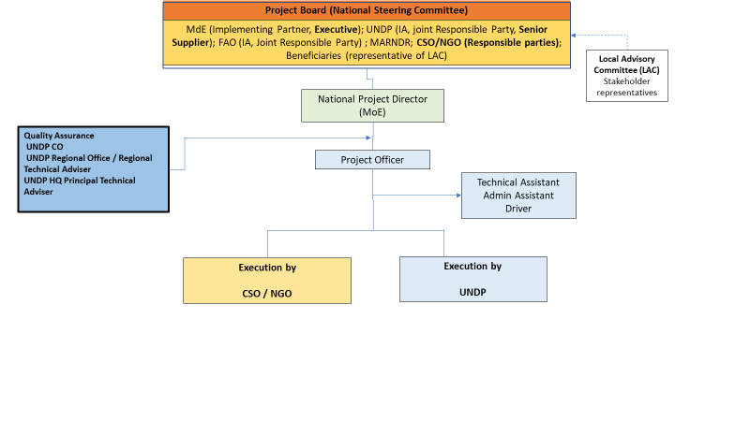
- The Implementing Partner for this project will be the Ministry of the Environment (MoE), which will appoint the chair of the Project Board and the National Project Director (see below). The Implementing Partner (IP) will be responsible and accountable for managing the project, including the monitoring and evaluation of project interventions, achieving project outcomes, and the effective use of GEF resources.
- The project will be governed by a National Steering Committee, known as the Project Board. The Board shall be composed of the Minister of Environment or his/her representative, in the role of Executive; and UNDP, in its role as joint Implementing Agency and joint Responsible Party, as Senior Supplier. Other core members will include FAO, as secondary Implementing Agency and Responsible Party; the Ministry of Agriculture; and representatives of CSO/NGOs, private sector and beneficiaries. The Project Board will approve the annual work plan, the budget structure and the reports on project advances. It will meet annually.
- The Project Board (also called Project Steering Committee) is responsible for making by consensus, management decisions when guidance is required by the Project Officer , including recommendations for UNDP/Implementing Partner approval of project plans and revisions, and addressing any project level grievances. In order to ensure UNDP’s ultimate accountability, Project Board decisions should be made in accordance with standards that shall ensure management for development results, best value money, fairness, integrity, transparency and effective international competition. In case a consensus cannot be reached within the Board, final decision shall rest with the UNDP Programme Manager.
- Terms of reference shall frame the Committee’ functions and ensure that its focus remains on issues directly associated with the Project.
- The Project Board (also called Project Steering Committee) will be the project coordination and decision-making body, responsible for making executive decisions for the project, in particular when guidance is required by the PO. It will meet annually and may be convened extraordinarily by the Chair, on the request of individual members. The responsibility of the Board is to see that project activities lead to the required outcomes as defined in the Project Document. It will play a critical role in facilitating inter-ministerial coordination, project monitoring and evaluations by quality assuring these processes and products, and using evaluations for performance improvement, accountability and learning. The Board will oversee project implementation, approve work plans and budgets as supplied by the Project Officer , approve any major changes in project plans, approve major project deliverables, arbitrate any conflicts which might arise, and be responsible for the overall evaluation of the project. In order to ensure UNDP’s ultimate accountability, Project Board decisions will be made in accordance with standards that shall ensure management for development results, best value money, fairness, integrity, transparency and effective international competition. In case a consensus cannot be reached within the Board, final decision shall rest with the UNDP Programme Manager.
- The Project Board will be comprised as follows (the make-up and TORs of the Board will be finalized in the Project Inception Workshop):
- The Executive, who will chair the Board. This role will be filled by a representative of MoE.
- A representative of the Senior Supplier, who will provide guidance regarding the technical feasibility of the project. This role will be filled by UNDP.
- FAO, as joint Implementing Agency and joint Responsible Party.
- CSO/NGOs, as Responsible Party
- The Project Officer, who will have voice but without voting rights.
- Senior Beneficiary: a representative of the Local Advisory Committee (see below) who will also participate with voice but without voting rights.
- The project will be under the overall leadership of a National Project Director (NPD), who will be a representative of MoE and will be responsible for orienting and advising the Project Officeroon Government policy and priorities. The NPD will also be responsible for maintaining regular communication with the lead institutions in the agriculture and livestock sectors and ensuring that their interests are communicated effectively to the Project Officer (PO). The National Project Director will be represented on the Project Board, as Secretary.
- The project will be executed in practice, on behalf of the Implementing Partner within the constraints laid down by the Board, by a Project Management Unit (PMU).
- The PMU will be led by a Project Officer (PO), who will be hired through a competitive process and will coordinate directly with the National Director. The PO function will end when the final project terminal evaluation report and corresponding management response, and other documentation required by the GEF and UNDP, have been completed and submitted to UNDP (including operational closure of the project).
- The PO will be responsible for the implementation of the project, providing technical expertise, reviewing and preparing TOR’s and reviewing the outputs of consultants and other sub-contractors. The PO will:
- Ensure the logistical, administrative and financial effectiveness of the IP in fulfilling its roles set out above
- To this end, provide monitoring, supervision and guidance to the technical teams based in the project area
- Promote incidence in and coordination with MoE, UNDP, FAO and the donor agencies that are supporting them.
- In addition, the PO will manage the following:
- preparation of project reports, work plans, budgets and accounting records,
- drafting of TORs, technical specifications and other documents,
- identification of consultants and supervision of consultants and suppliers,
- overseeing the implementation of project activities in a timely and efficient way,
- maintaining contacts with project partners at the national, state and local level,
- organization of seminars, workshops and field trips which are linked to project activities.
- The PO will produce in a timely fashion annual work plans and budgets to be approved by the Project Board and quarterly operational and annual progress reports for submission to the Board. The reports will provide details about the progress made, any shortcomings and the necessary adjustments made to achieve project outcomes. The PO will also be responsible for any national or international service provider and the recruitment of specialist services (with due consultation with the Board).
Governance role for project target groups:
- The project will make concrete provisions to ensure that target groups are engaged in decision making for the project. The stakeholders of the project at local level will include all of the inhabitants of the target area whose livelihood support and productive actions have implications for the condition of the targeted global environmental values, those whose livelihoods might potentially be affected by the proposed conservation strategies, and those with the potential to participate in the conservation strategies (for example, through the adoption of BD-friendly production systems).
- Regional and Local Governments will play a particularly significant role as facilitators of the participation of different local stakeholder groups, and will be important partners of the project in this regard.
- In order to ensure that stakeholders’ interests are adequately considered in the strategic decisions of the project, a Local Advisory Committee (LAC) will be established in the project area, in which representatives of all main stakeholder groups will be invited to participate. The chair of the LAC will be a representative of one the three Departmental Governments covered by the project, on a rotating basis between the three Departments. In meetings of the Project Board, one representative of the LAC will participate to communicate the decisions and recommendations of the LAC. This representative will participate with voice but no vote: the representative will be nominated on each occasion by the members of the LAC through procedures to be defined by the LAC at the time of its first meeting (either by election or on a rotating basis). The Project Board will not be bound by the recommendations of the LAC, but will be obliged to give them reasonable consideration in its decisions.
Support Services
- At the request of the Government of Haiti, UNDP shall also provide Direct Project Services (DPS) specific to project inputs according to its policies and convenience. These services, and the costs thereof, are specified in the Letters of Agreement in Section IV Part XII. In accordance with GEF requirements, the costs of these services will be part of the executing entity’s Project Management Cost allocation identified in the project budget. UNDP and the Government of Haiti acknowledge and agree that these services are not mandatory and will only be provided in full accordance with UNDP policies on recovery of direct costs.
- Agreement on intellectual property rights and use of logo on the project’s deliverables and disclosure of information: In order to accord proper acknowledgement to the GEF for providing grant funding, the GEF logo will appear together with the UNDP logo on all promotional materials, other written materials like publications developed by the project, and project hardware. Any citation on publications regarding projects funded by the GEF will also accord proper acknowledgement to the GEF. Information will be disclosed in accordance with relevant policies notably the UNDP Disclosure Policy and the GEF policy on public involvement.

            - Relation between UNDP and FAO organizational structures

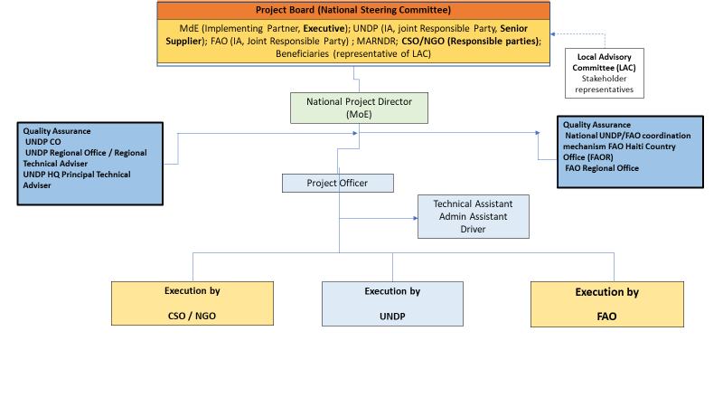

Financial Planning and Management

- The total cost of the project is USD 51,207,561. This is financed through a GEF grant of USD 3,500,000, USD 200,000 in cash co-financing to be administered by UNDP and USD 47,507,561 in parallel co-financing. UNDP, as the GEF Implementing Agency, will be responsible for the execution of the GEF resources and any cash co-financing transferred to UNDP bank account only.
- The actual realization of project co-financing will be monitored during the mid-term review and terminal evaluation process and will be reported to the GEF.
Table 18. Cofinancing description
F | Type | Amount | Planned Activities/Outputs
FAO | Cash | 1,821,572 | Amount | Activity
FAO | Cash | 1,821,572 | Component 1
FAO | Cash | 1,821,572 | 123,890 | TCP/HAI/3701: support to preparation of funding proposal for Green Climate Fund
FAO | Cash | 1,821,572 | 257,396 | TCP/HAI/3603: technical assistance to the institutionalization and application of Farmer Field School and Conservation Agriculture approaches in MARNDR
FAO | Cash | 1,821,572 | 604,739 | OSRO/RLA/801/EC: capacity building to increase food security and rought resilience
FAO | Cash | 1,821,572 | Component 2
FAO | Cash | 1,821,572 | 197,997 | TCP/SLC/3704: advancing disaster risk reduction measures
FAO | Cash | 1,821,572 | 276,630 | TCP/RLA/3606: strengthening technical and institutional capacities for sustainable use of natural resources, CCA and risk management
FAO | Cash | 1,821,572 | Component 3
FAO | Cash | 1,821,572 | 113,143 | TCP/HAI/3606: strengthening of MARNDR technical assistance services in Département du Sud
FAO | Cash | 1,821,572 | 197,997 | TCP/HAI/3605: Support to fruit sector in Grande Anse and Sud Departments
FAO | Cash | 1,821,572 | Project Management Costs
FAO | Cash | 1,821,572 | 49,780 | OSRO/RLA/801/EC: capacity building to increase food security and rought resilience
UNDP | Cash | 2,206,252 | 1,414,264 | NAP/GCF: National Adaptation Planning, with an implementation period between 2019 and 2023, aims to strengthen institutional and technical capacities for an effective integration of CCA into national and sub-national coordination, planning and budgeting process and will therefore contribute to knowledge management and learning.
UNDP | Cash | 2,206,252 | 678,847 | The SDG project aims at strengthening SDG achievement and advocacy in Haiti at local and national level.
UNDP | Cash | 2,206,252 | 113,141 | Support to project management
IDB | Cash | 43,479,737 |  | The PITAG project (Agricultural and Agroforestry Technological Innovation Program) will increase agricultural productivity for small farmers in selected areas of the North, Northeast and Artibonite departments, through applied research and training for the development and adaptation of sustainable agricultural technologies, and the Promotion of sustainable agricultural technologies.
Total: |  | 47,507,561

- Budget Revision and Tolerance: As per UNDP requirements outlined in the UNDP POPP, the Project Board will agree on a budget tolerance level for each plan under the overall annual work plan allowing the project O to expend up to the tolerance level beyond the approved project budget amount for the year without requiring a revision from the Project Board. Should the following deviations occur, the Project Officer and UNDP Country Office will seek the approval of the UNDP-GEF team as these are considered major amendments by the GEF: a) Budget re-allocations among components in the project with amounts involving 10% of the total project grant or more; b) Introduction of new budget items/or components that exceed 5% of original GEF allocation.
- Any over expenditure incurred beyond the available GEF grant amount will be absorbed by non-GEF resources (e.g. UNDP TRAC or cash co-financing).
- Refund to Donor: Should a refund of unspent funds to the GEF be necessary, this will be managed directly by the UNDP-GEF Unit in New York.
- Project Closure: Project closure will be conducted as per UNDP requirements outlined in the UNDP POPP. On an exceptional basis only, a no-cost extension beyond the initial duration of the project will be sought from in-country UNDP colleagues and then the UNDP-GEF Executive Coordinator.
- Operational completion: The project will be operationally completed when the last GEF-financed inputs have been provided and the related activities have been completed. This includes the final clearance of the Terminal Evaluation Report (that will be available in English) and the corresponding management response, and the end-of-project review Project Board meeting. The Implementing Partner through a Project Board decision will notify the UNDP Country Office when operational closure has been completed. At this time, the relevant parties will have already agreed and confirmed in writing on the arrangements for the disposal of any equipment that is still the property of UNDP.
- Transfer or disposal of assets: In consultation with the NIM Implementing Partner and other parties of the project, UNDP programme manager (UNDP Resident Representative) is responsible for deciding on the transfer or other disposal of assets. Transfer or disposal of assets is recommended to be reviewed and endorsed by the project board following UNDP rules and regulations. It is highly recommended that assets are transferred to the technical directorate that was in charge of the project technical implementation. Assets may be transferred to the government for project activities managed by a national institution at any time during the life of a project. In all cases of transfer, a transfer document must be prepared and kept on file.
- Financial completion: The project will be financially closed when the following conditions have been met: a) The project is operationally completed or has been cancelled; b) The Implementing Partner has reported all financial transactions to UNDP; c) UNDP has closed the accounts for the project; d) UNDP and the Implementing Partner have certified a final Combined Delivery Report (which serves as final budget revision).
- The project will be financially completed within 12 months of operational closure or after the date of cancellation. Between operational and financial closure, the implementing partner will identify and settle all financial obligations and prepare a final expenditure report. The UNDP Country Office will send the final signed closure documents including confirmation of final cumulative expenditure and unspent balance to the UNDP-GEF Unit for confirmation before the project will be financially closed in Atlas by the UNDP Country Office.

Total Budget and Workplan
Total Budget and Work Plan
Atlas Proposal or Award ID: | 00118747 | Atlas Primary Output Project ID: | 00115449
Atlas Proposal or Award Title: | Sustainable management of wooded production landscapes for biodiversity conservation
Atlas Business Unit: | HTI10
Atlas Primary Output Project Title: | Sustainable management of wooded production landscapes for biodiversity conservation
UNDP-GEF PIMS No.: | 5765
Implementing Partner: | Ministry of Environment
UNDP Budget
GEF Outcome/ Atlas Activity | Implementing Agent | Fund ID | Donor name |  | Atlas Code |  | ERP/ATLAS Budget Description/ Input |  |  | Year 1 | Year 2 |  | Year 3 | Year 4 | Year 5 | Total | Budget Notes (see table below)
 |  |  |  |  |  |  |  |  |  | US$ | US$ |  | US$ | US$ | US$ | US$ | Budget Notes (see table below)
COMPONENT/OUTCOME 1 | Ministry of Environment | 62000 | GEFTF |  | 71200 |  | International Consultants |  |  | 45,000 |  |  |  |  |  | 45,000 | 1
 |  |  |  |  | 71300 |  | Local Consultants |  |  | 43,200 |  |  | 12,000 |  |  | 55,200 | 2
Creation of enabling conditions for application and scaling-up of landscape management model | Ministry of Environment | 62000 |  |  | 71400 |  | Contractual Services - Individual |  |  | 48,000 | 48,000 |  | 48,000 | 48,000 | 48,000 | 240,000 | 3
 |  |  |  |  | 71600 |  | Travel |  |  | 20,000 | 20,000 |  | 20,000 | 20,000 | 20,000 | 100,000 | 4
 |  |  |  |  | 72100 |  | Contractual services - companies |  |  | 22,000 | 22,000 |  | 22,000 | 22,000 | 22,000 | 110,000 | 5
 |  |  |  |  | 72200 |  | Equipment and Furniture |  |  | 25,000 | 25,000 |  | 25,000 | 25,000 | 25,000 | 125,000 | 6
 |  |  |  |  | 72400 |  | Communic & Audio-Visual Equipment |  |  | 6,000 | 6,000 |  | 6,000 | 6,000 | 5,334 | 29,334 | 7
 |  |  |  |  | 72800 |  | Information Technology Equipment |  |  | 10,000 | 10,000 |  | 9000 | 5000 | 5000 | 39,000 | 8
 |  |  |  |  | 73100 |  | Rental and Maintenance - Premises |  |  | 7,000 | 7,000 |  | 7,000 | 7,000 | 7,000 | 35,000 | 9
 |  |  |  |  | 73400 |  | Rental and Maintenance – other equipment |  |  | 7,500 | 7,500 |  | 7,500 | 7,500 | 7,500 | 37,500 | 10
 |  |  |  |  | 74200 |  | Audio Visual&Print Prod Costs |  |  | 6,000 | 6,000 |  | 6,000 | 6,000 | 6,000 | 30,000 | 11
 |  |  |  |  | 74500 |  | Miscellaneous Expenses |  |  | 2,000 | 2,000 |  | 2,000 | 2,000 | 2,000 | 10,000 | 12
 |  |  |  |  | 75700 |  | Training |  |  | 84,000 | 84,000 |  | 84,000 | 84,000 | 84,000 | 420,000 | 13
 | Ministry of Environment | Subtotal Outcome 1 |  |  |  |  |  |  |  | 325,700 |  | 237,500 | 248,500 | 232,500 | 231,834 | 1,276,034
COMPONENT/OUTCOME 2 | Ministry of Environment | 62000 | GEFTF |  | 71400 |  | Contractual Services - Individ |  |  | 50,000 | 50,000 |  | 50,000 | 50,000 | 50,000 | 250,000 | 14
Conservation compatible tree-based production systems as part of sustainable landscape mosaics | Ministry of Environment | 62000 |  |  | 71600 |  | Travel |  |  | 10,000 | 15,000 |  | 15,000 | 15,000 | 15,000 | 70,000 | 15
 |  |  |  |  | 72100 |  | Contractual services - companies |  |  | 15,000 | 15,000 |  | 15,000 | 15,000 | 15,000 | 75,000 | 16
 |  |  |  |  | 72200 |  | Equipment and Furniture |  |  | 19,000 | 19,000 |  | 19,000 | 19,000 | 19,000 | 95,000 | 17
 |  |  |  |  | 72400 |  | Communic & Audio-Visual Equipment |  |  | 5,000 | 5,000 |  | 5,000 | 5,000 | 5,000 | 25,000 | 18
 |  |  |  |  | 72800 |  | Information Technology Equipment |  |  | 4,000 | 3,000 |  | 3,000 | 3,000 | 3,000 | 16,000 | 19
 |  |  |  |  | 73100 |  | Rental and Maintenance - Premises |  |  | 10,000 | 10,000 |  | 10,000 | 10,000 | 10,000 | 50,000 | 20
 |  |  |  |  | 73400 |  | Rental and Maintenance – other equipment |  |  | 10,000 | 10,000 |  | 10,000 | 10,000 | 10,000 | 50,000 | 21
 |  |  |  |  | 74500 |  | Miscellaneous Expenses |  |  | 3,000 | 3,000 |  | 3,000 | 3,000 | 3,000 | 15,000 | 22
 |  |  |  |  | 75700 |  | Training |  |  | 13,800 | 22,000 |  | 25,000 | 25,000 | 16,000 | 101,800 | 23
 | Ministry of Environment | Subtotal Outcome 2 |  |  |  |  |  |  |  | 139,800 | 152,000 |  | 155,000 | 155,000 | 146,000 | 747,800
COMPONENT/OUTCOME 3 | Ministry of Environment | 62000 | GEFTF |  | 71200 |  | International Consultants |  |  | 10,000 | 20,000 |  | 35,000 | 30,000 | 25,000 | 120,000 | 24
Knowledge management and learning | Ministry of Environment | 62000 |  |  | 71300 |  | Local Consultants |  |  | 30,000 | 5,000 |  | 48,000 | 6,000 | 48,000 | 137,000 | 25
 |  |  |  |  | 71400 |  | Contractual Services - Individ |  |  | 48,840 | 48,840 |  | 48,840 | 48,840 | 48,840 | 244,200 | 26
 |  |  |  |  | 71600 |  | Travel |  |  | 9,000 | 15,000 |  | 20,000 | 20,350 | 20,000 | 84,350 | 27
 |  |  |  |  | 72100 |  | Contractual services - companies |  |  | 8,500 | 8,500 |  | 8,500 | 8,500 | 8,500 | 42,500 | 28
 |  |  |  |  | 72200 |  | Equipment and Furniture |  |  | 71,000 | 71,000 |  | 71,000 | 71,000 | 71,000 | 355,000 | 29
 |  |  |  |  | 72400 |  | Communic & Audio-Visual Equipment |  |  | 9,500 | 6,000 |  | 6,000 | 6,000 | 6,000 | 33,500 | 30
 |  |  |  |  | 72800 |  | Information Technology Equipment |  |  | 15,000 | 5,000 |  | 5,000 | 5,000 | 5,000 | 35,000 | 31
 |  |  |  |  | 73100 |  | Rental and Maintenance - Premises |  |  | 20,000 | 20,000 |  | 20,000 | 20,000 | 20,000 | 100,000 | 32
 |  |  |  |  | 73400 |  | Rental and Maintenance – other equipment |  |  | 10,000 | 10,000 |  | 10,000 | 10,000 | 10,000 | 50,000 | 33
 |  |  |  |  | 74200 |  | Audio Visual&Print Prod Costs |  |  | 4,000 | 3,000 |  | 10,000 | 7,000 | 10,000 | 34,000 | 34
 |  |  |  |  | 75700 |  | Training, workshops and Confer |  |  | 12,000 | 12,500 |  | 12,500 | 12,000 | 12,000 | 61,000 | 35
 |  |  |  |  | 74500 |  | Miscellaneous Expenses |  |  | 3,000 | 3,067 |  | 3,000 | 3,000 | 3,000 | 15,067 | 36
Knowledge management and learning | Ministry of Environment | Subtotal Outcome 3 |  |  |  |  |  |  |  | 250,840 | 227,907 |  | 297,840 | 247,690 | 287,340 | 1,311,617
Project Management Costs | UNDP | 62000 | GEFTF |  | 74596 |  | Services to projects GOE for CO |  |  | 9,910 | 9,910 |  | 9,910 | 9,910 | 9,909 | 49,549 | 37
 |  |  |  |  | 71400 |  | Contractual Services-Individual |  |  | 18,000 | 18,000 |  | 18,000 | 18,000 | 18,000 | 90,000 | 38
 |  |  |  |  | 74100 |  | Audit |  |  | 0 | 0 |  | 0 | 0 | 25,000 | 25,000 | 39
Project Management Costs | UNDP | Subtotal PMC |  |  |  |  |  |  |  | 27,910 | 27,910 |  | 27,910 | 27,910 | 52,909 | 164,549
Cofinancing | UNDP | 04000 | UNDP |  | 75700 |  | Training, workshops and Confer |  |  |  | 5,000 |  | 5,000 | 5,000 | 5,000 | 20,000 | 40
 |  |  |  |  | 71400 |  | Contractual Services - Individual |  |  | 36,000 | 36,000 |  | 36,000 | 36,000 | 36,000 | 180,000 | 41
Cofinancing | UNDP |  |  |  |  |  |  |  | Subtotal TRAC | 36,000 | 41,000 |  | 41,000 | 41,000 | 41,000 | 200,000
 | UNDP | Total Mangement |  |  |  |  |  |  |  | 63,910 | 68,910 |  | 68,910 | 68,910 | 93,909 | 364,549
 |  | Project Total (GEF) |  |  |  |  |  |  |  | 744,250 | 645,317 |  | 729,250 | 663,100 | 718,083 | 3,500,000
 |  | Project Total (including TRAC) |  |  |  |  |  |  |  | 780,250 | 686,317 |  | 770,250 | 704,100 | 759,083 | 3,700,000

UNDP Budget Notes

Budget note # | Amount (USD) | Budget code | Explanation
COMPONENT/OUTCOME 1: Creation of enabling conditions for application and scaling-up of landscape management model

1 | 45,000 | 71200 International Consultants | USD24,000: International consultant to analyse the factors that affect the conservation status of target species, provide orientation on priorities for biological connectivity, and recommend management strategies for the promotion of connectivity (in support of Output 1.1: Decision making tools to optimize the configuration of landscape elements). 40 days @ USD600.
1 | 45,000 | 71200 International Consultants | USD21,000: International consultant for the generation of technical recommendations for the formulation environmental monitorong and information management systems, and for these to support adaptive management mechanisms (in support of Output 1.1: Decision making tools to optimize the configuration of landscape elements). 35 days @ USD600.
2 | 55,200 | 71300 Local Consultants | USD14,400: National consultant for the analysis of capacities in Departmental Governments and territorial collectivities, and the formulation of a strategy and plan for capacity development (in support of Output 1.1: Decision making tools to optimize the configuration of landscape elements). 24 days @ USD600.
2 | 55,200 | 71300 Local Consultants | USD14,400: National consultant to analyse the capacities of cooperatives for monitoring and traceability (in support of Output 1.1: Decision making tools to optimize the configuration of landscape elements). 24 days @ USD600
2 | 55,200 | 71300 Local Consultants | USD14,400: National consultant: updated review of Government provisions for supporting sustainable production (in support of Output 1.3: Market-based instruments for safeguarding biodiversity) 24 days @ USD600
2 | 55,200 | 71300 Local Consultants | - USD12,000: National consultant: formulation of policy documents (in support of Output 1.3: Market-based instruments for safeguarding biodiversity) 20 days @ USD600
3 | 240,000 | 71400 Contractual services - individual | USD 90,000: Salary of Governance, capacity strengthening and policy specialist (5 person/years @ USD18,000) to oversee the Component 1 (in support of Outputs 1.1 Decision making tools to optimize the configuration of landscape elements, 1.2 Socially- and institutionally sustainable mechanisms for governance and 1.3 Market-based instruments for safeguarding biodiversity)
3 | 240,000 | 71400 Contractual services - individual | USD90,000: Salary of value chain specialist (5 person/years @ USD18,000) to oversee all value chain-related activities under UNDP responsibility (in support of Output 1.3 Market-based instruments for safeguarding biodiversity)
3 | 240,000 | 71400 Contractual services - individual | USD 60,000 : Salary of the Administrative and Finacial Assistant of the NGO/CSO (5 person/years @ USD12,000)
4 | 100,000 | 71600 Travel | USD 30,000: Travel costs (tickets and DSA) for national consultants (see note 2) contributing to Output 1.1: Decision making tools to optimize the configuration of landscape elements
4 | 100,000 | 71600 Travel | USD 40,000: Travel costs (tickets and DSA) for international consultants (see note 1) contributing to Output 1.1: Decision making tools to optimize the configuration of landscape elements
4 | 100,000 | 71600 Travel | USD 30,000 : Travels costs (tickets and DSA) for NGO/CSO staff for supervision and monitoring activities
5 | 110,000 | 72100 Contractual services - companies | USD 50,000: GIS analyses of the dynamics and spatial configurations of the factors that affect landscapes, environmental services and environmental values (in support of Output 1.1: Decision making tools to optimize the configuration of landscape elements)
5 | 110,000 | 72100 Contractual services - companies | USD 50,000: GIS analyses to inform the formulation/updating of spatial and economic plans (in support of Output 1.1: Decision making tools to optimize the configuration of landscape elements)
5 | 110,000 | 72100 Contractual services - companies | USD 10,000: Costs of office security (total USD 2,000 over 5 years)
6 | 125,000 | 72200 Equipment and furniture | USD 42,000: Equipment for environmental monitoring and information management (in support of Output 1.1: Decision making tools to optimize the configuration of landscape elements)
6 | 125,000 | 72200 Equipment and furniture | USD 11,200: office equipment in support of Outputs 1.1 Decision making tools to optimize the configuration of landscape elements and 1.2 Socially- and institutionally sustainable mechanisms for governance)
6 | 125,000 | 72200 Equipment and furniture | USD 36,800: Costs of stationery, Office materials and other Equipment (NGO/CSO)
6 | 125,000 | 72200 Equipment and furniture | USD 10,000: Costs of GPS (total 25 @ USD400)
6 | 125,000 | 72200 Equipment and furniture | USD 25,000: costs of motorcycles (total 5 @ USD5,000 = USD25,000)
7 | 29,334 | 72400 Communic & Audio-Visual Equipment | USD 29,334: Costs of communication equipment (Over 5 yeras)
8 | 39,000 | 72800 Information Technology Equipment | USD 20,000: costs of portable computers and supplies (Over 5 years)
8 | 39,000 | 72800 Information Technology Equipment | USD19,000: Specialized Software (Arc Gis, Remote Sensors) (in support of Output 1.1 Decision making tools to optimize the configuration of landscape elements)
9 | 35,000 | 73100 Rental and Maintenance - Premises | USD35,000: Costs of office rental and maintenance for NGO/CSO (USD7,000 over 5 years)
10 | 37,500 | 73400 Rental and Maintenance – other equipment | USD 37,500: Costs of rental and maintenance of cars, motorcycles and others materials (total USD7,500 over 5 years)
11 | 30,000 | 74200 Audio Visual&Print Prod Costs | USD 12,000: Publication of synthesis documents on the planning framework generated under Output 1.1 (Decision making tools to optimize the configuration of landscape elements)
11 | 30,000 | 74200 Audio Visual&Print Prod Costs | USD 18,000: Communication of results under Output 1.3 (market-based instruments for safeguarding biodiversity)
12 | 10,000 | 74500 Miscellaneous | USD 10,000: Miscellaneous costs including contingencies and other expenses
13 | 420,000 | 75700 Training | USD54,000: 10 workshops for the joint intersector formulation of the harmonized planning framework (Output 1.1: Decision making tools to optimize the configuration of landscape elements)
13 | 420,000 | 75700 Training | USD45,000: 8 workshops for the dissemination of the planning framework (Output 1.1: Decision making tools to optimize the configuration of landscape elements)
13 | 420,000 | 75700 Training | USD68,000: 16 training events for staff and technicians of Departmental Governments and territorial collectivities on the generation of environmental benefits in the production systems/landscapes (Output 1.1: Decision making tools to optimize the configuration of landscape elements)
13 | 420,000 | 75700 Training | USD68,000: 16 workshops for the formulation/updating of the plans (Output 1.1: Decision making tools to optimize the configuration of landscape elements)
13 | 420,000 | 75700 Training | USD56,000: 12 training events for of staff/technicians of Departmental Governments/territorial collectivities on the introduction and application of systems for environmental monitoring and information management (Output 1.1: Decision making tools to optimize the configuration of landscape elements)
13 | 420,000 | 75700 Training | USD43,000: 10 training events for members of cooperatives/federations on systems for monitoring, record keeping and traceability (Output 1.1: Decision making tools to optimize the configuration of landscape elements)
13 | 420,000 | 75700 Training | USD43,000: 10 community workshops for participatory analysis, training and participatory training/strengthening of community governance mechanisms (Output 1.2: Socially- and institutionally sustainable mechanisms for governance)
13 | 420,000 | 75700 Training | USD43,000: 10 community workshops for participatory analysis and training of members of community organisations (Output 1.2: Socially- and institutionally sustainable mechanisms for governance)
COMPONENT/OUTCOME 2: Conservation compatible tree-based production systems as part of sustainable landscape mosaics
14 | 250,000 | 71400 Contractual services - individual | USD 96,000: Field technician (community governance) (2 people for 5 years @ USD 9,600) for field level community governance activities in support of Output 1.2 (Socially- and institutionally sustainable mechanisms for governance)
14 | 250,000 | 71400 Contractual services - individual | USD 94,000: Field technician (value chains) (2 people for 5 years @ USD 9,400,000) for field level work on development of value chains and related capacities in support of Output 1.2 (market-based instruments for safeguarding biodiversity)
14 | 250,000 | 71400 Contractual services - individual | USD 60,000 : Salary of the Administrative / Financial Assistant of the NGO/CSO (5 person/years @ USD12,000)
15 | 70,000 | 71600 Travel | USD 35,000: Travel costs (tickets and DSA) for Value Chain Specialist, Governance Specialist, Administrative Asssistant
15 | 70,000 | 71600 Travel | USD 35,000: Travel costs for Supervision and Monitoring activities by NGO/CSO (Mitigation Plan) (Over 5 years)
16 | 75,000 | 72100 Contractual services - companies | USD35,000: Costs of office security (over 5 years)  USD40,000: Costs of communication services company
17 | 95,000 | 72200 Equipment and furniture | USD 30,000: costs of stationery, Office materials and other equipments (Over 5 years)
17 | 95,000 | 72200 Equipment and furniture | USD 10,000:costs of tables and chairs
17 | 95,000 | 72200 Equipment and furniture | USD 5,000: Costs for training materials
17 | 95,000 | 72200 Equipment and furniture | USD 20,000: Costs of vehicle maintenance and Fuel (over 5 years)
17 | 95,000 | 72200 Equipment and furniture | USD 30,000: Costs of generator, inverter, batteries, solar panel and electrical installations
18 | 25,000 | 72400 Communic & Audio-Visual Equipment | USD 25,000: Costs of communication equipment
19 | 16,000 | 72800 Information Technology Equipment | USD16,000: Costs of portable computers and supplies (Over 5 years)
20 | 50,000 | 73100 Rental and Maintenance - Premises | USD 50,000: Costs of office rental and maintenance (over 5 years)
21 | 50,000 | 73400 Rental and Maintenance – other equipment | USD 50,000: Costs of rental and maintenance of cars, motorcycles and other materials (over 5 years)
22 | 15,000 | 74500 Miscellaneous | USD 15,000: Miscellaneous costs including contingencies and other expenses (over 5 years)
23 | 101,800 | 75700 Training | USD36,000: Awareness raising materials and meetings/events (8) with finance institutions (in support of Output 2.2 Financing mechanisms for tree-based production systems)
23 | 101,800 | 75700 Training | USD36,000: Facilitation of strategic planning by finance institutions to make provision for including credit packages for businesses based on tree-based production systems (in support of Output 2.2 Financing mechanisms for tree-based production systems)
23 | 101,800 | 75700 Training | USD29,800: Facilitation of discussions between finance institutions and potential beneficiaries (in support of Output 2.2 Financing mechanisms for tree-based production systems)
COMPONENT/OUTCOME 3: Knowledge management and learning
24 | 120,000 | 71200 International Consultants | USD 24,000: International Consultant for ESMF Development (40 days @ 600 USD)
24 | 120,000 | 71200 International Consultants | USD 48,000: Development of value chain strengthening strategies and establishment of an exchange platform between producers and buyers ( 80 days @ 600) (Over 3 years)  USD 48,000: International consultant to conduct mid-term and final evaluations
25 | 137,000 | 71300 Local Consultants | USD 35,000 : Local consultant for the ESMF Development ( 70 days @ USD 500)
25 | 137,000 | 71300 Local Consultants | USD 30,000: National consultant for formulation of knowledge management and dissemination/scaling up strategy (60 days @ USD 500)
25 | 137,000 | 71300 Local Consultants | USD 30,000: Budget for national consultants to conduct midterm and final evaluation ( 30 days x2 @ USD 500)  USD 12,000 : Budget for translation of the mid-term and final evaluation document
25 | 137,000 | 71300 Local Consultants | USD 30,000: Formulation of communication and dissemination strategy (Output 3.2): (60 days @ USD500 )
26 | 244,200 | 71400 Contractual Services - Individ | USD 98,400: Salary of the Administrative assistant (total 5 person/years @ USD19,680 per year
26 | 244,200 | 71400 Contractual Services - Individ | USD 55,800: Salary of the driver (total 5 person/years @ USD11,160 per year)
26 | 244,200 | 71400 Contractual Services - Individ | USD 90,000: 50% of total Salary of Technical Assistant to provide technical support to the Project Officer (total 5 person/years @ USD36,000 per year); the remaining budget is covered under DPC
27 | 84,350 | 71600 Travel | USD 29,000: Travel costs (tickets and DSA) for the Project Officer
27 | 84,350 | 71600 Travel | USD 29,000: Travel costs (tickets and DSA) for the Driver
27 | 84,350 | 71600 Travel | USD 8,000: Travel costs (tickets and DSA) for Administrative Assistant
27 | 84,350 | 71600 Travel | USD 18,350: Travel costs for Monitoring activities (Mitigation Plan)
28 | 42,500 | 72100 Contractual services - companies | USD42,500: Costs of office security (over 5 years)
29 | 355,000 | 72200 Equipment and Furniture | USD 50,000: Costs of stationery and Office materials (Over 5 years)
29 | 355,000 | 72200 Equipment and Furniture | USD 90,000: Costs of 4X4 cars (total 2@USD 45,000) needed to enable technical and coordination staff to reach widely dispersed project locations for technical oversight and coordination work
29 | 355,000 | 72200 Equipment and Furniture | USD 25,000: Costs of tables and chairs (Over 5 years)
29 | 355,000 | 72200 Equipment and Furniture | USD 80 000: Costs of vehicle maintenance ( over 5 years)
29 | 355,000 | 72200 Equipment and Furniture | USD 110,000: Costs of generator, inverter, batteries, solar panel and electrical installations
30 | 33,500 | 72400 Communic & Audio-Visual Equipment | USD 33,500: Costs of communication equipment (Over 5 years)
31 | 35,000 | 72800 Information Technology Equipment | USD 35,000: Costs of portable computers and supplies for project staff (Over 5 years)
32 | 100,000 | 73100 Rental and Maintenance - Premises | USD 100,000: Costs of office rental and maintenance (over 5 years)
33 | 50,000 | 73400 Rental and Maintenance – other equipment | USD 50,000: Costs of rental and maintenance of cars and others materials (Over 5 years)
34 | 34,000 | 74200 Audio Visual&Print Prod Costs | USD20,000: Publishing services in support of Output 3.2 (Communication strategy)
34 | 34,000 | 74200 Audio Visual&Print Prod Costs | USD 14,000: Final report in support of Output 3.3 (Monitoring and evaluation strategy)
35 | 61,000 | 75700 Training | USD 22,000: 8 Worshops for study presentation and validation
35 | 61,000 | 75700 Training | USD 9,000: Inception workshop
35 | 61,000 | 75700 Training | USD 20,000: Trainings and workshops related Development of value chain strengthening strategies and establishment of an exchange platform between producers and buyers
35 | 61,000 | 75700 Training | USD 10,000: Workshops related ESMF development
36 | 15,067 | 74500 Miscellaneous Expenses | USD 15,067: Miscellaneous costs including contingencies and other expenses (over 5 years)
Project Management Costs
37 | 49,549 | 74596 Services to projects GOE for CO | USD 49,549: Budget for Direct Project Costs are estimated for direct project services planned to be carried out by UNDP, such as: recruitment of project personnel, procurement of goods and services, processing travel, payments, logistic support to workshops.
38 | 90,000 | 71400 Contractual Services Individual | USD 90,000 : 50% of total Salary of technical Assistant to provide technical support to the Project Officer (total 5 person/years @ USD36,000 per year); the remaining budget is covered OUTCOME3
39 | 25,000 | 74100 Audit | USD25,000: Budget for the Audit services
40 | 20,000 | 75700 Workshop, Training and Conf | USD 20,000 : 5 Workshops on SDG implementation and Biodiversity
41 | 180,000 | 71400 Contractual Services - Individual | USD 180,000: total Salary of the Project Officer (total 5 person/years @ USD36,000 per year)

Summary of funds
Source | Year 1 | Year 2 | Year 3 | Year 4 | Year 5 | Amount ($)
GEF | 744,250 | 645,317 | 729,250 | 663,100 | 718,083 | 3,500,000
TRAC | 36,000 | 41,000 | 41,000 | 41,000 | 41,000 | 200,000
Interamerican Development Bank | 8,695,947 | 8,695,947 | 8,695,947 | 8,695,948 | 8,695,948 | 43,479,737
United Nations Development Programme | 441,250 | 441,250 | 441,250 | 441,251 | 441,251 | 2,206,252
Food and Agriculture Organization | 364,314 | 364,314 | 364,314 | 364,315 | 364,315 | 1,821,572
Total | 10,281,761 | 10,187,828 | 10,271,761 | 10,205,614 | 10,260,597 | 51,207,561

Breakdown by budget code (UNDP)

ERP/ATLAS Budget Description/ Input | Atlas Code | Year 1 | Year 2 | Year 3 | Year 4 | Year 5 | Totals
International Consultants | 71200 | 73,000 | 38,000 | 53,000 | 48,000 | 43,000 | 255,000
Local Consultants | 71300 | 73,200 | 5,000 | 60,000 | 6,000 | 48,000 | 192,200
Contractual Services - Individual | 71400 | 182,840 | 182,840 | 182,840 | 182,840 | 182,840 | 914,200
Travel | 71600 | 39,000 | 50,000 | 55,000 | 55,350 | 55,000 | 254,350
Contractual services - companies | 72100 | 45,500 | 45,500 | 45,500 | 45,500 | 45,500 | 227,500
Equipment and Furniture | 72200 | 115,000 | 115,000 | 115,000 | 115,000 | 115,000 | 575,000
Communic & Audio-Visual Equipment | 72400 | 20,500 | 17,000 | 17,000 | 17,000 | 16,334 | 87,834
Information Technology Equipment | 72800 | 29,000 | 18,000 | 17,000 | 13,000 | 13,000 | 90,000
Rental and Maintenance - Premises | 73100 | 37,000 | 37,000 | 37,000 | 37,000 | 37,000 | 185,000
Rental and Maintenance – other equiment | 73400 | 27,500 | 27,500 | 27,500 | 27,500 | 27,500 | 137,500
Audio Visual&Print Prod Costs | 74200 | 10,000 | 9,000 | 16,000 | 13,000 | 16,000 | 64,000
Miscellaneous Expenses | 74500 | 8,000 | 8,067 | 8,000 | 8,000 | 8,000 | 40,067
Services to projects GOE for CO | 74596 | 9,910 | 9,910 | 9,910 | 9,910 | 9,909 | 49,549
Training | 75700 | 109,800 | 123,500 | 126,500 | 126,000 | 117,000 | 602,800
Audit | 74100 | 0 | 0 | 0 | 0 | 25,000 | 25,000
Total |  | 780,250 | 686,317 | 770,250 | 704,100 | 759,083 | 3,700,000

Legal Context

- This project document shall be the instrument referred to as such in Article 1 of the Standard Basic Assistance Agreement between the Government of Haiti and UNDP, signed on June 28, 1973. All references in the SBAA to “Executing Agency” shall be deemed to refer to “Implementing Partner.”

- This project will be implemented by Ministry of Environment (“Implementing Partner”) in accordance with its financial regulations, rules, practices and procedures only to the extent that they do not contravene the principles of the Financial Regulations and Rules of UNDP. Where the financial governance of an Implementing Partner does not provide the required guidance to ensure best value for money, fairness, integrity, transparency, and effective international competition, the financial governance of UNDP shall apply.

- Any designations on maps or other references employed in this project document do not imply the expression of any opinion whatsoever on the part of UNDP concerning the legal status of any country, territory, city or area or its authorities, or concerning the delimitation of its frontiers or boundaries

RISK MANAGEMENT
- Consistent with the Article III of the SBAA [or the Supplemental Provisions to the Project Document], the responsibility for the safety and security of the Implementing Partner and its personnel and property, and of UNDP’s property in the Implementing Partner’s custody, rests with the Implementing Partner. To this end, the Implementing Partner shall:
- put in place an appropriate security plan and maintain the security plan, taking into account the security situation in the country where the project is being carried;
- assume all risks and liabilities related to the Implementing Partner’s security, and the full implementation of the security plan.
- UNDP reserves the right to verify whether such a plan is in place, and to suggest modifications to the plan when necessary. Failure to maintain and implement an appropriate security plan as required hereunder shall be deemed a breach of the Implementing Partner’s obligations under this Project Document.
- The Implementing Partner agrees to undertake all reasonable efforts to ensure that no UNDP funds received pursuant to the Project Document are used to provide support to individuals or entities associated with terrorism and that the recipients of any amounts provided by UNDP hereunder do not appear on the list maintained by the Security Council Committee established pursuant to resolution 1267 (1999). The list can be accessed via http://www.un.org/sc/committees/1267/aq_sanctions_list.shtml.
- Social and environmental sustainability will be enhanced through application of the UNDP Social and Environmental Standards (http://www.undp.org/ses) and related Accountability Mechanism (http://www.undp.org/secu-srm).
- The Implementing Partner shall: (a) conduct project and programme-related activities in a manner consistent with the UNDP Social and Environmental Standards, (b) implement any management or mitigation plan prepared for the project or programme to comply with such standards, and (c) engage in a constructive and timely manner to address any concerns and complaints raised through the Accountability Mechanism. UNDP will seek to ensure that communities and other project stakeholders are informed of and have access to the Accountability Mechanism.
- All signatories to the Project Document shall cooperate in good faith with any exercise to evaluate any programme or project-related commitments or compliance with the UNDP Social and Environmental Standards. This includes providing access to project sites, relevant personnel, information, and documentation.
- The Implementing Partner will take appropriate steps to prevent misuse of funds, fraud or corruption, by its officials, consultants, responsible parties, subcontractors and sub-recipients in implementing the project or using UNDP funds. The Implementing Partner will ensure that its financial management, anti-corruption and anti-fraud policies are in place and enforced for all funding received from or through UNDP.
- The requirements of the following documents, then in force at the time of signature of the Project Document, apply to the Implementing Partner: (a) UNDP Policy on Fraud and other Corrupt Practices and (b) UNDP Office of Audit and Investigations Investigation Guidelines. The Implementing Partner agrees to the requirements of the above documents, which are an integral part of this Project Document and are available online at www.undp.org.
- In the event that an investigation is required, UNDP has the obligation to conduct investigations relating to any aspect of UNDP projects and programmes. The Implementing Partner shall provide its full cooperation, including making available personnel, relevant documentation, and granting access to the Implementing Partner’s (and its consultants’, responsible parties’, subcontractors’ and sub-recipients’) premises, for such purposes at reasonable times and on reasonable conditions as may be required for the purpose of an investigation. Should there be a limitation in meeting this obligation, UNDP shall consult with the Implementing Partner to find a solution.
- The signatories to this Project Document will promptly inform one another in case of any incidence of inappropriate use of funds, or credible allegation of fraud or corruption with due confidentiality.
- Where the Implementing Partner becomes aware that a UNDP project or activity, in whole or in part, is the focus of investigation for alleged fraud/corruption, the Implementing Partner will inform the UNDP Resident Representative/Head of Office, who will promptly inform UNDP’s Office of Audit and Investigations (OAI). The Implementing Partner shall provide regular updates to the head of UNDP in the country and OAI of the status of, and actions relating to, such investigation.
- UNDP shall be entitled to a refund from the Implementing Partner of any funds provided that have been used inappropriately, including through fraud or corruption, or otherwise paid other than in accordance with the terms and conditions of the Project Document. Such amount may be deducted by UNDP from any payment due to the Implementing Partner under this or any other agreement.
- Where such funds have not been refunded to UNDP, the Implementing Partner agrees that donors to UNDP (including the Government) whose funding is the source, in whole or in part, of the funds for the activities under this Project Document, may seek recourse to the Implementing Partner for the recovery of any funds determined by UNDP to have been used inappropriately, including through fraud or corruption, or otherwise paid other than in accordance with the terms and conditions of the Project Document.
- Note: The term “Project Document” as used in this clause shall be deemed to include any relevant subsidiary agreement further to the Project Document, including those with responsible parties, subcontractors and sub-recipients.
- Each contract issued by the Implementing Partner in connection with this Project Document shall include a provision representing that no fees, gratuities, rebates, gifts, commissions or other payments, other than those shown in the proposal, have been given, received, or promised in connection with the selection process or in contract execution, and that the recipient of funds from the Implementing Partner shall cooperate with any and all investigations and post-payment audits.
- Should UNDP refer to the relevant national authorities for appropriate legal action any alleged wrongdoing relating to the project, the Government will ensure that the relevant national authorities shall actively investigate the same and take appropriate legal action against all individuals found to have participated in the wrongdoing, recover and return any recovered funds to UNDP.
- The Implementing Partner shall ensure that all of its obligations set forth under this section entitled “Risk Management” are passed on to each responsible party, subcontractor and sub-recipient and that all the clauses under this section entitled “Risk Management Standard Clauses” are included, mutatis mutandis, in all sub-contracts or sub-agreements entered into further to this Project Document.

Mandatory Annexes

Multi year Workplan

Outputs | Activities | Y1 |  |  |  | Y2 |  |  |  | Y3 |  |  |  | Y4 |  |  |  | Y5
Outputs | Activities | 1 | 2 | 3 | 4 | 1 | 2 | 3 | 4 | 1 | 2 | 3 | 4 | 1 | 2 | 3 | 4 | 1 | 2 | 3 | 4
Contracting of project team |  | X | X
Procurement of project field and office equipment |  | X | X
Formulation of procedural, strategic and conceptual guidance materials for project implementation |  | X | X
Output 1.1 Decision making tools to optimize the configuration of landscape elements in relation to spatial aspects of connectivity, biological importance, production potential, vulnerability and flows of ecosystem services
- Region-wide framework for harmonizing interventions | Studies and analyses to generate technical inputs for development of framework |  |  | X | X | X | X
- Region-wide framework for harmonizing interventions | Multi-stakeholder development of region-wide framework |  |  | X | X | X | X | X | X | X | X
- Social and economic development plans formulated and implemented by local governments that include provisions for the promotion of BD-friendly production systems | Introductory planning meetings with local Governments |  |  | X | X | X | X
 | Studies and analyses to generate technical inputs for development of planning instruments |  |  | X | X | X | X | X | X | X | X
 | Review of planning instruments and definition of needs for action |  |  | X | X | X | X | X | X | X | X
 | Capacity development for development and updating of planning instruments |  |  |  |  | X | X | X | X | X | X | X | X | X | X | X | X
- Systems for environmental monitoring and information management at landscape level | Review of existing monitoring systems |  |  | X | X | X | X | X | X
 | Development of strategies and plans for strengthening of systems and capacities |  |  |  |  | X | X | X | X | X | X | X | X | X | X | X | X
 | Training of local Government staff |  |  |  |  | X | X | X | X | X | X | X | X | X | X | X | X
 | Development of monitoring and information management protocols |  |  |  |  | X | X | X | X | X | X
 | Acquisition and installation of equipment |  |  |  |  |  |  | X | X | X | X | X | X | X | X
 | Ongoing follow-up, oversight and on-the-job training |  |  |  |  |  |  | X | X | X | X | X | X | X | X | X | X | X | X | X | X
- Consolidation of the capacities of producer cooperatives/federations for monitoring the compliance of their member producers with environmental management and traceability standards | Review of existing capacities and standards for compliance monitoring |  |  |  |  | X | X | X | X
 | Development of compliance monitoring protocols |  |  |  |  |  |  | X | X | X | X | X | X
 | Training of members of cooperatives, federations and producer groups on environmental management and traceability standards, and monitoring protocols |  |  |  |  | X | X | X | X | X | X | X | X | X | X | X | X
Output 1.2. Socially- and institutionally sustainable mechanisms for governance in support of tree-rich production systems
- Community-based mechanisms for countering threats to community interests in relation to natural resources | Participatory diagnostics of environmental threats and governance mechanisms |  |  |  |  | X | X | X | X
 | Participatory development of proposals for strengthening of governance mechanisms |  |  |  |  |  |  | X | X | X | X | X | X
 | Facilitation of strengthening of governance mechanisms, including training |  |  |  |  |  |  |  |  | X | X | X | X | X | X | X | X | X | X
 | Follow-up participatory reviews of effectiveness of governance mechanisms |  |  |  |  |  |  |  |  |  |  | X | X | X | X | X | X | X | X | X | X
- Community-based organisations strengthened to facilitate joint action in support of BD-friendly landscape and ecosystem management | Participatory review of willingness and opportunities for carrying out community-based actions |  |  |  |  | X | X | X | X
 | Participatory planning of community-based actions |  |  |  |  |  |  | X | X | X | X | X | X
 | Implementation of community-based actions (facilitation and follow-up) |  |  |  |  |  |  |  |  | X | X | X | X | X | X | X | X | X | X | X | X
Output 1.3 Market-based instruments to facilitate the delivery of environmental benefits
- Coherent framework for Government support to integrating producers into markets that favour sustainable production | Updated review of Government provisions for supporting sustainable production |  |  | X | X | X | X | X | X
 | Facilitation and technical support to the formulation or improvement of frameworks for Government support |  |  |  |  | X | X | X | X | X | X | X | X | X | X
 | Generation of policy documents |  |  |  |  |  |  | X | X | X | X | X | X | X | X | X | X
 | Communication of results |  |  |  |  |  |  |  |  |  |  | X | X | X | X | X | X | X | X | X | X
- Branding based on socio-cultural-environmental factors | Market preference surveys in local and export markets |  |  |  |  | X | X | X | X | X | X | X | X
- Branding based on socio-cultural-environmental factors | Advisory support for definition of product characteristics on which to base branding |  |  |  |  |  |  | X | X | X | X | X | X | X | X
- Branding based on socio-cultural-environmental factors | Development of marketing materials |  |  |  |  |  |  |  |  | X | X | X | X | X | X | X | X
- Local and national value chains | Market surveys and analyses |  |  |  |  | X | X | X | X | X | X | X | X
- Local and national value chains | Promotional meetings with value chain actors and marketing fairs |  |  |  |  |  |  | X | X | X | X | X | X | X | X | X | X | X | X | X | X
- Local and national value chains | Facilitation of contact and negotiations between producer organisations and private sector processors, retailers and exporters regarding supply agreements and contracts, and environmental and quality standards |  |  |  |  |  |  | X | X | X | X | X | X | X | X | X | X | X | X
- Local and national value chains | Feasibility studies of PGS systems |  |  |  |  | X | X | X | X
- Local and national value chains | Facilitation of establishment of PGS systems |  |  |  |  |  |  | X | X | X | X | X | X | X | X | X | X
- Increased involvement of chambers of commerce in support of sustainable production systems | Information events with chambers of commerce regarding supply and value chain options related to sustainable tree-based production systems, and facilitation of exchanges with producers |  |  |  |  | X | X | X | X | X | X | X | X | X | X | X | X
Output 2.1 Improved service delivery systems for technical assistance
2.1.1 Mechanisms for the generation and transfer of knowledge on the application of tree-based systems generating multiple environmental benefits | Community-level participatory situation analyses and mapping, resulting in the prioritisation and spatial zoning of production systems to be supported by technical assistance |  |  | X | X | X | X | X | X
 | Support to farmers in prioritising productive options and preparing proposals for support by partner projects |  |  |  |  | X | X | X | X | X | X
 | Training of service providers in technical aspects of sustainable tree-based production systems and businesses |  |  |  |  | X | X | X | X | X | X
 | Establishment and facilitation of Farmer Field Schools for producers supported directly with GEF resources |  |  |  |  |  |  | X | X | X | X | X | X | X | X | X | X | X | X
2.1.2 Technical guidelines and extension materials on the management of tree-based production systems. | Formulation and production of technical guidelines and extension material |  |  |  |  | X | X | X | X
 | Launching and distribution of materials |  |  |  |  |  |  |  |  | X | X | X | X | X | X | X | X
 | Follow-up meetings for promotion of materials, orientation on their interpretation and use, and assessment of update and effectiveness |  |  |  |  |  |  |  |  |  |  | X | X | X | X | X | X | X | X | X | X
Output 2.2 Improved financing mechanisms for tree-based production systems
2.2.1 Analysis and guidance materials on creditworthiness of businesses related to tree-based production systems | Creditworthiness studies of selected businesses (business and financial management capacities, access to guarantees, profitability, markets). |  |  |  |  | X | X | X | X
2.2.2 Tree-based businesses with capacities to take on and manage finance | Facilitation of business planning in preparation for accessing finance |  |  |  |  | X | X | X | X | X | X | X | X | X | X | X | X
 | Identification and selection of potential sources of finance |  |  |  |  | X | X | X | X | X | X | X | X
 | Development of capacities (skills and systems) for business and financial management. |  |  |  |  | X | X | X | X | X | X | X | X | X | X | X | X
2.2.3 Credit packages developed and offered by diverse financing sources | Awareness raising materials and meetings/events with finance institutions |  |  |  |  |  |  | X | X | X | X | X | X
 | Facilitation of strategic planning by finance institutions to make provision for including credit packages for businesses based on tree-based production systems |  |  |  |  |  |  |  |  | X | X | X | X | X | X | X | X | X | X
 | Facilitation of discussions between finance institutions and potential beneficiaries |  |  |  |  |  |  |  |  | X | X | X | X | X | X | X | X | X | X
Output 2.3 Capacities for generating revenue from tree-based systems on farm
2.3.1 Producer organisations, businesses and cooperatives with strengthened capacities for identifying favourable market opportunities and gaining access to certification systems | Capacity development of producer organisations on identification, scoping and selection of market options, product branding, presentation and promotion, contract negotiation, administrative procedures for sale and export, alternative options for third-party certification. |  |  |  |  | X | X | X | X | X | X | X | X
2.3.2 Improved capacities for adding value to the products of trees and tree-based management systems | Participatory identification with community members of potential value-added products |  |  |  |  | X | X | X | X | X | X | X | X
 | Technical and financial feasibility studies of value-adding options |  |  |  |  |  |  | X | X | X | X | X | X | X | X
 | Training of community members on value-adding practices, including organisational development |  |  |  |  |  |  | X | X | X | X | X | X | X | X | X | X | X | X
 | Investment in value-adding facilities |  |  |  |  |  |  |  |  | X | X | X | X | X | X | X | X
 | Ongoing technical support and trouble-shooting |  |  |  |  |  |  |  |  |  |  | X | X | X | X | X | X | X | X | X | X
Output 3.1 Knowledge management and dissemination/scaling up strategy
Formulation of knowledge management and dissemination/scaling up strategy |  | X | X
Output 3.2 Communication strategy to ensure that project objectives, concepts, principles and progress are effectively communicated to all key stakeholder categories
Formulation of communication strategy |  | X | X
Formulation and dissemination of communication materials
Output 3.3 Monitoring and evaluation strategy
Project inception workshop |  |  | X
Environmental and Social Management Framework and Confirmation of baseline values of indicators |  |  | X | X
First external review |  |  |  |  |  |  |  |  |  |  | X
Second external review |  |  |  |  |  |  |  |  |  |  |  |  |  |  |  |  |  |  | X
Final evaluation |  |  |  |  |  |  |  |  |  |  |  |  |  |  |  |  |  |  |  | X | X

Monitoring Plan

Monitoring | Indicator Description | Data source/Collection Methods | Frequency | Responsible for data collection | Means of verification | Assumptions and Risks
Objective: The generation of multiple environmental and social benefits through the integrated and sustainable management of wooded production landscapes in the Massif du Nord with globally significant biodiversity | - Area of deforested land restored to forest, and forested land with improved tree cover, favouring the delivery of multiple environmental benefits | Field inspections and review of registers of restoration activities held by field teams | Annual | Field technicians | Reports of technicians | None
 | - Area of cacao plantations in project target communities with improved management that favours BD habitat and connectivity (e.g. increased diversity of structure and composition), increases overall economic viability, contributes to food security, and responds to provisions of spatial plans that provide for BD connectivity and ecosystem services | Field inspections of a sample of plantations | Annual | Field technicians | Reports of technicians | Willingness of farmers to permit farm inspections
 | - Area of coffee plantations in project target communities with improved management that favours BD habitat and connectivity (e.g. increased diversity of structure and composition), increases overall economic viability, contributes to food security, and responds to provisions of spatial plans that provide for BD connectivity and ecosystem services | Field inspections of a sample of plantations | Annual | Field technicians (FAO) | Reports of technicians | Willingness of farmers to permit farm inspections
 | - Area of home gardens, annual cropping and grazing areas with agroforestry with improved management that favours BD habitat and connectivity (e.g. increased diversity of structure and composition), increases overall economic viability, contributes to food security, and responds to provisions of spatial plans that provide for BD connectivity and ecosystem services | Field inspections of a sample of farms | Annual | Field technicians (FAO) | Reports of technicians | Willingness of farmers to permit farm inspections
 | - Area of cacao plantations in the overall project area certified under certification schemes with requirements that coincide with those of target BD | Registers of cooperatives and certification entities | Annual | Field technicians | Reports of technicians | Willingness of cooperatives and certification entities to share data
 | - Area of coffee plantations in the overall project area certified under certification schemes with requirements that coincide with those of target BD | Registers of cooperatives and certification entities | Annual | Field technicians | Reports of technicians | Willingness of cooperatives and certification entities to share data
 | - Total area of land in target communities with improved tree cover, delivering SLM benefits | Sum of indicators O1, O2, O3 and O4 | Annual | Project Officer (UNDP) | Report of Project Officer | None
 | - Net carbon balance as a result of reduced loss of tree-rich production systems, and enrichment of tree cover on agricultural and forest lands | Ex-ACT based on values of indicators O1, O2, O3 and O4 | Annual | Project Officer (UNDP) based on inputs from NGO/CSO | Report of Project Officer | None
 | - Number of families and people (men and women) with increased levels of household income as a result of the integrated and sustainable management of wooded production landscapes | Questionnaires and focus groups | Every two years | Field technicians under guidance of FAO participation and gender specialist | Reports of technicians | Willingness of community members to participate and share information
Component 1:  Creation of enabling conditions for application and scaling-up of landscape management model | - Area prioritised in land use plans (produced through inter-sector processes and accords) across the project area for production systems on the basis of their importance for connectivity | Review of land use plans | Annual | Project Officer (UNDP) based on inputs from NGO/CSO | Report of NGO/CSO | None
 | - Area prioritised in land use plans across the project area for protective management and restoration as forest cover | Review of land use plans | Annual | Project Officer (UNDP) based on inputs from NGO/CSO | Report of CS0/NGO | None
 | - Number of communities with improved mechanisms for natural resource governance | Focus groups, interviews with community members | Every two years | Field technicians under guidance of FAO participation and gender specialist | Reports of technicians | Willingness of community members to participate and share information
 | - Number of value chains, based on products of sustainable production systems, functioning consistently and generating equitable benefits for producers (producers receive at least 80% of the final sale price in the case of crops and 70% in the case of value-added products) | Focus groups, interviews with value chain actors | Annual | Community-level value chain facilitator | Reports of community-level value chain facilitator | Willingness of value chain actors to participate and share information
Component 2: Conservation compatible tree-based production systems as part of sustainable landscape mosaics | 2.1 Number of farming families with improved access to reliable sources of technical support for the application of sustainable production systems | Farmer interviews, reviews of extension systems | Every two years | Field technicians under guidance of FAO participation and gender specialist | Reports of technicians | Willingness of farmers to participate and share information
 | 2.2 Number of farmers who have applied and maintained modifications to their farms as a result of knowledge gained through participation in Farmer Field Schools | Field visit, farmer interviews | Annual | Field technicians | Reports of technicians | Willingness of farmers to participate and permit farm inspections
 | 2.3 Number of families with businesses based on sustainable production systems, with improved access to reliable sources of financial support | Farmer interviews, review of financial institutions’ credit packages | Annual | Field technicians under guidance of FAO participation and gender specialist | Reports of technicians | Willingness of farmers and credit institutions to share information
Component 3: Knowledge management and learning | 3.1 Number of other projects incorporating project approaches in their operations | Interviews with staff of other projects | Annual | Project Officer (UNDP) based on data from NGO/CSO | Report of project Officer | Willingness of project representatives to share information
Component 3: Knowledge management and learning | 3.2 Proportion of members in key stakeholder categories with adequate knowledge and understanding of project objectives, concepts, principles and progress | Interviews and questionnaires | Annual | Project Officer (UNDP) | Report of project Officer | Willingness of stakeholders to participate in evaluations

Evaluation Plan

Evaluation Title | Planned start date  Month/year | Planned end date  Month/year | Included in the Country Office Evaluation Plan | Budget for consultants, travel and translation
Mid Term Evaluation | Month 30/60 | Month 33/60 | Yes | USD 48,000
Terminal Evaluation | Month 57/60 | Month 60/60 | Yes  Mandatory | USD 48,000
Total evaluation budget |  |  |  | USD 96,000

Overview of Technical Consultancies

Consultant | Time Input | Tasks, Inputs and Outputs
Outcome 1
Local/national contracting
Regional government capacity assessment consultant | 24 days @ USD600 | Analysis of capacities in Departmental Governments and territorial collectivities, and the formulation of a strategy and plan for capacity development
Cooperative capacity assessment consultant | 24 days @ USD600 | Analyse the capacities of cooperatives for monitoring and traceability (in support of Output 1.1: Decision making tools to optimize the configuration of landscape elements).
Sustainable production policy consultant | 24 days @ USD600 | updated review of Government provisions for supporting sustainable production (in support of Output 1.3: Market-based instruments for safeguarding biodiversity)
Market policy consultant | 20 days @ USD600 | Formulation of policy documents (in support of Output 1.3: Market-based instruments for safeguarding biodiversity)
International contracting
Conservation specialist | 40 days @ USD600. | International consultant to analyse the factors that affect the conservation status of target species, provide orientation on priorities for biological connectivity, and recommend management strategies for the promotion of connectivity (in support of Output 1.1: Decision making tools to optimize the configuration of landscape elements).
Environmental monitoring specialist | 35 days @ USD600 | International consultant for the generation of technical recommendations for the formulation environmental monitorong and information management systems, and for these to support adaptive management mechanisms (in support of Output 1.1: Decision making tools to optimize the configuration of landscape elements).
International contracting
Outcome 3
Local/national contracting
Communication consultant | 60 days @ USD500 | Formulation of communication strategy (Output 3.2)
National ESMF consultant | 70 days @ USD 500 | National consultant for the ESMF Development
External evaluation consultants | 30 days @ USD 500 | Budget for national consultants to conduct midterm and final evaluation
National Consultant | 1000 days @USD 120 | National consultant for translation
National Consultant for Knowledge management formulation and dissemination strategy | 60 days @ USD 600 | National consultant for formulation of knowledge management and dissemination/scaling up strategy (25 days @ USD 600)
International contracting
External evaluation consultants | 80 days @ USD 600 | Budget for international consultant to conduct midterm and final evaluation
Value Chain strengthening strategies and exchange platform etablishment | 80 days @ USD 600 | Development of value chain strengthening strategies and establishment of an exchange platform between producers and buyers
Environmental and Social Monitoring Specialist | 40 days @ USD 600 | Support to the development and implementation of the Environmental and Social Monitoring Framework (ESMF)

Terms of Reference

  - Project Officer (PO)
The Project Officer will be locally recruited following UNDP procedure, with input to the selection process from the Project partners. The position will be appointed by the project implementing agencies and funded entirely from the UNDP cofinancing to the project. The Project Officer in collaboration with the technical Assistant will be responsible for the overall management of the Project, including the mobilisation of all project inputs, supervision over project staff, consultants and sub-contractors. The Project Officer will report to the assigned UNDP Programme Manager in close consultation with the NPD for all of the Project’s substantive and administrative issues. From the strategic point of view of the Project, the Project Officer will report on a periodic basis to the Project Board, based on the Project Director’s instruction. Generally, the Project Officer will support the Project Director who will be responsible for meeting government obligations under the Project’s NIM execution modality. The Project Officer will perform a liaison role with the government, UNDP and other UN agencies, CSOs and project partners, and maintain close collaboration with other donor agencies providing co-financing. The Project Officer will work closely with the Project Implementation Unit Coordinators.
Responsibilities
Under the authority of the Deputy Res.Rep. and the Head of the Resilience Unit, and in close collaboration with the National Project Directo (NPD), the PO will have the following responsibilities:
- Coordination of project actions, in compliance with Annual Work Plans and Budgets (APWBs).
- Supervision of the activities of the technical members of the Project Management Unit (PMU), thereby ensuring their relevance, effectiveness and efficiency.
- Preparation of terms of reference for external consultants contracted by the project, supervision and coordination of their work, and review and approval of their products.
- Ensuring that the project is implemented with the full participation of local actors and that functioning mechanisms exist that ensure that their interests are taken into account, communicated and reflected in the implementation of the project.
- Promotion of the coordinated participation of Government institutions and NGOs, at central and local levels, in project implementation.
- Realization of continuous and periodic monitoring of project impacts, in relation to the achievements foreseen in the APWBs and the impacts foreseen in the project results framework.
- In communication with the NPD, ensuring that the project is implemented in accordance with the policies and plans of MoE, as Executing Agency.
- In communication with the Programme Official of UNDP, ensuring that the project is implemented in accordance with the United Nations Development Assistance Framework (UNDAF) in Haiti.
- Identification and promotion opportunities for actions by other agencies of the UN system in the project areas.
- Ensuring that a cross-cutting gender focus is incorporated into the actions of the project.
- Together with UNDP, preparation of Periodic Implementation Reports (PIRs), detailing project progress, to be presented to GEF.
- Together with UNDP and the project team and in discussion with local stakeholders, preparation of APWBs for approval by the Project Steering Committee and the GEF.
- With support from the project administrative team, ensuring efficient and transparent execution of financial and physical resources, in conformity with the rules of the Government, GEF and UNDP.
- Design and implementation of professional development plans for the members for the PMU.
- Identification of risks that could affect the achievement of the foreseen impacts of the project, and the definition and application of corresponding mitigation strategies.
- Support to the functioning of the Project Steering Committee, through the provision of advice and logistics.
- Preparation and oversight of the implementation of the operational manuals for the implementation of the project.
- Organization and support of external evaluations of the project.

Required skills and expertise
- University degree at Master's level in Project Management or other related fields.
- Minimum of five (2) years of experience, with proven skills in monitoring and evaluation;
- At least five (5) years of significant experience in fields related to environmental and natural resource management
- Specific experience in sustainable development initiatives related to Biodiversity
- Proven experience in project monitoring and evaluation;
- Computer literacy and previous experience in an international organization will be considered an advantage;
- Perfect command of Creole, French language and good practice of written English;

Competencies
General Skills
- Demonstrates integrity and acts in accordance with United Nations values and ethics;
- Demonstrates political and diplomatic judgment, impartiality and discretion;
- Works easily in a team environment;
- Demonstrates sensitivity and adaptability to individual differences (gender, age, religion, etc.).
Functional skills:
- Demonstrates leadership, guides work effectively, resolves conflicts, focuses on impact and outcome for the client and responds positively to critical opinions;
- Approaches work with determination, energy and a positive and constructive attitude;
- Encourages risk-taking in the pursuit of creativity and innovation;
- Can work independently, pragmatically, under high pressure and manage work frustrations;
- Demonstrates critical thinking and analysis, and the ability to identify best practices and lessons in the field of competence;
- Demonstrates excellent oral and written communication skills;
- Establishes strong relationships with clients and external actors.
Technical skills:
- Good knowledge and understanding of Haiti's public administration and institutional landscape;
- Strong knowledge of information and communication technologies;
- Ability to lead in defining strategic planning, results-oriented and reporting;
- Proficiency in computer tools, current software and other computer applications.

  - Admin.Assistant
Under the authority of the Deputy Res.Rep. and the Head of the Resilience Unit and under the direct supervision of the Project Officer, the Admin Assistant is responsible for the effective execution of financial services, the efficient and transparent use of financial resources and the integrity of financial services. It analyzes and interprets financial rules and regulations and provides solutions to a wide range of complex financial issues. The Admin. Assistant is also responsible for promoting a client-centred collaborative environment that complies with UNDP regulations and procedures. He/she must work closely with the operations, MSU and other programme teams that are building bridges of synergy with this project in UNDP.
More specifically, the Admin Assistant shall perform the following tasks:
- Support the Project Management in the development and/or revision of periodic work plans
- Monitor financial exception reports generated by unusual transactions and anomalies, investigate imputation errors and take corrective accounting actions
- Coordinate and control the combined delivery, monitoring and periodic follow-up of dashboards and exceptions
- Prepare necessary documents for disbursements in accordance with UNDP rules and regulations
- Participate in regular internal meetings
- Check and ensure the existence and conformity of supporting documents relating to financial transactions carried out on the Project account, in particular ensure that each Voucher is accompanied by the corresponding supporting documents
- Monitor the regularity of payments made by the Project to third parties and ensure that they are entered in Atlas and maintain a monitoring system
- Perform the role required in the Atlas for the procurement and procurement functions
- Ensure the preparation of the necessary documents for disbursements in accordance with UNDP rules and regulations, in particular the FACE forms
- Contribute to the budget review and check the conformity of the entries of past revisions
- Contribute to the finalization of the Project's periodic narrative and financial reports to the donor and the Government
- Ensure that any disbursement of funds is made on time, in accordance with procedures, budget and disbursement schedules
- Support the management of the partnership with the national counterpart and partner institutions, municipalities, community-based organizations (CBOs) ensuring that contractual provisions are respected by both parties
- Prepare answers to questions asked by Headquarters on the financial aspects of the Project
- Manage all activities related to the acquisition of project equipment and assets, maintain and manage an asset register, prepare the necessary documents for disbursements and ensure the timely delivery of goods and services in accordance with UNDP rules and regulations
- Organize procurement processes, including the preparation of requests for quotations, tender documents or requests for proposals, Preparation of purchase orders
- Ensure that the Project's "Assets Management" in Atlas has all the information on the different items purchased by the Project
- Contribute to the drafting of the Terms of Reference and the preparation of documentation relating to acquisitions necessary for the purposes of the audit of the common fund, the preparation of responses to audit observations and the examination of the accounts
- Support the closure of the project, transfer of assets
- Ensure regular notification of payment notices to partners and/or service providers
- Make timely corrections to non-validated transactions, including those with budget verification errors, matching exceptions and non-approved accounting documents
- Maintain a system for monitoring and tracking grant agreements to ensure that the accounting documents that are processed are verified and complete; that accounting documents are properly recorded and validated in the Atlas system
- Perform, at the request of the Project Officer, any other tasks within the scope of the terms of reference, project mandate and Project Management Unit (PMU).
Functional skills:
- Demonstrates integrity and acts in accordance with United Nations values and ethics
- Demonstrates leadership, guides work effectively, focuses on impact and outcome for the client
- Demonstrates political and diplomatic judgment, impartiality and discretion and responds positively to critical opinions
- Demonstrates creativity and innovation
- Can work independently, pragmatically, under high pressure and manage work frustrations
- Demonstrates excellent oral and written communication skills
- Establishes strong relationships with customers and external actors
- Demonstrates sensitivity and adaptability to individual differences (gender, age, religion, etc.)
Operational and Technical Skills:
- Strong ability to analyze and synthesize situations and to find solutions
- Ability to work under time and results constraints
- Ability and interest in working as a team in a multicultural environment
- Ability to communicate effectively with the various partners involved
- Ability to work in a multidisciplinary team
- Ability to plan, prioritize and organize tasks
- Proficiency in computer tools, current software and other computer applications, good knowledge of the ATLAS system
- Excellent knowledge of financial rules and regulations, accounting
- A perfect command of the French and Creole languages, both written and oral, is essential; A working knowledge of English is an asset
- Knowledge of new information technologies (basic software: Word, Excel, PowerPoint; practice of e-mail and networking etc.).
Education and experience requirements:
- Have a degree in economics or management sciences, finance, accounting, auditing or equivalent
- Experience: At least five (5) years' experience of progressive financial or accounting responsibilities required at the national or international level, with knowledge of program and project management
- Knowledge of UNDP project management rules and procedures (highly desirable)
- Knowledge of United Nations accounting procedures and systems and joint programmes in particular.
- Experience in accounting, IPSAS standards.
- Perfect knowledge of ERP management software such as Atlas; and of United Nations system procedures in finance and administration (highly desirable).

  - Technical Assistant
Under the authority of theDeputy Res. Rep. and the Head of the Resilience Unit and in close collaboration with the Project Officer, the Technical Assistant is responsible for the following activities:
In general terms:
- Support the implementation of the project
- Provide support to the project activity planning process
- Contribute to the conduct of studies relevant to the identification of project activities
- Participate in the dissemination of key project results
- Support coordination with key project partners
- Support the monitoring and evaluation of project activities
- Provide regular reports on the progress of pilot projects;
- Perform, at the request of the Project Officer, any other task likely to promote the successful implementation of the project.
Specific areas of work:
- Advise on and oversee project activities in support of natual resource governance, institutional strengthening and policy development
- Support project team in the planning and implementation of activities aimed at strengthening natural resources and environmental governance mechanisms.
- Support the development of initiatives aimed at the sustainable management of watersheds, value chains by integrating regulated use and the integration of local populations.
- Facilitate the implementation of viable, adaptable and sustainable alternative strategies to reduce pressure on natural resources and biodiversity conservation
- Contribute to local capacity building activities in a sustainable management perspective for value chain
- Promote and support the development of good practices related to the sustainable management, biodiversity conservation
- Contribute to the strengthening of synergy bridges between the actors (private, civil society, public), strategic operators involved in the implementation of the project at the regional level through better coordination
- Ensure that the development of the main components is aligned with the agenda of the Sustainable Development Goals (SDGs) and the frameworks defined between the government and the United Nations system
Competencies
General Qualification:
- Demonstrates integrity and acts in accordance with United Nations values and ethics;
- Demonstrates political and diplomatic judgment, impartiality and discretion;
- Works easily in a team environment;
- Demonstrates sensitivity and adaptability to individual differences (gender, age, religion, etc.).
Technical skills:
- At least 8 years' experience in watershed management, value chains
- Experience in Geomatics is a plus.
- Proven experience in field survey coordination and natural resource inventories
Ability to lead in defining strategic planning, results-oriented and reporting;
Personal and Professional Skills:
- Excellent organizational capacity
- Ability to work effectively and efficiently under pressure and in an emergency context
- Good knowledge of the environmental and socio-economic reality of Haiti
- Excellent ability to prioritize actions and measures to be taken and solve problems
- Good ability to coordinate teams and information
- Excellent ability to work alone or in a team
- Ability to work independently and take initiative
- A good knowledge of Haitian public administration is a plus
Education:
- Master’s degree in agronomic sciences and all other related disciplines, -A Specialization in natural resource management is an asset
Experience:
- Proven professional experience in the fields of landuse mapping, land use conflict and zoning; knowledge on the use of GIS software, knowledge on green commodities, approach to watershed management. (desired)
- Specific experience in strategic planning, national policy development, promotion and development of sustainable development initiatives related to biodiversity preservation, strategic watershed management;
Languages:
- Perfect command of Creole and French language;
- Knowledge of English (an asset).

  - Green value chain specialist
Under the supervision of the Project Officer , the green value chain specialist will oversee the support by the project to the development of green value chains, including the strengthening of the capacities of value chain actors and the promotion of linkages between them.
Specifically, the green value chain specialist will:
- Support and advise project field technicians in their interactions with producers in the project area in relation to value chain issues
- Support the identification of market/value chain opportunities for products from sustainable production systems
- Carry out/support analyses of the market/value chain opportunities identified, in order to determine their effectiveness and reliability, considering issues such as global price stability, price/demand elasticity, market size and growth potential, requirements in terms of quality and quantity.
- Carry out/support analyses of barriers to the effective participation of producers in the identified green value chains, such as technical, financial or administrative capacities or access to information, and propose actions to be undertaken by the project to ensure the sustained removal of the barriers
- Facilitate the establishment of linkages between producers and other value chain actors leading to the establishment/strengthening of value chains that effectively reward producers for the application of sustainable production practices.
General Qualification:
- Demonstrates integrity and acts in accordance with United Nations values and ethics;
- Demonstrates political and diplomatic judgment, impartiality and discretion;
- Works easily in a team environment;
- Demonstrates sensitivity and adaptability to individual differences (gender, age, religion, etc.).
Technical skills and experience:
- At least 5 years' experience of working with value chains for natural resource/agriculture-based products in rural Haiti
- Experience in working with rural communities and farmers in Haiti, and awareness of their livelihood conditions and constraints
- Experience in working with value chain actors, including with private sector companies, of relevance to the target production systems.
- Ability to lead in defining strategic planning, results-oriented and reporting;
Personal and Professional Skills:
- Excellent organizational capacity
- Ability to work effectively and efficiently under pressure and in an emergency context
- Good knowledge of the environmental and socio-economic reality of Haiti
- Excellent ability to prioritize actions and measures to be taken and solve problems
- Good ability to coordinate teams and information
- Excellent ability to work alone or in a team
- Ability to work independently and take initiative
- A good knowledge of Haitian public administration is a plus
Education:
- Diploma in agronomic sciences and/or business management
Languages:
- Perfect command of Creole and French language;
- Knowledge of English (an asset).

  - Gender Specialist
Under the supervision of the Project Officer , and in collaboration with the Gender Advisor of the UNDP Office in Port-au-Prince, the Gender Thematic Expert is mandated to ensure that a gender approach is taken into account in the project, which will promote the active participation of women in all activities, systematically considering the needs differentiated between women and men. The expert will support this project approach in the design, analysis and monitoring of the implementation of activities, with an emphasis on awareness-raising and advocacy for gender equality.
More specifically, he or she will assume the following tasks, as well as any other tasks that may be assigned to him or her:
1. Design and analysis
- Contribute to the development of the project's strategic plan and work plans by ensuring that gender equality issues are effectively taken into account in all project interventions;
- Make available data, thematic notes and updated analyses on gender equality issues in the country and in particular on the project area;
- Produce opinions and develop practical tools for the proper integration of gender equality into territorial planning documents and the implementation of related activities;
- Provide strategic and technical support to the project's target local authorities for the development of gender-sensitive budgets;
- Carry out a mapping of women's organisations in the border area and or national women's organisations with representation in the project intervention area;
- Produce thematic gender equality analyses and tools to raise awareness and knowledge among project actors and partners on good practices;
- Assist in the identification of key and innovative areas for addressing the specific needs and strategic interests of women;
- Review documentation and strategic plans and produce recommendations and advice for effective gender mainstreaming in the project;

2. Monitoring of implementation
- Monitor the implementation of the strategic plan and work plans on gender aspects, producing reports that include applicable recommendations for better integration of gender equality into the project;
- Produce opinions on gender equality strategies developed by state actors and project partners as part of strengthening local ownership and ensure follow-up for optimal gender mainstreaming;
- Contribute technically to the design and preparation of project documents resulting from the territorial planning of target municipalities, in order to ensure that gender equality is taken into account;
- Produce opinions on request on key reports provided by selected service providers for gender mainstreaming;
- Support project implementing partners in planning activities for effective gender mainstreaming;
- Participate in field visits and, if necessary, in steering committee meetings, by preparing technical information notes on the progress of the project with regard to gender equality;
- Contribute to the preparation of periodic technical reports as provided for in the UNDP funding agreement and procedures, to ensure that gender issues are better taken into account;
- Contribute to the project's monitoring and evaluation plan with the proposal of gender-sensitive indicators;
- Work closely with the project monitoring and evaluation officer to ensure the measurement and analysis of gender equality results;
- Support the process of documenting lessons learned and good project practices with an emphasis on the project's contribution to gender equality

3. Awareness-raising and support for gender equality advocacy
- Support field partners (actors and beneficiaries) in the planning and implementation of activities aimed at strengthening women's capacities and female leadership;
- Establish communication mechanisms between the different feminist structures in order to achieve broad consultation for greater synergy in the fight for gender equality in local governance;
- Develop strategies for implementing projects on issues of participation, community involvement, women's participation, inclusion of minorities and transparency in the management of public resources and goods;
- Identify advocacy opportunities on gender equality and local governance, conduct advocacy projects and ensure that fieldwork influences policies at subnational and national levels;
- Ensure the availability of up-to-date and relevant data and analysis related to local governance, women's leadership and social movements in Haiti;
- Facilitate networking of the project with other organizations involved in advocacy for women's empowerment;
- Facilitate actions to support women's capacity building, participation and leadership, mainly in power and decision-making spaces;
- Develop a plan to strengthen civil society organizations and local authorities, focusing on governance and gender equality;
- Ensure that staff involved in the implementation of the project are sensitized to UNDP gender equality policies;
- Ensure that gender equality is cross-cutting with the other thematic experts of the project;
- Align the project's action plan with that of UNDP on gender equality.

Competencies
General skills :
- Respect for the fundamental values of the United Nations: integrity, neutrality, professionalism and respect for diversity;
- Strong commitment to UNDP;
- Ability to interact, establish and maintain effective working relationships with colleagues and clients in a manner that respects cultural diversity, gender, religion, nationality and age difference;
- Sensitivity to cultural and gender issues;
- Excellent interpersonal skills;
- Dynamism, rigour, discipline and a sense of diplomacy;
- Ability to work under pressure in a complex and changing environment;
- Flexibility and positive attitude towards change;
- Motivation and ability to pursue personal development and learning.

Functional skills:
- Demonstrated technical knowledge to perform the responsibilities and requirements of the position with excellence;
- Ability to set clear objectives and performance standards to achieve quality results in line with the objectives;
- Creativity, good analytical skills and the search for innovative and practical solutions to deal with complex situations;
- Ability to interact, establish and maintain effective working relationships with colleagues, partners and beneficiaries in a manner that respects diversity;
- Good communication skills, sharing know-how and interpersonal skills;
- Ability to travel and conduct missions and field visits in hard-to-reach areas.

Qualifications and Experience
a. Education
- University degree in gender studies and/or gender equality or in related disciplines (social sciences or political science).
b. Experience
- Have at least five (10) years of professional experience, including five (05) years working specifically on gender equality issues for a development organization, program or project;
- Knowledge of gender equality issues in Haiti, through the preparation of publications, reports or specific studies on this theme;
- Experience in identifying, designing, planning, analysing, monitoring and evaluating specific projects with a gender equality component
- Ability to identify local governance issues related to gender equality;
- Good knowledge of public administration, the NGO sector and international organizations;
- Good knowledge of the problems of local governance, deconcentration and decentralization;
- Proficiency in computer tools: Windows environment (Word, Excel, PowerPoint), Email, Internet, Intranet;
- An additional Master's level training on gender equality would be an asset.
c. Languages
- A perfect command of the French and Creole language is essential;
- A working knowledge of English will be considered an asset.
- With equal skills, female candidates will be favoured

  - ESMP Expert
The consultant is hired to assist and support the CO in Haiti to work under the supervision of and report to the Deputy Res. Rep. and the Head of Resilience Unit of the UNDP Country Office in Haiti. Prior to engaging with the UNDP CO in Haiti, the consultant will ensure to be fully familiarized with the UNDP Social and Environmental Standards (SES) as well with GEF requirements on social and environmental risk assessments and safeguards. The consultant will be responsible for the following activities:
- Review project document and SESP study to document/identify potential environmental and social risks.
- As necessary, recommend issues for further discussion during stakeholder consultations undertaken during project development and in country mission.
- Ensure that identified social and environmental risks at the project proposal are effectively described in a detailed assessment and management planning ESMF.
Qualifications:
- MSc in Environmental, social and development studies or related field
- Minimum 10 years’ experience in relation to environmental and social safeguards and/or biodiversity conservation in developing countries, including gender assessment
- Experience with design and/or management of GEF projects or other large-scale environmental management projects
- Fluency in written and spoken French
- A working knowledge of English will be considered an asset.

UNDP Social and Environmental Screening Procedure (SESP)

Project Information

Project Information
- Project Title | Sustainable management of wooded production landscapes for biodiversity conservation
- Project Number | UNDP-GEF PIMS ID number 5765; GEF ID number 9777
- Location (Global/Region/Country) | Haiti (North and North-East)

Part A. Integrating Overarching Principles to Strengthen Social and Environmental Sustainability

QUESTION 1: How Does the Project Integrate the Overarching Principles in order to Strengthen Social and Environmental Sustainability?
Briefly describe in the space below how the Project mainstreams the human-rights based approach

The project mainstreams a human rights-based approach by supporting the resilience and restoration of the wooded production landscapes on which the extremely vulnerable rural Haitian population directly depends for their livelihoods. Furthermore, the Haitian population, both rural and urban, is extremely vulnerable to flood events, affecting the safety and security of millions of Haitians. It has been widely recognized that the severity of flooding in Haiti is a direct result of the lack of tree cover, and hence an important co-benefit of project will also be to improve infiltration and slow run-off, resulting in reduced mortality in the case of future flood events. Furthermore, the project will support the development of governance conditions in local communities, in order to ensure adequate representation of all stakeholders’ interests in the planning of landscape management, promoting the right to expression and democratic processes. Finally, the project promotes multiple environmental and social benefits at the landscape scale, ensuring the sustainability of restored wooded areas and production systems by explicitly valuing not only the biodiversity value of these areas, but also the quantity and quality of farm-produced food, and the revenues received for livelihood support, through the creation of viable value chains for cocoa, coffee, fruit, medicinal plants and enhanced transformation of traditional products. By supporting such diverse production and farming systems, the project will help to ensure access to income (to help meet the basic rights to education and health) as well as food security for a range of Haitian farmers.
Briefly describe in the space below how the Project is likely to improve gender equality and women’s empowerment

The project supports a participatory and gender-equitable approach to both the design and implementation of interventions. By supporting the target population in generating revenue from tree-based systems of agricultural production, the project provides direct economic benefits, while contributing to the motivation of farmers to adopt and maintain the trees and management practices. In order to ensure that that revenue-generation incentives are gender-responsive, community consultations were conducted to assess which types of fruit trees and secondary products from native species, typically managed in association with crops or in home gardens, would be of most interest to female beneficiaries. As many aspects of the coffee and cacao value chains, as well as agricultural involvement more broadly is gendered in Haiti, a comprehensive gender analysis was carried out to understand roles, land tenure, governance and community dynamics in order to inform gender-specific actions as part of the Gender Assessment and Action Plan (GAAP) prepared for this project. As women often take a leading role in small-scale processing and the commercialization of several tree products (such as the making of fruit preserves), this project strategy will have particular potential to generate benefits for women and in women-headed households. The project promotes adequate representation of women in agricultural extension activities (see Gender Asessment and Action Plan), as well as in decision-making and governance mechanisms related to natural resource management at the community and local government level and will ensure that extension and support activities are delivered in a gender sensitive manner. Finally, the project’s focus not only on value chains with commercial potential such as cocoa and coffee, but also household creole gardens jaden lakou, pré-kay, and lwen-kay, primarily managed by women
Briefly describe in the space below how the Project mainstreams environmental sustainability
The main focus of the project will be on promoting the integration of diverse agroforestry perennial-based production systems into existing farming systems, which will have multiple inherent benefits in terms of environmental sustainability through improved connectivity of landscapes for habitat integrity and biodiversity, soil protection, hydrological and nutrient cycling, carbon capture, and climate resilience Furthermore the projects focuses on the promotion of diverse low-input systems, rather than agriculture extension with a sole focus on productivity, thereby promoting practices which tend to conserve soil, and without the advense environmental impacts of input intensive cash crops. The long-term solution is to create conditions and capacities in national, regional and local institutions, local communities and the private sector that will allow farmers to manage their lands in ways that generate multiple environmental benefits and respond to landscape-wide social, productive and environmental dynamics, especially through the increased incorporation and improved management of woody perennials in diverse components of their farming systems. As Haiti is host to dozens of Key Biodiversity Areas, a selection of which are “wholly irreplaceable sites” with populations of globally threatened species, including many endemic and range-restricted species, the project interventions have been designed to protect this critical biodiversity in a sustainable manner which strikes a balance between the conservation, rehabilitation and livelihood needs. Finally, the project also supports market-based instruments to promote sustainability in coffee and cacao systems through training on voluntary certification schemes, with improved environmental and social outcomes.

Part B. Identifying and Managing Social and Environmental Risks

QUESTION 2: What are the Potential Social and Environmental Risks? | QUESTION 3: What is the level of significance of the potential social and environmental risks?  Note: Respond to Questions 4 and 5 below before proceeding to Question 6 |  |  | QUESTION 6: What social and environmental assessment and management measures have been conducted and/or are required to address potential risks (for Risks with Moderate and High Significance)?
Risk Description | Impact and Probability (1-5) | Significance  (Low, Moderate, High) | Comments | Description of assessment and management measures as reflected in the Project design. If ESIA or SESA is required note that the assessment should consider all potential impacts and risks.
Risk 1: The Project would potentially reproduce discriminations against women based on gender | I = 3  P = 2 | Moderate | If inadequately formulated and managed there is the potential for a focus on perennial cash crops to have differentiated, and potentially negative, gender implications due to existing gendered differences in economic and productive roles within coffee and cacao value chains. Given women’s roles in the charcoal value chain, sensitization among project beneficiaries regarding environmentally damaging activities such as cutting down trees, may also indirectly limit women’s opportunities to use natural resources as a source of livelihood support. | Analyses of gender a differentiation in economic and productive roles has been carried out during the PPG phase and comprehensive Gender Assessment and Action Plan (GAPP) prepared accordingly. The GAAP has informed the design of the project activities, including a focus on a diversity of value chains, including support for household creole gardens in which women dominate, as well as support of fruit, and medicinal plant value chains and the transformation of products (such as creating sweets with coconut using traditional methods), in which women can play a leading role. As part of monitoring of the GAAP the following indicators are included:  Percentage of participatory activities promoting production in gardens, diversified and nutritious varieties, and crops for sale in domestic markets  Number/% of women and men participating in activities targeting commercialization of tree products, small-scale processing, transformation of products into handicrafts - Total/% of participatory activities  Various other gender-specific activities and indicators have also been identified and promoted to ensure equitable opportunities for women to benefit from the target production systems and their value chains, or from productive alternatives. Of particular significance is that the baseline situation is characterized by cash tree crops (cacao and coffee) principally managed by men; with project interventions allowing those same plantations to also provide productive opportunities for women (herbs, fruit etc.). Finally, the project also emphasizes integration of women’s group in local governance mechanisms and the equitable participation of women in local institutional planning structure and as recipients of agricultural extension activities.
Risk 2: The potential outcomes of the Project would be sensitive or vulnerable to potential impacts of climate change | I = 2  P = 3 | Moderate | Climate change could affect the viability of coffee and cocoa production systems, but these are more resilient than most of the current annual production systems | Haiti is one of the countries most vulnerable to the impacts of climate change on agricultural production systems, so any interventions will carry this risk. The project however will promote production systems with high levels of structural and compositional diversity, the use of climate-resistant varieties, and the maintenance of overall diversity of livelihood support options and farm systems, in order to maximize climate resilience, and therefore improves overall vulnerability to climate change compared to the baseline situation. The interventions also draw on the extensive experience of FAO on climate resilient agricultural interventions, in regards to species selection. Species that show the most resistance to changing environmental conditions will be used.
Risk 3: The proposed Project would be susceptible to earthquakes, subsidence, landslides, erosion, flooding or extreme climatic conditions: | I = 2  P = 3 | Moderate | Natural disasters could damage the target production systems and affect market access routes, but the target production systems would not be more susceptible than existing systems. | Haiti is one of the countries most vulnerable to the impacts of extreme climatic conditions, so any interventions will carry this risk. The project activities however will support the maintenance of diverse, as well as robust/resilient livelihood support and farming systems in order to minimize the livelihood implications of the failure of individual productive components due to natural disasters. As mentioned above, the interventions will also draw on the extensive experience of FAO on climate resilient agricultural interventions, in regards to species selection, time and location of planting, to minimize any possible losses.
Risk 4: The Project would potentially result in the release of pollutants to the environment due to routine or non-routine circumstances with the potential for adverse impacts. This release may lead to adverse impacts to habitats and/or ecosystems. | I = 2  P = 1 | Low | One potential limited environmental risk of expansion and promotion of the coffee and cacao value chains is the potential for wet coffee milling to result in the release of organic pollutants (from leachate) to watercourses, if significantly expanded and inadequately managed. Watercourses, which act as habitats for aquatic flora and fauna may thereby be negatively impacted by increased Biological oxygen demand (BOD).  In the very limited locations where wet milling might occur within the areas of intervention of the project, the project will support the use of “ecological” washing and milling facilities in order to minimize the environmental impact of these existing facilities. The project will also provide technical assistance to farmers on converting waste coffee pulp into organic compost. Finally, the project PPG studies have shown that certification schemes (carrying both environmental and social conditions) are a viable option as a market-based incentive for environmental sustainability. | To be further assessed prior to project inception and captured in subsequent management plan(s)
Risk 5: Potential child labour in promoted agroforestry for coffee, cacao and home gardens. | I = 2  P = 2 | Low | There is a low risk of the use of child labour in home gardens, cacao and coffee agroforestry systems in Haiti.  The risk was investigated through the stakeholder consultations, which occurred in the project PPG phase and was not considered significant among the stakeholders consulted. Furthermore, in the 2017 report produced by the Bureau of International Labour Affairs of the US Department of Labour ‘Worst forms of child labour’ Report from Haiti, there is no indication of child labour in the coffee, cacao and home garden production systems. The sectors identified in the report are sugarcane agriculture, fishing and livestock, domestic work and construction. The risk has therefore been considered low but should be reassessed in the project inception phase. | To be further assessed prior to project inception and captured in subsequent management plan(s).
Risk 6: The Project would potentially limit women’s ability to use, develop and protect natural resources, taking into account different roles and positions of women and men in accessing environmental goods and services | I = 3  P = 2 | Moderate | If inadequately formulated and managed there is the potential for a focus on perennial cash crops to have differentiated, and potentially negative, gender implications due to existing gendered differences in economic and productive roles within coffee and cacao value chains. Given women’s roles in the charcoal value chain, sensitization among project beneficiaries regarding environmentally damaging activities such as cutting down trees, may also indirectly limit women’s opportunities to use natural resources as a source of livelihood support. | Analyses of gender a differentiation in economic and productive roles has been carried out during the PPG phase and comprehensive Gender Assessment and Action Plan (GAPP) prepared accordingly. The GAAP has informed the design of the project activities, including a focus on a diversity of value chains, including support for household creole gardens in which women dominate, as well as support of fruit, and medicinal plant value chains and the transformation of products (such as creating sweets with coconut using traditional methods), in which women can play a leading role. As part of monitoring of the GAAP the following indicators are included:  Percentage of participatory activities promoting production in gardens, diversified and nutritious varieties, and crops for sale in domestic markets  Number/% of women and men participating in activities targeting commercialization of tree products, small-scale processing, transformation of products into handicrafts - Total/% of participatory activities  Various other gender-specific activities and indicators have also been identified and promoted to ensure equitable opportunities for women to benefit from the target production systems and their value chains, or from productive alternatives. Of particular significance is that the baseline situation is characterized by cash tree crops (cacao and coffee) principally managed by men; with project interventions allowing those same plantations to also provide productive opportunities for women (herbs, fruit etc.). Finally, the project also emphasizes integration of women’s group in local governance mechanisms and the equitable participation of women in local institutional planning structure and as recipients of agricultural extension activities.
Risk 7: he Project could potentially cause adverse impacts to habitats (e.g. modified, natural, and critical habitats) and/or ecosystems and ecosystem services  Risk to have any Project activities proposed within or adjacent to critical habitats and/or environmentally sensitive areas, recognized as such by authoritative sources and/or indigenous peoples or local communities | I = 2  P = 1 | Low | One potential limited environmental risk of expansion and promotion of the coffee and cacao value chains is the potential for wet coffee milling to result in the release of organic pollutants (from leachate) to watercourses, if significantly expanded and inadequately managed. Watercourses, which act as habitats for aquatic flora and fauna may thereby be negatively impacted by increased Biological oxygen demand (BOD).  In the very limited locations where wet milling might occur within the areas of intervention of the project, the project will support the use of “ecological” washing and milling facilities in order to minimize the environmental impact of these existing facilities. The project will also provide technical assistance to farmers on converting waste coffee pulp into organic compost. Finally, the project PPG studies have shown that certification schemes (carrying both environmental and social conditions) are a viable option as a market-based incentive for environmental sustainability. | To be further assessed prior to project inception and captured in subsequent management plan(s).

 | QUESTION 4: What is the overall Project risk categorization?
 | Select one (see SESP for guidance) |  | Comments
 | Low Risk
 | Moderate Risk | X | Due to the presence of three moderate risks, the project risk category has been deemed as ‘Moderate’  An ESMF will be prepared by a project safeguards specialist in the first year of project implementation, during which the risks will be fully identified and the need for further assessment/management properly determined
 | High Risk | ☐
 | QUESTION 5: Based on the identified risks and risk categorization, what requirements of the SES are relevant?
 | Check all that apply |  | Comments
 | Principle 1: Human Rights | ☐
 | Principle 2: Gender Equality and Women’s Empowerment | X | Gender Assessment and Action Plan was carried out during the PPG phase and has been attached as an Annex.
 | 1. Biodiversity Conservation and Natural Resource Management | X | There is a slight possibility of increased wet milling of coffee with the expansion of coffee agriculture, which may have an adverse impact on watercourses. Dry processing, which accounts for <90% production in Haiti is expected to predominate.
 | 2. Climate Change Mitigation and Adaptation | X | The project increases climate change resilience and climate resilient agricultural production systems are promoted in project design. Regardless, due to the extreme vulnerability of Haiti to climate change impacts, this remains moderate.
 | 3. Community Health, Safety and Working Conditions | X | The risk of child labour has been deemed low in the value chains supported by the project, but the risk will be re-validated in the inception phase of the project.
 | 4. Cultural Heritage | ☐
 | 5. Displacement and Resettlement | ☐
 | 6. Indigenous Peoples | ☐
 | 7.Pollution Prevention and Resource Efficiency | X | Although coffee processing is overwhelming natural in Haiti, the possibility of wet milling will be verified in the inception phase of the project.

Final Sign Off
Signature | Date | Description
QA Assessor |  | UNDP staff member responsible for the Project, typically a UNDP Programme Officer. Final signature confirms they have “checked” to ensure that the SESP is adequately conducted.
QA Approver |  | UNDP senior manager, typically the UNDP Deputy Country Director (DCD), Country Director (CD), Deputy Resident Representative (DRR), or Resident Representative (RR). The QA Approver cannot also be the QA Assessor. Final signature confirms they have “cleared” the SESP prior to submittal to the Project Approval Committee (PAC).
PAC Chair |  | UNDP chair of the PAC. In some cases PAC Chair may also be the QA Approver. Final signature confirms that the SESP was considered as part of the project appraisal and considered in recommendations of the PAC.

SESP Attachment 1. Social and Environmental Risk Screening Checklist

Checklist Potential Social and Environmental Risks
Principles 1: Human Rights | Answer  (Yes/No)
1. Could the Project lead to adverse impacts on enjoyment of the human rights (civil, political, economic, social or cultural) of the affected population and particularly of marginalized groups? | No
2. Is there a likelihood that the Project would have inequitable or discriminatory adverse impacts on affected populations, particularly people living in poverty or marginalized or excluded individuals or groups? | No
3. Could the Project potentially restrict availability, quality of and access to resources or basic services, in particular to marginalized individuals or groups? | No
4. Is there a likelihood that the Project would exclude any potentially affected stakeholders, in particular marginalized groups, from fully participating in decisions that may affect them? | No
5. Is there a risk that duty-bearers do not have the capacity to meet their obligations in the Project? | No
6. Is there a risk that rights-holders do not have the capacity to claim their rights? | No
7. Have local communities or individuals, given the opportunity, raised human rights concerns regarding the Project during the stakeholder engagement process? | No
8. Is there a risk that the Project would exacerbate conflicts among and/or the risk of violence to project-affected communities and individuals? | No
Principle 2: Gender Equality and Women’s Empowerment
1. Is there likelihood that the proposed Project would have adverse impacts on gender equality and/or the situation of women and girls? | No
2. Would the Project potentially reproduce discriminations against women based on gender, especially regarding participation in design and implementation or access to opportunities and benefits? | Yes
3. Have women’s groups/leaders raised gender equality concerns regarding the Project during the stakeholder engagement process and has this been included in the overall Project proposal and in the risk assessment? | No
4. Would the Project potentially limit women’s ability to use, develop and protect natural resources, taking into account different roles and positions of women and men in accessing environmental goods and services?  For example, activities that could lead to natural resources degradation or depletion in communities who depend on these resources for their livelihoods and well being | Yes
Principle 3: Environmental Sustainability: Screening questions regarding environmental risks are encompassed by the specific Standard-related questions below
Standard 1: Biodiversity Conservation and Sustainable Natural Resource Management
1.1 Would the Project potentially cause adverse impacts to habitats (e.g. modified, natural, and critical habitats) and/or ecosystems and ecosystem services?  For example, through habitat loss, conversion or degradation, fragmentation, hydrological changes | Yes
1.2 Are any Project activities proposed within or adjacent to critical habitats and/or environmentally sensitive areas, including legally protected areas (e.g. nature reserve, national park), areas proposed for protection, or recognized as such by authoritative sources and/or indigenous peoples or local communities? | Yes
1.3 Does the Project involve changes to the use of lands and resources that may have adverse impacts on habitats, ecosystems, and/or livelihoods? (Note: if restrictions and/or limitations of access to lands would apply, refer to Standard 5) | No
1.4 Would Project activities pose risks to endangered species? | No
1.5 Would the Project pose a risk of introducing invasive alien species? | No
1.6 Does the Project involve harvesting of natural forests, plantation development, or reforestation? | No
1.7 Does the Project involve the production and/or harvesting of fish populations or other aquatic species? | No
1.8 Does the Project involve significant extraction, diversion or containment of surface or ground water?  For example, construction of dams, reservoirs, river basin developments, groundwater extraction | No
1.9 Does the Project involve utilization of genetic resources? (e.g. collection and/or harvesting, commercial development) | No
1.10 Would the Project generate potential adverse transboundary or global environmental concerns? | No
1.11 Would the Project result in secondary or consequential development activities, which could lead to adverse social and environmental effects, or would it generate cumulative impacts with other known existing or planned activities in the area?  For example, a new road through forested lands will generate direct environmental and social impacts (e.g. felling of trees, earthworks, potential relocation of inhabitants). The new road may also facilitate encroachment on lands by illegal settlers or generate unplanned commercial development along the route, potentially in sensitive areas. These are indirect, secondary, or induced impacts that need to be considered. Also, if similar developments in the same forested area are planned, then cumulative impacts of multiple activities (even if not part of the same Project) need to be considered. | No
Standard 2: Climate Change Mitigation and Adaptation
2.1 Will the proposed Project result in significant greenhouse gas emissions or may exacerbate climate change? | No
2.2 Would the potential outcomes of the Project be sensitive or vulnerable to potential impacts of climate change? | Yes
2.3 Is the proposed Project likely to directly or indirectly increase social and environmental vulnerability to climate change now or in the future (also known as maladaptive practices)?  For example, changes to land use planning may encourage further development of floodplains, potentially increasing the population’s vulnerability to climate change, specifically flooding | No
Standard 3: Community Health, Safety and Working Conditions
3.1 Would elements of Project construction, operation, or decommissioning pose potential safety risks to local communities? | No
3.2 Would the Project pose potential risks to community health and safety due to the transport, storage, and use and/or disposal of hazardous or dangerous materials (e.g. explosives, fuel and other chemicals during construction and operation)? | No
3.3 Does the Project involve large-scale infrastructure development (e.g. dams, roads, buildings)? | No
3.4 Would failure of structural elements of the Project pose risks to communities? (e.g. collapse of buildings or infrastructure) | No
3.5 Would the proposed Project be susceptible to or lead to increased vulnerability to earthquakes, subsidence, landslides, erosion, flooding or extreme climatic conditions? | Yes
3.6 Would the Project result in potential increased health risks (e.g. from water-borne or other vector-borne diseases or communicable infections such as HIV/AIDS)? | No
3.7 Does the Project pose potential risks and vulnerabilities related to occupational health and safety due to physical, chemical, biological, and radiological hazards during Project construction, operation, or decommissioning? | No
3.8 Does the Project involve support for employment or livelihoods that may fail to comply with national and international labor standards (i.e. principles and standards of ILO fundamental conventions)? | Yes
3.9 Does the Project engage security personnel that may pose a potential risk to health and safety of communities and/or individuals (e.g. due to a lack of adequate training or accountability)? | No
Standard 4: Cultural Heritage
4.1 Will the proposed Project result in interventions that would potentially adversely impact sites, structures, or objects with historical, cultural, artistic, traditional or religious values or intangible forms of culture (e.g. knowledge, innovations, practices)? (Note: Projects intended to protect and conserve Cultural Heritage may also have inadvertent adverse impacts) | No
4.2 Does the Project propose utilizing tangible and/or intangible forms of cultural heritage for commercial or other purposes? | No
Standard 5: Displacement and Resettlement
5.1 Would the Project potentially involve temporary or permanent and full or partial physical displacement? | No
5.2 Would the Project possibly result in economic displacement (e.g. loss of assets or access to resources due to land acquisition or access restrictions – even in the absence of physical relocation)? | No
5.3 Is there a risk that the Project would lead to forced evictions? | No
5.4 Would the proposed Project possibly affect land tenure arrangements and/or community based property rights/customary rights to land, territories and/or resources? | No
Standard 6: Indigenous Peoples
6.1 Are indigenous peoples present in the Project area (including Project area of influence)? | No
6.2 Is it likely that the Project or portions of the Project will be located on lands and territories claimed by indigenous peoples? | No
6.3 Would the proposed Project potentially affect the human rights, lands, natural resources, territories, and traditional livelihoods of indigenous peoples (regardless of whether indigenous peoples possess the legal titles to such areas, whether the Project is located within or outside of the lands and territories inhabited by the affected peoples, or whether the indigenous peoples are recognized as indigenous peoples by the country in question)?  If the answer to the screening question 6.3 is “yes” the potential risk impacts are considered potentially severe and/or critical and the Project would be categorized as either Moderate or High Risk. | No
6.4 Has there been an absence of culturally appropriate consultations carried out with the objective of achieving FPIC on matters that may affect the rights and interests, lands, resources, territories and traditional livelihoods of the indigenous peoples concerned? | No
6.5 Does the proposed Project involve the utilization and/or commercial development of natural resources on lands and territories claimed by indigenous peoples? | No
6.6 Is there a potential for forced eviction or the whole or partial physical or economic displacement of indigenous peoples, including through access restrictions to lands, territories, and resources? | No
6.7 Would the Project adversely affect the development priorities of indigenous peoples as defined by them? | No
6.8 Would the Project potentially affect the physical and cultural survival of indigenous peoples? | No
6.9 Would the Project potentially affect the Cultural Heritage of indigenous peoples, including through the commercialization or use of their traditional knowledge and practices? | No
Standard 7: Pollution Prevention and Resource Efficiency
7.1 Would the Project potentially result in the release of pollutants to the environment due to routine or non-routine circumstances with the potential for adverse local, regional, and/or transboundary impacts? | Yes
7.2 Would the proposed Project potentially result in the generation of waste (both hazardous and non-hazardous)? | No
7.3 Will the proposed Project potentially involve the manufacture, trade, release, and/or use of hazardous chemicals and/or materials? Does the Project propose use of chemicals or materials subject to international bans or phase-outs?  For example, DDT, PCBs and other chemicals listed in international conventions such as the Stockholm Conventions on Persistent Organic Pollutants or the Montreal Protocol | No
7.4 Will the proposed Project involve the application of pesticides that may have a negative effect on the environment or human health? | No
7.5 Does the Project include activities that require significant consumption of raw materials, energy, and/or water? | No

UNDP Project Quality Assurance Report (to be completed by UNDP Country Office) to be added at time of project implementation workshop

UNDP Risk Log (to be completed by UNDP Country Office)

# | Description of the risk | Significance | Countermeasures/ Mngt response | Type (Risk category) | Probability & Impact (1-5)
1 | Government may not have funds to sustain the national arrangements, once the project ends | High | The project will involve formulating mechanisms for scaling up investments and addressing financial gaps. This will guide:  - Awareness raising among decision-makers;  - Development of an investment strategy;  - Outreach to potential donors and private sector investors;  - Collaboration with other co-financing projects which will help to assure synergies among actions on the ground. | Financial | I=4  P=3
2 | Weaknesses in Political governance | High | Regular meetings with counterparts will be held to reduce risks of discontinuity and increase effectiveness of project monitoring  Frequent workshop to sensitize the elected local and national officials to promote biodiversity and natural resources preservation  Regular technical training organized for technical officers to ensure continuity through political instability | Political and organi-zational | I=4  P=4
3 | Weak capacities in Government institutions | High | Strengthening of socially- and institutionally sustainable mechanisms for governance in support of tree-rich production systems (Output 1.2), to complement weak State capacities for governance  Support to farmer-based technology generation and transfer under Output 2.1, to complement to weak State-managed extension services  Support (under Output 2.1) to the private sector in the development and consolidation of systems for the provision of technical assistance (TA) to their supplying farmers, including environmental considerations, to address their concerns regarding the lack of continuity of the TA typically provided by short-term development projects. | Organi-zational | I=4  P=5
4 | Limited willingness of purchasers, retailers and exporters to reward producers for delivering GEBs through the provision of price premiums and/or preferential access to markets, and of producers to assume the costs of compliance in the expectation of uncertain price and market benefits. There is also a risk of intended industry-wide standards being undermined by non-compliant private sector actors. | Moderate | Awareness-raising in private sector on the benefits of sound environmental management for ensuring reliability of product supply (under output 1.3, the project will emphasise to both purchasers and producers the tangible benefits that can be expected from compliance with market-based environmental standards, such as ecological and productive sustainability and the buffering of crop production against the impacts of climate change).  Awareness-raising among producers regarding the benefits of sound environmental management for productive and livelihood sustainability, as alternative motivations in addition to market-based instruments  Support to farmer-based technology generation and transfer in order to reduce reliance on private sector support | Economic | I-3  P=3
5 | Variations or weakness in markets and value chains for target products | Moderate | Promotion of productive diversification in order to buffer variations in individual components, through participatory farm planning, the systematization and dissemination of traditional knowledge on diverse farming systems, and the inclusion of diversified systems in the TA packages to be supported through the project.  Complementary emphasis on non-market benefits such as provision of subsistence products, food security and CC resilience | Economic and organi-zational | P=3
6 | The existence of inadequate conditions of land tenure security is given by private sector actors as a disincentive for their investment in significant areas of perennial cash crop production, such as coffee and cacao plantations. | Low | While it is beyond the scope of the project to resolve land tenure issues, it will work with local communities to explore options for developing customary-based mechanisms which provide sufficient social sanction of occupancy and use rights to allow farmers to invest in such production systems.  Research suggests that poor levels of development of social capital resources are more significant than tenure as a determinant of smallholders’ willingness to adopt agricultural technologies, including agroforestry and tree planting, and to this end the project will invest in strengthening social and capital. | Social and legal | P=3
7 | The Project would potentially reproduce discriminations against women based on gender (SESP Risk 1, please see Annex F) | Moderate | Analyses of gender a differentiation in economic and productive roles has been carried out during the PPG phase and comprehensive Gender Assessment and Action Plan (GAPP) prepared accordingly. The GAAP has informed the design of the project activities, including a focus on a diversity of value chains, including support for household creole gardens in which women dominate, as well as support of fruit, and medicinal plant value chains and the transformation of products (such as creating sweets with coconut using traditional methods), in which women can play a leading role. As part of monitoring of the GAAP the following indicators are included:  - Percentage of participatory activities promoting production in gardens, diversified and nutritious varieties, and crops for sale in domestic markets  - Number/% of women and men participating in activities targeting commercialization of tree products, small-scale processing, transformation of products into handicrafts –  - Total/% of participatory activities  Various other gender-specific activities and indicators have also been identified and promoted to ensure equitable opportunities for women to benefit from the target production systems and their value chains, or from productive alternatives. Of particular significance is that the baseline situation is characterized by cash tree crops (cacao and coffee) principally managed by men; with project interventions allowing those same plantations to also provide productive opportunities for women (herbs, fruit etc.). Finally, the project also emphasizes integration of women’s group in local governance mechanisms and the equitable participation of women in local institutional planning structure and as recipients of agricultural extension activities. | Social | I = 3  P = 2
8 | The potential outcomes of the Project would be sensitive or vulnerable to potential impacts of climate change (SESP Risk 2, please see Annex F) | Moderate | Haiti is one of the countries most vulnerable to the impacts of climate change on agricultural production systems, so any interventions will carry this risk. The project however will promote production systems with high levels of structural and compositional diversity, the use of climate-resistant varieties, and the maintenance of overall diversity of livelihood support options and farm systems, in order to maximize climate resilience, and therefore improves overall vulnerability to climate change compared to the baseline situation. The interventions also draw on the extensive experience of FAO on climate resilient agricultural interventions, in regards to species selection. Species that show the most resistance to changing environmental conditions will be used. | Environ-mental | I = 2  P = 3
9 | The proposed Project would be susceptible to earthquakes, subsidence, landslides, erosion, flooding or extreme climatic conditions (SESP Risk 3, please see Annex F) | Moderate | Haiti is one of the countries most vulnerable to the impacts of extreme climatic conditions, so any interventions will carry this risk. The project activities however will support the maintenance of diverse, as well as robust/resilient livelihood support and farming systems in order to minimize the livelihood implications of the failure of individual productive components due to natural disasters. As mentioned above, the interventions will also draw on the extensive experience of FAO on climate resilient agricultural interventions, in regards to species selection, time and location of planting, to minimize any possible losses. | Environ-mental | I = 2  P = 3
10 | The Project would potentially result in the release of pollutants to the environment due to routine or non-routine circumstances with the potential for adverse impacts (there is the potential for wet coffee milling to result in the release of organic pollutants to water courses if inadequately managed). This release may lead to adverse impacts to habitats and/or ecosystems  (SESP Risk 4, please see Annex F) | Low | It is expected that “naturel” production will continue to predominate: wet milling will not be actively promoted, but in cases where producers choose to use this method the project will support the use of “ecological” washing and milling facilities in order to minimize environmental impacts.  To be further assessed prior to project inception and captured in subsequent management plan(s), if determined necessary in the assessment. | Environ-mental | I = 2  P = 1
11 | Potential child labour in promoted agroforestry for coffee, cacao and home gardens  (SESP Risk 5, please see Annex F). | Low | To be further assessed prior to project inception and captured in subsequent management plan(s) | Social | I = 2  P = 2
12 | The Project would potentially limit women’s ability to use, develop and protect natural resources, taking into account different roles and positions of women and men in accessing environmental goods and services  (SESP Risk 6, please see Annex F) | Moderate | Analyses of gender a differentiation in economic and productive roles has been carried out during the PPG phase and comprehensive Gender Assessment and Action Plan (GAPP) prepared accordingly. The GAAP has informed the design of the project activities, including a focus on a diversity of value chains, including support for household creole gardens in which women dominate, as well as support of fruit, and medicinal plant value chains and the transformation of products (such as creating sweets with coconut using traditional methods), in which women can play a leading role. As part of monitoring of the GAAP the following indicators are included:  - Percentage of participatory activities promoting production in gardens, diversified and nutritious varieties, and crops for sale in domestic markets  - Number/% of women and men participating in activities targeting commercialization of tree products, small-scale processing, transformation of products into handicrafts  - Total/% of participatory activities  Various other gender-specific activities and indicators have also been identified and promoted to ensure equitable opportunities for women to benefit from the target production systems and their value chains, or from productive alternatives. Of particular significance is that the baseline situation is characterized by cash tree crops (cacao and coffee) principally managed by men; with project interventions allowing those same plantations to also provide productive opportunities for women (herbs, fruit etc.). Finally, the project also emphasizes integration of women’s group in local governance mechanisms and the equitable participation of women in local institutional planning structure and as recipients of agricultural extension activities. | Social  Environ-mental | I = 3  P = 2
13 | The Project could potentially cause adverse impacts to habitats (e.g. modified, natural, and critical habitats) and/or ecosystems and ecosystem services  (SESP Risk 7, please see Annex F) | Low | To be further assessed prior to project inception and captured in subsequent management plan(s) | Environ-mental | I = 2  P = 1
14 | Risk to have any Project activities proposed within or adjacent to critical habitats and/or environmentally sensitive areas, recognized as such by authoritative sources and/or indigenous peoples or local communities  (SESP Risk 8, please see Annex F) | Low | To be further assessed prior to project inception and captured in subsequent management plan(s) | Environ-mental | I = 2  P = 1

Results of the capacity assessment of the project implementing partner and HACT micro assessment to be added after LPAC / at time of prodoc signature

Gender rating
Based on UNDP´s Tracking Gender-Related Investments and Expenditures in ATLAS
Output | Gender rating
1.1 Decision making tools to optimize the configuration of landscape elements in relation to spatial aspects of connectivity, biological importance, production potential, vulnerability and flows of ecosystem services:
- Region-wide framework for harmonizing interventions in relation to the promotion of sustainable production and management systems | 1
- Social and economic development plans formulated and implemented by local governments that include provisions for the promotion of BD-friendly production systems | 2
- Systems for environmental monitoring and information management at landscape level established and perationalized in Department and Commune governments (including Commune Agricultural Offices), permitting management of landscapes in favour of environmental benefits to respond adaptively to evolving social, economic and environmental conditions: | 1
- Consolidation of the capacities of producer cooperatives/federations for monitoring the compliance of their member producers with environmental management and traceability standards | 1
1.2 Socially- and institutionally sustainable mechanisms for governance in support of tree-rich production systems:
- Community-based mechanisms for countering threats to community interests in relation to natural resources | 2
- Community-based organisations strengthened to facilitate joint action in support of BD-friendly landscape and ecosystem management such as the protection of remnants of vegetation and the restoration of degraded areas around water catchment areas, and the effective social control of threats | 1
1.3 Market-based instruments to facilitate the delivery of environmental benefits:
- Coherent framework for Government support to integrating producers into markets that favour sustainable production | 2
- Branding based on socio-cultural-environmental factors | 2
- Local and national value chains | 1
- Increased involvement of chambers of commerce in support of sustainable production systems | 0
2.1 Improved service delivery systems for technical assistance:
2.1.1 Mechanisms for the generation and transfer of knowledge on the application of tree-based systems generating multiple environmental benefits | 2
2.1.2 Technical guidelines and extension materials on the management of tree-based production systems. | 1
2.2 Improved financing mechanisms for tree-based production systems:
2.2.1 Analysis and guidance materials on creditworthiness of businesses related to tree-based production systems | 0
2.2.2 Tree-based businesses with capacities to take on and manage finance | 1
2.2.3 Credit packages developed and offered by diverse financing sources | 1
2.3 Capacities for generating revenue from tree-based systems on farm:
- Producer organisations, businesses and cooperatives with strengthened capacities for identifying favourable market opportunities and gaining access to certification systems | 1
- Improved capacities for adding value to the products of trees and tree-based management systems | 2
Output 3.1 Knowledge management and dissemination/scaling up strategy | 1
Output 3.2 Communication strategy | 2
Output 3.3 Monitoring and evaluation strategy | 2

Rating.
3. Outputs that have gender equality as a principal objective.
2. Outputs that have gender equality as a significant objective
1. Outputs that will contribute in some way to gender equality, but not significantly
0. Outputs that are not expected to contribute noticeably to gender equality

STANDARD LETTER OF AGREEMENT BETWEEN UNDP AND THE GOVERNMENT FOR THE PROVISION OF SUPPORT SERVICES
(to be signed before the start of project implementation)

STANDARD LETTER OF AGREEMENT BETWEEN UNDP AND THE GOVERNMENT OF HAITI FOR THE PROVISION OF SUPPORT SERVICES

Dear Mr. Jean Claudy Pierre

1. Reference is made to consultations between officials of the Government of Haiti (hereinafter referred to as “the Government”) and officials of UNDP with respect to the provision of support services by the UNDP country office for nationally managed programmes and projects. UNDP and the Government hereby agree that the UNDP country office may provide such support services at the request of the Government through its institution designated in the relevant programme support document or project document, as described below.

2. The UNDP country office may provide support services for assistance with reporting requirements and direct payment. In providing such support services, the UNDP country office shall ensure that the capacity of the Government-designated institution is strengthened to enable it to carry out such activities directly. The costs incurred by the UNDP country office in providing such support services shall be recovered from the administrative budget of the office.

3. The UNDP country office may provide, at the request of the designated institution, the following support services for the activities of the programme/project:
(a) Identification and/or recruitment of project and programme personnel;
(b) Identification and facilitation of training activities;
(с) Procurement of goods and services.

4. The procurement of goods and services and the recruitment of project and programme personnel by the UNDP country office shall be in accordance with the UNDP regulations, rules, policies and procedures. Support services described in paragraph 3 above shall be detailed in an annex to the programme support document or project document, in the form provided in the Attachment hereto. If the requirements for support services by the country office change during the life of a programme or project, the annex to the programme support document or project document is revised with the mutual agreement of the UNDP resident representative and the designated institution.

5. The relevant provisions of the UNDP standard basic assistance agreement with the Government signed on June 28, 1973 (the “SBAA”), including the provisions on liability and privileges and immunities, shall apply to the provision of such support services. The Government shall retain overall responsibility for the nationally managed programme or project through its designated institution. The responsibility of the UNDP country office for the provision of the support services described herein shall be limited to the provision of such support services detailed in the annex to the programme support document or project document.

6. Any claim or dispute arising under or in connection with the provision of support services by the UNDP country office in accordance with this letter shall be handled pursuant to the relevant provisions of the SBAA.

7. The manner and method of cost-recovery by the UNDP country office in providing the support services described in paragraph 3 above shall be specified in the annex to the programme support document or project document.

8. The UNDP country office shall submit progress reports on the support services provided and shall report on the costs reimbursed in providing such services, as may be required.

9. Any modification of the present arrangements shall be effected by mutual written agreement of the parties hereto.

10. If you are in agreement with the provisions set forth above, please sign and return to this office two signed copies of this letter. Upon your signature, this letter shall constitute an agreement between your Government and UNDP on the terms and conditions for the provision of support services by the UNDP country office for nationally managed programmes and projects.

Yours sincerely,

________________________
Signed on behalf of UNDP
Fernando Hiraldo
Resident Representative

_____________________
For the Government
Mr. Jean Claudy Pierre, Minister of Planning and External Cooperation
[Date]

Attachment

DESCRIPTION OF UNDP COUNTRY OFFICE SUPPORT SERVICES

1. Reference is made to consultations between Ministry of Environment, the institution designated by the Government of Haiti and officials of UNDP with respect to the provision of support services by the UNDP country office for the nationally managed project “Sustainable management of wooded production landscapes for biodiversity conservation”.

2. In accordance with the provisions of the letter of agreement signed on ------------------- and the project document “Sustainable management of wooded production landscapes for biodiversity conservation”, the UNDP country office shall provide support services for the Project as described below.

3. Support services to be provided:

Support services | Schedule for the provision of the support services | Cost to UNDP of providing such support services | Amount and method of reimbursement of UNDP
Payments, disbursements and other financial transactions | For the project duration | 7,999.20 | Payment processes for consultants and other project suppliers and service providers  176 transactions @ $45.45
Staff selection and recruitment process; local personnel HR and benefits administration & management; recurrent personnel management services | For the project duration | 23,807.70 | Recruitment of project management unit  3 @ 1,399.76  contract issuance, enrollment, payroll setup  3 @ 318.64  Staff Payroll & Banking Administration & Management (per staff, per calendar year)  3 @ 1,197.20 x 5 years  Issuance and renewal of ID cards  3 @ 46.30 x 5 years
Procurement of consultants | For the project duration | 4,605.75 | Individual consultants to conduct studies, midterm and Final Project Evaluation  9 @ 511.75
Procurement of services and equipment, disposal of equipment | For the project duration | 7,508.60 | Procurement process involving local CAP, RFP requirements  4 @ 1,098.82  Procurement process not involving local CAP (low value procurement)  5 @ 278.57  Disposal of equipment  3 @ 573.49
ICT services to UNDP contract staff | For the project duration | 4,000.80 | Diagnostic and troubleshoot  Help and support for internet installation  Installation of software, operating system, email configuration, backup and recovery data etc.  Assistance on purchasing ICT equipment (work on specification and evaluation, verification and check of material)
Communication services | For the project duration | 1,626.95 | Communication services for the coverage of activities important to the project
TOTAL |  | 49,549.00

4. Description of functions and responsibilities of the parties involved:

The Government through the Ministry of Environment has overall responsibility for the project managed at the national level, while the UNDP country office's responsibility is limited to providing the following support services¹ for the implementation of project activities:
a. Direct payment of certain project expenses;
b. Identification and/or recruitment of personnel to be assigned to the project and management of their contracts;
c. ICT services for UNDP contract staff;
d. Definition and facilitation of training activities;
e. The purchase of goods and services;
f. Communication services for the coverage of activities important to the project

STAKEHOLDER ENGAGEMENT PLAN FOR THE IMPLEMENTATION PHASE

I. Introduction
One of the instruments of the United Nations Development Programme's (UNDP) social and environmental clarification process, as well as a key element of the Global Environment Facility (GEF) project design, is a consultation process and the development of a stakeholder engagement plan. These tools aim to enable full, effective and inclusive engagement of stakeholders, including national and local government authorities and local communities, throughout the project cycle.
The objective of a strong stakeholder engagement plan is to provide information that can inform project design by describing mechanisms that will facilitate disclosure and essential communication procedures throughout the implementation of the project. The document includes a plan for iterative consultations and indicates how the project sites and activities were selected through a participatory process with national and local stakeholders. The consultation process was relevant both for the design of the project's physical interventions (activities to rehabilitate productive wooded ecosystems such as cocoa and coffee) and for other project interventions (capacity building on biodiversity management, diversification of agricultural activities, knowledge management, etc.) for which stakeholder participation is particularly important.
As part of the project preparation and in accordance with the UNDP social and environmental assessment procedure, an environmental and social risk analysis was undertaken. This risk analysis determined that the project has an average moderate risk. An Environmental and Social Management Framework (ESMF) has also been prepared. Therefore, the stakeholder consultation process was also conducted to validate the risks identified in the environmental and social assessment process, as well as to help develop relevant and appropriate mitigation and management plans based on the local context, and to design the project application mechanism.
The conclusions of the stakeholder consultation and analysis below form the basis of the engagement plan, which describes how stakeholder participation in the project will take place during its implementation. The stakeholder engagement plan also takes into account gender issues, considering the equitable representation of women and men. It describes the project context in terms of gender and proposes specific mechanisms to ensure the full and effective participation of women and the consideration of their interests.
The Project Management Unit (PMU), in collaboration with the United Nations Development Programme (UNDP) and the Food and Agriculture Organization of the United Nations (FAO), and in particular the Head of Guarantees and Gender Equality, will ensure the inclusive participation of the stakeholders involved,
with particular attention to the participation of women and other groups with unique accessibility needs (older people, children, disabled).
The broad and inclusive participation strategy described herein covers the entire project cycle and includes (i) identification of actors; (ii) dissemination of information; (iii) consultation; and (iv) procedural complaints and grievances.
The scope of a stakeholder engagement strategy depends on the type of project, its interventions and impacts, and the direct or indirect involvement of stakeholders. The project "Sustainable management of productive wooded landscapes for biodiversity conservation" is a particularly participatory project. Outcome 1 focuses on decision support tools to optimize the configuration of landscape features according to spatial aspects of connectivity, biological importance, production potential, vulnerability and flows of ecosystem services; output 2 is dedicated to Enhanced Service Delivery Systems for technical assistance; and output 3 is based on knowledge management strategies and their dissemination/scaling.
II. Objectives and requirements for stakeholder engagement
The Stakeholder Engagement Plan (PEPP) is based on a dynamic and evolving process from identification to project implementation. In particular, it will take into account the general categories of actors that can be refined into subcategories (e.g. by geographical area, technical specificity, etc.).
This document has been prepared to meet the requirements and commitment of stakeholders. It is organized as follows:
First, a summary of the stakeholder consultation activities that took place during the project design process is presented in Section 3. A stakeholder analysis is provided in Section 4, with a description of all relevant stakeholders and their roles. Section 5 presents social inclusion considerations and section 6 presents the stakeholder participation plan. Section 7 provides a brief overview of the project's dispute resolution mechanism, which can also be found in (Appendix X). Finally, Section 8 provides documentation in support of the SEP by referring to UNDP social and environmental standards and Section 9 to the stakeholder analysis provided in Section 4 by presenting the stakeholder mapping.
III. Previous stakeholder engagement activities
A wide range of stakeholders at national, departmental, communal and local levels were consulted to develop this proposal, including key government actors involved in environmental management, biodiversity protection, and the project design is aligned with Haiti's overall plan for biodiversity management and protection. In addition, various stakeholders were consulted, including locally involved communities, institutional actors from the environment, planning, education (including academia), economic sectors and project-related services such as environment and agriculture, cocoa and coffee farming cooperatives, forestry and representatives of community-based organizations and civil society organizations.
These consultations aimed to:
- Understand and identify stakeholders' perceptions of biodiversity and the role of ecosystem health in protecting and conserving biodiversity;
- To integrate stakeholders' views and suggestions on project activities for project design, validate various types of interventions, including adaptation protocols based on the forested productive systems ultimately selected for the project;
- Identify and assess the possible social and environmental risks/impacts on their communities during the implementation of project activities;
- Identify / Confirm the roles of stakeholders in the implementation of the project;
- Identify other obstacles and opportunities.

The consultations were conducted in five main stages, as described below. Overall, the consultation activities were successful, with a high level of active participation and engagement, demonstrating the participation and interest of stakeholders in the implementation of the project.
The first stage of the consultations consisted in a complete mapping of the actors involved in the project, identifying their functions and powers along different axes (government, socio-cultural and economic, regulatory and management, information and knowledge management) related to the associated wooded productive landscapes systems. This exercise provided an overview of the actors for each component of the proposed project, their interrelationships and key functions (see Section 9).
The second phase was devoted to community outreach activities to describe the participant consultation process, including its phases, methodology and target audience. This information dissemination phase enabled local government actors and community stakeholders to build the capacity to manage, maintain and replicate the approach proposed by the project.
The third step was to develop an organizational and methodological plan for the consultation instruments and the application of these tools. The consultations were conducted using various instruments and modalities, including participatory mapping, field visits, formal meetings / discussion groups, electronic and telephone communication and a national consultation workshop held on May 16, 2018 at Hotel Montana in Pétion-Ville, to validate the approach and ensure territorial ownership. Surveys were also conducted in three departments (Artibonite, North and North-East) to obtain information on the views and interests of stakeholders regarding the project (see summary of this preliminary information in section 10).
The fourth step included the analysis and development of the results, identifying key stakeholders and community members who were committed and motivated to participate in the project.
The last step focused on integrating the suggestions and results of the public consultation into the project design and risk assessment. The tools and information from the six stages of public consultations were used to develop an integrated stakeholder engagement plan for project implementation, as described in Section 6.
The following instruments were used throughout the stakeholder consultation process:
- Observation: Observations related to situations, behaviours and social actions that occur in the context of the Haitian communities concerned were recorded.
- Triangulation: Triangulation of sources, techniques and informants was used to increase validity and reliability.
- Documentation analysis: The compilation, selection and analysis of documents as reference sources were used, with an emphasis on reports and documents produced by academic institutions, the results of previous projects in Haiti.
- Interviews: Additional interviews, using structured and unstructured questions, were used to obtain additional information.
- Focus Groups: Several focus groups were held at the community level with moderators from the UNDP/FAO national consultant team, as well as local officials (MoE, MARNDR) acting as moderators to conduct semi-structured discussions explaining the context of the project and to solicit information and comments.
- Workshops: Workshops were organized with broad participation of government actors, civil society, cocoa and coffee cooperatives, external agencies and organizations involved in the agricultural and environmental sector in Haiti, including experienced Haitian practitioners with extensive experience in the design and implementation of agricultural and environmental projects, education, reflection and inter-institutional debates. These workshops were instrumental in defining the methodological aspects of the project design.

IV. Stakeholder analysis
In order to implement the project with the full, effective and inclusive participation of stakeholders, it was necessary to define the actors and population groups involved in the project and to identify the roles they can play throughout the project cycle. The process and methods used to carry out this analysis are described in the section above on previous stakeholder engagement activities.
Relevant stakeholder groups
One of the main outcomes of the consultations was a detailed stakeholder mapping, which analysed the scope and decision-making capacities, as well as the socio-economic aspects of these different groups. This mapping, which is found in Section 9, was used to identify the key groups involved in the project and their relevance to each of the three components of the project.
Based on this stakeholder mapping, the following entities were identified as relevant to the Governance component of the project, namely those dealing with communication and involvement in planning, governance and environmental management entities, biodiversity conservation and related ecosystem services: MoE, MARNDR, MICT, DBD, DDE-N, DDE-A, DDE-NE, DDA-NE, DDA-N, DDA-A, DDA-NE, FECCANO, RECOCARNO, NOVELLA, USAID, CHEMONICS, PITTAG, PTTA, PDL, UNESCO, GIZ, CASEC, ASEC, CCJ (see Section 9 for all relevant acronyms).
With regard to the operational component of the project, namely product 1 dealing with decision support tools to optimise the configuration of landscape features according to spatial aspects of connectivity, biological importance, production potential, vulnerability and flows of ecosystem services, the following entities were identified as most relevant on the basis of their scores (above 3.0) on the "operational" measure of the stakeholder map: MoE, MARNDR, MICT, DBD, DDE-N, DDE-A, DDE-NE, DDA-NE, DDA-N, DDA-A, DDA-NE, FECCANO, RECOCARNO, NOVELLA, USAID, CHEMONICS, PITTAG, PTTA, PDL, UNESCO, GIZ, CASEC, ASEC, CCJ.
The capacity building component of the project is a component that requires strategic and operational skills to implement. Thus, the "general" measure was used (scores above 3.0) to identify the corresponding entities, i.e: MoE, MARNDR, MICT, DBD, DDE-N, DDE-A, DDE-NE, DDA-NE, DDA-N, DDA-A, DDA-NE, FECCANO, RECOCARNO, NOVELLA, USAID, CHEMONICS, PITTAG, PTTA, PDL, UNESCO, GIZ, CASEC, ASEC, CCJ.
The final result of this mapping exercise is summarized in Table 1, which lists the main stakeholders (a list of acronyms used is provided in Section 9).

Table 1. List of institutional stakeholder groups identified during the public consultations, classified according to their function and level of action. The most relevant project activities for each stakeholder are identified and coded as follows: 1 = Decision support to optimize the configuration of landscape features according to spatial aspects of connectivity, biological importance, production potential, vulnerability and flows of ecosystem services; 2 = Improved service delivery systems for technical assistance; 3 = knowledge management and dissemination strategies.
Stakeholder institution | FDI | Function at the national level | Relevance of the Project Component
MoE |  | The Ministry of Environment (MoE) is the national environmental authority in the country. It was created to manage and protect the environment for future generations. He is involved in many activities related to climate change, including adaptation to the CC, biodiversity conservation, reforestation activities and National Park management, among others. It will be the main partner in the coordination and implementation of this project at both national and departmental levels.  The Ministry of Environment has been decentralized and has a presence at the departmental level, which allows it to have different levels of operational capacity.  The MoE, as the national environmental authority, provides the lead for the implementation of the Project. The MoE will be closely supported by the Ministry of Agriculture and Natural Resources and Rural Development (MARNDR) Head of the agricultural sector responsible for promoting the development of crops such as coffee and cocoa.  Through its Central Directorate of Biodiversity, Reforestation and Agroforestry, will be closely associated with the implementation of the activities of this project, including the establishment of "nursery schools" for the production of seedlings of fruit and forest species, thus contributing to the resilience of agroforestry production systems, thus ensuring that the need to link the strengthening of agricultural production, the conservation and increase of Biodiversity and the protection of the environment are taken into account. | 1, 2, 3
MARNDR |  | MARNDR, through the Management of the National Coffee Institute (INCAH), the Departmental Departments (DDA) and the Communal Agricultural Offices (BAC) will be closely involved in the implementation of the project activities, relating to the development and improvement of the value chain of the coffee and cocoa sectors.  The Ministry of Agriculture, as a member, will assist in decision-making to optimize the configuration of landscape features according to spatial aspects of connectivity, biological importance, production potential, vulnerability and flows of ecosystem services; it will also participate in improved service delivery systems for technical assistance and in the development of knowledge management strategies and their dissemination.  MARNDR is the second leading institution as the authority responsible for promoting agriculture that promotes rural development, conservation and use of natural resources. | 1, 2, 3
MoE | DBD | MoE Biodiversity Directorate: The Biodiversity Directorate of the Ministry of Environment (DBD) is responsible for drafting and proposing a national biodiversity policy, preserving it and monitoring its implementation.  Since the creation of the Organization, this department has led the development of the national Biodiversity legislation programme, actively participates in international meetings and workshops on Biodiversity, organizes activities related to the promotion, protection and conservation of Biodiversity, and prepares and disseminates existing reports and regulations.  It works in close collaboration with the National Agency for Protected Areas (ANAP). | 1
MoE | DDE | Departmental Environment Directorate (DDE): The Departmental Environment Directorate of the MoE is responsible for enforcing environmental policies and monitoring compliance with them in Haiti's various departments. They are also responsible for implementing national biodiversity policies, preserving biodiversity and monitoring compliance.  Since the creation of this State Institution, they have disseminated and directed the existing national programmes of environmental legislation and environmental regulations.  They represent the MoE in the departments and are also responsible for coordinating and monitoring the national plan to combat climate change at the departmental level.  These directorates will contribute, with the knowledge and tools to consolidate, the integrative vision of the management of productive wooded landscapes for biodiversity conservation.  This will facilitate the coordination of actions with other management bodies, other national and international projects. As part of their duties, they will also oversee the proper functioning of the National Project Implementation Office. | 1, 2, 3
MARNDR | DDA | Departmental Agriculture Directorate: The Departmental Agriculture Directorate of MARNDR is responsible for enforcing agricultural policies and monitoring compliance with them in the various departments of Haiti. | 1, 2, 3

Table 2. Community Stakeholders: The project activities of most interest to them are identified and coded as follows 1 = ecosystem conservation area; 2 = ecosystem preservation area; 3 = ecosystem recovery area.
Department | Municipalities / intervention area | Level of the community situation | Activities | Relevant project components
Northeast | Conservation area :  Carice; Mont-Organisé; Vallières; Sainte-Suzanne; Mombin-Crochu. | Characterized by a process of visible degradation and erosion of biodiversity that can be recovered in the medium term:  - Opportunities to work with local authorities;  - The organizational bases are active but financially and technically weak;  - Alarming levels of youth migration or transition to other economic activities outside agriculture (e.g. motorcycle taxis). | Training on agricultural management and entrepreneurship for organized groups. | 1
North | Conservation area:  Bahon;  Port-Margot | Characterized by a process of visible degradation and erosion of biodiversity that can be recovered in the medium term:  - Opportunities to work with local authorities;  - The organisational bases are active but financially and technically weak;  - Alarming levels of youth migration or transition to other economic activities outside agriculture (e.g. motorcycle taxis). | Training on agricultural management and entrepreneurship for organized groups. | 1,2,3
North | Preservation area:  Pilate; Pleasure | - Relatively low degradation processes, significant species diversity  - Well-developed and extensive vegetation structure with at least three layers  - Increased environmental awareness among farmers, despite the weakness of State authorities at the central level  - Positive collaboration between elected local authorities and local leaders for the protection of agro-environmental heritage. | Training on natural resource management, environment, soil conservation and Agricultural Techniques on Land on Slopes (TATP) and agricultural entrepreneurship for organized groups. | 1,2,3
 | Recovery area:  North Great River; Dondon; Milot; North Plain; Limbé; Borgne | - Accelerated degradation processes, with serious risks to the possibility of recovery and regeneration  - The preservation of the remaining ecosystems is due in part to the presence of value chain actors (such as Novella, FECCANO, RECOCANO);  - Better-off producers tend to be more resilient. | Training on natural resource management, environment, soil conservation and Agricultural Techniques on Land on Slopes (TATP) and agricultural entrepreneurship for organized groups.
Artibonite | Marmalade |  | Training on natural resource management, environment, soil conservation and Agricultural Techniques on Land on Slopes (TATP). | 1

V. Social inclusion considerations
The above-mentioned consultation process and the resulting stakeholder mapping exercise were based on a gender-sensitive approach, based on gender-sensitive issues and modalities, thus ensuring that the voices and ideas of women and men are included.
Among the community stakeholder groups identified in the table above, the representation of women is high. In addition, women have similar access to participation opportunities compared to men. Some cooperatives such as the cocoa cooperative (Coopérative Agricole Jean Baptiste Chavannes CAJBC) in Grande rivière du Nord and the coffee cooperative (Coopérative Agricole Femmes Unies de Mont-Organisé CAFUMO) require at least 30% women on their management committees.
In order to ensure full and equitable participation in the project cycle, an action and evaluation plan has been developed to ensure the fair and equitable participation of men and women in consultations with stakeholders and in the implementation of the project.
VI. Stakeholder Engagement Plan
Dissemination of information
Disclosure refers to the provision of timely and accessible information about the project and its potential social and environmental impacts to stakeholders. It is necessary to facilitate meaningful, effective and informed participation in the design and implementation of the project. Social and environmental standards contain requirements for the disclosure of social and environmental risk analyses, management plans, any social and environmental monitoring, and social and environmental assessments. Draft versions of these reports were discussed with a broad representation of Haitian stakeholders in workshops, interviews and focus groups.
Two key ministries will be the implementing partners for this project: the Ministry of Environment (MoE), and the Ministry of Agriculture, Natural Resources and Rural Development (MARNDR) of Haiti.
The Ministry of the Environment (MoE) is the national environmental authority in the country. It was created to protect the environment for future generations. He is involved in many activities related to climate change, including adaptation to the CC, biodiversity conservation, reforestation activities and National Park management, among others. It will be a key partner in the coordination of this project.
The Ministry of Environment has been decentralized and has a presence at the departmental level, which allows it to have different levels of operational capacity. The Ministry of the Environment and the Ministry of Agriculture will be the main implementing partners for this project at both national and departmental levels.
The MoE through its Central Directorate of Biodiversity, Reforestation and Agroforestry will be closely involved in the implementation of the related activities of this project, including the establishment of "school nurseries" for the production and dissemination of seedlings of tree species contributing to the resilience of agroforestry production systems, thus ensuring that the need to link the strengthening of agricultural production, the conservation and increase of Biodiversity and environmental protection is taken into account.
MARNDR, through the Management of the National Coffee Institute (INCAH), the Departmental Departments (DDA) and the Communal Agricultural Offices (BAC) will be closely involved in the implementation of the project activities, relating to the development and improvement of the value chain of the coffee and cocoa sectors.
Another Prenatal Party at the national level will be the Ministry of the Interior and Territorial Communities (MICT) through local elected officials and the Directorate of Civil Protection and its Risk and Disaster Management Unit in charge of implementing a National Plan for Natural Disaster Risk Reduction in order to strengthen the capacity to respond to natural disasters at the national, departmental, municipal and local levels. The Civil Protection Department is decentralized and has a department in each municipality and civil protection committees in the municipal sections chaired by the Boards of Directors of the Municipal Sections (CASEC) and the Assemblies of the Municipal Sections (ASEC) act as focal points and are responsible for implementing the Natural Disaster Risk Reduction Plans at the local level. This network also includes the Departmental Delegates and various women's, youth and farmers' associations.
At the departmental level, the project will collaborate with the Departmental Directorates of Agriculture (DDA) and Environment (DDE) on the promotion of Biodiversity, agriculture, rural development and the conservation and use of natural resources. Ministries will participate in the monitoring and evaluation of project activities.
In addition, local and international NGOs working in the targeted areas, as well as CASECs, ASECs, cocoa and coffee cooperatives, farmers' and women's associations, will be integrated into the various project activities to ensure grassroots participation and local ownership. Some of these stakeholders will be represented by a member at the coordination and information meetings to be convened by NGOs, CSO, UNDP and FAO in the various departments where the project will develop its activities. The purpose of these meetings will be to inform about the project activities, to establish a forum for dialogue on topics related to the project activities. These discussions could take place during special sessions of the Sectoral Tables meetings already active at the departmental level.
Local authorities and community institutions in ecosystem rehabilitation areas or those targeted by other programmes planned under the project (capacity building activities, decision-making involving local governance), have been informed of the objective and scope of the project, and will continue to be informed and involved in ongoing activities during implementation. The potential positive and negative impacts of all project interventions were also discussed with stakeholders, as well as the management measures that will be applied to prevent, mitigate or compensate for any negative impacts, as well as to reinforce the positive impacts and their respective outcomes, of the pre-investment phase. Overall, institutional and community stakeholders were presented with clear, relevant, timely and culturally appropriate information (in Creole), including local authorities and institutions, on the purpose, nature and size of the project, the entity responsible for the project and the activities carried out for design and implementation.
More specifically, the following information will be available:
- Stakeholder engagement plans and synthesis reports of stakeholder consultations,
- Social and environmental balance sheet reports with project documentation (30 days before approval),
- Management framework for the main components of the project (good practices for forested productive systems; training and capacity building plans; institutional and organizational management and strengthening plan),
- Mechanism and procedure for complaints and/or claims (within the framework of the CGES).
- Gender evaluation and action plan.
- Full financing proposal.
CSO, NGOs, UNDP, FAO, MoE and MARNDR will develop and publish regular updates on the project to provide interested stakeholders with information on the progress of the project. All inquiries, concerns, complaints and/or grievances will be recorded in a log and the appropriate manager will be informed. All material will be published in French as appropriate. Information should be disseminated throughout the project cycle, if necessary. The content and type of information will depend on the progress of the project, will be provided in the project area and the location of stakeholders will be adapted to the characteristics of the target population so that it is easily understood, in French and, if necessary, access will be facilitated.
Ongoing consultations
Consultations, as conducted during project design, may continue throughout the project, depending on changes in context, project design or identified impacts, whether positive or negative. The call for consultation activities should be broad so that all interested parties can participate. Any consultation should be based on the prior disclosure of relevant and adequate information.
The participation of all social actors should be facilitated, with particular emphasis on the contribution of women, and should be carried out according to the same principles as those applied to the dissemination of information. The development and conclusions of the consultations should be documented in such a way that all stakeholders have access to the results of the consultations. If the population is very large or diverse, several consultations should be organised in order to facilitate the participation of the stakeholders concerned.
Follow-up of the Engagement Plan with stakeholders
From the beginning of the implementation of the engagement plan, the project PMU will visit stakeholders to verify that they have indeed been informed or consulted according to the engagement strategies and the planned timetable. During the operational phase, missions will be organised periodically in consultation with the Ministries of Environment and Agriculture (at least once every six months).
The project monitoring team must be able to verify the effectiveness of compliance with the content of the project document and ensure that good relations are maintained between the actors directly involved in its implementation in the field.
In order to facilitate and ensure effective monitoring of the engagement plan, the project coordination will set up an information collection and management system. The data collected must be reliable, relevant and constitute indicators of results. This information will also be disseminated through the PMU's communication tools and media.
In addition to selected CSO and NGO, The United Nations Development Programme (UNDP) and the Food and Agriculture Organization of the United Nations (FAO) will be the executing and implementing agencies for the project. As implementing agencies for the GEF, UNDP and FAO will be responsible for the technical coordination of the project to ensure that GEF policies and criteria are respected, that the project achieves its objectives and achieves the expected results as set out in the project document in an efficient and effective manner.
UNDP and FAO will submit progress reports to the GEF Secretariat and financial reports will be sent to the GEF Trustee. UNDP and FAO will jointly, closely supervise and carry out project supervision missions to the field.
Processes of relationship with populations and conflict management
In order to facilitate the support and involvement of the populations benefiting from the project, an organization must be set up and supported through facilitators. This structuring should facilitate the circulation of information/exchanges between the Project and the selected beneficiary populations.
The selected facilitators are in charge of liaising between the different actors in the regions. Their work includes the following:
- Maintain the mobilization, dynamics and circulation of project information to the populations concerned.
- Ensure the proper circulation of information on the project area to all stakeholders (State and traditional authorities, NGOs, media and opinion leaders)
- Be proactive in the circulation of information and in responding to the questions people ask themselves.
- Facilitate the work of the various missions (technical studies, training and other capacity building activities) carried out within the framework of the Project.
The scope of the conflict management system will vary depending on the nature and size of the project. As an example, the following organization is suggested:
The creation of a local monitoring committee in each intervention community that will meet periodically (about once a month). The CLSs will bring together the Focal Points (FPs) of the relevant Regional Directorates (environment & agriculture), Local Elected Officials, Notaries, etc...
During these meetings, the concerns and complaints raised will be discussed in order to provide appropriate responses to the various concerns.
The organization and animation of these Committees will be ensured by the Facilitators in close collaboration with the Focal Points in charge of the registration of complaints. Minutes of meetings will be sent to the project coordination with proposals and solutions for validation.
- Training and capacity building programmes for stakeholders at different levels on ecosystem management, productive wooded landscapes and biodiversity conservation.
- Programs related to the promotion of diversified crop systems;
- Preparation of guides of good practices for the management of natural resources;
- Creation of audiovisuals linked to poor environmental practices of communities in the intervention areas;
- Development of illustrative brochures on ecosystem goods and services, and others.
Dialogue with stakeholders, Steering Committee, Review of the Commitment Plan
Once every six months, the stakeholder engagement plan will be subject to a complete review. If necessary, an update of the description, impacts and results, locations and timelines, legal framework, engagement strategies, responsibilities of the manager(s), etc. will be carried out.
A summary of the main causes and typical profile of complainants, as well as the remedies, compensation and mitigation measures proposed in response to complaints, is provided on a quarterly basis. The Manager reviews the conflict management mechanism based on the results of the balance sheet.
It also ensures that bidders' comments on the complaint management mechanism are taken into account in the continuous improvement of the process.
Inclusive measures for women and vulnerable groups, including children, adults, people with disabilities
A gender action plan has been developed (Annex P) to fully integrate women and men into the project design, thus providing the framework for a gender and socially inclusive project. This is based on the constraints and opportunities for women and men identified during the gender analysis. Training and capacity building on measures to encourage the participation of women and men in all activities in the community, which take into account the constraints faced by these groups, have been integrated into the project activities.
Particular attention will be paid to the possibility of making future consultation, training and capacity building activities accessible to people with access constraints or limited mobility (by adapting the locations and timing of training).
Participation and engagement programme
The stakeholder participation and engagement programme is presented in Table 3.
The community consultations and information gathered in the public focus groups and stakeholder evaluation/mapping served as the basis for the stakeholder engagement plan that directly informed the project design, particularly the associated activities, which are all multi-stakeholder participatory activities. Overall, rather than creating a parallel process, stakeholder participation activities were streamlined in the project design to create a locally driven project. Moreover, long and strong experience of the local NGO/CSO involved in the project will play a key role in engaging the local communities.
In addition, the following general content guidelines have been taken into account:
- Perceptions of stakeholders and different population groups regarding: cocoa and coffee production systems and their impacts on biodiversity and the community; Knowledge of good practices in natural resource and biodiversity management; How forested production systems and cocoa and coffee can have a positive impact on people's lives and lifestyles; Traditional and current technological cultural practices that contribute to increasing biodiversity; Natural resource management and conservation practices.
- Views and suggestions of local actors and population groups of the project to be implemented: questions, doubts, concerns and suggestions for better implementation.
- Definition of the roles of different stakeholders and population groups in the consultation and implementation process of the project.

Table 3. Summary of the participation plan. For stakeholder group acronyms, see Section 6 (supporting documentation). Refer to Tables 1 and 2 for a description of these actors.
Project Activities | Included stakeholders | Methods of operation | Inclusion objective | Implementation period | Timeline | Responsible Entity
Component 1:
Regulatory and planning frameworks for land use and natural resource management at different levels of governance will be strengthened in response to the Forest Productive Systems Management Initiative. | CPCN ; KAFUBO ; KAPB ; CAPB ; KAPBM ; OFPB ; GPK ; APROVAL ; GATAB; APPB ; CAJBC | Public meetings, workshops and/or focus groups with specific groups | Strengthen regulations, plans and policies supervised by these stakeholders | At the start of the Project | several 3-day workshops with institutional stakeholders. | UNDP/FAO/ MoE/MARNDR CSO/NGO
Component 2:
The rehabilitation of cocoa and coffee systems in the project intervention areas will be based on a combination of regeneration and the establishment of new plantations (planting based on good agricultural and environmental practices) as well as the restoration of hydrological flows to enable the restoration of ecosystem structure, functions and services. | CPCN; KAFUBO; KAPB; CAPB; KAPBM; OFPB; GPK; APROVAL; GATAB; APPB; CAJBC | Public meetings, workshops and/or focus groups with specific groups  Interviews with stakeholder representatives and key informants  Surveys, surveys and questionnaires. | Identify risks;  Disclose information;  Design project interventions; gender-sensitive awareness campaigns | Project design, project start, consultations followed throughout the project cycle. | 1 week in each community | UNDP/FAO/  MoE/MARNDR  CSO/NGO
Training and education programmes will be set up for communities, beneficiaries and organized groups in the agricultural and environmental sector. | CPCN ; KAFUBO ; KAPB ; CAPB ; KAPBM ; OFPB ; GPK ; APROVAL ; GATAB; APPB ; CAJBC | Public meetings, workshops and/or focus groups with specific groups | Implement gender-sensitive and accessible training | At the start of the Project | 1 week in each community, several 3-day workshops with institutional actors. | UNDP/FAO/ MoE/MARNDR CSO/NGO
Component 3:
Development and updating of local climate information products and other environmental and biodiversity data. | CPCN ; KAFUBO ; KAPB ; CAPB ; KAPBM ; OFPB ; GPK ; APROVAL ; GATAB; APPB ; CAJBC | Public meetings, workshops and/or focus groups with specific groups  Interviews with stakeholder representatives and key informants  Surveys, surveys and interviews | Design and implement gender-sensitive monitoring and information products, valuing local ecological knowledge and taking into account barriers to access by different community actors. | Project design, project start, consultations followed throughout the project cycle. | 1 week in each community, | UNDP/FAO/ MoE/MARNDR
A knowledge management platform for the management of forest production systems focused on cocoa and coffee crops will be updated to integrate and manage local and communal climate information and products. | CPCN ; KAFUBO ; KAPB ; CAPB ; KAPBM ; OFPB ; GPK ; APROVAL ; GATAB; APPB ; CAJBC | Public meetings, workshops and/or focus groups with specific groups | build and strengthen the platform between these stakeholders | At the start of the Project | several 3-day workshops with institutional stakeholders. | UNDP/FAO/MoE/MARNDR

VII. Complaint mechanisms
A Complaint Resolution Mechanism (CRM) has been designed to be a problem-solving mechanism with voluntary efforts in good faith. The project-level claims resolution mechanism does not replace the judicial process. To the extent possible, the Claims Resolution Mechanism shall endeavour to resolve claims and/or claims on terms mutually acceptable to all parties and in a manner that is immediately accessible.
A three-tiered structure has been developed to handle all complaints and/or grievances. The first level mechanism involves the receipt of a complaint and/or grievance at project level, the PMU, and in particular the Head of Guarantees and Gender Issues) is responsible for coordinating with the persons concerned to resolve the grievances. Some problems may be more complex and cannot be solved through a project-level mechanism. At the second level, a grievance committee formed at the provincial level to deal with the complaint and/or grievance will also be available. In addition to the first and second level recourse mechanisms, complainants have the opportunity to access a third level, either through existing national legislative frameworks or through the UNDP accountability mechanism (stakeholder response mechanism), which is under investigation by the independent UNDP Subcommittee on Social Affairs. All complainants must be treated with respect, politeness and tact. Some inquiries, concerns, complaints and/or grievances may require a longer period of time. Complainants will be kept informed of progress made in remedying the situation. All inquiries, concerns, complaints and/or grievances will be investigated, and a response provided to the complainant as soon as possible.
All stakeholder engagement activities will provide participants with clear and concise information on: (i) the various national and international grievance mechanisms available to them, as indicated above, and (ii) where and how they can access these mechanisms and related resources. All this information will be provided in the most effective and efficient manner and will be adapted, where appropriate, to the cultural and socio-economic characteristics of the stakeholders. All stakeholders, including local communities, will be involved in monitoring project implementation, potential impacts and management/mitigation measures. The results of stakeholder engagement activities will be communicated to the affected and broader stakeholder groups through appropriate means, such as newsletters / newsletters, social and environmental assessment reports, monitoring reports and mid-term and final project evaluations. These processes are also described in detail in the CGES.
VIII. Documentation in support of the stakeholder engagement plan
General considerations on the link between UNDP social and environmental standards and project interventions:
Assessment and management of environmental and social risks and impacts is a key element in the design and implementation of the project. Following the UNDP social and environmental screening process and the application of the matrix for identifying social and environmental risks, environmental and social risks were identified, and possible mitigation measures were defined, which were then discussed and validated with stakeholders. The main considerations and comments mentioned by stakeholders regarding UNDP social and environmental standards are summarized below and have been incorporated into the project design, as well as into the SESP and CGES.
Standard 1: Biodiversity conservation and sustainable management of natural resources: Stakeholders considered that the interventions planned in the project are unlikely to have a negative impact on biodiversity or ecosystem services. On the contrary, all stakeholders considered that the implementation of ecosystem-based adaptation protocols supports the ability of ecosystems to function as natural buffers, reducing exposure to certain risks, such as coastal flooding. They recognized that such interventions also contribute to the integration of conservation needs and development priorities. Stakeholders repeatedly mentioned that autonomous rehabilitation was not enough, but concerned the sustainable management of natural resources - conservation and restoration of ecosystems were also essential.
National experts mentioned that reforestation/vegetation interventions should be developed according to biodiversity conservation criteria, as forested production systems support multiple species. Prohibiting the use of alien species (and developing monitoring and maintenance protocols to help control and eradicate them), the use of native species adapted to ecosystem characteristics, as well as the use of species diversity to ensure reforestation is not encouraged in a monospecific manner and is more vulnerable to parasites, were all mentioned as promising mitigation measures.
National and local government stakeholders indicated that any activities to be developed in the vicinity of protected areas or their buffer zones should respect the rules defined in the respective management plans, as defined in the national legal framework, and that monitoring processes may have been necessary to strengthen. In addition, stakeholders indicated that the monitoring to be developed in the project's intervention areas would enable practitioners and institutional actors to obtain information on ecosystem health and the evolution of the effects of the interventions developed.
Standard 2: Climate change adaptation and mitigation: Stakeholders agreed that they consider biodiversity degradation to be a key issue for both the security and the economic future of Haiti. Community stakeholders shared a wealth of experience on the impacts of poor biodiversity and ecosystem management, including erosion and increasingly extreme storms leading to biodiversity damage and loss.
From the point of view of mitigation, interventions that promote revegetation. With regard to project interventions leading to possible maladaptation, stakeholders agreed that an adaptive, diversified ecosystem-based management approach was the most appropriate on long-term resilience as well as reducing the possibility of environmental risk.
Standard 3: Community, health security and working conditions: The interventions planned under the project were considered to have few adverse effects on the health and safety of communities in the project intervention areas and can provide a positive impact on the quality of natural resources, such as drinking water, as well as a positive impact on other ecosystem services.
With regard to working and employment conditions, institutional stakeholders stressed that the framework of national policies and regulations ensures that, for the interventions provided for in the project, the principles of fair treatment, non-discrimination and equal opportunities in the workplace, as well as the requirements of social security at work, will be observed. These regulations also define the mechanisms by which workers can exercise their right to complain, their age and working hours. Nevertheless, as it was indicated during the interviews that men and women hold jobs that are well proportionate to gender equality in communities, gender equity indicators have been incorporated into GAAP (Appendix X).
Standard 4: Cultural heritage: the interventions planned under the project are not likely to affect the cultural heritage values located in the sections where the project will be developed.
Considering that the interventions foreseen in the project will promote the resilience of ecosystems to the effects of climate change, stakeholders considered that the project would contribute to the protection of the tangible values of cultural heritage.
Standard 5: Displacement and resettlement: The interventions envisaged in the project do not intend or imply the need to change ownership and tenure, nor any type of economic or physical displacement. In addition, the dynamics around the use of fuelwood and construction wood were discussed, as this practice would compromise the sustainability of the intervention to rehabilitate woodland systems; the availability of other energy sources would be possible.
Standard 6: Pollution prevention and resource efficiency: National and community stakeholders stressed that the management of forest systems is a key issue, both to ensure the health of ecosystems and to maintain the quality of agricultural land.
There are no plans to develop interventions involving the handling of chemicals or pesticides. On the contrary, the project activities focus on the sustainable use of natural resources, while promoting good management practices.

IX. Participation strategies per socioeconomic category
Socio-economic categories | Listing of activity system components | Approximate weight of operators in percentage (%) (see Workshop work) | Involvement and participation of beneficiaries in project activities | Strategies to be adopted to promote the planned activities
Smallholders with less than 0.5 Cx of land in operation and/or landless | Collection and sale of bundles for resale * Manufacture of mats/strings/.... handicrafts * Sale of water on donkeys' backs or at home * Garden guardians for socio-economic categories of improved socio-economic conditions * High labour intensity work in urban areas * Handling work / Door-faix * Labourer in masonry work * Housewives in urban residences * Washerwoman * Pileers for millet/sorghum and/or coffee * Collection and transport of sand in rivers for construction work * Agricultural workers (increasingly neglected activity, harvesting of coffee, cocoa and other agricultural products, etc.) * Cultivation practices, sometimes with the integration of small livestock heads * Daily use of motorcycle taxis (rental). | 10 - 15% | Agricultural and skilled workers;  Farmers with sometimes 1 plot integrating coffee (losing momentum), cocoa (especially) into its cropping system; on the other hand, food crops (subsistence) occupy more than 90% of the UAA of his farm;  Farmers with less than 0.5 hectares of land or no land at most; with rarely a few feet of cocoa and/or coffee in the farm's yard garden (residence); his small farm sown almost entirely with subsistence crops. | - Training provided by the project (use of manual seed drills, pruning and grafting, etc.) for the sale of specialized agricultural services;  - Garden guardians for categories with improved socio-economic conditions;
 |  | 10 - 15% | Workers / day labourers and workers specialized in the processing of agricultural products (coffee, cocoa) | - People in particular will benefit from the training provided by the project for the processing of coffee, cocoa and other food and agricultural products.
Average agropastoralists between 0.5 and 2.5 Cx | Dominance of agricultural activities (Medium livestock farming and agroforestry systems * Seasonal livestock trade * School teacher * Roadside petrol merchant * Sale of used clothing in Dajabón or major cities in the region * Motorcycle taxi owner (often). | 30 – 35% | Local promoters of processed agricultural products | - Training provided by the project for the promotion and distribution of processed products (coffee, cocoa and other agricultural products), etc.  - Contribution in the promotion and popularization of good practices in the management, marketing and consumption of local products.
Manual trades | Tailors, seamstresses / Hairdressers / Masons / Carpenters & Cabinetmakers / Small brick manufacturers / Tinsmiths / Tinsmiths / Ironwork * Agriculture. | 10 – 15% | Local promoters of processed agricultural products | - Training provided by the project for the promotion and distribution of processed products (coffee, cocoa and other agricultural products), etc.  - Contribution in the promotion of good practices in the consumption of local products.
Employees of public/private institutions | Public officials / NGO employees / School teachers / Traders (urban stores) /... * Owner of trucks (sometimes), vans and several motorcycle taxis. | 10 – 15% | Promoters of good (agricultural) hygiene practices | - Training provided by the project for the promotion of good agricultural practices and hygiene;  - Contribution in the promotion of good hygiene practices.
Merchant operators | Agri-food products / Meat / Purchase and resale of cereals / Purchase and resale of animals * Agricultural practices (Sometimes). | 20 – 25% | Local business management and marketing; | - Training provided by the project for the promotion and distribution of processed products (coffee, cocoa and other agricultural products), etc.  - Contribution in the promotion of good hygiene practices and consumption of local products.
Better off operators between 3 and 5 Cx | Livestock (cattle, goats, sheep, horses) * Agroforestry (Ginger, Cocoa, Coffee, Ginger, Yam, Banana, Beans, Corn, Sorghum, Peas-Congo, Sugar cane, etc.) * Stores in the communities and sometimes in the city centre * Owner of trucks -s, vans -s and several motorcycle taxis * | 20 – 25% | Training on agricultural management and entrepreneurship and good agricultural practices.  Farmers with at least three (3) plots integrating coffee (losing momentum), cocoa (mainly) or ginger (Carice, Mombin Crochu) into their cropping system. | - Training provided by the project for the promotion of good agricultural practices;  - Training on natural resource management, environment, agroforestry, crop association, soil conservation and Land-based Agriculture Techniques on Slopes (TATP) and agricultural entrepreneurship for organized groups.

Table 4. List of acronyms of entities, organizations and bodies of Decentralized State Institutions (FDI) used in the Stakeholder Engagement Plan.
Acronyms | Organizations, Entities and FDI
CPCN | Cooperative for the Production of Northern Cocoa
KAFUBO | Coopérative Agricole Femmes Unies Femmes Unies Borgne
KAPB | Kafé Avni Peyizan Borgne
CAPB | Cooperative Avni Peyizan Borgne
KAPBM | Kooperative Agricole Planteurs Boucan Michel
OFPB | Women's Organisation Petit Bourg Borgne
GPK | Komb Farmers Group (Bethany, Borgne)
APROVAL | Association of Limbé Vanilla Producers
GTAB | Groupement Avenir Travailleurs Agricole de Borgne
APPB | Association of the Plateau Farmers of Borgne
CAJBC | Coopérative Agricole Jean Baptiste Chavannes
MoE | Ministry of Environment
MARNDR | Ministry of Agriculture, Natural Resources and Rural Development
MICT | Ministry of the Interior and Territorial Communities
MEF | Ministry of Economy and Finance
DDE | Departmental Directorate of the Environment
DDA | Departmental Directorate of Agriculture
DBD | Biodiversity Department
FAMV | Faculty of Agronomy and Veterinary Medicine

Register of participation in stakeholder consultations
        - Chemonics, Cap Haitien, 19/4/2018

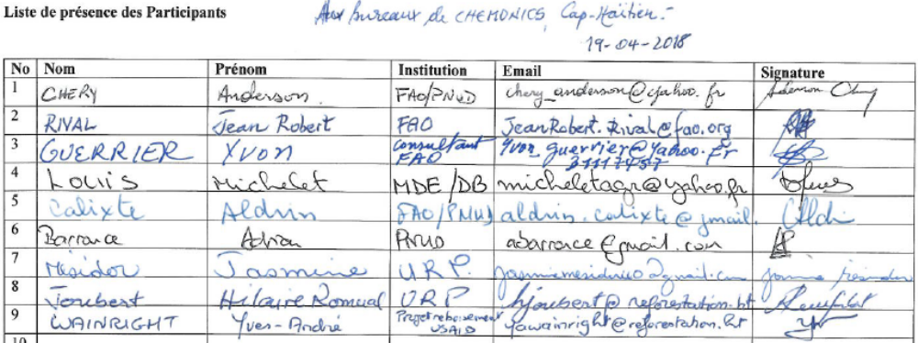
        - North Department Office of the Ministry of Environment, 19/4/2018
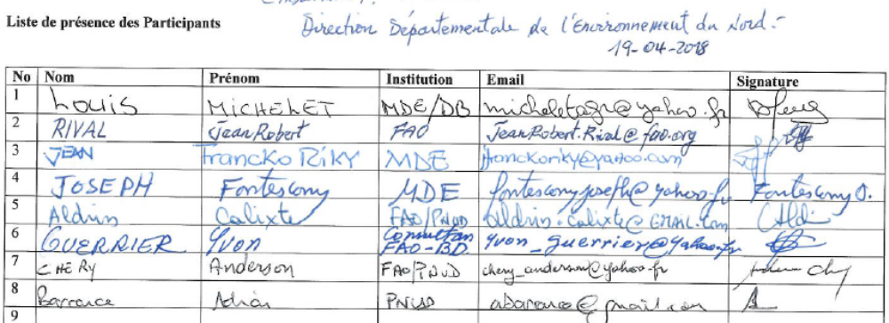
        - Novella cocoa trading company, Cap Haitien, 20/4/2019

        - Ministry of Environment meeting, Port-au-Prince, 24/4/2018
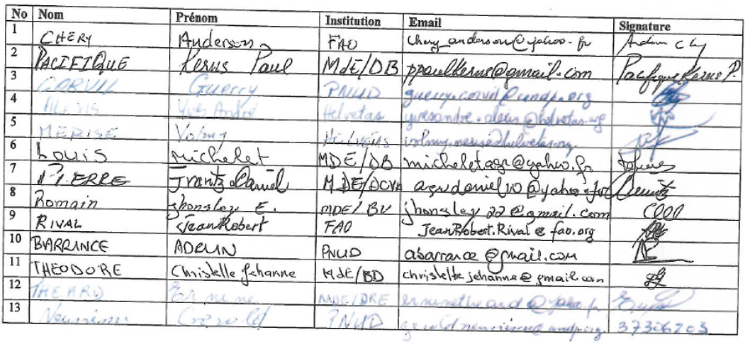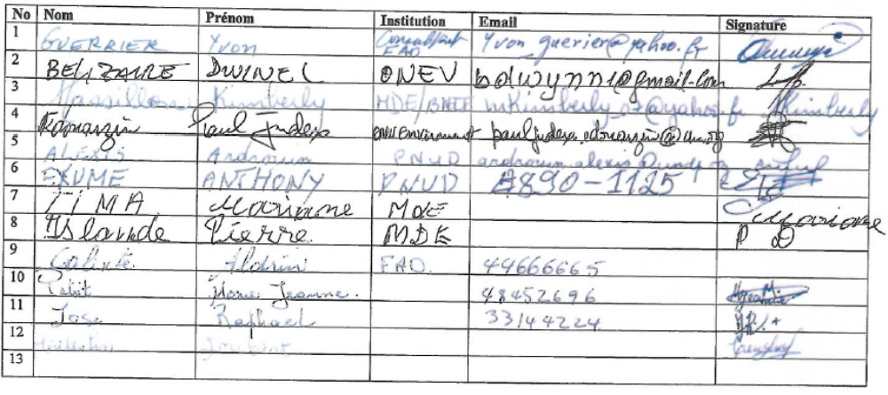
        - PPG Inception workshop, Hotel Montana, Port-au-Prince, 16/05/2018
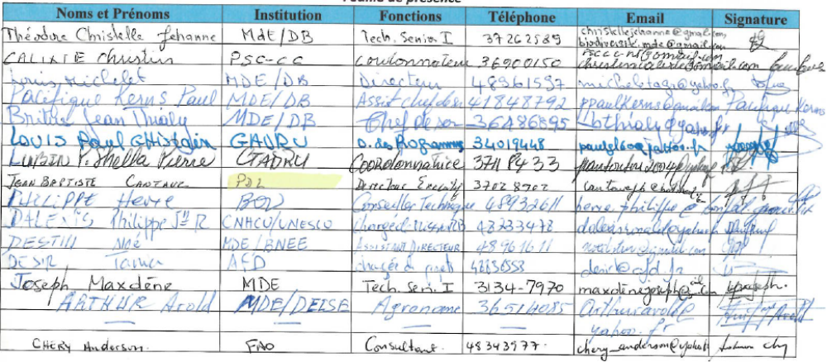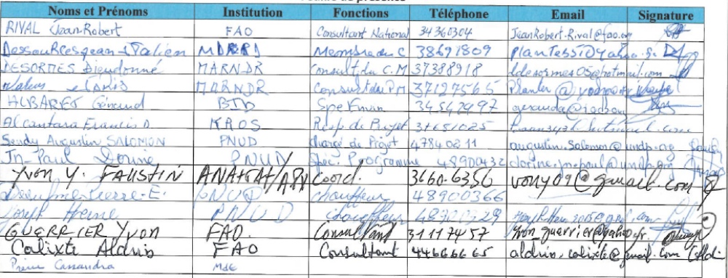
        - GIZ, Thiotte, 17/05/2018
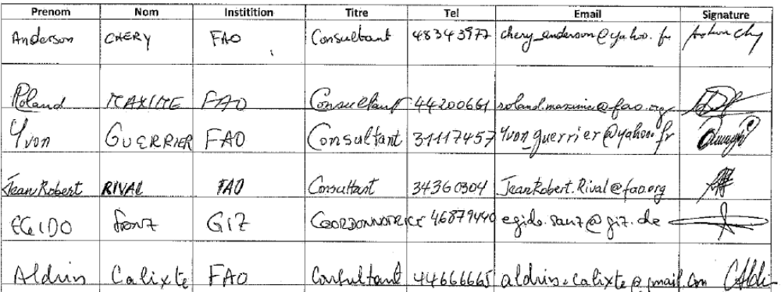
        - COOPCAB, 17/5/2019

        - COPCAB Thiotte, 17/5/2018
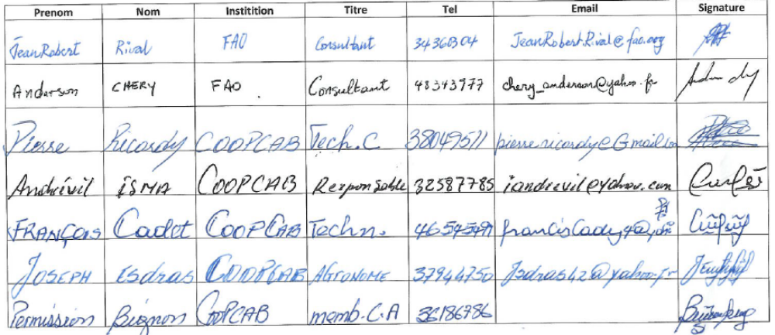
        - Organizasyon Fanm Konsekan Mapon, Belle Anse (Women’s Organization) 18/5/2018
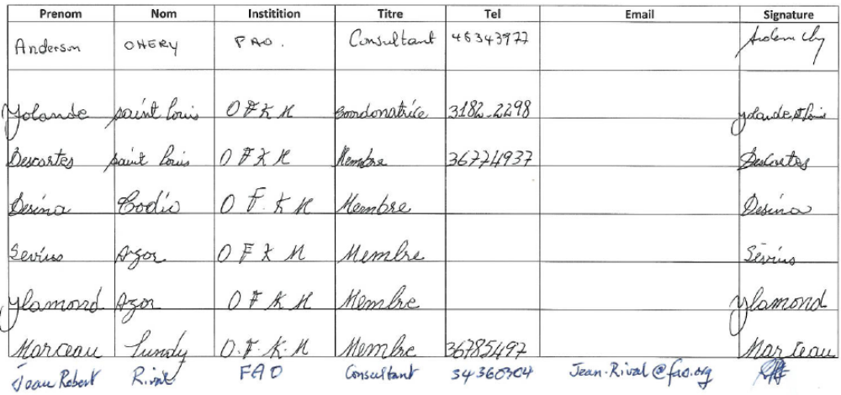
        - Cacao Cooperative, Grande Rivière du Nord, 7/8/2018
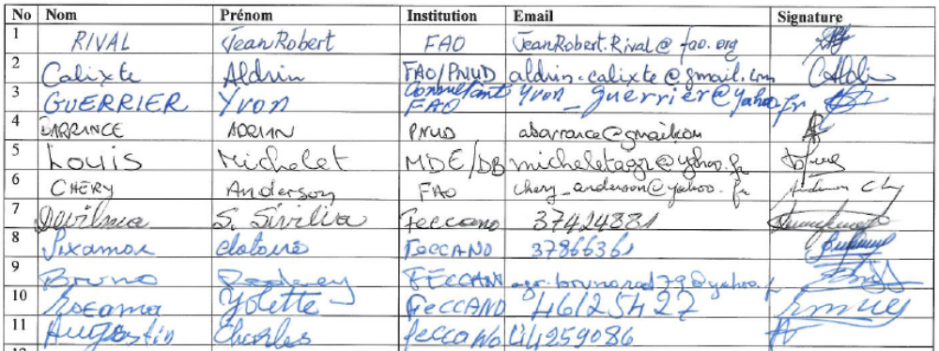
        - Consultation workshop, Vallière, 10/8/2018
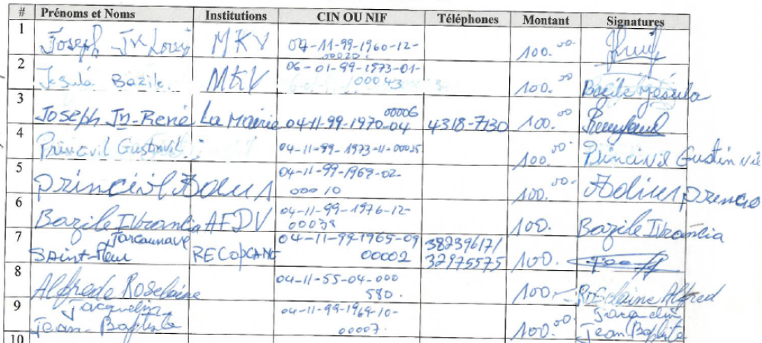
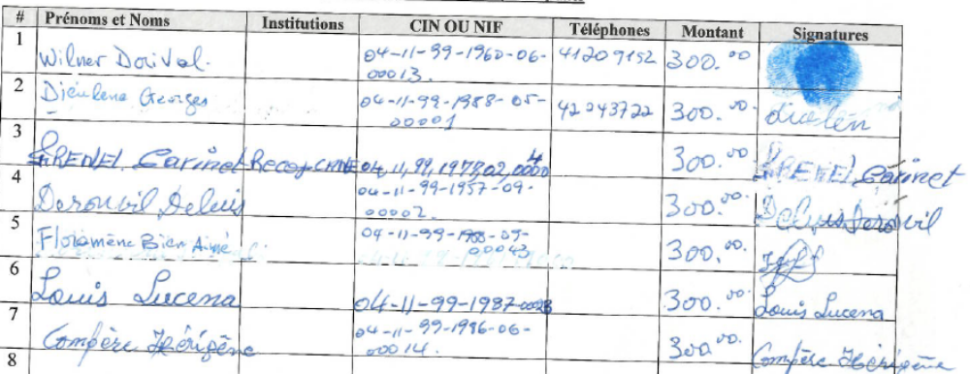

        - Consultation workshop, Limbé, 14/8/2018

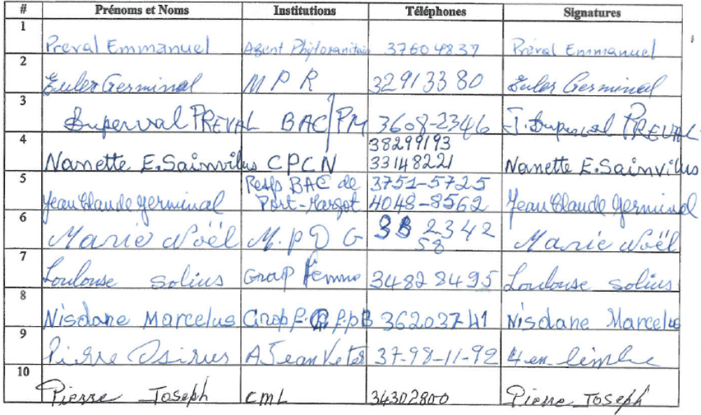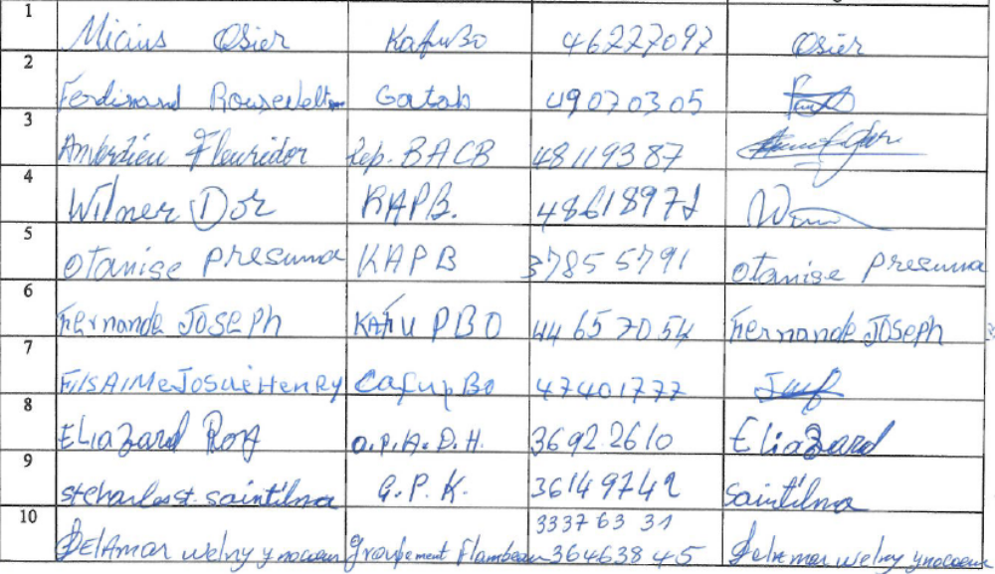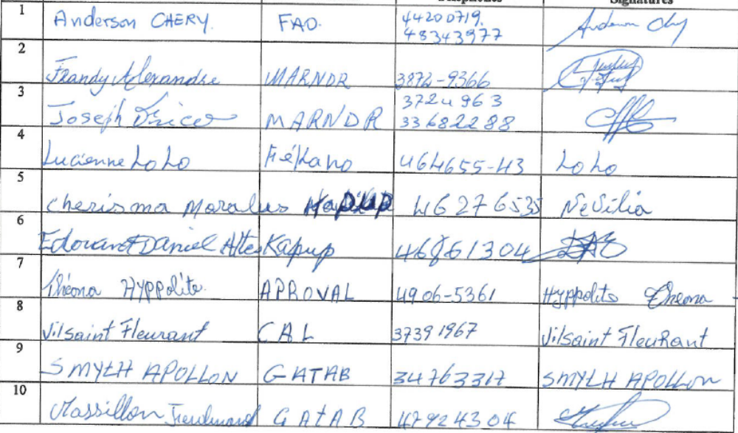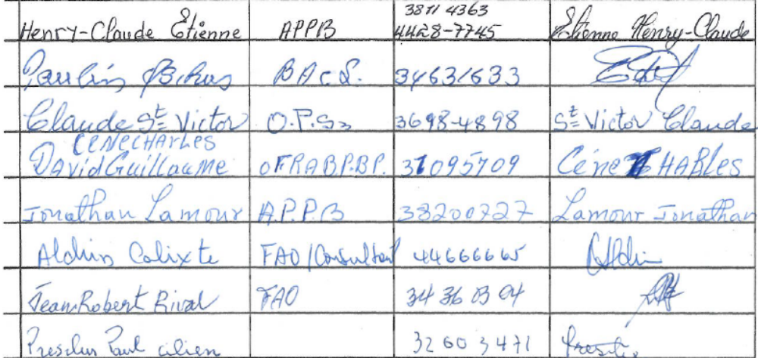

GENDER ANALYSIS AND STRATEGY

- Introduction
The following Gender Assessment and Action Plan (GAAP) was undertaken to scope gender aspects relevant to the proposed GEF project “Sustainable management of wooded production landscapes for biodiversity conservation” which involves the generation of multiple environmental and social benefits through integrated and sustainable management of wooded production landscapes in the Massif du Nord and Grande Rivière du Nord with globally significant biodiversity. The project takes a market-based and community –based approach to integrated environmental management through 1) Creating enabling conditions for landscape management, 2) Promoting conservation compatible tree-based production systems (including coffee and cacao) as part of sustainable landscape mosaics, and tying it together with 3) Knowledge management and sharing.
This GAAP therefore reviews the national context to analyze factors relevant to the inclusive and gender-responsive implementation of this project, including access to productive resources and services, and gendered roles in agriculture and participation in conservation/resource management. The analysis informs the gender action plan, which proposes strategies for strengthening the project’s gender responsive actions and highlight gender transformative opportunities.
This document is based upon available data and information retrieved from a review of literature and key documentation from the Government of Haiti, reports from multi-lateral institutions and development agencies, and interviews and field visits with relevant stakeholders during a field mission with the national team in April 2018, a national stakeholder consultation workshop held in May 2018, and extensive field visits held in September, by the project development team in Haiti. It includes insight from national experts, representatives of cooperatives and special interest/community groups, as well as with direct community stakeholders at the local-level engaging especially women to understand potential impacts of the project and builds on lessons learned from past studies and assessments on gender in Haiti and other countries related to agroforestry and agricultural value-chains.
Haiti is among the lowest in the HDI rankings (163/187 in 2016) and challenges are especially prevalent in the area of health and education, political participation, and employment that by and large affect women and girls. Haiti also supports high biodiversity and levels of endemism, yet many species are endangered by extensive deforestation and landscape degradation.
Understanding and addressing the persistent gender inequalities across the social, economic and political spheres within projects can enhance the development of interventions that generate equitable livelihood benefits and support effective conservation of biodiversity in productive landscapes, of which women are central actors and key beneficiaries. Two-thirds of the rural population in Haiti are dependent on agriculture; among them, women make up the majority of labour force involved in all aspects of agricultural processes. Although both women and men participate in agricultural production, women are the primary actors in trade and commercialization of domestic produce, while men tend to engage in value chains of more valuable export commodities.
This document is organized as follows: First there is an analysis of existing gender inequalities and gender gaps across a number of thematic areas, including agriculture, productive resource access, and forest resources. This is followed by a review of the stakeholder consultations and field surveys carried out in the targeted interventions areas, where specific information on the local context and gender roles in cacao/coffee production systems is highlighted. Thirdly, there is a section on recommendations and lessons learned to improve gender mainstreaming of this project, drawing on the analysis of field survey data, consultations, desktop review, and other experiences in agroforestry in Haiti. Finally, a gender action plan is presented.
- Existing gender inequality in Haiti
In Haiti, there are more women living under extreme poverty than men. Over 40% of households are headed by women and in rural areas; this is even higher (55%),. While Haiti has indeed made advances to close gender gaps, persistent challenges remain. Discriminatory attitudes and beliefs that permeate Haiti’s social fabric continue to limit women’s job opportunities and meaningful participation in public political life. Women are also socialized to be primary caretakers of the household and the burden of this unpaid, invisibilized labour is an additional obstacle.
Gender Inequality Indices
In Haiti, there is a lack of sex-disaggregated data, especially post-earthquake (2010) and subsequent disasters such as Hurricane Matthew (2015) that have seriously compromised the country’s institutional capacities and resources to oversee gender-specific monitoring and evaluations. Data is insufficient to calculate standard indicators such as the Global Gender Gap Index (GGGI) of the World Economic Forum or the United Nations Development Programme (UNDP) Gender Development Index (GDI). Among the indicators that have been calculated, the UNDP Gender Inequality Index (GII), which measures inequalities across three axes (reproductive health, empowerment, and economic status), ascribed Haiti a value of 0.593 in 2015, ranking it at 142 out of 187 countries assessed. Similarly, the Social Institutions and Gender Index (SIGI) of the Organization for Economic Cooperation and Development (OECD) calculated a value for Haiti of 0.1466 in 2014, suggesting that discrimination against women is medium.
Gender roles, power, and decision-making
In the household, Haitian women generally have decision-making independence, taking on the majority of household decisions related to budgeting and the allocation of financial resources (e.g., small expenses, food purchasing and preparation etc.). In fact, some 78% of married women have sole or joint decision-making power for major household purchases. Nonetheless, prevailing sexist beliefs and social norms regarding men and women in Haitian society inform the “acceptable” gender roles at school, in the workforce and at home, such that overall, women do not uphold the social status as men, nor the same economic and political independence,. Manifested along geographic and class divides, the position and expectations of women in society are important barriers that reinforce existing gender inequalities in the country.
Traditionally, men hold social positions of importance and influence, namely as politicians, spiritual leaders, and school headmasters, while women and girls assume the responsibility of primary caretakers of the household and family well being,. Women spend twice as much time on domestic tasks compared to men (15.4 h/week, vs. to 7h/week), and this difference is more pronounced in rural areas. Cooking, cleaning, child rearing are burdensome tasks, and women may additionally spend up to five hours per day collecting firewood and numerous hours per day collecting water. In fact, over a third of households must travel 30 minutes or more to access potable water supplies. Moreover, not only are women expected to manage social relations and conflict in the home, but they are also called upon to do so at the community-level. Although a main thread in the social fabric and primordial to the daily functioning of Haitian life, this work is typically undervalued, invisibilized and non-remunerated.
Women also play a key role in the rural economy. They are the main actors in the commercialization, processing, and transformation of agricultural products for local markets, they also plant and weed crops, ensure household food security, and the supply of drinking water. Men on the other hand, engage in the heavier labor activities, animal husbandry, and production of export crops (coffee, mangoes, etc.).
Poverty
Haiti is one of the poorest countries in the world, with 59% of the population living on less than 2.5 USD per day (equivalent to about 162.5 gourds). Over the last thirty years, there has been a “feminization” of poverty and today are more women in extreme poverty than men, living on under USD 1.23 per day. Overall women earn less than half of what men earn, and most women are employed in the informal sector, making them vulnerable to labor exploitation.
The incidence of poverty is much higher among the rural population (75% compared to 41% in urban areas), especially with a high rate of unemployment and precariousness of production. In fact, the highest poverty headcount index is highest in the Northeast (84%) and Northwest (72%) departments, where part of this GEF project will take place. Poverty affects all aspects of life, including housing, nutrition, education, and human and environmental health. In fact, these spatial disparities closely parallel the geographic distribution of health outcomes and access to basic services.
Almost half of the households in Haiti are women-led, yet the per capita income in these households is 7% less than those headed by men.
Education
Nearly half of all Haitian children do not attend school, highlighting the myriad challenges both girls and boys face in accessing free, quality education - especially those from poor and rural households. The public education system faces shortages of qualified teachers, limited supplies and a lack of infrastructure. The bulk of functioning schools (85%) are run by private entities, many of the elite operated by Canada, France or the United States, with school fees that are prohibitively unaffordable for low-income families. Consequently, more than 500,000 children and youth remain out of primary and secondary school, which has created and reinforces an educational divide and continual poverty gap that exists in Haiti.
Although the available data suggests that both boys and girls have equal access to education - with a near gender parity in terms of education levels and similar illiteracy rates among men and women - discriminatory attitudes and gender stereotypes are prevalent. Consequently, education tends to favor the advancement of boys, while young girls face numerous obstacles. Indeed, in post-secondary institutions, women students are underrepresented compared to men, and in the job market they tend to get lower paying jobs in more “feminized” niches,. Gaps among rural and urban areas also highlight the geographic and class distribution of education, where only about 64% of women in rural areas are literate, compared to 84% in urban areas, and this is most acute among poor households.
To counteract the gender stereotypes that shape women’s life options, the Ministry of the Feminine Condition and Women’s Rights (MCFDF) signed a protocole d'accord in 2007 with the Ministry of Education, focusing on the issue of the exclusion of girls in the education system. Nonetheless, gender roles and the unequal division of unpaid labor continues to limit the opportunities of girls receiving a quality education, by confining them to the household and burdening them with domestic chores.
Enforced child labor is already a prevailing risk in Haiti, especially among uneducated girls from low-income families who may be sold to more affluent families to work as “restavèks” under unregulated and often abject conditions.
Political participation
Rural women are insufficiently informed, consulted, or included in the design of public policies and, at the national level, few actions have been taken to create a space where women can fully and meaningfully participate in environmental management. This is even more pronounced in in areas outside the capital and in the target ​​regions of this project.
While women face no legal obstacles to vote and stand for election, in the 2015 presidential and legislative elections, over 90% of the candidates were men. While a constitutional amendment in 1987, decreed a 30-percent quota for women’s participation in all levels of public office, gender inequalities continue to exist, and tis especially evident among the positions of power that are dominated by men. Furthermore, representation is regressing, with currently only 3% of women in the Haitian parliament (2017), while in 2003 there were 9% of women. This gender gap is evident at all levels and branches of the government. At the local level, only 3% of CASEC (Conseil d'Administration de la Section Communale) representatives are women, and 11% of mayors are women (data from 2012) . Each municipality is governed by a board of 3 members. There is a limited number of cities that have a woman at the board level and often does not occupy the first place.
MCFDF’s recent inquiry into women’s low rates of political participation indicates that primary barrier to wider engagement is the burden of family responsibilities that mostly (sometimes exclusively) concern women. Lack of financial resources and sexist stereotypes are additional obstacles that are especially relevant for poor rural women. While women have historically been highly involved in social and political demonstrations, the danger linked to these activities is also noted as a limitation, notably the fear of losing one's life and leaving children behind.
Recognizing that women have been historically excluded from political debates and decisions on the direction of society, the Government has introduced gender aspects to their projects “to reinforce the capacity of women... and their participation in development projects”, and four priority areas have been identified in relation to gender mainstreaming: Agriculture and Food Security, Water Resources Management, Disaster and Risk Management, and Health. However, policy decisions and practices are still being implemented, and women are still largely excluded from in policymaking and decisions, especially with respect to disaster risk reduction and agriculture.
Labor force
The work force is segregated by gender, and women have considerably fewer employment opportunities than men across all age groups. The most recent available data shows that women make up only 38.4% of the active population, although women earn less than half of what men earn. While equal salary policies have been adopted in the public administrative positions, women are unrepresented in the higher paying, more influential positions in this sector. In fact, this is echoed across all sectors, where women tend to have the lowest paying jobs, with particularly high disparities in private sector salary, and they are underrepresented among professional jobs such as engineering, agronomy, and law. In the project’s region of application, the level of employment is especially low, with an unemployment rate of more than 42% (REF). This, among other influences, promotes out-migration, particularly of young people looking for opportunities to other countries, namely in Dominican Republic or North America – many working as illegal immigrants.
Women predominate in the informal sector (75.1%), where work conditions are unregulated and undocumented, so exploitation and income stability are relevant gender concerns. This also means that, in socio-economic crises, women will be the primary victims and it will be largely undetectable or unreportable as this work is invisibilized. The prevalence of child domestic workers is also common; in fact, pre-earthquake data indicates that almost all Haitian girls between the ages of 5 and 9 work in the informal market. Often, this is to help low-income families with domestic tasks, however, the prevalence of “restavèks” – children sent/sold to wealthier families to perform chores in exchange for room and board - is a major concern, especially for the rights of young girls. According to some estimates, there may be as many as 300,000 children working as restavèks in Haiti. Although the minimum age is set to 15 for work in industrial, agricultural, and commercial enterprises, there is currently no labor code that sets a minimum age domestic work.
Women also hold a majority (70%) of jobs in trade in the primary sector, especially in agriculture where they are the primary actors working in commercialization as well as processing and transformation. The work of women farmworkers is often undervalued, and they tend to suffer wage discrimination. This means that they have little access to stable income sources, that are dependent on the changing environmental conditions, contributing to gender-specific vulnerabilities. This also indicates that there is a lot of potential for projects to support women’s role in agriculture and to benefit women.
Agriculture and food security
Agriculture has been the backbone of Haiti’s economy and an architect of Haitian society since the colonial area. Today, a majority of agricultural production occurs on small farms, primarily oriented towards subsistence production in a variety of microclimates and altitudes. Both women and men participate in the cultivation of subsistence crops (namely of tubers and beans) as well as staple crop production that is marketed nationally (such as maize and rice),. Although these crops (beans, rice, corn) are most vulnerable to crop loss from climate change, demonstrating the disproportionate impacts incurred by women and rural, low-income households.
Women make up a majority of the labour force in agriculture, yet income-generating activities in this sector are skewed by gender. While women primarily work with domestic trade and commerce, the lucrative export commodities, such as essential oils, mango, cacao and coffee, tend to be controlled by men. Women face additional income generating obstacles in this sector: with limited access to private transportation they are more likely to use public services to undergo transactions. This not only contributes to the time poverty Haitian women already face, but also highlights their livelihood vulnerability to extreme flooding, which decreases transportation options and limits their ability to actively engage in the commercial transactions that many depend on.
Not only do domestically consumed crops generate less income, but they also receive less attention in agrarian development agendas compared to cash crops of coffee, cacao and mango. Given the gender distribution of agricultural production and sales, a prioritization of cash crops risks directly excluding women and their access to development program benefits. Indeed, export commodity value chains are often promoted a favourable pathway to generating more income in the country, however, over-investment in export crops may ultimately widen the economic gap between men and women, unless explicit action are taken to integrate women in these value chains.
Up until now, there has been minimal support and regulation from the state for women in agricultural value chains; nonetheless women have innovated by establishing expansive information and trade networks . In the fields, men are often responsible for large livestock (cattle, horses, etc.) and heavier, machine labour, while women assist with tasks such as harvesting and weeding or tending to smaller livestock (chickens, goats, etc.).
Over the last 50 years, agricultural production, processing and marketing have decreased, and today it accounts for about 25% of gross national product; given women’s central role in agricultural this has implications for their well-being and livelihoods. With continual land degradation, productivity is often low on farms; compounded by population growth and climate change, Haiti’s agricultural sector is struggling to meet the national food demand.
For rural farming families, production does not often generate enough income to meet basic dietary and household needs. In fact, only a quarter of their cash income originates from farming, so livelihoods must be supplemented by additional income sources. At the same time, malnutrition affects over half the population, while Haiti imports as much as 60% of its food, making it especially vulnerable to global economic and food crisis. Trade liberalization has exposed farmers to competition from subsidized U.S. rice exports and made consumers vulnerable to volatile global food prices. Food aid has also disrupted local markets and agriculture. As such, access to nutritious and stable food supplies depends more on household purchasing power than on household farm production. Food security is a thus a central, crosscutting component that is relevant to the proposed GEF interventions. Given women’s role in the production, distribution, and provision of food to their communities and families, it is an opportunity ripe for gender-transformative actions.
Notwithstanding their central role in agriculture and food security, women’s access to and rights over productive land remain limiting factors that contribute to gender gaps and poverty. Women often face difficulties obtaining legal titles and do not often gain equal land inheritance; as such, they rarely own land or tend farm on land that belongs to their male relatives,. Low-income families and women-led households are thus often relegated to farming on the most unproductive, infertile lands for subsistence production, namely denuded, steep sloping terrains.
Forest resources and charcoal production
Haiti is infamously known as one of the most deforested areas in the world, with poor governance, population growth, and growing demands for energy and arable land being commonly cited as direct drivers of extreme forest loss and degradation over the last century. While the FAO statistics of 2% - 4% forest cover are often used as a reference,, more rigorous, local land cover classifications show that forested area is between 19.5% - 32.4%, depending on the data and methods used. This incites a re-evaluation of the predominant narrative about environmental degradation and the use of forest resources in the country. Of the forested areas, coffee and cacao plantations represent a large portion of this cover (50% in the case of coffee).
The majority (over 90%) of Haitian households meet their energy needs by charcoal and firewood, as only about a third have access to electricity – primarily in urban areas. In fact, about 10,000 sacs of charcoal are used a day. Both men and women are actively involved in the production of charcoal, while women are the main traders and users of this wood-based energy source (for cooking and cleaning). As such, this is an issue of relevance to both gender and environmental management. With a stable national demand for charcoal, it is often a supplementary or primary source of revenue for poor rural families. While charcoal production has long been painted as unsustainable, practices involving the cutting of fast-growing trees such as cassia and acacia (that coppice and regrow within 4 – 6 years), are bringing into question this assertion that prevails across green development narratives. As such, interest is surging on how to integrate, rather than eliminate, charcoal production and use into programs and projects – representing a potential for improving co-benefits of agroforestry systems.
With differentiated gender roles and responsibilities in the household and the economy, the intended use and preferences of forest resources are often distinct between men and women. For example, recent reforestation initiatives in Haiti led by the Climate Change Adaptation Facility (CCAF) found that men tended to favor tree species for charcoal production and construction, while women expressed preferences for fruit trees and vegetable crops to integrate into home gardens. In some regions of Haiti, there may also be taboos around the use, planting or cutting of certain tree species. With the prevalence of men in spiritual leadership positions, their power and control over belief systems that shape these practices may be particularly relevant, yet it is a largely unexplored and overlooked aspect of reforestation efforts. Indeed, evaluations of previous reforestation attempts in Haiti indicate that interventions are most successful when there is a strong incentive for local populations to ensure the survival of seedlings and maintain tree-cover .
Access to productive land
In Haiti, women make up a majority of the labor force in agriculture, contributing to all aspects of production and especially commercialization and trade, yet ownership and rights over productive land resources is highly skewed by gender. The national statistics are a testament to this, with only 9% property owners in the country being women, while 20% of women have joint-ownership of a property. Land tenure is regulated by a civil code (enacted in 1962), that requires tenure registration for all land, yet a third of parcels do not have a legally recognized title, while 19% of land ownership is de facto declared by a sales receipt, indicating that the land tenure situation is uncertain and fragile across many Haitian households.
Most rural households (80%) have access to at least one hectare of land, with climate change and soil degradation however, the productivity of land is declining. Fertile land may have decreased by as much as 70% since the 1970s; in fact, estimates put loses of 10,000 to 15,000 fertile hectares per year due to erosion linked to a combination of land use practices and climate change.
Haiti has a particular and highly informal land ownership scheme rooted in traditional family relations that are structured around the family patriarch, or “lakou”, . Land is typically passed through inheritance and distributed among children, which has contributed to the fragmentation of land into smaller and smaller parcels over time. With each generation, the inheritance situation is re-evaluated, such that relationships to home and land may be impermanent and unstable for families from one generation to the next.
For women and girls, these tenure customs are a serious obstacle regarding their access to and securing their rights over productive land. Although inheritance is bilateral, with both daughters and sons being included in the division of land and homes, daughters traditionally receive smaller inheritances,. Haitian marriage law recognizes that both men and women have equal inheritance rights, yet women have little legal and intuitional recourse to affirm these rights, as common law relationships and unofficial unions are extremely common. In the case of adopted children, those born of wedlock and “restaveks” (child domestic workers, who are often young girls), they are not recognized in informal hereditary arrangements; moreover, they retain their original family names and consequently have no legal rights to inherited land.
For landless households, sharecropping is common, particularly under informal agreements of the “mèt té” system, whereby up to half of the agricultural production is collected by the property owner, most of which are men. Moreover, these parcels are often the most remote and degraded lands,. Within Haitian polygamist practices – which account for up to one-third of unions – secondary wives do not have the same family status, yet men may still collect yields and thus revenue from their farms or gardens.
Being constrained to farming on small, unfertile plots and steep slopes, the livelihood security and well being of these marginalized families is especially at risk with the intensification of prolonged droughts, extreme tropical storms, and natural disasters. In fact, conflict over increasingly scarce productive resources has multiplied in recent years,. Further land conflicts may emerge from natural disasters, as post-earthquake inquires found that urban populations moved back to rural areas to farm or claim land.
Access to extension services and finances
With the prevalence of rural aid projects from donors, NGOs and the private sector, agricultural extension services are readily available in Haiti – although the portion of public extension services has diminished in the last decades. According to a World Bank (2013) study, both men and women are equally likely to receive agricultural extension services in certain regions of Haiti, although this is probably due to women’s higher demand and active seeking out these services, rather than an outcome of gender equal access. Moreover, the report found that there are fewer positive outcomes of agricultural training among women-led households.
In terms of credit, the MCFDF highlights that eligibility criteria of microfinancing institutions create barriers for women to access sufficient funds to effectively implement agrarian projects or transition to other economic sectors,. With women as key actors in agricultural value chains, particularly the commercialization and sale of produce, low access to credit is a missed opportunity for increasing livelihood security.
Gender-based Violence
In Haiti, gender-based violence (GBV) is a pervasive problem, and current legal and judiciary structures do not adequately address this vulnerability. It is a major obstacle for the empowerment of women and girls, as it reduces their ability to fully participate in the public and private spheres of life. One in three Haitian women aged 15-49 has experienced physical and/or sexual violence, and the rate of intimate partner violence has risen since 2005.
A majority of GBV cases go unnoticed and unreported – as the most recent surveys indicate that 43.1% of women never told anyone, while 65% percent of women did not seek help of any kind. When they do seek help, it is most commonly among family members and neighbours, as official reporting accompanies a fear of revenge violence from abusers and the perception that official avenues are ineffective. Indeed, the prevalence of police violence targeting women and other marginalized groups, inevitably deters the denouncement of aggressors or making formal complaints regarding conflicts of any kind. Among cases of violence reported in 2009-2011, the majority were physical in nature (59.74%), followed by sexual violence (29.80%), while cases of psychological and economic violence constituted a minority (5.88% and 4.58% respectively). Although very few of these cases are investigated or prosecuted.
Currently, there is no specific legislation to deal with domestic violence or sexual harassment, and while rape was criminalized just over a decade ago, alarmingly the law still does not recognize spousal rape as a crime. Although the Government has made efforts to combat violence against women and girls, with the support of the UN Committee on the Elimination of Discrimination Against Women (CEDAW) and other agencies, recent political crises and natural disasters have obstructed the effective reform and adoption of gender protective legislations,.
- Legal and Administrative Frameworks for Protecting Women and Gender Equality
Incorporating gender and gender-sensitive policy and planning is an essential part of effectively and strategically achieving project outcomes that are sustainable and generate equitable benefits. Overall, Haiti’s mechanisms and reform plans for gender equality are based on a number of international agreements and conventions for women's rights. Several such instruments have been ratified in Haiti, including:
- The Convention for the Suppression of Human Trafficking and Exploitation of the Prostitution of Others September 2, 1952
- The Convention on the political Rights of Women, July 31, 1957 (Please note that the Haitian woman has the right to vote since 1950)
- The Convention on the Elimination of all forms of Discrimination with regard to Women (CEDAW), 7 April 1981
- The Convention on the fight against discrimination in the field of Education, October 15, 1984
- The International Covenant on Civil and Political rights, 23 November 1990
- The Convention on Children's rights, December 23, 1994
- The Inter American Convention on the prevention, punishment and eradication of violence against Women, 3 April 1996
The Ministry of Women and Women's Rights (MCFDF) is tasked with ensuring that signed agreements and conventions (domestic and international) are implemented, as part of its broader mission to guide the formulation, implementation, and enforcement of equitable public policies. Recently, the adoption of the Gender Equality Bill as well as the implementation of the National Plan for Gender Equality, and the National Plan for the Fight Against Gender Equality (2017), attests to Haiti's continued efforts to protect the rights of women. The Ministry’s operations are divided across four areas: Women's Rights Promotion Directorate (DPDDF), Gender Analysis Directorate (DPAG), the Directorate of Administrative Affairs (DAF), and Direction of coordination of the departmental offices.
MCFDF representatives (or Gender Focal Points/ Point Focal genre) are in place across ministries and state structures to coordinate and collaborate on women's rights and gender equality in the public sphere. Notably, a key function of this department is the production of national gender analyses and awareness-raising and training activities. However, the MCFDF faces insufficient budget allocation, as well as limited human resources human resources and technical capacities to carry out its intended mission, while a lack of regulation for the functioning of this strategic institution means that its level of authority and influence in orienting governance activities is weak.
There are few links between developing planning/natural resource management structures and the established frameworks for gender equality and women’s empowerment (i.e., MCFDF, National Gender Equality Policy).
- Field survey and stakeholder consultations
The project development team from UNDP and FAO, including national experts on environmental and social safeguards and gender, organized focus group discussions, workshops and field visits with key actors (both institutional and community) from areas targeted by the project. In the North Department, this includes the communes Grande Rivière du Nord, Limbé, Pilate, Borgne, Port-Margot, Plaisance, Milot and Cap-Haïtien. In the North-East Department, this includes the communes of Ste Suzanne, Mont-Organisé, Mombin crochu, Vallières and Carice. This made it possible, among other things, to collect relevant data to better understand the problems of landscape and agriculture while taking particular care to take into account the concerns of the most vulnerable socio-economic categories of communities by mobilizing analysis tools focused on the gender approach. The municipality of Marmelade in the Artibonite Department was also visited. It is particularly well equipped with certain infrastructure, in particular for the basic processing of coffee and for the processing of citrus fruits (orange, chadèque and pineapple) into juice and jams. Women’s participation was strongly encouraged in meetings and workshops that were held with groups of 10 to 35 people. Local authorities (mayors, CASEC, ASEC, elders, agricultural and environmental leaders and even religious authorities) were contacted and included in these activities.
The following stakeholders were consulted:
- State agricultural and environmental officials, local elected officials,
- Representatives of private companies operating in the coffee/cocoa sector,
- Representatives of civil society organizations working at the regional level to promote and develop effective and sustainable practices in the protection of natural resources and the environment,
- Elders and representatives of women's organizations operating in other sectors of crosscutting activities.
- Representatives of agricultural cooperatives and farmers' organizations,
The specific objectives of these activities were:
- Discuss with participants issues related to environmental degradation and landscape management;
- To stimulate and supervise debates in order to understand and analyze participants' perception and/or understanding of the issues for very specific themes such as: planning and management of ecosystems (productive forested landscapes), local adaptation strategies and the search for certain possible options proposed by local authorities in terms of viable response mechanisms to be developed in relation to the main concerns of communities, the environment and the productive forested landscape,
- Identify the importance agricultural production systems and/or in the wooded productive landscapes and problems that farmers encounter in these systems
Gender and the coffee/cocoa sector in the project intervention areas
Rural Haitian women (particularly those who were visited and met during consultations) participate in almost all agricultural activities. They face various difficulties such as lack of supervision and technical training, among others; some activities are 'reserved for women', which limit their participation in agricultural activities.
Unlike men, women must notify their husbands of their travel or intention to participate in certain activities.
In some municipalities, such as Carice, Mont-Organisé, Vallières, it was reported that women participate up to 30% in the preparation of the gardens, 40% in the harvesting activities and 100% in the sale of post-harvest products at the markets.
The COSAHEC cocoa cooperative in Carice, for example, requires the participation of women on its board of directors; currently their board is composed of 9 members, 5 of who are women. 60% of women integrate agro-processing activities; 70% participate in harvesting and 80% in the sale of products; they agree with their husbands to manage the money that is generated.
The Coopérative Chavannes Jean Baptiste à Grande Rivière du Nord entrusts 80% of its management to women; women, forming a significant part of its members, carry out all activities (harvesting, grafting, processing, transportation, etc.). According to the people met in Grande Rivière du Nord, the area planted with cocoa has increased over the last 8 years, hence the production as well. In this municipality, 15% of women participate in agricultural activities and the remaining 85% are involved in small-scale trade and other unspecified activities.
In the municipality of Plaisance, women do engage in land ploughing, but they participate in up to 30% in Kombits (other production activities, from soil preparation to harvesting) either in the preparation of food or other activities that require a little less energy expenditure. For harvesting and processing of agricultural products (mainly cocoa), 50% of women participate. Women are responsible for roasting and for sale, while mean grind the cocoa. Unlike the other municipalities, in Piacenza, a very high number of women own their own plots (50%), however, in the same municipality 70% of the occupants do not have title to their property.
According to workshop participants, in addition to the role of occupying children and preparing food at home and other tasks traditionally known in the country, women work mainly as managers of "Laku gardens" and "Pre-kay gardens". They are the backbone of the economy, children's education and household financial management.

From these meetings, workshops and focus groups organized, the important role that women play at all stages of the production process was emphasized, as was their constraints and low access to means of production, low income and the difficulties of managing this income.

- Challenges, opportunities and lessons learned
Although Haiti faces challenges with respect to its capacities and resources to address landscape degradation and threats to biodiversity,, the country is making advances despite significant set-backs related to recent natural disasters and political corruption. There is a wide variety of support from donor agencies, foreign governments, international NGOs, and researchers that aim to strengthen capacities and support Haiti in its commitment to improving social and ecological conditions and prioritizing gender equality within its policies and planning.
The gender analysis carried out highlights the complexities of gender relations in Haiti and identifies barriers to gender equality. The analysis is a foundation, supporting the identification of opportunities to improve gender-responsive approaches to management activities and risk reduction in the context of climate change adaptation.
Overall this gender analysis highlights the challenges and opportunities for implementing tree-rich cropping systems or agro-forestry systems that generate benefits for women and other marginalized groups.
Stakeholder engagement activities highlighted the following strategic concerns:
- How can women be more involved to ensure that their concerns are better taken into account and that the sector is better developed?
- How can we help women to be more profitable in production, processing and marketing?
- What strategies should be adopted to help women sell their production?
- Lack of national legal frameworks to take gender into account in the agricultural sector.
- The diversity of socio-cultural and economic barriers women face
The following areas should be considered for gender-sensitive implementation of tree-based systems to contribute to sustainable landscape mosaics for conservation in Haiti:
- Productive resources: A majority of women and women-led households depend on agriculture for their livelihoods, yet they are more likely to rely on unproductive land resources and have insecure land tenure.
- Decision-making: Women are responsible for and have control over decisions related to household “gardens”, which may be an important source of income for the household. However, control over farmland is either shared or controlled by men. Farms tend to be larger than gardens, while men control the most productive and accessible land assets.
- Value Chains: Women are more likely to be key players in domestic produce value chains, leading in the trade and sale of fruits, vegetables, tubers and other locally consumed agricultural produce in the informal sector. Men, on the other hand, tend to be key players in export commodity value chains, including coffee and cacao. This brings about gender disparities in terms of income, and employment security.
- Preferences and priorities: Given the gendered roles in production and sales as well as skewed responsibilities for family food security, men and women may have different needs and interests in terms of land management choices, including the selection of tree/crop species (subsistence vs. cash crops, export vs. domestic sales) and areas selected for cultivation (size and location, gardens vs. farms).
- Access to credit and extension services: low access to credit make it difficult for women to improve their production systems in the face of CC and secure a sustainable income. This is compounded by gender-skewed land ownership and the accompanying deeds to prove this ownership.
- Time burden: Women have a large number of dependents to care for and take on the majority of domestic tasks related to family care, water and wood supplies, and often must travel distances to sell produce.
- Institutional frameworks: Gender equality is not fully addressed in Haiti’s the majority of Haiti’s natural resource management strategies or action plans
- Participation and representation: Women and women’s groups do not fully participate in policymaking and decisions related to natural resource management. Few women are represented in management positions of co-operative organizations.
Lessons learnt from previous programmes and projects in the country and elsewhere can be drawn upon to improve the transformative potential of tree-rich cropping/agroforestry systems and conservation/landscape management activities, thereby ensuring equal participation and benefit-sharing among men and women and other marginalized groups. These are:
Support and encourage women-led productive activities
  - Promote poly-valent strategies that encourage farmers to implement or improve production in jardins
  - Promote diversified (agro-forestry) production based on local tree species and crops that support food security (e.g., beans, plantains, corn, tree fruits, legumes and vegetables) as well as soil and biodiversity conservation.
Promote skills that empower women to improve their businesses strategies and create opportunities to secure new/additional sources of income
  - Provide training in entrepreneurship, sales and marketing of agro-ecological and agroforestry products for women
  - When export crops, such as coffee and cacao, are promoted, provide training specifically for women, encouraging their engagement in this sector
  - Promote participation and inclusion of women in agricultural cooperatives through project activities
  - Engage and collaborate with local women’s groups to strengthen regional networks that support women’s involvement in value chains and encourage the development/recruitment of women’s participation in cash crops (coffee and cacao) value chains.
Promoting knowledge and skills that encourage women to be actors in sustainable landscape management
  - Encourage sensitivity and motivation among communities, youth and women, about planting trees and maintaining forest cover for biodiversity conservation and other ecosystem services
  - Promote energy forests that support the sustainable production of charcoal production and multipurpose forages, including nurseries and training on management of fast-growing trees, and extraction of branches
  - Ensure that project activities do not reduce women’s access to water and land resources, and do not increase time burdens.
  - Promote green value chains
- Project design and Implementation
Gender benefits through this project will be optimized by promoting the full involvement of women in decision-making regarding the design, location and approach of tree-rich systems and conservation management actions. In addition, during the implementation of this project strong efforts will be made to ensure the equal participation of women. Additionally, going forward beyond the implementation phase, equal participation of women should be pursued and achieved in ongoing management and governance on productive landscapes and biodiversity conservation.
Addressing gender dimensions within the project design and implementation, this proposal works to identify and integrate interventions to provide gender responsive and transformative results.
Recognizing women as key players in agriculture, food security, and sustainable landscape management, and building on the results of the above gender analysis and local stakeholder consultations, the project design and implementation has integrated the following to ensure gender-mainstreaming and equitable benefit sharing:
  - Gender integrated into the implementation plan with identification of concrete actions based on women's and men's priorities at sector level that can contribute to reducing inequalities and promoting sustainable development;
  - Emphasis placed on gender involvement in implementation and, above all, attention paid to the allocation of resources to promote women’s entrepreneurship in the agricultural sector;
  - Capacity building of the various actors in the sector, especially gender decision-makers delivered in a gender responsive manner;
  - Raise awareness among the various partners who will have to intervene in the sector to ensure that gender is better taken into account, including at the local government levels (CASEC);
  - Capitalize and visibilize gender actions within the sector through written publications or audio-visual productions;
- Strategies included for targeting beneficiaries in the field to ensure the effective participation of women and men at all stages; Specific strategies to include / target female-headed households;
  - Communication actions planned for a change in behavior on the ground with a view to eradicating certain harmful practices that prevent women from enjoying their rights in land tenure, other factors of production, food practices, access and income control, etc.;
  - Project actions will prioritize equitable participation at all levels (recruitment, decision-making, and positions of responsibility, participation in meetings, workshops, and seminars, training sessions, research, extension and others.
  - Identify gaps in gender equality through the use of sex-disaggregated data, and devote resources and expertise for implementing such strategies, monitoring the results of implementation, and holding individuals and institutions accountable for outcomes that promote gender equality.

  - Inclusion of a Gender Specialist position / provision of advice within the project to implement gender related activities.

  - Support for value chain development through environmental standards or certification should include a clear, policy and provisions on women's participation and gender equality

During project implementation, qualitative assessments will be conducted on the gender-specific benefits that can be directly associated to the project. This will be incorporated in the annual Project Implementation Report, Mid-Term Evaluation, and Terminal Evaluation. Indicators to quantify the achievement of project objectives in relation to gender equality will include men and women who had access to affordable solutions, number of men and women employed from the jobs created by the project, training opportunities, knowledge management and information dissemination.

Stakeholder engagement
Ensuring that project activities are gender-sensitive and gender-responsive requires the full and effective participation of women from local communities as well as women’s interest/advocacy groups and organizations across all levels, from the local to the national. This includes, for example, the involvement of women’s organizations, farmers cooperatives, The Ministry of Women and Women's Rights (MCFDF), and other relevant actors at the initial stages of the project design and implementation, in order to ensure adequate representation of women’s issues and gender-sensitive activities throughout the project cycle. The involvement of these stakeholder in the project design, aided in identifying gender issues relevant to the design, implementation, and monitoring of tree-rich cropping/agroforestry systems and landscape/conservation management activities.

Previous stakeholder consultations and engagement activities are described in the Section on Field survey and stakeholder consultations. An additional annex to this proposal shows the full results from the stakeholder engagement, which details the specific issues and difficulties, that women face regarding agricultural livelihoods and public participation. The specific issues they raised include are described in the Section on Challenges, opportunities and lessons learned.

Monitoring and evaluation
The analysis identified the differences between men and women that are relevant to biodiversity conservation in productive landscapes. These include gender disparities in farm production, engagement in value-chains, poverty, and access to productive land/land tenure security, and participation in decision-making processes. Data has been collated to establish a baseline, which shall be monitored throughout project implementation and evaluation.
In order to monitor and evaluate progress of the project, the following indicators can be measured:
Quantitative outcomes:
- Female-headed households as beneficiaries:
  - # of women-level households with implemented cropping systems/receiving financial support
  - # of women participating in training/capacity building and knowledge sharing activities for biodiversity conservation and sustainable management
  - # of women participating in value-chains (new/established green/export commodity)
- Improvements in food security and nutrition:
  - Diversity of crops grown
  - Proportion of crops from consumption/sale
- Improved livelihoods:
  - Income generated
  - Time burdens: unpaid and farm labor
- Participation:
  - Women’s inclusion in the development of management plans for landscape conservation (local and national level) and socio-economic development plans
- Business development services component targeting rural women entrepreneur groups.

Qualitative outcomes:
- Opportunities to generate additional income. Women are more likely to respond to incentives that address their family’s basic needs, such as better health and nutrition;
- Contribution to improved self-esteem and empowerment of women in the community;
- Expanded involvement in public and project decision-making as a result of initiation of women into active participation in income generating activities;
- Support for training/capacity building and knowledge-sharing activities enable women’s empowerment and involvement (or increased involvement)
- Proposed Gender Action Plan
This Gender Action plan provides entry points for gender-responsive actions to be taken under each of the Activity areas of the project. In addition, specific indicators are also proposed to measure and track progress on these actions at the activity level. This can be incorporated into the detailed M&E plan which will be developed at the start of implementation, and provides concrete recommendations on how to ensure gender (including disaggregated data) continues to be collected and measured throughout implementation. Indicators have been provided. Baselines will be determined in first year of implementation. For the participation indicators found below a participation target of 30% has been set as a minimum requirement. For the training indicators, targets will be determined in the first year of implementation according to the established baseline.

For all outputs, focus group or other participatory methods will be used to seek qualitative information on progress in relation to the objectives, regarding the effectiveness and implications of participation by women, youth and other vulnerable people.

 | Objectives | Indicators | Responsible Institutions
Results and long-term effects for women: Increase in farmed areas / Increase in and diversification of production/ increase in family food supply and food security / Access to new activities and jobs / Reinforcement of women’s entrepreneurship / Increased income and economic independence / Better access to financial/extension services and credit / Access to training and professionalization / Capacity-building of women/Increase in the number of women in decision-making bodies and/or cooperatives/ / / access to water-fuel wood resources/reducing workload/the visibility of women’s productive work;

Component 1: Creation of enabling conditions for the application and scaling-up of the landscape management model
Output 1.1:  Decision making tools to optimize the configuration of landscape elements in relation to spatial aspects of connectivity, biological importance, production potential, vulnerability and flows of ecosystem services | Community consultation and participation that is inclusive to women, youth, and other vulnerable people for decision-making and planning of buffer zones, corridors and PAs;  Ensure local access to information for women, youth, and other vulnerable people  Sensitize decision-makers/trainers/technical teams to gender issues and importance of gender mainstreaming in regional planning and policies.  Promote the inclusion of projects led by women and women’s advocacy groups in landscape management activities; | Number and % of men and women consulted, participating in decision-making  Number of women involved in dialogue, coordination and conflict resolution mechanisms  Number and % of participatory workshops  Number/% of decision-makers/trainers/technical teams sensitized  Numbers of women and men per Project team  Number of men and women participants from staff/public institutions/municipalities | UNDP/FAO
Output 1.2:  Socially- and institutionally sustainable mechanisms for governance in support of tree-rich production systems | Sensitize decision-makers/trainers/technical teams to gender issues and importance of gender mainstreaming  Promote the representation of women in positions of responsibility and power;  Promote the inclusion of projects led by women and women’s advocacy groups in landscape management activities;  Capacity-building of women and community groups for sustainable landscape management;  Review and integrate women’s and elder’s ecological/ethno-botanical knowledge into decision making and management practices;  Ensure local communities, women, and other vulnerable groups are aware of and can access information relevant to their land occupancy and use rights | Number of trained technicians and extension agents  Number/% of trained women and men in local communities  Number/% of decision-makers/trainers/technical teams sensitized  Numbers of men and women in Project teams  Number and % of participatory workshops  Number of staff/public institutions/municipalities  Numbers of women or women's groups represented  Number of Women representatives as managers/executives/cooperatives  Number and % of men and women consulted, participating  Number of follow-up Reports and information sharing strategies  Baseline: To de determined in first year of implementation  Target: 30% for participation indicators. For training indicators, targets will be determined in the first year of implementation according to the established baseline. | UNDP/FAO
Output 1.3 Market-based instruments to facilitate the delivery of environmental benefits: | Promote commitment to gender and gender equality among cooperatives and private sector actors;  Strict policy on women's participation in value chain development, standards and certifications  Promote women’s participation within cooperatives and encourage women's access to places of power in cooperatives;  Capacity-building of women, both individually and collectively, to support productive activities and involvement in value chains  Development and promotion of projects led by women; | Number of women's groups/cooperatives/outside cooperatives  Number of women/group  Number of female members;  Number of female executives/co-operatives  Number of individual or collective projects/activities developed/business initiatives  Number of awareness workshops and trainings for women's groups/number of participants; | UNDP/FAO
Component 2: Conservation compatible tree-based production systems as part of sustainable landscape mosaics
Output 2.1:  Improved service delivery systems for technical assistance: | Improve women’s access to technical and financial assistance for green value chains and certification systems  Promote commitments to gender and equality among private sector actors and private sector plans  Participation of women, youth, and other vulnerable people in Field schools | Number/% of women and men participating in Field schools, number of workshops/number of extension packages  Number of new value chains and % men and women in these industries  Number/% of decision-makers/trainers/technical teams sensitized on gender and gender equality  Number women and men/% beneficiaries receiving loans, trees (cacao, coffee and others), or additional material/financial assistance  Number of coffee/cocoa plants distributed to producers (subsidised/partially subsidised/non-subsidised), % men and women.  Total/% land area under cacao and/or coffee cultivation that is managed by women and men. | UNDP/FAO
Output 2.2: Improved financing mechanisms for tree-based production systems: | Promote gender mainstreaming in financial mechanisms (through institutions such as savings banks and cooperatives) and Government incentive programmes to improve access to women | Number of awareness workshops and trainings for gender mainstreaming and gender equality | UNDP/FAO
Output 2.3 Participatory systems for knowledge generation and development: | Capacity building of women, both individually and collectively, to support diversified productive activities  Knowledge sharing and integration of women’s and elder’s ecological/ethno-botanical knowledge into management practices;  Ensure local communities, women, and other vulnerable groups are aware of and can access information relevant to their land occupancy and use rights  Promote women’s participation within cooperatives and encourage women's access to places of power in cooperatives;  Promote the inclusion of projects led by women and women’s advocacy groups in diversified management activities; | Number/% of women and men participating in activities  Percentage of participatory activities promoting production in gardens, diversified and nutritious varieties, and crops for sale in domestic markets | UNDP/FAO
Output 2.4 Capacities for generating revenue from other tree-based systems on farm: | Promote entrepreneurship among women and build women’s capacities  Improve women’s and women-led household income, empower women economically  Promote women’s participation within cooperatives and encourage women's access to places of power in cooperatives | Total/% area of other tree-based systems that are managed by women and men.  Number/% of women and men participating in activities targeting commercialization of tree products, small-scale processing, transformation of products into handicrafts - Total/% of participatory activities  Number of women-led households/% women beneficiaries with improved annual income  Number/% of women and men in new and previously established cooperatives and community organizations  Number/% of women and men in positions of power in new and previously established cooperatives and community organizations  Number of new value chains for tree-based products - total number of value chains for tree-based products | UNDP/FAO
Component 3: Knowledge management and learning
Output 3.1  Knowledge management and dissemination/scaling up strategy | Establishment of a gender/observatory section for landscape management and tree-based systems; | Data broken down by gender and overall analyses  Number of documents/publications produced with gender data | UNDP/FAO
Output 3.2  Communication strategy to ensure that project objectives, concepts, principles and progress are effectively communicated to all key stakeholder categories | Ensure that communication strategy is gender-responsive by accounting for the differing information needs and access constraints that women may have | Number of men and women beneficiaries aware of project objectives and progress | UNDP/FAO
Output 3.3  Monitoring and evaluation strategy | Set up of monitoring with project data broken down by gender;  Production of research and dissemination of findings on gender/biodiversity/agriculture;  Systematize the lessons learned through comparative analyses of the impact on women-led households (e.g. changes to the division of labour according to gender, observed changes to production-reproduction activities, benefits, etc.);  Contribution to information and knowledge on project impacts/effects by gender and inequalities/leverage for action; | Number of women and women-headed households with better access to agricultural extension services  Number of women and women-headed households with better access to finance for the sustainability of tree-based production systems  Number of women and women-headed households involved in the transformation of products from tree-based production systems | UNDP/FAO

Target species of global conservation concern

Species | Status | Information of relevance to conservation
Amphibians
Eleutherodactylus grahami Graham's Robber Frog | Endangered, endemic to NW Haiti | 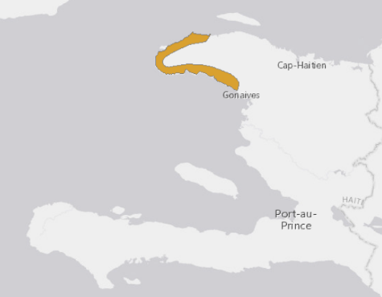  Justification: Listed as Endangered because its Extent of Occurrence is less than 5,000 km2, its distribution is severely fragmented, and there is continuing decline in the extent and quality of its habitat on Haiti.  Range Description: This species is restricted to the north-west of Haiti, ranging from 20-330m asl.  Habitat and Ecology: It is found on limestone ridges with boulders and xerophytic vegetation. Eggs are laid on the ground and it breeds by direct development.  Major Threat(s): Extremely severe habitat destruction due to charcoaling and small-scale agriculture is taking place on the north-western peninsula of Haiti, which now looks like a lunar landscape, devoid of vegetation, although some pockets remain where this species might occur.  Conservation Actions: It is not known to occur in any protected areas. There is an urgent need for effective protection of remaining suitable habitat in the range of this species.
Eleutherodactylus lucioi (St. Nicholas Robber Frog) | Critically Endangered, endemic to NW Haiti | Justification: Listed as Critically Endangered because of an expected population decline of greater than 80% over the next ten years, predicted from severe degradation of the species' habitat; and because its Extent of Occurrence is less than 100 km2, its Area of Occupancy is less than 10km2, all individuals are in a single location, and there is continuing decline in the extent and quality of its habitat.  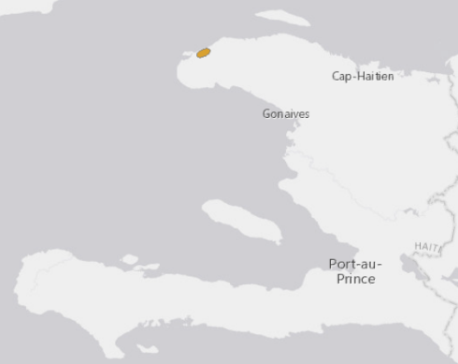  Range Description: This species is known from a single locality in the Presquile du Nord Ouest, Haiti, at around 100 m asl. Lower/upper elevation limit: 100 metres.  Habitat and Ecology: The species was recorded in a rocky ravine in remnant riparian forest. Eggs are laid on the ground, and it breeds by direct development.  Major Threat(s): Logging by local people (charcoaling) and slash-and-burn agriculture are the main threats to the species.  Conservation Actions: It is not known to occur in any protected areas. Further survey work is urgently needed to determine the population status of this species and whether or not it still survives in the wild. Maintenance of existing habitat at the type locality is also required.
Eleutherodactylus poolei (Poole's Robber Frog) | Critically Endangered, N Haiti | 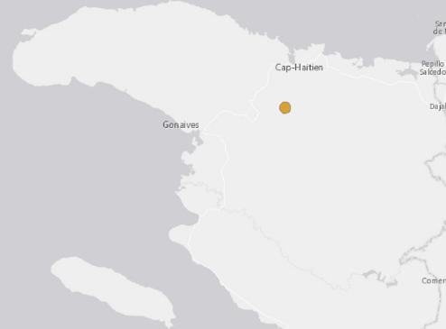  Justification: Listed as Critically Endangered because of an expected population decline of greater than 80% over the next ten years, predicted from severe degradation of the species' habitat; and because its Extent of Occurrence is less than 100 km2 and its Area Of Occupancy is less than 10km2, all individuals are in a single location, and there is continuing decline in the extent and quality of its habitat around the Citadel Laferriere (Citadel of King Christophe), Haiti.  Range Description: This species has a very restricted range, and is found only in and around the Citadel Laferriere (Citadel of King Christophe), a huge fortress built on the peak of a mountain nearly a thousand metres above the plain from which it rises, in northern Haiti. Its altitudinal range is from 550-650 m asl. There is a second, albeit questionable, record from the nearby Carrefour Marmelade.  Habitat and Ecology: It was recorded from a moist dungeon in an old fort and probably occurs in the surrounding forest. Eggs are laid on the ground and it breeds by direct development.  Major Threat(s): The primary threat to this species is habitat destruction due to charcoal collection and subsistence farming.  Conservation Actions: The Citadel Laferriere is a World Heritage Site (designated in 1982), and is one of the most popular tourist destinations in Haiti. The current status of the species is unclear, and further survey work is needed determine its population status. Maintenance of the surrounding forest is necessary.
Eleutherodactylus rhodesi (Rhode's Robber Frog) | Critically Endangered, endemic to NW Haiti | Justification: Listed as Critically Endangered because of an expected population decline of greater than 80% over the next ten years, predicted from severe degradation of the species' habitat on the Presqu'ile du Nord-Ouest, Haiti; and because its Extent of Occurrence is less than 100 km2 and its Area Of Occupancy is less than 10km2, all individuals are in a single location, and there is continuing decline in the extent and quality of its habitat.  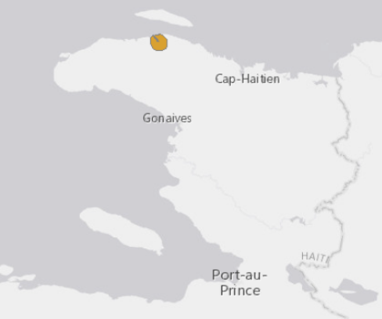  Range Description: This species has a very restricted range (occurring in just one small area) on the north-eastern base of the Presqu'ile du Nord-Ouest, Haiti, at an altitude of around 30 m asl.  Habitat and Ecology: It is a terrestrial species that has been found in leaf-litter and under rocks in forest. Eggs are laid on the ground and it breeds by direct development.  Major Threat(s): The main threat is extensive habitat destruction due to logging by local people (charcoaling) and slash-and-burn agriculture.
Eleutherodactylus schmidti (Schmidt's Robber Frog) | Critically Endangered, Hispaniolan endemic | 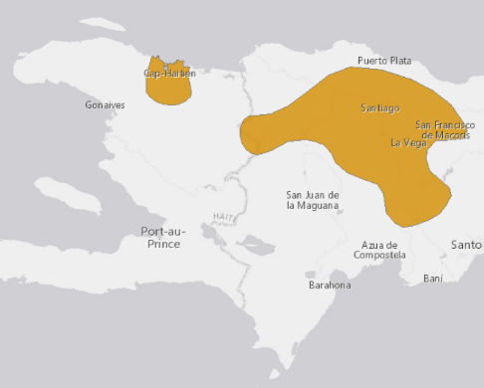  Justification: Listed as Critically Endangered because of a population decline of greater than 80% over the last ten years, estimated from direct observation, a decline in the quality of its habitat, and the possible effects of chytridiomycosis.  Range Description: This species has a restricted range in the Cordillera Septentrional and Cordillera Central, in the Dominican Republic, and in the Massif du Nord, Haiti. It has been recorded from sea level to 1,758 m asl.  Population: It was common in the past and was known from many localities, but it has not been recorded since the mid 1980s. Extensive surveys were carried out within its range between 1998 and 2000 (M. Hernandez pers. comm.), but these failed to find any individuals, thus suggesting a catastrophic decline, even within suitable habitats.  Habitat and Ecology: It is usually found beside streams in mesic closed-canopy rainforests. Males call from the river and stream banks. Eggs are laid on the ground, and it breeds by direct development.  Major Threat(s): In the Cordillera Central of the Dominican Republic, habitat destruction is taking place as a result of agricultural development (including livestock farming), and disturbance from ecotourism. However, chytridiomycosis is a possible reason for its decline within suitable habitats.
Hypsiboas heilprini Los Bracitos Treefrog | Vulnerable. Hispaniolan endemic | Justification: Listed as Vulnerable given that its area of occupancy (AOO) is estimated to be between 1,527 and 2,000 km2, its population is considered to be severely fragmented and there is a continuing decline in its extent of occurrence (EOO), AOO, and the area, extent and quality of its habitat throughout much of Hispaniola.  Range Description: This species has a spotty and fragmented distribution throughout Hispaniola, from sea level up to 1,856 m asl. Surveys from 2008-2010 have recorded this species in 16 geographical localities of the Dominican Republic including Nalga de Maco, Salto de la Damajagua, San José de Las Matas, Armando Bermudez, José del Carmen Ramírez, Diego de Ocampo, San José de Ocoa, Camaano Deno, Loma La Canela, La Vega, Ebano Verde, Monte Plata, Sánchez Ramírez, La Humeadora, Miches and Los Haitises. These surveys have expanded this species' area of occupancy (AOO) since its last assessment in 2004 (G. Ross pers. comm. March 2011). However, even considering this expansion, the occupied area (herein taken as a proxy for AOO, although the actual AOO would be more restricted by virtue of the species' association with watersheds) in the Dominican Republic is estimated to be 1,527 km2 based on field work and presence of suitable habitat (R. Powell pers. comm. February 2012). While there is no estimate for its occupied area in Haiti, based on the current original forest cover (estimated to be 277.5 km2 or 1% of the original forest cover in Haiti; B. Hedges pers. comm. April 2012) and the rate of habitat loss experienced by this country, suitable sites are projected to disappear within 10-20 years (R. Powell pers. comm. February 2012; B. Hedges pers. comm. February 2012), so it is expected that this species' AOO will most likely not exceed 2,000 km2. Its current overall range (taken as a proxy for extent of occurrence) is estimated to be 37,774 km2, which evidences a reduction in the area historically demarcated as its range (R. Powell pers. comm. February 2012). Many watersheds with forested riparian zones no longer exist at sites where these frogs have been collected historically (R. Powell pers. comm. February 2012).  Population: This species is believed to have undergone a decline in the years preceding 2004, and during the course of recent surveys in Haiti was found to be absent from a number of streams (B. Hedges pers. comm.February 2012). More recently, 2008-2010 surveys have documented approximately 135 mature individuals in 16 geographical localities (G. Ross pers. comm. March 2011). During a survey in Furcy, Haiti, in 2010 one individual was heard calling (M. Landestoy pers comm. March 2011). In the Cordillera Central of the Dominican Republic, it appears to persist in appropriate habitat at several localities (based on field observations from 1998-2010; M. Hernández pers. comm. and G. Ross pers. comm. March 2011). In 2010 surveys conducted in Sierra de Bahoruco and Barahona peninsula recorded individuals in two localities, expanding the southern extent of the known range (Proyecto Rana RD). The population is considered to be severely fragmented as per the IUCN Red List Guidelines, i.e. it occurs in fragmented habitat patches, it has a poor dispersal ability and limited gene flux, and 50% or more of individuals are found in isolated and fragmented habitat patches.  Habitat and Ecology: It is a stream-breeding amphibian found in high-quality mountain streams associated with well-conserved mesic broadleaf forests (R. Powell pers. comm. December 2011; B. Hedges pers. comm. February 2012). It has also been found in areas with various land uses, such as cacao plantations, coffee plantations, pastures, crop agriculture, areas with livestock, and forestry activities (Pueblo Viejo Dominicana Corporation pers. comm. January 2012; Pueblo Viejo Dominicana Corporation pers. comm. July 2012). Recent surveys have revealed that, of a total of 90 transects, the species was found primarily in different forest types (N=79), but was also recorded in agricultural areas (N=7) and wetlands, including marshes (N=4)(Pueblo Viejo Dominicana Corporation pers.comm. July 2012). Most of the surveyed transects (N=65) had various land use practices in the surrounding area, with 25 transects surrounded by unaltered forests (Pueblo Viejo Dominicana Corporation pers.comm. July 2012). These survey results suggest that, although this frog is found in habitat types that are contained within a variety of different land uses, it requires forests as the main habitat pockets to subsist within these different landscapes. In terms of micro-habitat occupation, males have been reported to call from rocks or low vegetation near and in water. It has been observed breeding in slow-moving water at Diego de Ocampo in April 2009 (G. Ross pers. comm. March 2011). Due to the fact that it is a mountain stream-dweller, it is considered to be more sensitive to habitat destruction than many other species.  Major Threat(s): In Haiti, severe degradation of streams has already significantly altered its breeding habitat, and streams in Hispaniola in general are being strongly impacted by deforestation due to agricultural activities, logging and charcoaling (B. Hedges pers. comm. February 2012). Suitable habitat where the species is currently found is being impacted by mining activities (Barrick Gold Corporation 2012). Infrastructure development is also a threat in some areas in the Dominican Republic. Chytrid fungus has been confirmed on individuals at Monte Plata and Sánchez Ramírez in 2009 (G. Ross pers. comm. March 2011), although it is not known whether it has been associated with mortality events or declines.  Conservation Actions: Its range includes several protected areas in the Dominican Republic, although most of these are in need of improved biodiversity conservation management and no known populations in Haiti are within protected areas. Small isolated populations outside of protected areas are thought to be at a very high risk of local extirpation within the next ten years if there is no intervention (R. Powell pers. comm. February 2012), so additional habitat protection is urgently required. Further survey work is necessary to determine the current population status of this species in the wild in Haiti, and to determine whether chytrid is a threat. The Dominican governmental agency Ministerio de Educación Superior, Ciencia y Tecnología (MECyT) is currently financing a three-year Dominican conservation project on threatened frogs due to climate change (RANA-RD), and which is expected to contribute towards a national Dominican amphibian conservation action plan with policy recommendations (C. Marte, M. Rodríguez and L. Diaz pers. comm. March 2011). Barrick Gold Corporation is funding a biodiversity project to establish assurance colonies of this and other Hylids impacted by its mining operation, and is also involved in building capacity and collecting additional biological information (Barrick Gold Corporation 2012).  The Amphibian Ark Conservation Needs Assessment process (Amphibian Ark 2011) conducted in the joint IUCN-Amphibian Ark workshop where this species was reassessed identified that further conservation actions for this taxon should include in situ conservation and conservation education.
Osteopilus pulchrilineatus Hispaniolan Yellow Treefrog | Vulnerable, Hispaniolan endemic | Justification: Listed as Vulnerable given that its area of occupancy (AOO) is estimated to be between 1,351 and 2,000 km2, its population is severely fragmented and there is a continuing decline in its extent of occurrence (EOO), AOO, and the area, extent and quality of its habitat throughout much of Hispaniola.  Range Description: This species has a highly fragmented distribution on Hispaniola, which suggests that it has declined from a previously more uniform distribution. It has been recorded from sea level up to 1,091 m asl (Henderson and Powell 2009). Surveys from 2008-2010 have recorded this species in ten geographical localities of the Dominican Republic, including Montecristi, Dajabon, Nalga de Maco, Santiago Rodríguez, Salto de la Damajagua, Loma La Canela, Monte Plata, Sanchez Ramírez, Samana and Los Haitises. These surveys have expanded its area of occupancy (AOO) since its last assessment in 2004. However, even considering this expansion, the occupied area (herein taken as a proxy for AOO, although the actual AOO would be more restricted as some sites consist of small ponds beyond the margins of which frogs cannot survive) in the Dominican Republic is estimated to be 1,074 km2 based on field work and presence of suitable habitat (R. Powell pers. comm. February 2012).  While there is no estimate for its occupied area in Haiti, based on the current original forest cover (estimated to be 277.5 km2 or 1% of the original forest cover in Haiti, B. Hedges pers. comm. April 2012) and the rate of natural habitat loss experienced by this country, suitable sites are projected to disappear within 10-20 years (R. Powell pers. comm. February 2012; B. Hedges pers. comm. February 2012), so it is expected that this species' AOO will most likely not exceed 2,000 km2. Its current overall range (taken as a proxy for extent of occurrence) is estimated to be 24,334 km2; which represents a reduction in its historical EOO, as areas previously demarcated as its range have undergone alteration due to human activities (e.g. loss of area in the Valle de Cibao, portions of the Valle de San Juan, eastern plains and Neiba uplands, central uplands east of HW 1; R. Powell pers. comm. February 2012).  Population: This species has always been hard to find, but even so it appeared to be in decline prior to the 2004 assessment, with many historic subpopulations that seemed to disappear. It was not recorded during extensive searches of the Cordillera Central in the Dominican Republic in suitable habitat from 1998 to 2000. However, more recent surveys conducted between 2008-2010 have documented approximately 340 mature individuals in ten localities including the Cordillera Central. Although single individuals have been observed, the species is more commonly heard actively calling in groups ranging from 3-80 individuals. These surveys have also detected breeding populations. This species was last recorded in Haiti during a survey conducted in October 2010 at Plain Formon, Massif de la Hotte. The population is considered to be severely fragmented as per the IUCN Red List Guidelines, i.e. it occurs in fragmented habitat patches, it has a poor dispersal ability and limited gene flux, and 50% or more of individuals are found in isolated and fragmented habitat patches.  Habitat and Ecology: It occurs in mesic broadleaf forests, riparian forests including remnant forests, mangrove forests, grasslands, marshes and agricultural landscapes including rice plantations, coffee and cacao plantations, and the presence of livestock (Pueblo Viejo Dominicana Corporation pers.comm. January 2012; Pueblo Viejo Dominicana Corporation pers.comm. July 2012). Recent surveys have revealed that, of a total of 53 transects, the species was found primarily in different forest types (N=40), but it was also recorded in wetlands (N=10), agricultural areas (N=2) and grasslands (N=1) (Pueblo Viejo Dominicana Corporation pers.comm. July 2012). Most of the surveyed transects (N=41) had various land use practices in the surrounding area, with only 12 transects surrounded by unaltered forests (Pueblo Viejo Dominicana Corporation pers.comm. July 2012). In terms of micro-habitat occupation, it is mainly found on shrubs and reeds (up to 2 m high) alongside and within streams, lagoons and flooded pools. Males call in flooded pools after heavy rain and eggs are laid in still water where the larvae also develop. Although this frog is found in habitat types that are contained within a variety of different land uses, the survey results above suggest that it requires forests and/or wetlands as the main habitat pockets to subsist within these different landscapes. In any event, its individual sites tend to be isolated from one another, making them vulnerable to trampling by livestock and local extirpation (R. Powell pers. comm. February 2012).
Osteopilus vastus Hispaniolan Giant Treefrog | Vulnerable, Hispaniolan endemic | Justification: Listed as Vulnerable given that its area of occupancy (AOO) is estimated to be between 1,165 and 2,000 km2, its population is considered to be severely fragmented and there is a continuing decline in its extent of occurrence (EOO), AOO, and the area, extent and quality of its habitat throughout much of Hispaniola.  Range Description: This species has a very patchy distribution in Hispaniola, suggesting that it has declined from a previously more uniform distribution. It has an altitudinal range from sea level to 1,697 m asl (Henderson and Powell 2009). Surveys conducted between 2008-2010 have recorded this frog at 15 geographic localities of the Dominican Republic including Nalga de Maco, San José de las Matas, San José de Ocoa, Salto de la Damajagua, Diego de Ocampo, La Vega, La Canela, Monte Plata, Sanchez Ramírez, Ebano Verde, Guaconejo, La Humeadora, Bonao, Miches and Los Haitises. These surveys have expanded its area of occupancy (AOO) since its last assessment in 2004 (G. Ross pers. comm. March 2011). However, even considering this expansion, the occupied area (herein taken as a proxy for AOO, although the actual AOO would be more restricted as some sites consist of small ponds beyond the margins of which frogs cannot survive) in the Dominican Republic is estimated to be 1,165 km2 based on field work and presence of suitable habitat (R. Powell pers. comm. February 2012). In Haiti, surveys conducted since 1984 have never recorded this frog from the "North Island" of Haiti (north of Port-au-Prince and the Cul-de-Sac; B. Hedges pers. comm. February 2012). There are only two historical records for the North Island (Schwartz and Henderson 1991), but it is possible that this frog could be extirpated in this area (B. Hedges pers. comm. February 2012). There is some forest on the South Island, in remote patches, where the possible new taxon is found (B. Hedges pers. comm. February 2012). While there is no estimate for its occupied area in this country, based on the current original forest cover (estimated to be 277.5 km2 or 1% of the original forest cover in Haiti, B. Hedges pers. comm. April 2012) and the rate of natural habitat loss experienced by Haiti, suitable sites are projected to disappear within 10-20 years (R. Powell pers. comm. February 2012; B. Hedges, February 2012), so it is expected that this species' AOO will most likely not exceed 2,000 km2. Its current overall range (taken as a proxy for extent of occurrence) is estimated to be 20,636 km2, which evidences a reduction in the area historically demarcated as its range given natural habitat alteration due to human activities (e.g. loss of area in the Valle de Cibao, portions of the eastern lowlands and central uplands east of HW 1; R. Powell pers. comm. February 2012).  Population: It is more common than Osteopilus pulchrilineatus in the Cordillera Central. This species is more commonly seen as lone individuals, with occasional breeding couples (G. Ross pers. comm. March 2011). It was found just outside Santo Domingo in 2001-2002, and during 2008-2010 surveys this species was frequently observed, with 182 mature individuals on record (G. Ross pers. comm. March 2011). Dead individuals found prior to the 2004 assessment are suggestive of some past localized declines. The population is considered to be severely fragmented as per the IUCN Red List Guidelines, i.e. it occurs in fragmented habitat patches, it has a poor dispersal ability and limited gene flux, and 50% or more of individuals are found in isolated and fragmented habitat patches.  Habitat and Ecology: It is found in mesic broadleaf forests, and has more recently been recorded in cacao and coffee plantations, pastures, and other types of crop agriculture (e.g., avocados and yams)(Pueblo Viejo Dominicana Corporation pers. comm. January 2012; Pueblo Viejo Dominicana Corporation pers. comm. July 2012). Recent surveys have revealed that, of a total of 96 transects, the species was found primarily in different forest types (N=85), but it was also recorded in agricultural areas (N=7) and wetlands (N=4)(Pueblo Viejo Dominicana Corporation pers.comm. July 2012). Most of the surveyed transects (N=74) had various land use practices in the surrounding area, with 22 transects surrounded by unaltered forests (Pueblo Viejo Dominicana Corporation pers.comm. July 2012). Within these different habitat types it can often be found along creeks and streams, although it has also been recorded in marshes (Pueblo Viejo Dominicana Corporation pers. comm. July 2012). In Haiti it has been recorded in pine forests, but not so in the Dominican Republic (M. Rodriguez pers. comm. March 2011). Males call from trees overhanging running water, in which eggs are deposited. Many individuals were detected high in the canopy (up to 15 m). It is possible that species may find refuge high in the canopy during the day (G. Ross pers. comm. March 2011). Although this frog is found in habitat types that are contained within a variety of different land uses, the survey results above suggest that it requires forests as the main habitat pockets to subsist within these different landscapes.  Major Threat(s): In Haiti, severe degradation of streams has already significantly altered one of its breeding habitats, and streams in Hispaniola in general are being highly impacted by deforestation due to agricultural activities, logging and charcoaling (B. Hedges pers. comm. February 2012). Suitable habitat where the species is currently found is being impacted by mining activities (Barrick Gold Corporation 2012). Infrastructure development is also a threat in some areas in the Dominican Republic. M. Hernández (pers. comm.) had found dead animals and animals with deformities (one animal with an eye on its back), and declines in suitable habitat are suggestive of chytridiomycosis. Indeed, chytrid was confirmed in this species in La Vega, Arroyazo, and in Sanchez Ramírez (2009), in the Dominican Republic (G. Ross pers. comm. March 2011). Small numbers are being exported to the US for the pet trade, suggesting that they are being harvested in the wild.  Conservation Actions: Its range includes several protected areas, although most of these are in need of improved biodiversity conservation management. Small isolated populations outside of protected areas are thought to be at a very high risk of local extirpation within the next ten years if there is no intervention (R. Powell pers. comm. February 2012), so additional habitat protection is urgently required. Further survey work is necessary to determine the current population status of this species in the wild in Haiti, and to determine the possible effects of chytrid as a threat. The Dominican governmental agency Ministerio de Educación Superior, Ciencia y Tecnología (MECyT) is currently financing a three-year Dominican conservation project on threatened frogs due to climate change (RANA-RD), and which is expected to contribute towards a national Dominican amphibian conservation action plan with policy recommendations (C. Marte, M. Rodríguez and L. Diaz pers. comm. March 2011). Barrick Gold Corporation is funding a biodiversity project to establish assurance colonies of this and other Hylids impacted by its mining operation, and is also involved in building capacity and collecting additional biological information (Barrick Gold Corporation 2012).  The Amphibian Ark Conservation Needs Assessment process (Amphibian Ark 2011) conducted in the joint IUCN-Amphibian Ark workshop where this species was reassessed identified that further conservation actions for this taxon should include in situ conservation and conservation education.
Peltophryne guentheri Gunther's Caribbean Toad | Vulnerable, Hispaniolan endemic | Justification: Listed as Vulnerable because its Area of Occupancy is less than 2,000 km2, its distribution is severely fragmented, and there is continuing decline in the extent and quality of its forest habitat on Hispaniola.  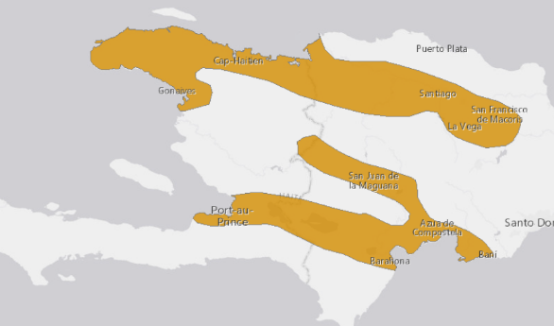  Range Description: This species is widely but patchily distributed in southern, central, and northern and north-western Hispaniola (both Haiti and Dominican Republic): Plaine du Nord-Valle de Cibao, Valle de San Juan, and Plaine du Cul de Sac-Valle de Neiba. The altitudinal range is from 40m below sea level up to 107m asl.  Habitat and Ecology: It occurs in dry lowland valleys, in both mesic and xeric areas, retreating under rocks and logs. Males call from rain-flooded areas, and eggs are laid in still water. The species breeds year round in some areas. It is occasionally found near water with heavy concentrations of sulphur.  Major Threat(s): The major threats to this lowland species are habitat loss, due to both livestock grazing and selective logging, and agricultural pollution.
Reptiles
Celestus warreni Giant Hispaniolan Galliwasp | Vulnerable, Hispaniola endemic | Justification: This species is listed as Vulnerable due to its limited distribution (with an extent of occurrence of 14,646 km2), fragmented subpopulations and ongoing threats include expanding agricultural activities, charcoal production, predation by cats, dogs and mongooses, it is killed by local people who mistakenly consider these lizards to be venomous, and it is on the illegal pet trade that continues to decline its extent of occurrence, and quality of habitat, and it is only found in a small protected area.  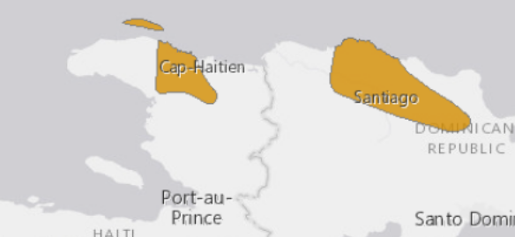  Range Description: This species is endemic to mainland Hispaniola (northern Haiti and northern Dominican Republic) and the offshore Ile de la Tortue. It occurs up to 702 m asl (M. Landestoy and S. Incháustegui pers. comm. 2015). Altitude range: 45-702m.  Population: It appears that the subpopulations in the Dominican Republic (formerly recognized as a separate species Celestus carraui) have almost been lost. The last collection and sightings were in 2014 in the Puerto Plata area (R. Powell pers. comm. 2014) and in San Francisco de Macoris province, a new locality record extending the species' distribution (S. Inchaustegui pers. comm. 2015). but there are occasional reports of sightings made by local people (S.J. Incháustegui pers. comm. 2015). In Haiti, the species is known with confidence from only a single locality despite intensive surveys and is considered very rare here (S.B. Hedges pers. comm. 2016).  Habitat and Ecology: This is presumed to be a burrowing species that occurs in mesic lowland broadleaf forest, dry forest, banana groves and cacao plantations (Henderson and Powell 2009). The captive longevity record is 11 years., but this was taken at a time when the captive husbandry requirements for these species were poorly understood. Based on captive specimens it appears that sexual maturity is reached at 3–4 years of age. A conservative estimate of generation time based on the known captive longevity record and age of sexual maturity would be 7 years. However, it is probable that once more data is collected this figure will be significantly larger. McGinnity (pers. comm. 2003) believes these animals are long lived (25–30 years, maybe longer), but that this may not be established for a very long time.  Major Threat(s): This species is threatened by loss of habitat, especially deforestation for agricultural activities (planting crops and creating pastures). This species is killed by local people who mistakenly consider these lizards to be venomous (the species reportedly has significance in the Voodoo religion). Lizards are also killed by dogs, cats and mongooses. The introduction and spread of the mongoose in Hispaniola, combined with habitat alteration, are most likely the proximate causes for the recent precipitous decline in giant species of Celestus (Powell and Henderson 2003).
Birds
Amazona ventralis (Hispaniolan Parrot) | Vulnerable, Hispaniola endemic | Justification: This species is considered Vulnerable because anecdotal evidence suggests that there has been a rapid population reduction. The size of the population and the exact extent of the decline are unclear, and clarification may lead to the species being reclassified as Near Threatened.  Range Description: Amazona ventralis is endemic to Hispaniola (Haiti and the Dominican Republic) and the associated islands of Grande Cayemite, Gonâve, Beata and Saona (AOU 1998). Introduced populations are established in Puerto Rico (to U.S.A.), and St Croix and St Thomas in the Virgin Islands (to U.S.A.) (AOU 1998). It was common on Hispaniola but declined significantly during the 20th century. By the 1930s, it was mainly restricted to the interior mountains, where it remains locally fairly common in suitable habitat, particularly within several major forest reserves (Juniper and Parr 1998, Raffaele et al. 1998). Elsewhere, it is now uncommon, rare or absent. The introduced population in Puerto Rico numbers several hundred and is apparently increasing (Juniper and Parr 1998).  There are no new data on population trends, but the species is suspected to be declining rapidly, as a result of hunting, habitat loss and trapping.  - Continuing decline in area of occupancy (AOO): Yes  - Estimated extent of occurrence (EOO) - km2: 99000  - Continuing decline in extent of occurrence (EOO): Yes  - Number of Locations: 11-100  - Upper elevation limit (metres): 1500  - Number of mature individuals: 6000-15000  Habitat and Ecology: It inhabits a variety of wooded habitats, from arid palm-savannah to pine and montane humid forest, up to and slightly above 1,500 m (Juniper and Parr 1998). It frequently forages in cultivated lands (AOU 1998), such as banana plantations and maize fields (Collar 1997a). Breeding is known from February to May, but prospecting pairs have been seen in mid-April, suggesting that the season may extend further into the year (Collar 1997a, Juniper and Parr 1998, G. M. Kirwan in litt. 1998). Nests are situated in tree-cavities, and sometimes dead tree-stumps (Collar 1997a, Juniper and Parr 1998, G. M. Kirwan in litt. 1998).  Major Threat(s): Agricultural conversion and charcoal production have destroyed most suitable habitat. It is also persecuted as a crop-pest, hunted for food and trapped for the local and formerly at least, international cage-bird trade (Juniper and Parr 1998). Trapping of adults and robbing nests for chicks to supply the local pet trade is a particular concern because in some areas most families own a parrot, and these only live a few years before they have to be replaced (G. Woolmer in litt. 2005, T. White in litt. 2012). Moreover, nest-robbing activities frequently result in destruction of the nest cavity or nest tree, further exacerbating loss of nesting habitat to other causes (T. White in litt. 2012).  Conservation Actions Underway: CITES Appendix II. An education strategy with community participation has been launched to protect the species (Vásquez et al. 1995). In 1997-1998, 49 captive-reared birds were released and radio-tracked in Parque del Este, Dominican Republic (Vilella et al. 1999). The Loma Charco Azul Biological Reserve, created in 2009, holds populations of the species. Also, recent public education and outreach work, including some enforcement actions, have taken place in several communities surrounding the Parque Nacional Jaragua, near the border with Haiti. In January 2012 there was also a release of 10 captive-reared parrots which had been confiscated as young chicks from nest poachers. These chicks were reared and rehabilitated at the Parque Zoologico Nacional, and successfully released on the grounds of the zoological park (T. White in litt. 2012).  Conservation Actions Proposed: Assess the current size of the population. Establish a comprehensive monitoring programme. Determine the extent of remaining habitat. Determine the impact of the various threats. Enforce the laws and regulations protecting this species and its habitat (Snyder et al. 2000). Encourage better bird-keeping practices to reduce the demand on wild birds and develop a captive breeding programme. Educate public regarding negative impact of native pet trade in the Dominican Republic (T. White in litt. 2012).
Corvus leucognaphalus (White-necked Crow) | Vulnerable, Hispaniolan endemic | Justification: This species has declined rapidly since the early 1980s, and the population and range are now small, fragmented and continuing to decline. It may decline more rapidly in the future owing to the westward spread of Pearly-eyed Thrasher Margarops fuscata and therefore deserves to be monitored closely. It consequently qualifies as Vulnerable.  Range Description: Corvus leucognaphalus is now confined to Haiti, the Dominican Republic and the offshore islands of Gonâve, Saona and Vache (Raffaele et al. 1998, T. Brooks in litt. 2000). It was once abundant on Puerto Rico (to USA), but was last recorded there in 1977 (R. Rodriguez in litt. 2007). On Hispaniola, it was considered locally common even in the early 1980s, but there has been a subsequent population decline (to less than 10,000 individuals) and range contraction. Sizeable populations are now restricted to Los Haitises and Jaragua National Parks, and the Sierra de Baoruco in the Dominican Republic, and it remains quite common on Île-à-Vache (T. Brooks in litt. 2000).  Population: The population is estimated to number 2,500-9,999 individuals based on an assessment of known records, descriptions of abundance and range size. This is consistent with recorded population density estimates for congeners or close relatives with a similar body size, and the fact that only a proportion of the estimated Extent of Occurrence is likely to be occupied. This estimate is equivalent to 1,667-6,666 mature individuals, rounded here to 1,500-7,000 mature individuals.  Trend Justification: There are no new data on population trends; however, the species is still suspected to be declining rapidly, and may do so more rapidly in the future owing to the westward spread of the Pearly-eyed Thrasher.  Habitat and Ecology: It inhabits lowland and montane wooded regions, where it probably favours old, mature forest (Madge and Burn 1993). It is intolerant of degraded habitats or areas opened up by forest clearance (Madge and Burn 1993). The diet is mainly fruit and seeds, but also vertebrates and large insects (Raffaele et al. 1998). It nests high in large trees or palms between the end of February and May (Madge and Burn 1993, Wiley 2006).  Major Threat(s): The extinction of this species on Puerto Rico, and the more recent decline on Hispaniola, are attributed to habitat loss for timber and agricultural conversion, and hunting for food and as a crop pest. However, the species tolerates degraded habitat and it is probable that the Pearly-eyed Thrasher Margarops fuscatus, a nest predator which spreads into degraded areas and has recently arrived on Dominican Republic and is established at Los Haitises National Park, contributed to the extinction of the crow on Puerto Rico and may accelerate its decline on Hispaniola (Wiley 2006).
Corvus palmarum (Palm Crow) | Near Threatened. Cuba; Dominican Republic; Haiti | Justification: This species is classified as Near Threatened because it has a moderately small range in which habitat degradation and hunting are causing it to decline; it almost meets the requirements for listing as threatened under criterion B1ab(iii,v).  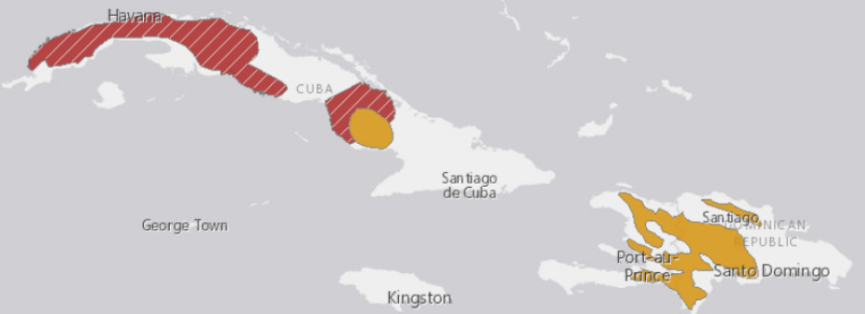  Range Description: This species constitutes two races, the nominate was formerly widespread in wooded areas from the lowlands to the mountains on Hispaniola (Garrido et al. 1997); however it has decreased and is now localised although not uncommon (Madge and Burn 1993) in Sierra de Baoruco, Isla Cabritos and the Cordillera Central of the Dominican Republic, and only remains locally common in the Massif de la Selle (Madge and Burn 1993, Dávalos and Brooks 2001) and in the northern pine belt of Haiti (Latta et al. 2006). The Cuban race minutus has a very restricted range (Garrido et al. 1997, Garrido and Kirkconnell 2000). It is rare and local (Madge and Burn 1993), with the only recent records being from five 'municipios' south of Camagüey city in south-central Camagüey province (P. Regalado in litt. 2007). The five municipalities holding the species in Camagüey province in order of importance are: Najasa, Jimaguayú, Vertientes, Santa Cruz and Camagüey city (Regalado in press). In Najasa, it is locally quite common (Madge and Burn 1993, A. Kirkconnell in litt. 1999), but although it has undergone historic declines (A. Mitchell in litt. 1998) surveys suggest that it remained stable between 2000-2006 (P. Regalado in litt. 2007). Although it has also been recorded from Pinar del Rio provinces (La Manaja, Los Acostas and El Francisco), there has only been one (undocumented) report from this area within the last 50 years (Kirkconnell et al. 2004). The species is historically known from Pan Valley, at Guajibon and in the Vinales Valley (Pinar del Rio province); Yaguaramas, near Cienfuegos; in the Trinidad Valley; and in the Sierra de Banao (Sancti Spiritus province) (Kirkconnell et al. 2004). It is thought to have had a wider distribution in Camagüey province in the past, occupying municipalities in the north: Cubitas, Minas and Guáimaro (Regalado in press).  Habitat and Ecology: On Hispaniola, birds are usually seen in small to medium-sized groups, foraging on the ground or in trees for fruit, seeds, insects, snails and lizards (Raffaele et al. 1998) and, in Haiti, it has even been recorded around local food markets (T. M. Brooks in litt. 2000). In Cuba the species is now known only from lowland cultivation with scattered groups of Royal Palms Roystonea regia (Madge and Burn 1993, P. Regalado in prep. 2016). Nests are located in stands of tall palms (Madge and Burn 1993), with breeding from March-July (Raffaele et al. 1998, A. Kirkconnell in litt. 1999, Garrido and Kirkconnell 2000). It roosts communally, including with C. nasicus where the two occur together (P. Regalado in litt. 2007).  Major Threat(s): On Hispaniola its decline is a result of widespread forest clearance for agriculture and probably also hunting for food (it is reputedly a delicacy) and sport (Madge and Burn 1993, Latta et al. 2006). It is more abundant on Haiti where gun ownership is lower (Latta et al. 2006). In Cuba, although partial clearance of dense forest may not have affected the species, the intensive clearance of Royal Palm (in which the species nests) for agriculture and livestock grazing may be causing declines and local extirpation, such as in Camagüey province (P. Regalado in litt. 2007). Housing developments have replaced much suitable habitat, and human disturbance of breeding sites and foraging areas may present a further threat (P. Regalado in litt. 2007). The species is extremely intolerant of humans and now lives in municipalities with the lowest human population densities (P. Regalado in prep. 2016). Competition with Cuban Crow C. nasicus, since habitat destruction has resulted in the overlap of their ranges, was thought to be a potential threat (A. Mitchell in litt. 1998), but it has since been suggested that the two species occupy different niches (P. Regalado in litt. 2007).  Conservation and Research Actions Proposed: Ensure the effective protection of habitat in national parks. Discourage the clearance of native forest for agriculture. Afford protection to the species and enforce this protection to discourage hunting. Monitor the species and investigate the effect of hunting on populations. Support efforts to create an ecological station at Najasa in order to implement conservation actions for this and other key species in collaboration with local communities and regional authorities (P. Regalado in litt. 2007).
Laterallus jamaicensis Black Rail |  | Justification: This poorly known species is believed to be declining at a moderately rapid rate and consequently it is classified as Near Threatened (del Hoyo et al. 1996).  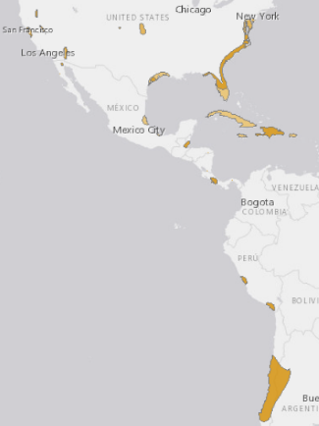  Range Description: Laterallus jamaicensis is widespread, but very local, in fresh and saline marshes, wet meadows and savanna in North, Central and South America, and the Caribbean. The nominate race occurs on the east coast of USA, with sporadic records inland to Colorado and Minnesota (but no confirmed nesting since 1932). It is very local in north-east Mexico, Belize, Guatemala (only in 1903), Costa Rica, Panama (only in 1963), and has recently been recorded in Honduras (R. Gallardo in litt. 2013). It is locally rare in the Dominican Republic and Haiti, but mainly a winter visitor on Jamaica and Cuba. It was probably extirpated as a breeder from Puerto Rico (to USA) by introduced mongooses and is now extremely rare in winter. It is recorded as a non-breeder in the Virgin Islands (to USA). There is one recent record from north Brazil. The race coturniculus is very local in south-west USA, irregularly to north-west Mexico (one recent record). The race murivagans occurs at few coastal marshes in central Peru. The race salinasi is rare and local in south Peru to central Chile and adjacent parts of west-central Argentina. It may occur (doubtful race pygmaeus) in the Colombian East Andes. In USA, most populations declined drastically in the 20th century, and the breeding range seriously contracted.  Trend Justification: This poorly known species is facing a number of serious threats which are thought to be causing declines in many parts of its range. The number of recent records suggest it is extremely scarce or no longer occurs in a number of former areas. There is anecdotal information to suggest that declines have occurred along the Atlantic coast of the US for the past 20 years due to loss of coastal breeding habitat, particularly in the Chesapeake bay region where the species is considered to have seen a big decline in occupied sites over the past 10 years (N. Roach in litt. 2016). The overall population is suspected to be declining at a moderately rapid rate.  Habitat and Ecology: It inhabits fresh and saline marshes, wet meadows and savanna. It occupies marshes with shallower water than other rallids and requires some tall vegetation to escape into. Feeds on terrestrial and aquatic invertebrates. Uses impoundments (managed wetlands) to forage and nest (Nicolette & Barrett 2015).  Major Threat(s): Continued massive degradation of wetlands habitats give cause for concern. In parts of its range it is threatened by pollution, drought, wildfires, groundwater removal, changing water levels, grazing and agricultural expansion (Eddleman et al. 1994, Taylor and van Perlo 1998).
Patagioenas leucocephala (White-crowned Pigeon) | Near Threatened | Justification: This species is classified as Near Threatened because although it has quite a wide range, it is restricted to low-lying areas where deforestation and habitat degradation are most intense. Together with hunting pressure, this is thought to be causing a moderately rapid population reduction.  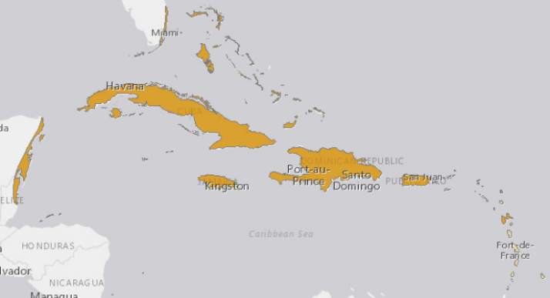  Range Description: Patagioenas leucocephala is found primarily in the Bahamas, Cuba, Jamaica and Antigua. It breeds in smaller numbers in Hispaniola (Dominican Republic and Haiti), Puerto Rico, the Virgin Islands (to USA), the Virgin Islands (to UK), San Andres (Colombia), Isla de Providencia and the Corn Islands (Nicaragua), Cayman Islands, Anguilla (to UK), St Barthelemy (to France), and more rarely on St Martin and Guadeloupe (to France) (Bancroft and Bowman 2001). Populations extend west along the Caribbean coasts of Yucatan Mexico, Belize, Honduras and north-west Panama. It reaches the USA only in the Florida Keys and the southern tip of mainland Florida (del Hoyo et al. 1997, Bancroft and Bowman 2001).  Habitat and Ecology: In Florida, the Bahamas, the coastal Yucatan islets and the Lesser Antilles it requires isolated offshore mangrove islets with limited disturbance for breeding, for feeding it flies to humid evergreen or semi-deciduous hardwood forests on adjacent mainland areas (Bancroft and Bowman 2001, Gibbs et al. 2001). Elsewhere it generally occupies lower-lying forest habitats (Gibbs et al. 2001).  Major Threat(s): Degradation of foraging habitat is a threat to this species (del Hoyo et al. 1997). In Florida removal of poisonwood Metopium toxiferum, which can cause severe human dermatitis, affects the species as it feeds on the poisonwood's fruit (Bancroft and Bowman 2001, Gibbs et al. 2001). P. leucocephala is an important game species through much of its range, and although hunting regulations in the Bahamas have been changed, illegal hunting seems to be a threat (Bancroft and Bowman 2001). Collision with man-made objects is a major source of mortality in Florida, and pesticide use and human impact may also have detrimental effects (Bancroft and Bowman 2001).  Conservation Actions Proposed: Protect important breeding islets. Ensure protection of low-lying forests on larger islands where the species forages. Discourage removal of poisonwood where possible in Florida. Enforce hunting laws. Take measures to reduce collision with man-made objects. Educational programs that encourage people to plant native, fruit-producing trees in the Florida Keys should be enacted. Investigate the effects of pesticide use on the species. Monitor key populations throughout the species range.
Psittacara chloropterus (Hispaniolan Parakeet) = Aratinga chloroptera | Vulnerable: Hispaniola endemic | This species has a small and fragmented range and population, which continues to decline as a result of habitat loss and persecution. It consequently qualifies as Vulnerable.  Geographic range: Psittacara chloroptera occurs in Haiti and the Dominican Republic It is now generally rare with isolated populations in the Cordillera Central, Sierra de Baoruco and the suburbs of Santo Domingo, Dominican Republic (S. Latta in litt. 1998). Its status in Haiti is unclear. It has been suggested that it may be extinct in Haiti (Juniper and Parr 1998), and the species was not recorded in the previously inhabited La Viste National Park in 2000 (Dávalos and Brooks 2001), but there are also claims that it is common in the Massif de la Selle and la Citadelle area of the Massif du Nord (Raffaele et al. 1998).  - Number of mature individuals: 1500-7000  - Continuing decline of mature individuals: Yes  - Population severely fragmented: Yes  - No. of subpopulations: 2-100  Habitat and Ecology: It inhabits all kinds of natural habitat from montane forest to arid lowland forest, palm-savannah and open woodland, and ranges into agricultural land and second growth (Juniper and Parr 1998). It occupies a wide altitudinal range from the lowlands to 3,000 m (Juniper and Parr 1998). Nesting takes place in tree-cavities or arboreal termite nests (Juniper and Parr 1998).  Movement patterns: Not a Migrant  Major Threat(s): Habitat loss and persecution as a crop-pest are the greatest threats to this species. It is exploited for local and international trade, but only 12 wild-caught individuals were reported in international trade in 1991-1995 (Snyder et al. 2000).  Conservation Actions Underway: CITES Appendix II. In the Dominican Republic, it is legally protected against hunting and trapping, but this legislation is not adequately enforced (Snyder et al. 2000). An education strategy with community participation has been launched for the protection of this species (Vásquez et al. 1995). Interactions between this species and Olive-throated Parakeet Aratinga nana (because of the recent increase in numbers of A. nana in the Sierra de Baoruco [S. Latta in litt. 1998]) are being investigated (Anon. 2007). A volunteer parrot protection group is to be set up and damaged nest cavities refurbished (Anon. 2007).  Conservation Actions Proposed: Clarify the status of the species in Haiti. Study ecology and breeding success to determine natural limiting factors. Enforce existing legislation in the Dominican Republic.
Siphonorhis brewsteri (Least Pauraque) | Near Threatened, Hispaniolan endemic | Justification: Although this species is very poorly known, its population is believed to be moderately small and declining owing to habitat loss and degradation. Its small range is, however, not yet severely fragmented or restricted to few locations. For these reasons it has been classified as Near Threatened.  Range Description: Siphonorhis brewsteri is found in central and west Dominican Republic (particularly on the north slope of the Sierra de Baoruco and between Oviedo and Pedernales), Haiti (between Arcahaie and Montruis north of Port-au-Prince) and, at least formerly, was numerous on Ile de la Gonâve (Raffaele et al. 1998). It is thought to be generally rare, although it can be locally common and is possibly under-recorded (Cleere and Nurney 1998, Raffaele et al. 1998). Surveys at Las Cruces, Sierra de Bahoruco, in March 1996 revealed 4.5 birds/km2, essentially unchanged from 4.8 birds/km2 during 1976 surveys in the same area.  Population: This species is suspected to have a moderately small population based upon its apparent rarity and the limited availability of suitable habitat. It is placed in the band 10,000-19,999 individuals, equating to 6,667-13,333 mature individuals, rounded here to 6,000-15,000 mature individuals. The species is suspected to be declining at a slow to moderate rate across much of its range, owing to habitat destruction (S. Latta in litt. 2006).  Habitat and Ecology: It is found in arid or semi-arid lowlands, especially scrubby woodland, and also broadleaf, pine or mixed forest up to 800 m (Cleere and Nurney 1998). Perches inconspicuously by day on branches close to the ground. Crepuscular and nocturnal, calling at night.  Major Threat(s): Habitat destruction and introduced predators are thought to threaten the species (Raffaele et al. 1998).
Mammals
Chilonatalus micropus (Cuban Lesser Funnel-eared Bat) | Near threatened | Listed as Near Threatened because historically only 15 caves (locations) are used by the species, and there is great pressure on them which is causing a population decline but at a rate of less than 30% over the past 10 years. Almost qualifies as threatened under criterion A2c.  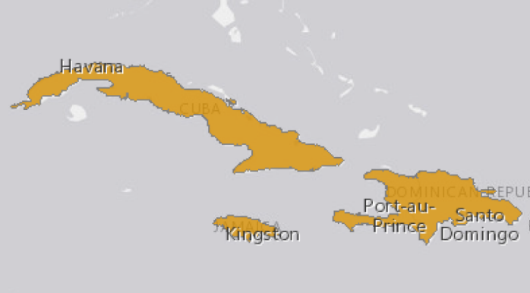  Range Description: This species is known from Cuba, Jamaica, Hispaniola, and Providencia Islands (Colombia) (Simmons, 2005).  Habitat and Ecology: This bat is an obligate cave roosting species. Its biology is poorly known. It is insectivorous. A female with an embryo was caught in December; and two lactating females were found in July (Genoways et al., 2005). 15 to 17 caves used by the species in Cuba.
Lasiurus minor Minor Red Bat | Vulnerable | Justification: Minor Red Bat has a small geographic range, occurs in less than 15 localities in only three Caribbean islands (Puerto Rico, Bahamas and Hispaniola). The species is affected by major threats like deforestation or decline in habitat quality, both of them associated to rapid expansion of human settlements. It is also highly susceptible to the impact of hurricanes. Habitat loss has had a direct effect on its populations, and it is suspected a past population reduction >30% and low population density in the past three generations (18 years; Pacifici et al. 2013). For this reason, the species is listed as Vulnerable.  Range Description: This species occurs in Bahamas, Hispaniola (Dominican Republic and Haiti), and Puerto Rico (Simmons 2005).  Habitat and Ecology: This species is solitary. It rests among the leaves of trees and does not take shelter in tree hollows, buildings, or caves. This bat is a swift flier but not highly manoeuvrable, consequently, it typically forages in open areas (above the canopy, in woodland open areas, and along forest edges). It is insectivorous, its diet has not been studied in detail. Some faecal pellets examined contained moths, winged termites, and flying ants (Rodriguez-Duran and Kunz 2001, Gannon et al. 2005). A lactating female with three pups was captured in Puerto Rico during the month of June (Rodríguez-Durán 1999).  Major Threat(s): Higher rates of deforestion associated to human population growth is especially serious in Haiti but also on western Dominican Republic. Loss of forests is a direct threat to species that roost in tree foliage, like L. minor. In addition, these islands are usually affected by severe weather, including seasonal hurricanes.
Natalus major (Hispaniolan Greater Funnel-eared Bat) | Near threatened | Listed as Near Threatened because, although the species is still reasonably widely distributed, it is dependent upon a highly fragile and threatened habitat (caves with very specific requirements). Given the current threats to these caves, and the fact that they seem to be increasing in recent years, it could qualify as Vulnerable under criterion A3c, due to a suspected population decline in the future - it is suspected that within the next three generations (approximately 17 years), the population decline will be 20-25%.  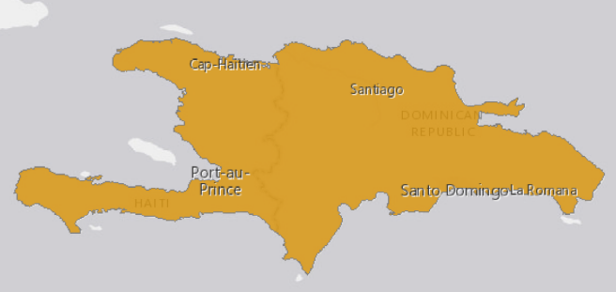  Population: Natalus major is known from 30 localities of which at least 10 have been roost sites, nine of them caves and one a large hollow tree (Timm and Genoways 2003). The caves where N. major has been found range from small to very large, are always humid, and often contain hot chambers and bodies of water. The species roosts in loose groups of less than 10 to more than 50 individuals, occupying areas of low ceilings or cave walls; roosting colonies may reach a few hundred individuals (Tejedor 2011). It may be locally common in specific areas (Hoyt and Baker 1980).  Habitat and Ecology: This species is found throughout dry areas. Natalus major has been found almost exclusively in caves, the exception being one report of nine individuals (2 females and 7 males) found roosting inside a large hollow tree in semiarid lowlands in the northern Dominican Republic (Timm and Genoways 2003). Its delicate wing membrane is subject to rapid dehydration; thus, this species probably requires caves with relative humidity for day time roosts. There is no reproductive information available (Hoyt and Baker 1980). It is insectivorous (Nowak 1999). It probably forages in rather cluttered vegetation and over relatively small home ranges (Tejedor et al. 2004).  Major Threat(s): Some of the caves where the species is known to roost are subject to modification for touristic activities, as well as for mining exploitation in Dominican Republic (Inchaustegui, pers. comm.). Other known threats come from access to caves for Guano extraction, or mining of caves for material construction (Rodriguez-Duran and Turvey, pers. comm.). This kind of disturbance can affect the suitability of caves for bats.
Insects
Battus zetides (Zetides Swallowtail) | Vulnerable: Hispaniola endemic
Crustaceans
Epilobocera haytensis | Vulnerable: Hispaniola endemic | Justification: This species is listed as Vulnerable because its extent of occurrence is about 20,000 km², and because there is a continuing decline in the extent and quality of its habitat due to human induced degradation driven by human population increases and industrial and agrarian development. It is not found in a protected area.  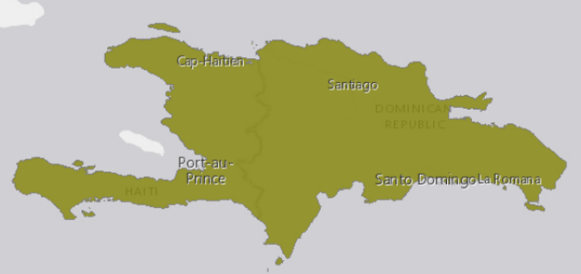  Range Description: Island of Hispaniola: found in both Haiti (Moline) and the Dominican Republic (Santo Domingo near Paradis). Found in nearly all lowland rivers on Hispaniola.  Major Threat(s): The major current and future threats to this species include human-induced habitat loss/degradation and water pollution due to urbanization and the development of agriculture. Forest loss has been rapid and wide reaching in the Dominican Republic, with cover reduced from 75% to 14% between 1920 and 1981 (Brothers 1997). This deterioration has continued, and is greatest at lower altitudes.
Plants
Albizia leonardii | Vulnerable, endemic | Range Description: North-west of Haiti  Habitat and Ecology: A small tree, localised in dry thickets.
Antirhea radiata | Vulnerable | Range Description: Occurring in central and eastern parts of Cuba and in the province of Pinar del Río, and also Hispaniola.  Habitat and Ecology: A tree of montane rainforest and submontane semi-deciduous forest.
Senna domingensis | Vulnerable | Range Description: Known in Cuba from a single locality in the coastal areas of Daiquirí, Santiago de Cuba province. The species is more widespread and more common in Hispaniola.  Habitat and Ecology: This small tree occurs infrequently in dry evergreen shrubwood and shrubland on limestone.

Cumulative dry matter yields (kg ha⁻¹) of marketable products harvested in five different cocoa production systems in Bolivia from 2009 to 2013.
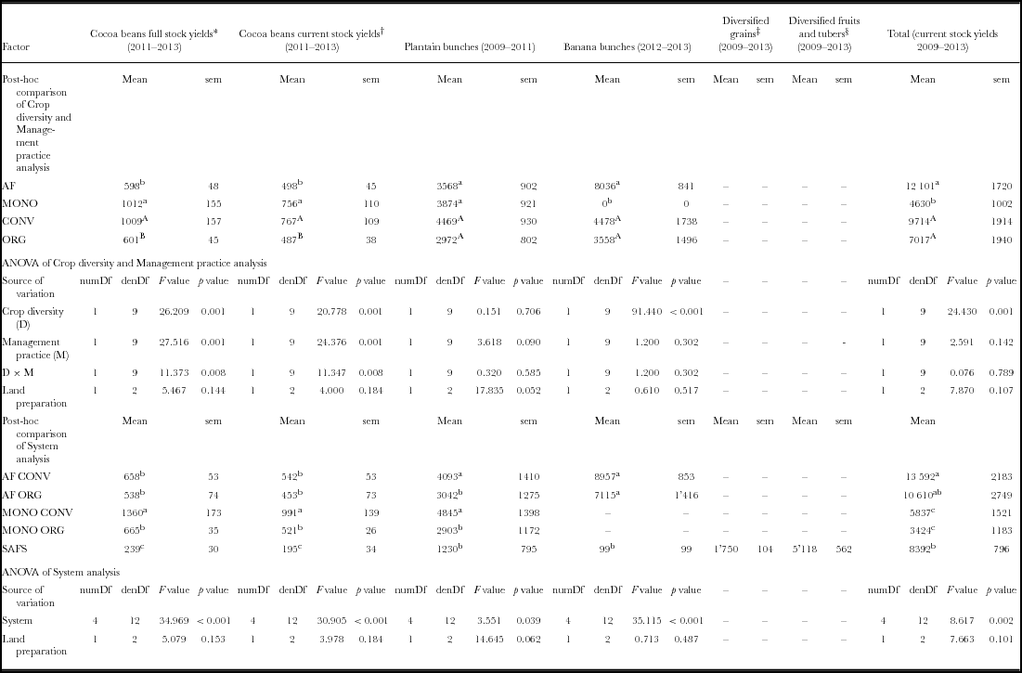

Partnership Arrangement between the MoE/UNDP/FAO/GEF Project "Sustainable management of wooded production landscapes for biodiversity conservation” and the IADB PITAG program
Context: The general objective of the Agricultural and Agroforestry Technological Innovation Program - PITAG (HA-G1038) is to increase agricultural productivity for small farmers in selected areas of the North, Northeast, Artibonite and South departments. The targeted beneficiaries are smallholder farmers living in selected areas of the North, Northeast, South and Artibonite Departments, in order to maximize synergies with other IDB programs in Haiti. The program will have two components:
- Applied research and training for the development and adaptation of sustainable agricultural technologies. This component will finance the following activities: (i) applied and adaptive agricultural research projects developed and implemented by national and/or international institutions, in order to create, improve and/or adapt innovative, profitable, and sustainable agricultural technologies that will enhance the supply of technological options available to farmers; and (ii) strengthening of the higher education curriculum to improve applied and adaptive research and technology transfer capabilities. In this context, specific attention will be given to the FAMV. The results of Component 1 will progressively provide input for the technology menu promoted by Component 2.
- Promotion of sustainable agricultural technologies. This component will finance the adoption of innovative, profitable and sustainable agricultural technologies that will improve long term farm profitability and generate positive environmental externalities. The component will be implemented through the agricultural incentives program conducted by the MARNDR and the technologies will be adapted to the different agro-ecological environments, local context and climate change perspectives. The technology menu may include: small irrigation equipment, harvest and post-harvest equipment as well as the application of sustainable agricultural practices (agroforestry systems, sustainable soil and water management techniques).
The operational modality of PITAG will involve the provision of technical and material support to farmers, for the implementation of innovative, profitable and sustainable agricultural technologies, by selected national service providers (NGOs), in response to expressions of demand formulated by the farmers.
The objectives of the proposed partnership between PITAG and the GEF project will be as follows:
- To help optimise the environmental sustainability of the agricultural technologies supported by PITAG, and the achievement of its aim of generating positive environmental externalities at the same time as long term farm profitability.
- To maximize the overall impact of the GEF project, by catalysing the generation of environmental benefits at scale through strategic association with a larger development program.
The operational contribution of the GEF project to the partnership will be as follows:
- The provision of logistical, technical and facilitation support to members of selected target communities in developing spatial and strategic plans. These will identify options for production and natural resource management that offer optimum prospects for environmental sustainability and benefits, taking into account social and biophysical conditions as well as the spatial dynamics of ecosystem flows, and will define how they should most appropriately be located in the landscape in order to optimize socioeconomic and environmental benefits. These processes will contribute to the construction of a “menu” of environmentally sustainable productive alternatives potentially to be supported through PITAG, together with a shortlist of farmers with potential to apply them and thereby to benefit from PITAG support; they will thereby contribute to optimizing the focalisation of the support provided through PITAG.
- The provision of technical and facilitation support to candidate farmers in developing proposals of productive options, for inclusion in their requests for support through PITAG. This will serve to optimize the technical and environmental soundness of the portfolio of initiatives to be supported by PITAG, thereby maximising their social, financial and environmental impacts and their sustainability.
- The provision of technical, material and advisory support to farmers, for the development and management of value-adding and commercial activities based on the emvironmentally-sustainable production practices supported by PITAG. This will optimise the financial benefits accruing to farmers, while at the same time providing financial incentives to farmers to favour sustainable forms of production.
- The provision of technical training to service providers collaborating with PITAG, in order to increase their effectiveness in supporting the application of environmentally-sustainable production practices by beneficiary farmers.
- The provision of technical advisory support to PITAG in developing and applying criteria, safeguards and indicators, applicable to the specific conditions of the target communities, to the production practices supported by PITAG.
Risks: the proposed partnership will imply no risks to the rate of execution or magnitude of impacts of either partner, for the following reasons:
- Although in the target communities the partnership will imply an initial process of participatory formulation of strategic and spatial plans, which will guide PITAG support to production practices, these communities will only constitute a small proportion of the total covered by PITAG. PITAG will therefore be able to progress without delay in other communities in the period between the commencement of its operations at the end of 2018 and the commencement of the field operations of the GEF project in the second half of 2019.
- In any of its target communities that may not be covered by PITAG, or in the event of any delay or change to the partnership arrangement, the GEF project will be able to provide the proposed support to farmers either directly or through alternative partnerships.
The specific operational arrangements for the partnership will be agreed in detail following project startup. PITAG and the GEF project will each have their separate administrative and implementation structures which will enable them to operate independently of each other. A coordination structure will be established at project start to permit the harmonisation and joint planning of operations and the consistency of the outreach messages delivered by both partners.

Procurement Plan

ITEM | ITEM DESCRIPTION | ESTIMATED COST (US $) | PROCUREMENT METHOD | ESTIMATED START DATE | PROJECTED CONTRACTING DATE
Goods and Non-Consulting Services
CS Individual | Project officer (SB4); Drivers; Admin; Technical | 514,200.00 | Local Advertisement | QTR1-YR1 | QTR2-YR1
CS Company | National contractual company for office security | 42,500.00 | Local Advertisement | QTR1-YR5 | QTR2-YR1
Vehicles and Motorcycles | Procurement for acquisition of 2 vehicles and 3 motorcycles | 355,000.00 | Desk Review – Competitive Sourcing | QTR1-YR1 | QTR2-YR1
IT Equipment | Various IT equipment (laptops, printer, GIS software, GPS etc.) | 35,000.00 | Desk Review – Competitive Sourcing | QTR1-YR1 – QTR2-YR5 | QTR1-YR1 – QTR2-YR5
Audio Visual&Print Prod Costs | Various Printing Material (dissemination, publications, results communication…) | 34,000.00 | Desk Review – Competitive Sourcing | QTR1-YR2 – QTR4-YR5 | QTR1-YR2 – QTR4-YR5
Communication & Audio Vis. Equip. | Communication and Aud. Vis. Equipment (Cell phones, recharges cards, internet …) | 33,500.00 | Desk Review – Competitive Sourcing | QTR1-YR1 – QTR4-YR5 | QTR1-YR1 – QTR4-YR5
Rental and Maintenance | Equipment (vehicles, motorcycles, inverter, office location, security)UNDP | 150,000.00 | Desk Review – Competitive Sourcing | QTR1-YR1 – QTR4-YR5 | QTR1-YR1 – QTR4-YR5
Trainings, Workshops, Conferences | Trainings, Workshops, | 81,000.00 | Desk Review – Competitive Sourcing | QTR1-YR1 – QTR2-YR5 | QTR1-YR1 – QTR2-YR5
SUB-TOTAL (US $) |  | 1,245,200.00
Consultancy Services
Local consultant | ESMF; mid-term and final evaluations; Value chain; translation | 137,000.00 | Local Advertisement - Desk Review – Competitive Sourcing | QTR2-YR1 | QTR3-YR1
Intl consultant | ESMF; mid-term and final evaluations; Value chain | 120,000.00 | Intl Advertisement - Desk Review – Competitive Sourcing | QTR2-YR1 | QTR3-YR1
SUB-TOTAL (US $) |  | 257,000.00
TOTAL COST (US $) |  | 1,502,200.00

Includes oceans and marine and freshwater ecosystems, forests, biodiversity and ecosystems, land rights, and management of chemicals and waste.
CEPF in its 2010 Ecosystem Profile: The Caribbean Islands Biodiversity Hotspot
USAID 2006 Haiti Analysis of Tropical Forestry and Biodiversity
Haiti Déforestée, Paysages Remodelés. Alex Bellande 2015, Éditions CIDIHCA
http://www.sciencedirect.com/science/article/pii/S0303243414000300
Lilin C and Koohafgan M (2012): Ravines et versants. Atelier de formation de Gros Morne. CIAT.
Garrigue N (1990): La place de l’arbre dans le paysage agricole : Étude des jardins boisés dans le bassin versant de Petite-Riviere de Nippes. Mémoire de fin d’études, CNEARC, Montpellier.
Une étude exhaustive et stratégique du secteur agricole/rural haïtien et des investissements publics requis pour son développement, Chapitre 6. Les filières agricoles Haïtiennes : un marché intérieur à reconquérir. Gaël Pressoir, Sandrine Fréguin Gresh, François-Xavier Lamure Tardieu, Fred Lançon. CIRAD/BID. Version finale -29 juin 2016
Haiti Déforestée, Paysages Remodelés. Alex Bellande 2015, Éditions CIDIHCA
Murgue (2009): Diagnostique agraire: le cacao, entre plaine et mornes dans le département du Nord en Haiti, Mémoire de fin d’études IRC-Supagro, Montpellier.
CRS Assessment of Haitian Coffee Value Chain (2010)
Assessment of Haitian Coffee Value Chain (Catholic Relief Services). Fernando Rodríguez, Nora Patricia Castañeda, Mark Lundy (2010). A participatory assessment of coffee chain actors in southern Haiti
Haiti Déforestée, Paysages Remodelés. Alex Bellande 2015, Éditions CIDIHCA
Jean-Denis S, Jean-Pierre D, Mutel M, Duchaufour H, Langlais C, Fernandes P, Alphonse M-E, Malézieux E (2014). Évolution de la structure d’un système agroforestier en relation avec le cycle de vie familial : cas du jardin de case en Haïti. Bois et forets des tropiques 2014, 321 (3).
Javan mongoose, an exotic introduced from SE Asia
1 Cx (carreau) = 1.29 ha
Une étude exhaustive et stratégique du secteur agricole/rural haïtien et des investissements publics requis pour son développement, Chapitre 6. Les filières agricoles Haïtiennes : un marché intérieur à reconquérir. Gaël Pressoir, Sandrine Fréguin Gresh, François-Xavier Lamure Tardieu, Fred Lançon. CIRAD/BID. Version finale -29 juin 2016
Économie Verte : étude sur les filières agricoles et le verdissement de l’économie dans le Département du Sud. PNUD/MoE/MARNDR (2016).
La filière Cacao d’Haïti : Un exemple de succès d’échanges Sud-Sud et de partenariat Nord-Sud. The Journal of Field Actions. Field Actions Science Reports. Special Issue 9 | 2014 : Haïti : Innovations locales, clés pour un développement durable et inclusif.
(Atelier INCAH, 2018)
CRS Assessment of Haitian Coffee Value Chain (2010)
https://espressocoffeeguide.com/gourmet-coffee/coffees-of-the-americas/haiti-coffee/haitian-blue-coffee/
https://www.haitilibre.com/article-11177-haiti-humanitaire-reouverture-de-l-usine-de-jus-naturels-de-fruits-de-marmelade.html
http://www.anatraf.org/
Sources : Haiti Déforestée, Paysages Remodelés. Alex Bellande 2015, Éditions CIDIHCA ; PPG studies.
Conseil national de financement populaire (KNFP, 2014))
Circular 113, 25th September 2018
Ministère de la Planification et de la Coopération Externe (MPCE). (2008). Document de Stratégie Nationale pour la Croissance et la Réduction de la Pauvreté (DSNCRP). 131p
Rodríguez et al (2010)
Haiti Déforestée, Paysages Remodelés. Alex Bellande 2015, Éditions CIDIHCA
FAES/Ministry of Social Affairs and the Bureaux of the Ministers in charge of Haitian Peasantry, Human Rights and The Fight Against Extreme Poverty
2013-2014 mid-term report to the Haitian Congress
MOE 2011, Feuille de route de l’action gouvernementale dans le domaine de l’environnement
https://www.iadb.org/en/project/HA-L1056
https://www.iadb.org/en/project/HA-L1097
Assessment of Haitian Coffee Value Chain. Fernando Rodríguez, Nora Patricia Castañeda, Mark Lundy. A participatory assessment of coffee chain actors in southern Haiti
Smucker et al, 2000
Bannister M.E. and Nair P.K.R. (2003). Agroforestry Systems February 2003, Volume 57, Issue 2, pp 149–157
Murray G.F and Bannister M.E (2004). Agroforestry Systems 61: 383–397, 2004.
cf. Conway 1986; Smucker and Timyan 1995
Grosenick 1986
Balzano (1986)
e.g. Smucker and Timyan 1995)
Cocoa and total system yields of organic and conventional agroforestry vs. monoculture systems in a long-term field trial in Bolivia. By M. Schneider, C. Andres, G. Trujillo, F. Alcon, P. Amurrio, E. Pérez, F. Weibel and J. Milz. Experimental Agriculture, Volume 53, Issue 3 July 2017, pp. 351-374
Eitzinger A; Läderach P; Carmona S; Collet L; Jean-Simon L; Dufane P; Nowak A. 2014. Haiti: Coffee and mango production under a changing climate. CIAT Policy Brief No.16. Centro Internacional de Agricultura Tropical (CIAT), Cali, Colombia. 8 p.
Galpin ME (1987). Spatial structure and population viability. In: Viable Populations for Conservation (ME Soulé ed.)., pp 125-139. Cambridge University Press, Cambridge. McArthur R and Wilson EO (1967). The Theory of Island Biogeography. Princeton University Press.
https://blog.nature.org/science/2017/09/21/ocean-flyway-surprising-open-water-routes-songbird-migrations/
http://www.iucnredlist.org/details/22721618/0
https://www.rainforest-alliance.org/articles/migratory-birds-sustainable-coffee-farms
Samuel Turvey, Senior Research Fellow, Institute of Zoology, Zoological Society of London (pers. comm.):
Turvey S, Fernández-Secades C, Nuñez-Miño J, Hart T, Martinez P, Brocca J, Young R (2014). Is local ecological knowledge a useful conservation tool for small mammals in a Caribbean multicultural landscape? Biological Conservation 169 (2014) 189–197
Turvey et al, op. cit.
1 Cx (carreau) = 1.29 ha
http://www.openforis.org/tools/collect-earth.html
http://www.fao.org/nr/kagera/tools-and-methods/lada-local-level-assessment-manuals/en/
http://www.fao.org/tc/exact/carbon-balance-tool-ex-act/en/
L. Gingembre (2012). Haiti: Lessons learned and way forward in natural resource management projects. In Assessing and Restoring Natural Resources in Post-Conflict Peacebuilding, ed. D. Jensen and S. Lonergan. London: Earthscan.
Haitian peasants have a long history of labour organization and shared work, especially in agriculture. Several peasant organizations are engaged in soil conservation and restoration work, and cooperate in micro watershed management. Others have created simple cooperatives. The widespread tradition of konbit (grouping people for a common goal, in Creole) reflects the long-standing culture of cooperation, particularly among peasants in rural Haiti, and lies at the core of Haitian society.
http://www.ethiquable.coop/fiche-producteur/feccano-commerce-equitable-haiti-cacao
6 ha in each of 14 communities where the project will work in partnership with the USAID Reforestation Project, and 3 ha in 18 other communities where the project will work alone
4,800 farmers trained in FFS, a 70% uptake rate following training, and practices applied over an average of 1.5 ha per farmer
600 farmers trained in FFS, a 20% uptake rate following training, and practices applied over an average of 0.25 ha per farmer.
1800 farmers trained in FFS, a 70% uptake rate following training, and practices applied over an average of 0.5 ha per farmer.
Applied studies will be carried out during the project lifetime to validate the effects of the application of the requirements of certification schemes with BD status
Includes non-target communities, benefited indirectly as a result of project support to FECCANO. Calculated as a 10% increase over the baseline.
Not measured separately: total of indicators O1, O2, O3 and O4.
25% of the 4,200 members of FECCANO + 70% of the 4,740 families with improved management of cacao, coffee and other agroforests + 500 members of 20 value-adding businesses + 1,000 employees of value-adding business + 16,590 value chain actors (number of farms adopting improved practices x assumed multiplier factor of 5). The lower value in the target range takes into the account the possibility that there may be overlap between the numbers of families adopting improved management of coffee, cacao and other agroforests.
25% of project area
Due to training/orientation of 75 service providers potentially serving 100 farmers each
Assumes 4,800 farmers trained on cacao agroforests with 70% uptake, 600 on coffee agroforests with 20% uptake, and 600 on home gardens, annual cropping and grazing areas with agroforestry with 70% uptake
Methodology and rating scheme to be developed at project start
See https://www.thegef.org/gef/policies_guidelines
See https://www.thegef.org/gef/gef_agencies
See guidance here: https://info.undp.org/global/popp/frm/pages/financial-management-and-execution-modalities.aspx
Excluding project team staff time and UNDP staff time and travel expenses.
The costs of UNDP Country Office and UNDP-GEF Unit’s participation and time are charged to the GEF Agency Fee.
See http://www.undp.org/content/undp/en/home/operations/transparency/information_disclosurepolicy/
See https://www.thegef.org/gef/policies_guidelines
A further USD 39,158,708 will be administered by FAO, consisting of a GEF grant of USD 2,686,964 and cofinancing of USD 36,471,744.
see https://info.undp.org/global/popp/ppm/Pages/Closing-a-Project.aspx
See separate guidance on how to enter the TBWP into Atlas17
UNDP budget for midterm evaluation = 24,000$ International consul. + 15,000 $ national consultant + 3,000$ Travel + 6000$ translation
UNDP budget for final evaluation = 24,000$ International consul. + 15,000 $ national consultant +3,000$ Travel + 6000$ translation
Prohibited grounds of discrimination include race, ethnicity, gender, age, language, disability, sexual orientation, religion, political or other opinion, national or social or geographical origin, property, birth or other status including as an indigenous person or as a member of a minority. References to “women and men” or similar is understood to include women and men, boys and girls, and other groups discriminated against based on their gender identities, such as transgender people and transsexuals.
In regards to CO_{2,} ‘significant emissions’ corresponds generally to more than 25,000 tons per year (from both direct and indirect sources). [The Guidance Note on Climate Change Mitigation and Adaptation provides additional information on GHG emissions.]
Forced evictions include acts and/or omissions involving the coerced or involuntary displacement of individuals, groups, or communities from homes and/or lands and common property resources that were occupied or depended upon, thus eliminating the ability of an individual, group, or community to reside or work in a particular dwelling, residence, or location without the provision of, and access to, appropriate forms of legal or other protections.
Land tenure and the adoption of agricultural technology in Haiti. Glenn R. Smucker, T. Anderson White and Michael Bannister. CAPRi Working Paper No. 6, CGIAR System-wide Program on Property Rights and Collective Action. October 2000.
Human Development Index, 2016
USAID (2016)
FAO, The Role of Women in Agriculture, 2011
MCFDF 2015. Statistiques de Genre: Comprendre pour mieux agir
IHSI, enquête, emploi, économie informelle, 2010
MCFDF 2015. Statistiques de Genre: Comprendre pour mieux agir
http://reports.weforum.org
United Nations Development Programme. Human Development Report. http://hdr.undp.org/en/content/table-4-gender-inequality-index.
http://hdr.undp.org/en/composite/GII
OECD. Social Institutions and Gender Index 2014. Country Profile http://www.genderindex.org/ranking
2012 EMMUS/DHS survey (République d’Haïti Ministère de La Santé Publique et de La Population (MSPP) (2012). Enquête Mortalité et Utilisation des Services EMMUS-V Haiti 2012 verify)
2012 EMMUS/DHS survey (République d’Haïti Ministère de La Santé Publique et de La Population (MSPP) (2012). Enquête Mortalité et Utilisation des Services EMMUS-V Haiti 2012 verify)
USAID (2016)
MCFDF (2014) politique d’égalité
USAID (2016)
Bellanca (2007)
USAID (2016)
USAID 2016 gender assessment
MCFDF 2015. Statistiques de Genre: Comprendre pour mieux agir
Gardella, 2006 (primary not found, from Feed the Future)
EMMUS (2012)
Shadow report, 2011
Gardella, Feed the future
Gardella Feed the future.
Haiti Overview: World Bank (http://www.worldbank.org/en/country/haiti/overview)
MCFDF 2014 politique d’égalité
Haiti Overview: World Bank (http://www.worldbank.org/en/country/haiti/overview)
Gardella, 2006 (primary not found, from Feed the Future)
Feed the Future, 2016
DSCRNP, 2007 (primary not found, citing from MCFDF 2014 politique d’égalité)
USAID ref 36
USAID ref 36
HRW (2017). Accessed May 2018. Available at: https://www.hrw.org/world-report/2018/country-chapters/haiti
Shadow report (2011)
MCFDF 2015. Statistiques de Genre: Comprendre pour mieux agir
MCFDF 2013. Le rapport de diagnostique des inégalités des genre
MCFDF 2015. Statistiques de Genre: Comprendre pour mieux agir
MCFDF 2013. Le rapport de diagnostique des inégalités des genre
MCFDF 2015. Statistiques de Genre: Comprendre pour mieux agir
MCFDF 2015. Statistiques de Genre: Comprendre pour mieux agir
HRW (2017). Accessed May 2018. Available at: https://www.hrw.org/world-report/2018/country-chapters/haiti
Shadow report (2011)
USAID (2016) gender assessment
Cite PFS gender assessment
MCFDF 2015. Statistiques de Genre: Comprendre pour mieux agir
MCFDF 2013. Le rapport de diagnostique des inégalités des genre
UNFPA Faits et chiffres clés sur la situation des femmes en Haïti, Novembre 2017. Available at : http://www.unfpa.org . Accessed May, 2018
MCFDF 2015. Statistiques de Genre: Comprendre pour mieux agir
PFS Gender Assessment
MCFDF (2014) Politque d’égalité femme hommes 2014 - 2034
Shadow report (2011)
Myriam Merlet. La participation politique des femmes en Haïti, quelques éléments d’analyse, 2002
REF 193 From USAID: Republic of Haiti (2016). Submission for the U.N. Universal Periodic Review 26th Session of the Working Group on the UPR Human Rights Council [31 Oct, – 11 Nov., 2016]. Climate Change and the Right to Food).
PFS gender assessment (from NAPA)
USAID (2016) gender assessment
MCFDF, 2013. Le rapport de diagnostic des inégalités de genre.
IHSI, estimation de la population haïtienne, 2009
Shadow report, 2011 – verify source within report.
MCFDF, 2013. Le rapport de diagnostic des inégalités de genre.
MCFDF, 2013. Le rapport de diagnostic des inégalités de genre.
Ibid.
MCFDF 2015. Statistiques de Genre: Comprendre pour mieux agir
MCFDF 2014. Politique d’égalité femmes hommes 2014-2034
Ref 39 from shadow report - verify Inter-American Commission for Human Rights.
HRW (2018) Accessed May 2018, Available at: From https://www.hrw.org/world-report/2018/country-chapters/haiti
HRW (2018) Accessed May 2018, Available at: From https://www.hrw.org/world-report/2018/country-chapters/haiti
MCFDF 2014. Politique d’égalité femmes hommes 2014-2034 (HRW website)
USAID and MCFDF
Shadow report
USAID – feed the future
FAOSTAT=
Feed the future (2016)
REF 160 from USAID 2016
MCFDF
FAOSTAT
Shadow Report (2011)
Shadow Report (2011)
Shadow Report (2011)
Oxfam. (2012). PLANTING NOW: Revitalizing Agriculture for Reconstruction and Development in Haiti. Briefing Paper. Port-au-Prince, Haiti. Oxfam. Retrieved from https://www.oxfam.org/en/research/planting-now-2nd-edition
USAID (2016) – citing Gardella, 2006
Feed the future (2016)
Feed the future
Shadow report (2011)
Shadow report (2011)
USAID (2016)
MCFDF 2014. Politique d’égalité femmes hommes 2014-2034
USAID (2016)
Oxfam (2012) planting now
Feed the future (2016)
FAO (2010) – FRA
FAO (2015) - FRA
Churches et al. (2014)
CIAT (2011) – coffee value chains
EMMUS (2012) – from USAID (2016)
FAO (from http://www.haitilibre.com/article-17656-haiti-environnement-l-onu-appelle-haiti-aux-bonnes-pratiques-environnementales-et-agricoles.html
UNEP (2016) Charcoal report
UNEP (2016) – charcoal report
See: https://haitiliberte.com/charcoal-is-not-the-cause-of-haitis-deforestation/
Canada-UNDP (2017)
See for example: Tarter (2015)
USAID (2016) – gender assessment
UNEP
MCFDF – which one? (Check Ref 91 in this document)
UNFPA (2017)
FAO (n.d.) – land rights database
FAO (n.d.) – landrights database
USAID (2015) – ICTP report
Arias, Brearly and Damais (2006) – verify source from CIAT 2011
CIRAD (2016)
FAO (n.d.) – land rights database
CIRAD (2016)
Gardella (2006) – from USAID (2016)
Feed the future (2016)
Feed the future (2016)
FAO (n.d.) – land rights database
FAO (n.d.) – land rights database
FAO (n.d.) – land rights database
Feed the future (2016)
http://www.rebuildingrespectforwomen.org/haiti.html
FAO (n.d.) – land rights database
USAID (2016)
USAID (2016)
Shadow report (2011)
Shadow report (2011)
Feed the future (2016) – check what their original reference was.
The World Bank (2013
MCFDF 2014. Politique d’égalité femmes hommes 2014-2034
USAID (2016)
EMMUS (2012)
EMMUS (2012)
EMMUS (2012)
USAID (2016)
Republic of Haiti (2016) – UN report on HR commission
FROM PFS GENDER ASSESSMENT: Kay Fanm and SOFA - which mainly receive abused women and girls - Gheskio and Médecins sans Frontières / MSF France
Shadow Report (2011)
HRW (2018). Accessed May, 2018; updated in 2018; available at: https://www.hrw.org/world-report/2018/country-chapters/haiti
USAID (2016)
Shadow report (2011)
UNDP (2016) - Projet de Renforcement des capacités adaptatives des communautés côtières aux changements climatiques en Haïti (ACC - PNUD/FEM/MOE)
USAID (2016)
Stoa (2017)
UNDP (2018) – NAP : lessons from Haiti
CIAT (2011), Oxfam (2014), AFD (2017)
Cocoa and total system yields of organic and conventional agroforestry vs. monoculture systems in a long-term field trial in Bolivia. By M. Schneider, C. Andres, G. Trujillo, F. Alcon, P. Amurrio, E. Pérez, F. Weibel and J. Milz. Experimental Agriculture, Volume 53, Issue 3 July 2017, pp. 351-374

